Đỗ Thị Thu Ngân - DS180213 - ReactHook and Ex12_6

Code vd1:

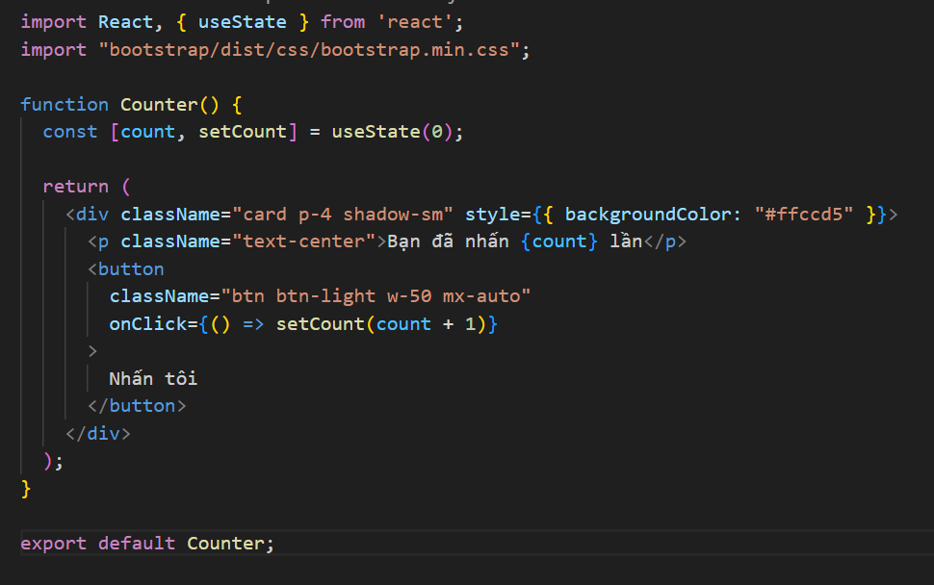

Result:





Code vd2:

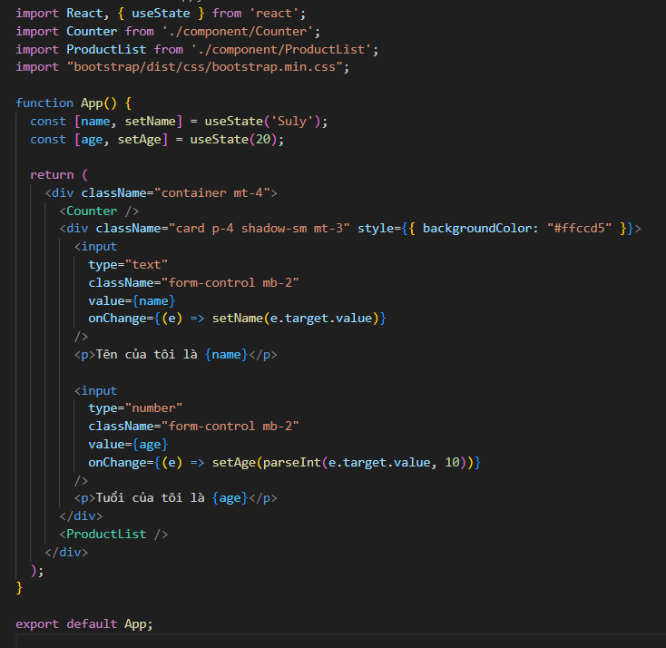

Result:

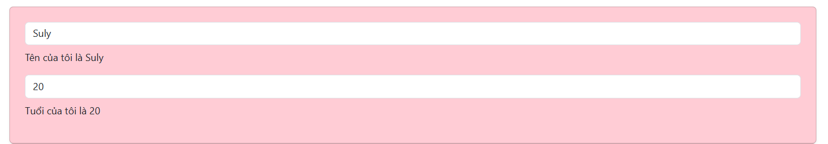

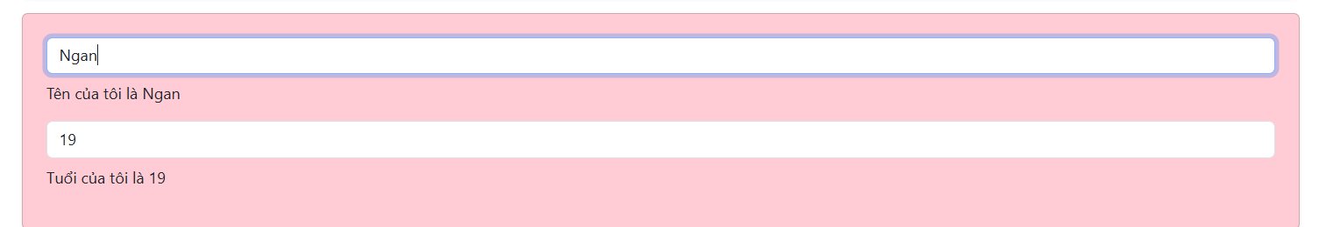

Code vd3:

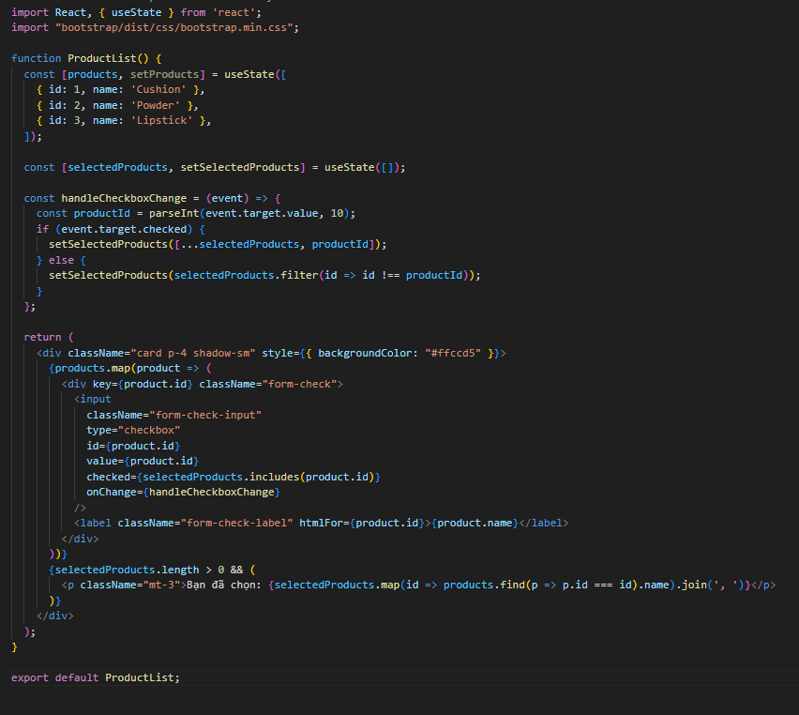

Result:

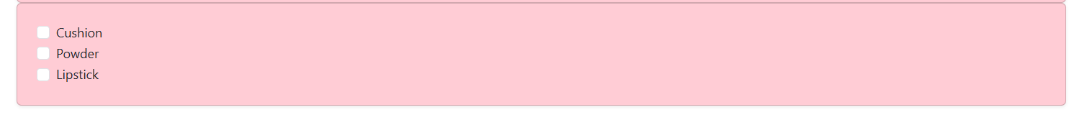

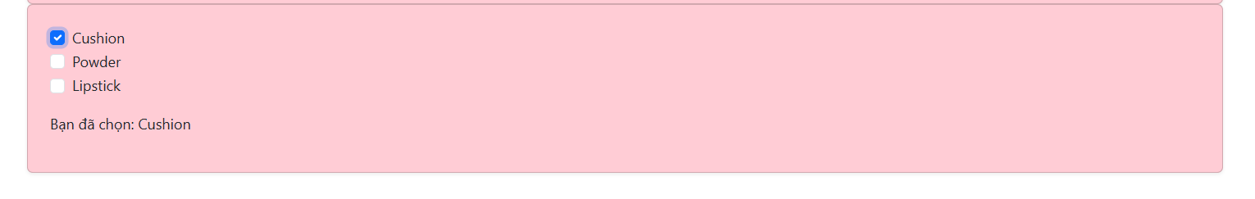

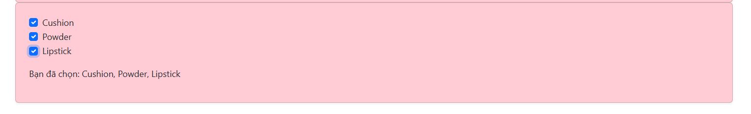

Code ex12_6:

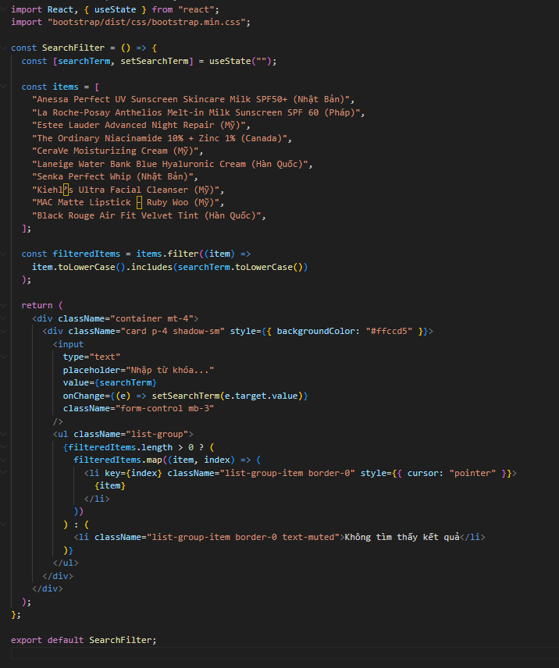

Result:

