Đỗ Thị Thu Ngân Slot2-ex4

Bài 1:

Code: 

Result:



Bài 2:

Code: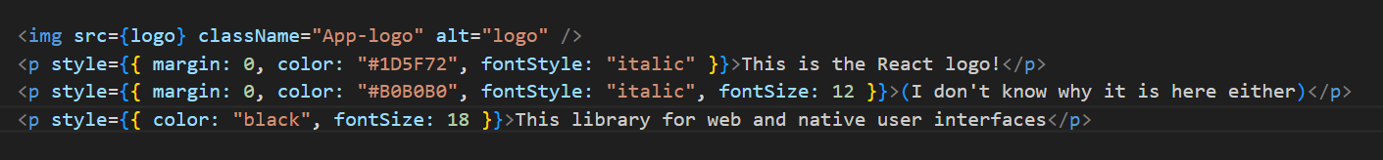

Result:

Bài 3:

Code:

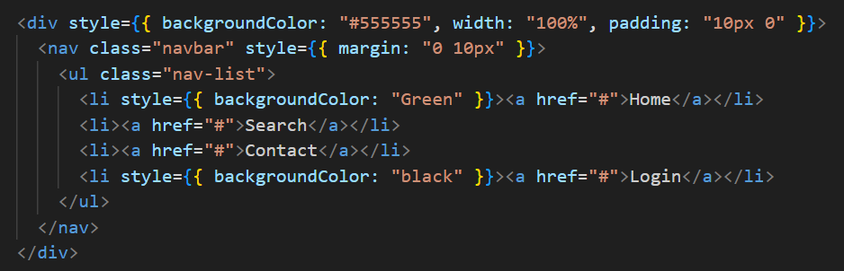

Result:



Bài 4:

Code:

Result:



Bài 5:

Code:

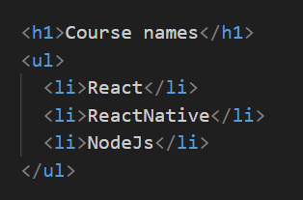

Result:



Using ES6 and JSX

Bài 1:

Code:

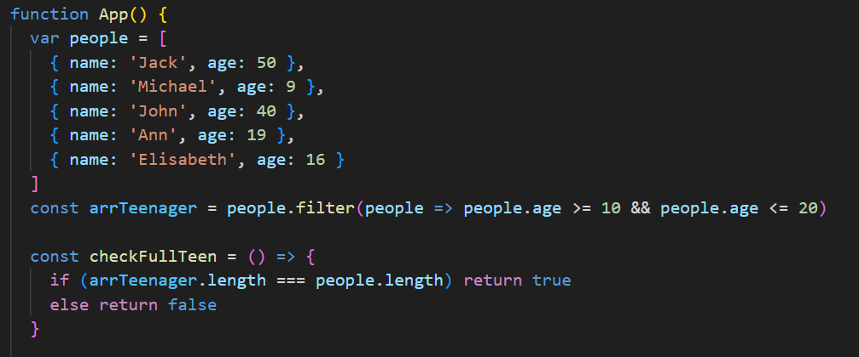

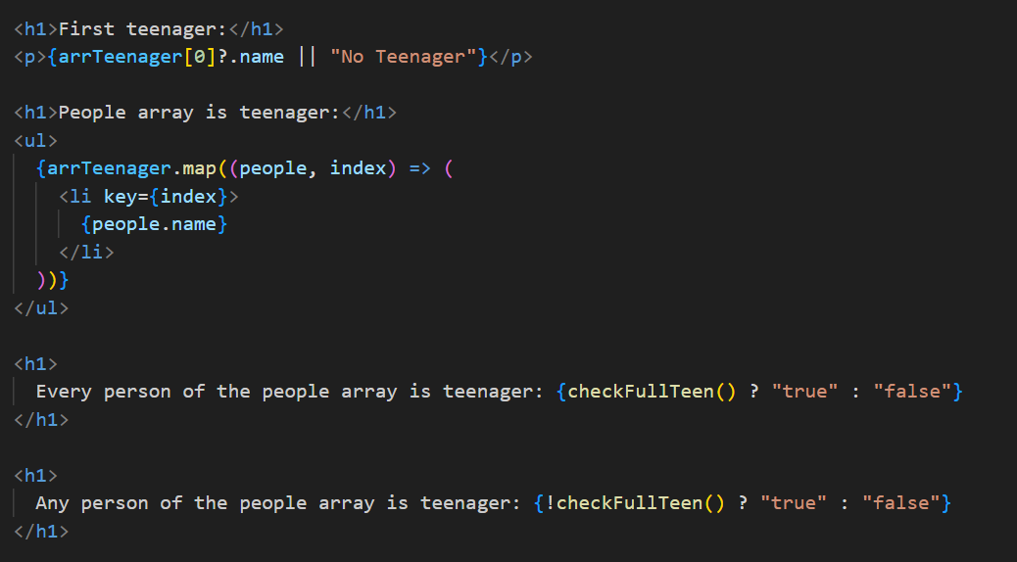

Result:

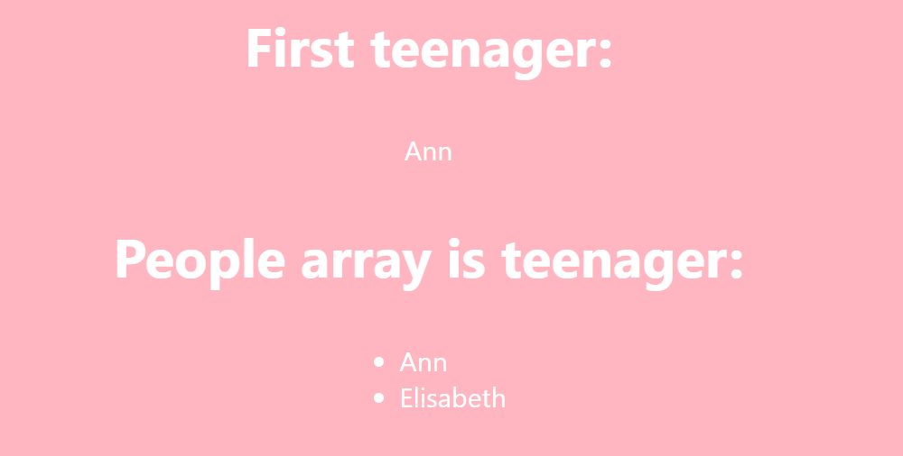



Bài 3:

3.1 Print the name of each company using forEach

Code:

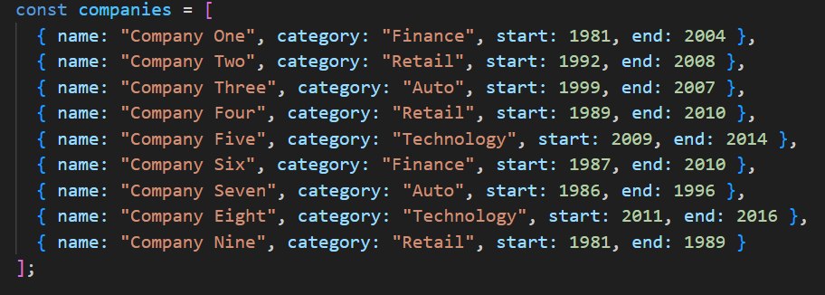

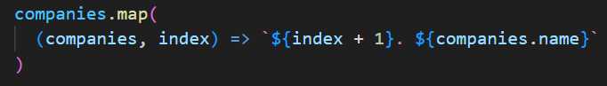

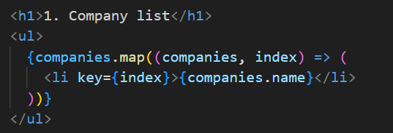

Result:

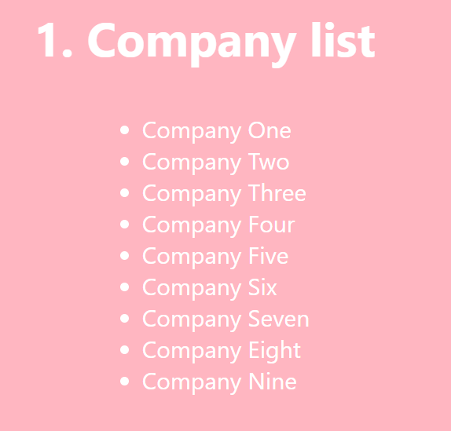

3.2 · Print the name of each company that started after 1987

Code:





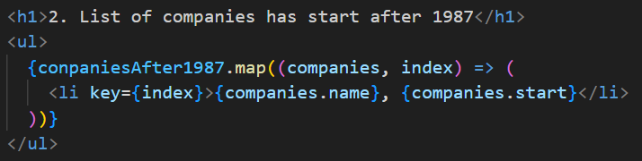

Result:



3.3 · Get only the companies that have category Retail, increment their start by 1 and append in the DOM a div that has the name, the category, the start and the end in paragraphs elements

Code:





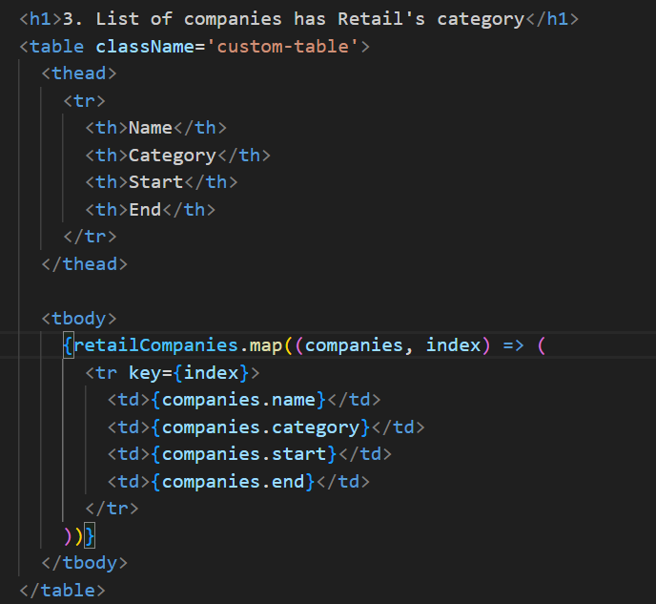

Result:

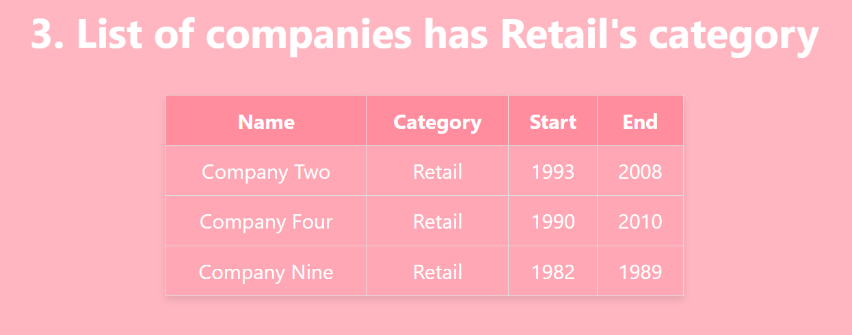

3.4 · Sort the companies based on their end date in ascending order

Code:





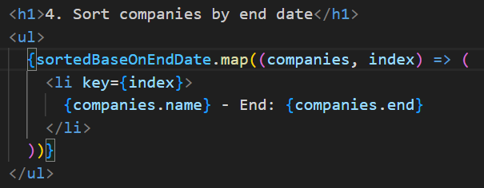

Result:

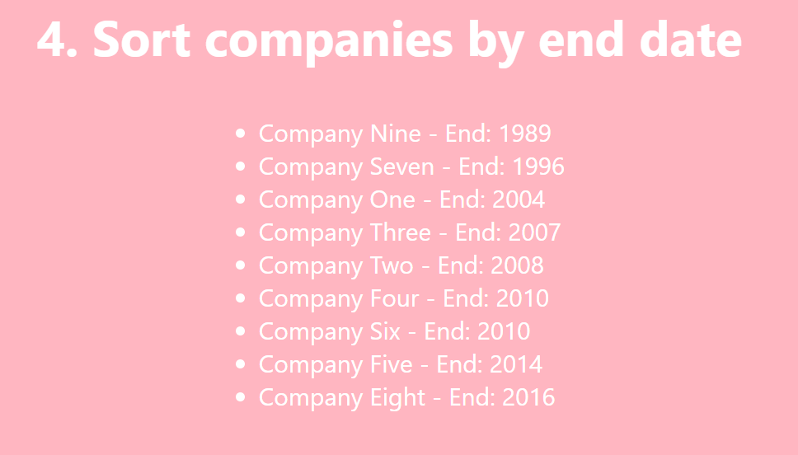

3.5 Sort the ages array in descending order

Code:





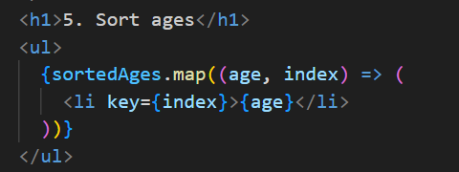

Result:

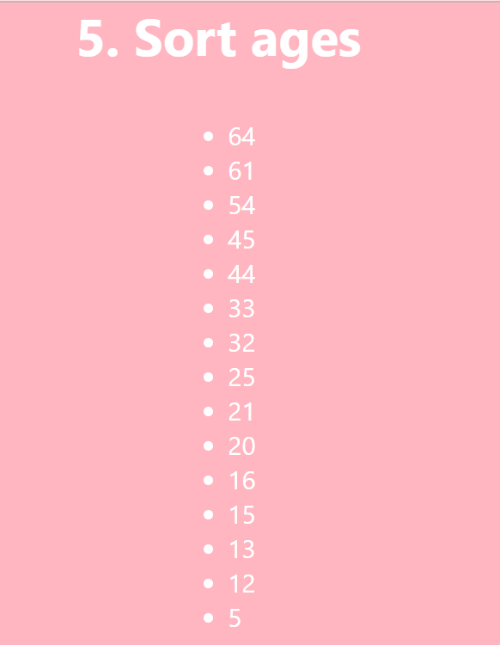

3.6 · Print the sum if you add all the ages using reduce

Code:



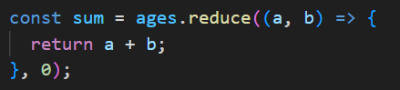



Result:



3.7 · Make a new object that has the properties of name and category same as the companies [0] and a method print that prints out the name, use object restructuring and ES6 JS

Code:





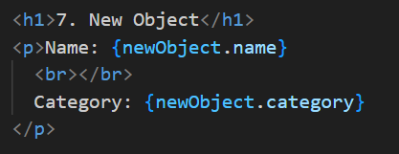

Result:

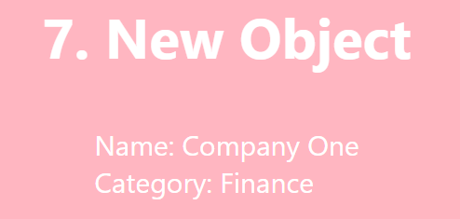

3.8 · Create a function that takes an unknown number of arguments that are numbers and return their sum;

Code:



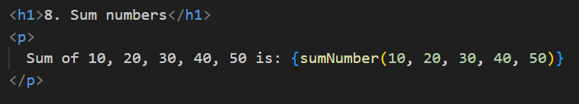

Result:

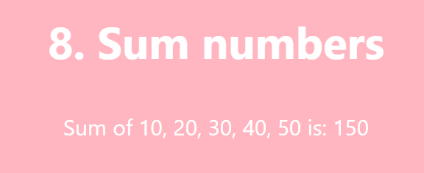

3.9 · Make a function that takes an unknown number of arguments of any type and adds them in an array and returns the array, if the argument is an array, it should add its values to the array that will be returned by the function

Code:

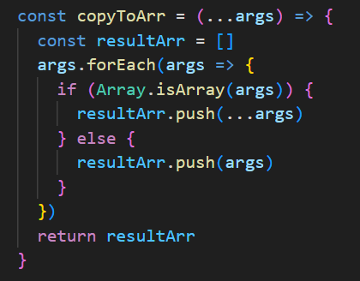

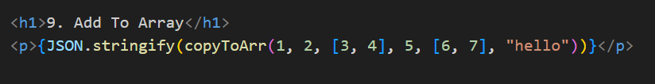

Result:

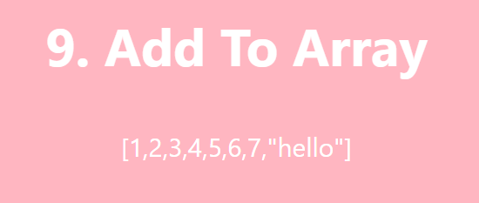

3.10 · Destructuring the property street in a variable named street from the object person

Code:

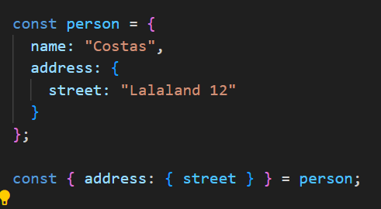



Result:



3.11 · Write a function that every time you call it, it returns a number that increments starting from 0

Code:

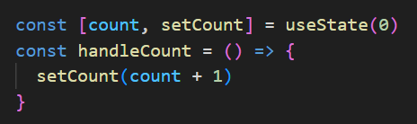

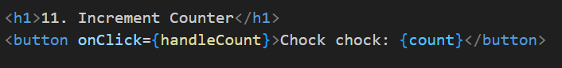

Result:







3.12 · Create a function that destructors the query parameters of a URL and adds them in an object as key value pairs and then returns the object

Code:

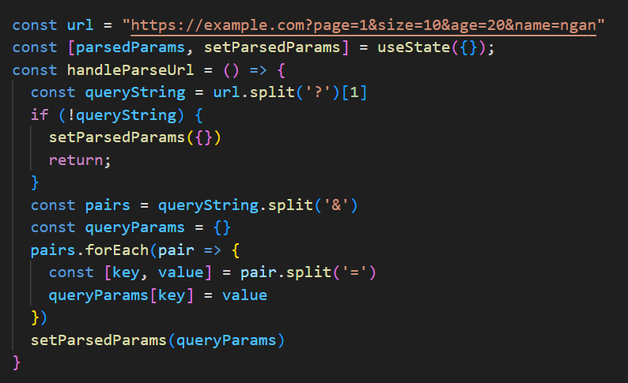

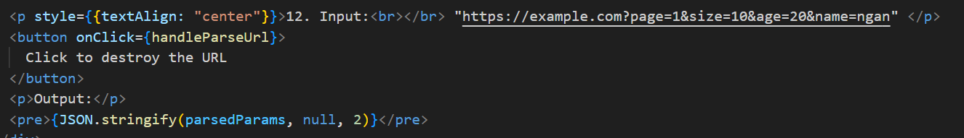

Result:

