SpaceRAG VR – Trust the Evidence, Protect the Crew
Project Link - https://github.com/sum1tbarua/SpaceRAG-VR

- Objective
The game is designed around the main stages of Retrieval-Augmented Generation (RAG). Rather than presenting RAG only as a technical pipeline, the main objective is to demonstrate its trustworthy AI aspects in a high-stake environment. The player must identify relevant evidence, rank the evidence, review the generated answer, and determine whether the answer is properly supported before sending it to the crew.
The space-mission setting makes the consequences of these decisions easier to understand. A well-supported answer allows the mission to continue safely, while incomplete evidence may delay an important crew decision. If an unsupported answer is accepted, the mission may experience a serious system failure or game-over condition.

- Target Learning Outcomes
After playing the game, the player is expected to be able to:
- Describe the basic RAG workflow in a simple way.
- Identify relevant and irrelevant evidence for a question.
- Explain why evidence ranking can affect the final LLM answer.
- Recognize the difference between grounded, incomplete and unsupported answers.
- Understand that citations are useful only when they support the answer.
- Explain why human validation is still important in a critical situation.
- Connect an AI reliability problem to a visible operational consequence.

- Game Setting and Player Role
The game takes place inside a spacecraft command center. The player is not controlling the spacecraft directly. Instead, the player is responsible for checking the information used by the ship's AI assistant.
The role of AI Mission Officer gives the player a clear responsibility: the player must make sure that the AI assistant does not send an unsupported answer to the crew. This role also makes the RAG process more interactive because the player is actively selecting, ranking, and validating evidence instead of only reading an explanation of how RAG works.

- Complete Game Plan
- Welcome Screen
The game begins with the SpaceRAG VR welcome screen. From here, the player can begin the game, start the tutorial, or exit. The purpose of this screen is to introduce the space-mission setting before showing the technical learning activities.

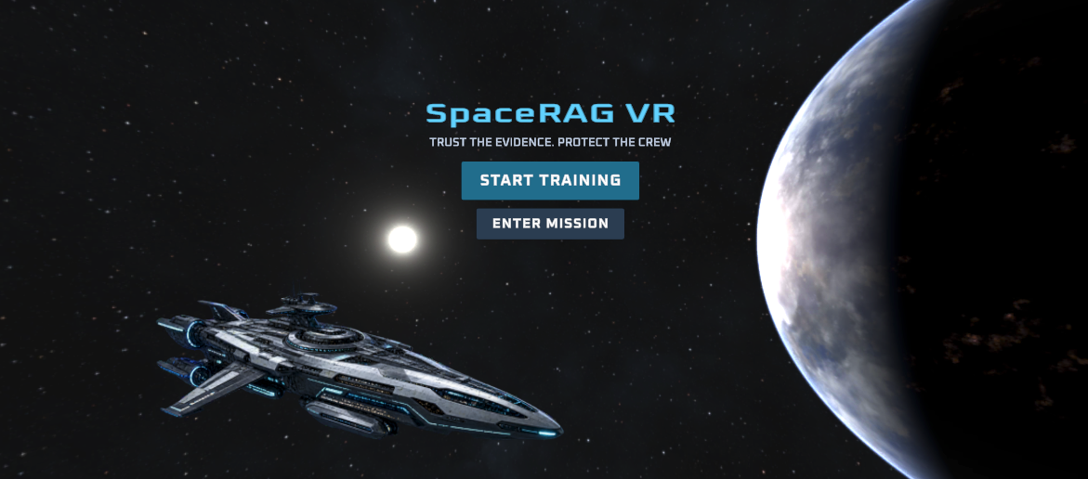
Fig: The landing screen of the game
- Tutorial
This gives the player a short explanation of the main tasks. It introduces the idea that some evidence is useful and some evidence may be incomplete or distracting. It also explains that the player will need to rank evidence and validate the AI response.

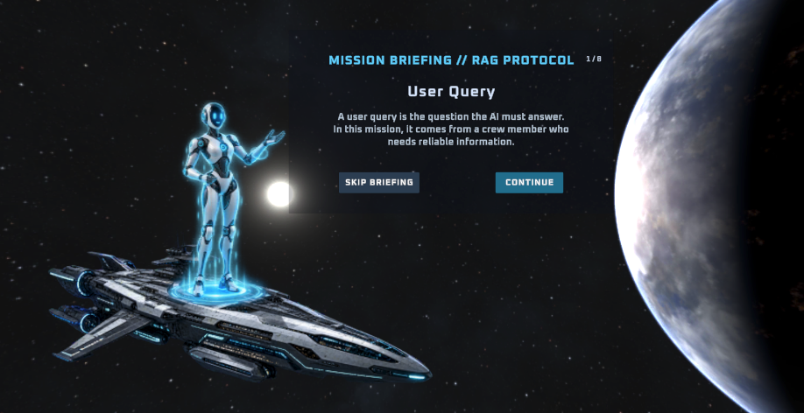
Fig: When a player clicks on “START TRAINING” in welcome page, this tutorial screen shows up. A player can either continue the tutorial or directly skip to game

- Mission Selection
After the tutorial, the player reaches the mission-selection screen. The current version contains the Space Mission AI Assistant game.

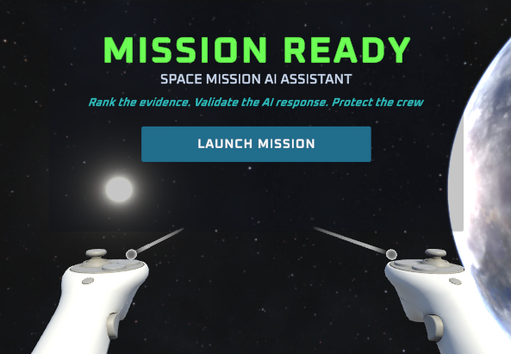
Fig: This screen shows up after a player ends the tutorial or starts the game directly

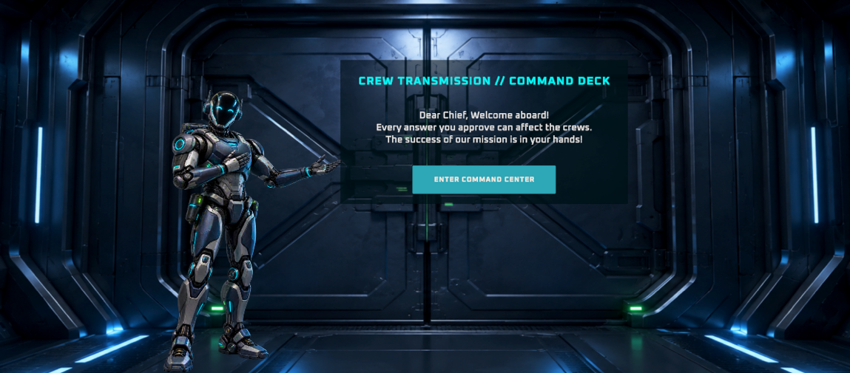
Fig: This screen shows up after player launches the mission. A robotic crew welcomes the player when the command center door being closed. After player hits enter, the door opens in simulation

- Crew Question and Mission Briefing
At the start of each mission, the crew sends a question related to a spacecraft problem. Once the player understands the question, they can begin the analysis of the question. During the analysis process, the player will see some internal RAG process such as query embedding, keyword matching, etc. Based on the query, an evidence box will pop up in the screen to give a player a feel the relevant files are retrieved based on the question topic.

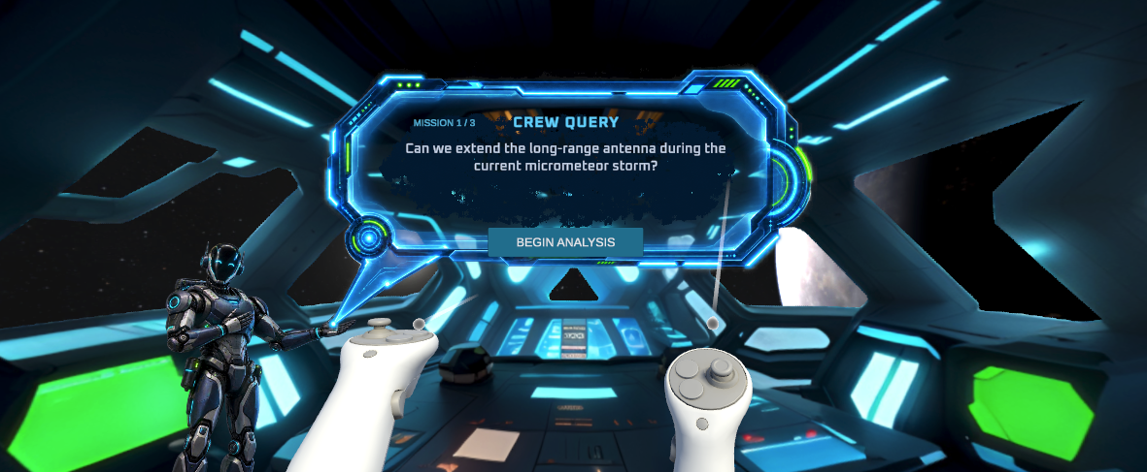
Fig: The crew question begins after the player enters the command center. The questions are kept normal space mission related

- Evidence Investigation
The player receives four evidence post cards. Some cards contain information that directly supports the answer, while other cards contain less relevant or distracting information. The player can inspect every card before deciding how the evidence should be ordered.

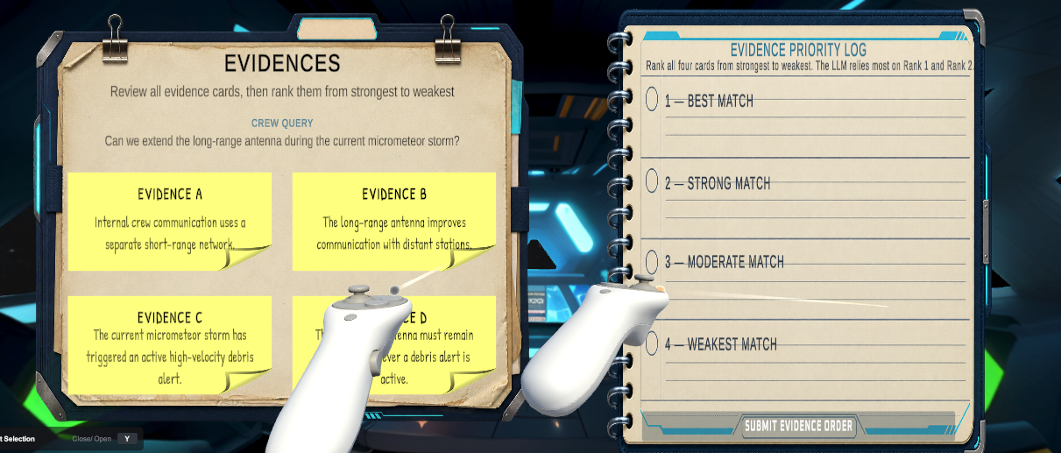
Fig: The evidence board on the left and reranking notebook on the right. The player will investigate the relevant evidence, then drag and drop in the reranking notebook
- Evidence Reranking
The player drags the four evidence cards into Rank 1 through Rank 4. The strongest evidence should be placed in the highest positions. The submission button remains disabled until all four ranking slots are filled. The ranking order affects the type of answer produced by the simulated AI assistant:
- If both key evidence cards are ranked at the top, the answer is grounded.
- If only part of the required evidence is prioritized, the answer is partially grounded.
- If the important evidence is not prioritized, the answer becomes risky or unsupported.
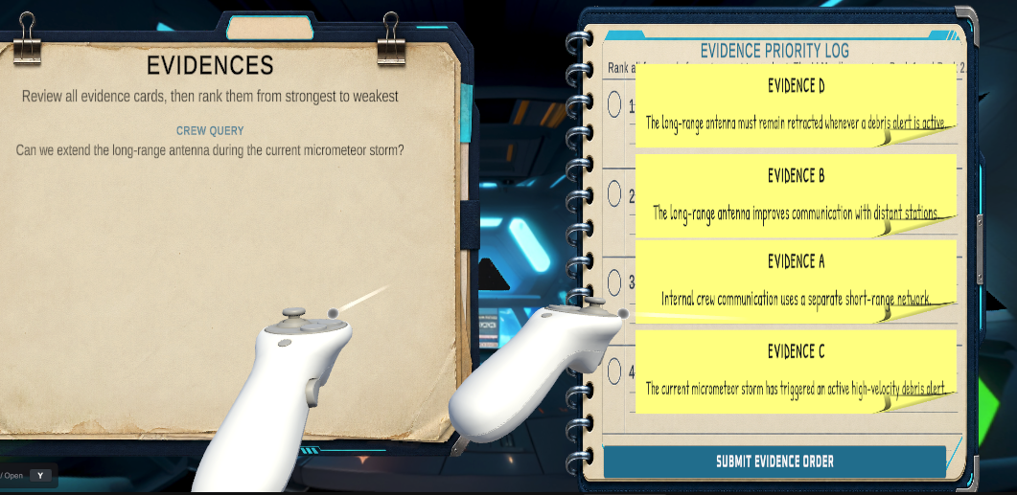
Fig: After player performs drag and drop based on the strongest and weakest evidence. A player may exchange the position of the ranking if needed before sending it to AI model

- Sending the Evidence to the AI Assistant
After completing the ranking, the player submits the evidence order to the AI assistant. A short loading sequence represents retrieval and answer generation. This helps show the connection between the evidence chosen by the player and the response produced by the AI system. The current version uses scripted answers rather than a live language model. This allows the same ranking decision to produce a controlled and repeatable learning outcome.
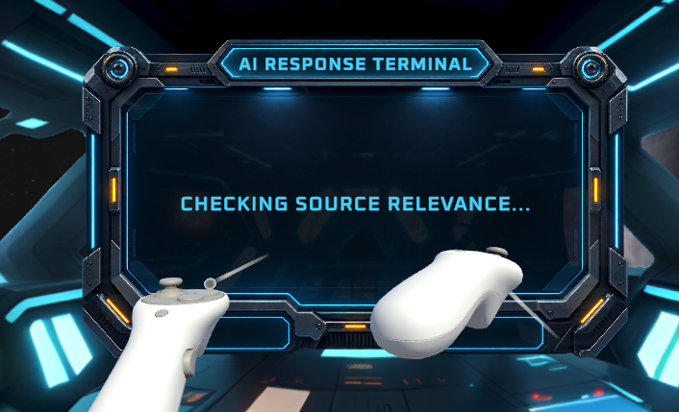
Fig: Showing the messages of internal workflow of a language model before producing a final answer

- Reviewing the Generated Answer
The AI response appears with its supporting references. The player can compare the generated answer with the selected evidence before making a validation decision.
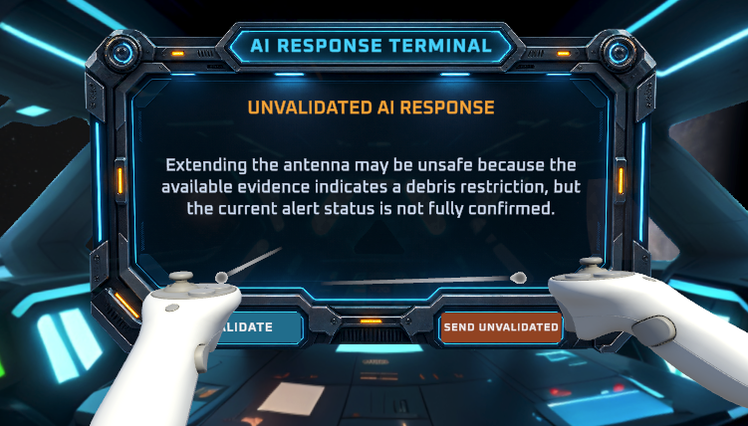
Fig: A predefined answer based on the ranked evidence is produced which can be manually validated or sent unvalidated by the player

- Manual Answer Validation
The player classifies the answer using one of three choices:
- Grounded: The answer is fully supported by the evidence.
- Partially Grounded: The answer contains useful information, but some required support is missing.
- Risky: The answer is unsupported, misleading, or unsafe to send directly to the crew.
The validation stage represents a human-checking layer. Even when retrieval or generation fails, the player may still protect the mission by recognizing the problem before the answer is used.
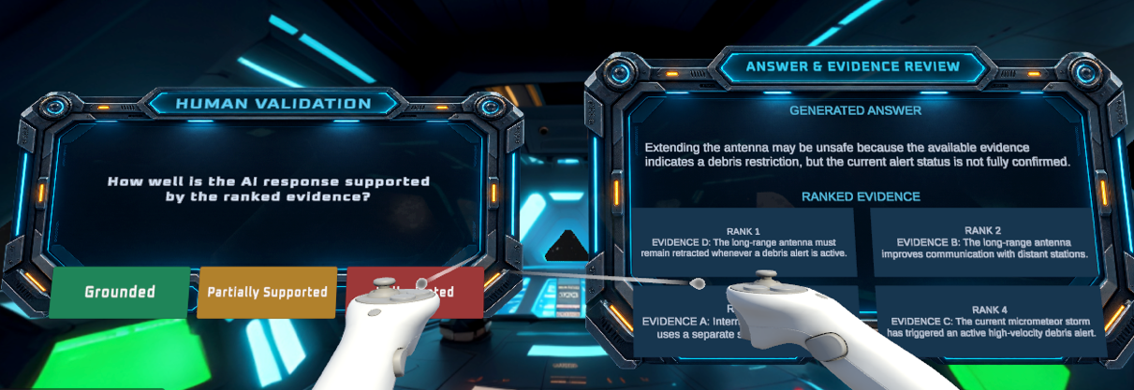
Fig: The player can review the ranked evidence, generated answer and confirm if the generated answer supports the evidence or not
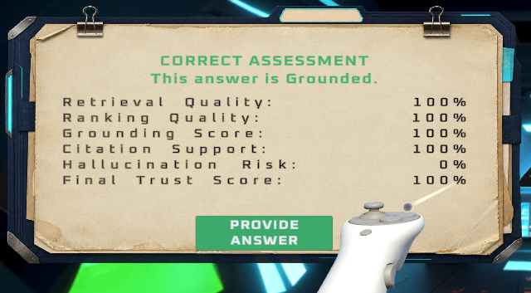
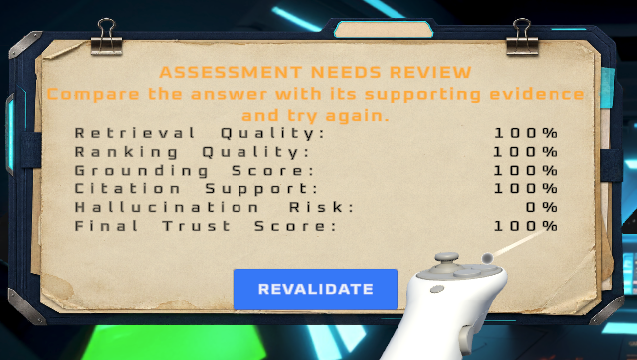
Fig: This assessment screen will show if the player chose correct or incorrect option in the validation. If the answer is incorrect, it will show that the assessment needs further review and ask the player to revalidate

- Mission Outcome and Consequence
After the player provides the answer, the game displays a mission outcome. The purpose of the consequence is to show why trustworthy AI matters. Instead of only showing that an answer was “wrong,” the game explains what could happen when unsupported information is used in a critical decision.

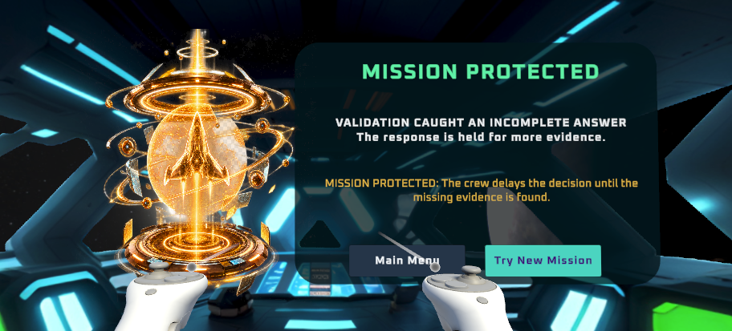
Fig: The consequence when player gets incomplete or partially grounded answer and click “Provide Answer”

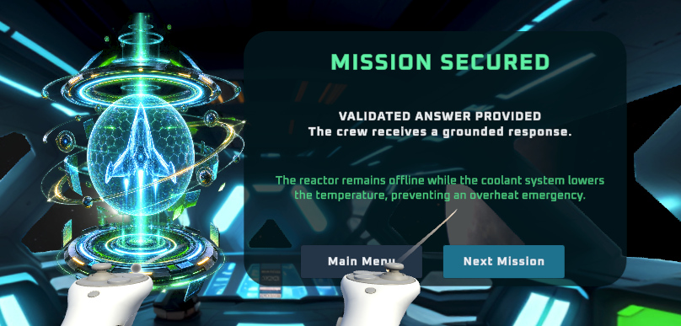
Fig: The outcome when player validates the answer correctly

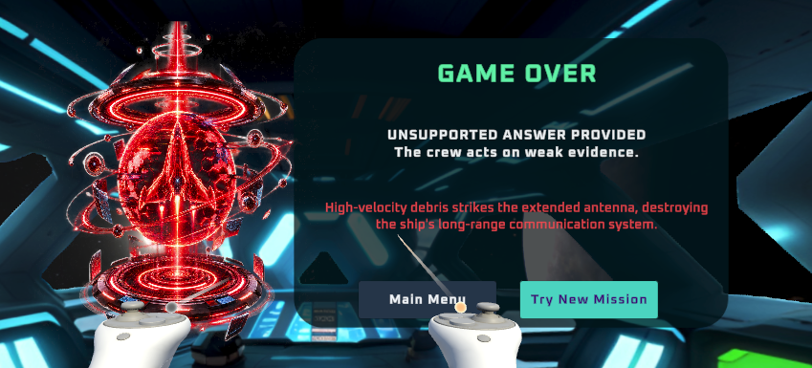
Fig: When the player sends a hallucinated or wrong answer unvalidated

- Continue, Retry, or Return to the Menu
After seeing the outcome, the player can continue to the next mission, retry with a new mission, or return to the main menu. The session contains three missions, which gives the player several opportunities to practice the same RAG concepts with different questions and evidence.

- Final Performance Debrief
After three missions, the player reaches the final performance screen. This screen is intended to help the player reflect on the full session rather than viewing each mission as an isolated task. The player can then play again or return to the main menu.
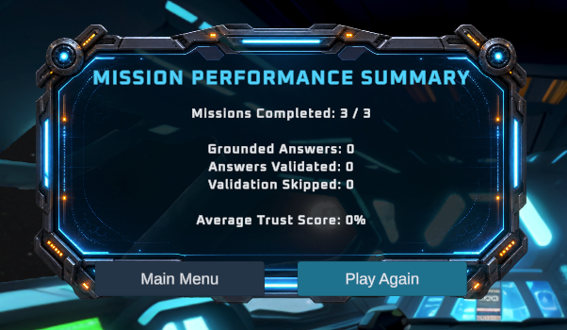
Fig: This screen will show up when player successfully completes 3 consecutive missions without any error

- Technical Scope of the Current Version
The current version was developed in Unity 6 for the Meta Quest 3S using OpenXR and the XR Interaction Toolkit. The game has been built and tested as a standalone Quest application. For this first version:
- The questions and evidence cards are predefined.
- The answer behavior is scripted based on evidence ranking.
- No live LLM or embedding model is used.
- Missions are randomly selected from the available mission set.
- The player uses Quest controllers for UI interaction and evidence reranking.
- The same controlled logic is used during testing so that expected and actual outcomes can be compared.
This controlled approach was selected because the main goal of game is to teach the RAG decision process. A live model could introduce unpredictable responses before the basic gameplay and learning design are evaluated.

- Expected Educational Value
We expect this game to make RAG concepts easier to understand than a lecture-only explanation. The player does not only read definitions of retrieval, reranking, grounding, and hallucination. Instead, the player makes decisions at each stage and then sees the result of those decisions.
The strongest part of the game is the connection between evidence quality and operational consequences. If the player ranks weak evidence highly, the generated answer becomes less trustworthy. If the player fails to validate that answer, the spacecraft may experience a failure. This gives the player a clear reason to care about trustworthy AI in critical situations.

