**Superstore Sales Analysis Report**

**Sumaya Mohamed**

**June 2025**

**svmaya1@outlook.com**

**Introduction:**

This project presents a comprehensive analysis of the Superstore sales dataset using SQL. The goal is to demonstrate practical data querying and analytical skills by answering key business questions related to sales performance, customer behavior and shipping efficiency. Through structured queries, data aggregation and visualisation, this analysis highlights trends and insights that can inform strategic decisions. The project reflects common tasks performed by analysts in diverse industries, showcasing proficiency in SQL as a foundational data tool.

**Insight 1: Total Sales by Product Category**

1. **Business Question:**

*Which product categories generate the most sales?*

1. **SQL Query:**

SELECT Category,

ROUND(SUM(Sales), 2) AS total_sales

FROM superstore

GROUP BY Category

ORDER BY total_sales DESC;

1. **Table Output:**

| **Category** | **Total Sales** |
| --- | --- |
| Technology | 827455.87 |
| Furniture | 728658.58 |
| Office Supplies | 705422.33 |

1. **Visualisation:**

**Figure 1:** Bar chart showing total sales (USD) by product category.

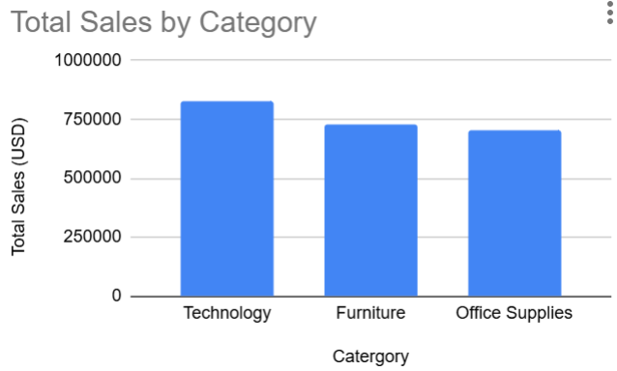

1. **Key Insights:**

* As shown in **Figure 1**, Technology leads all categories in sales with **$827,455.87,** accounting for approximately 37% of total revenue. It surpasses Furniture by nearly **$98,800**, indicating stronger demand or potentially higher pricing strategies.
* While **Furniture** and **Office Supplies** sales are somewhat close (around $700K each), the difference between Technology and the others suggests an opportunity to focus marketing and inventory efforts on Technology to maximise growth.
* **Office Supplies**, while essential, lags behind Technology and Furniture, potentially due to lower price points or commoditisation, indicating it may be more price sensitive or competitive.
* The data suggests that the company could focus on expanding and optimising inventory and marketing efforts in the **Technology** category to maximize growth potential.

**Insight 2: Monthly sales Trend**

1. **Business Question:**

*How do total sales vary by month?*

1. **SQL Query:**

SELECT

strftime('%Y-%m',

date(substr("Order Date", 7, 4) || '-' ||

substr("Order Date", 4, 2) || '-' ||

substr("Order Date", 1, 2))

) AS order_month,

ROUND(SUM(Sales), 2) AS monthly_sales

FROM superstore

GROUP BY order_month

ORDER BY order_month;

1. **Visualisation:**

**Figure 2:** Line Graph showing Monthly Sales Trend (2015-2018)

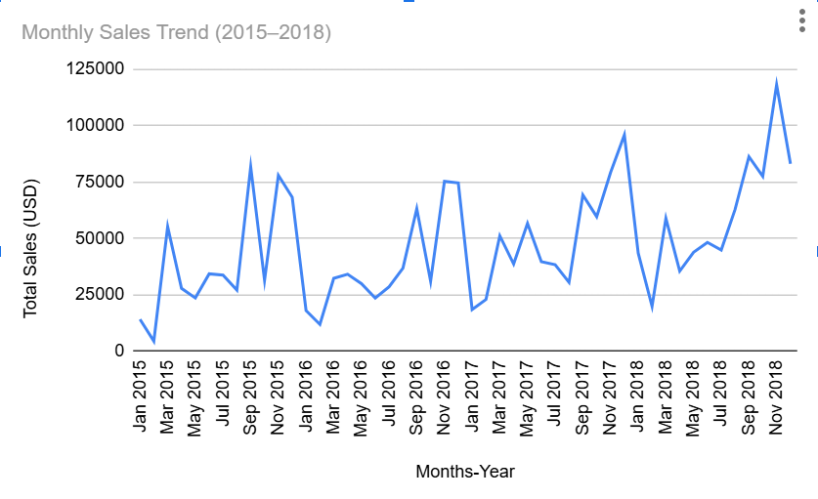

1. **Key Insights:**

* *As shown in* ***Figure 2****, monthly sales exhibit consistent seasonal peaks and a clear upward trend by 2018, indicating overall business growth.*
* Significant spikes in sales occur in **September**, **November** and **December**, likely tied to holiday shopping and end of year demand.
* A **year over year increase** is evident across the period. For example, **November sales** grew from **$77,907.66 in 2015** to **$117,938.15 in 2018**, highlighting strong seasonal momentum.
* **February** consistently shows the lowest sales each year, suggesting a post holiday slump or seasonal lull.
* Overall, the data reveals a **cyclical sales pattern** with increasing volumes year over year, reinforcing the need for effective planning during high demand months

*For full monthly sales data, see Appendix A1.*

**Insight 3: Top 10 Customers by Sales**

1. **Business Question:**

*Which customers contribute the most to our sales revenue?*

1. **SQL Query:**

SELECT "Customer Name",

ROUND(SUM(Sales), 2) AS total_sales

FROM superstore

GROUP BY "Customer Name"

ORDER BY total_sales DESC

LIMIT 10;

1. **Table Output**

| **Customer Name** | **Total Sales (USD)** |
| --- | --- |
| Sean Miller | 25043.05 |
| Tamara Chand | 19052.22 |
| Raymond Buch | 15117.34 |
| Tom Ashbrook | 14595.62 |
| Adrian Barton | 14473.57 |
| Ken Lonsdale | 14175.23 |
| Sanjit Chand | 14142.33 |
| Hunter Lopez | 12873.3 |
| Sanjit Engle | 12209.44 |
| Christopher Conant | 12129.07 |

1. **Visualisation**

**Figure 3:** Top 10 Customers by Sales

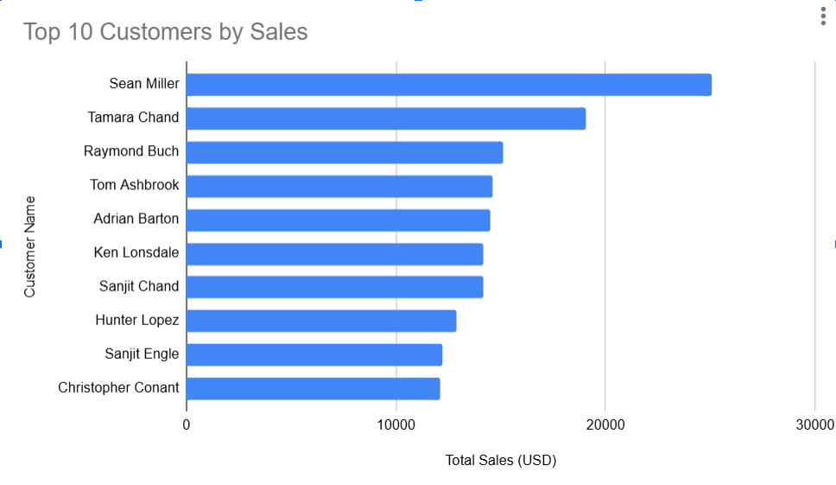

1. **Key Insights:**

*Based on Figure 3, the distribution of total sales among the top 10 customers reveals a notable concentration of revenue in a few key accounts.*

* **Sean Miller** is the top customer, contributing **$25,043.05**, significantly ahead of others on the list.
* Sales gradually decline from the top customer to the 10th, suggesting a **relatively balanced spread** among the top buyers but still with clear leaders.
* The **top three customers**, Sean Miller, Tamara Chand and Raymond Buch, together account for a substantial portion of total sales, indicating **reliance on a few high value clients**.
* This concentration highlights the importance of **maintaining strong B2C relationships** with these top customers to ensure revenue stability.
* There is potential to develop **personalised offers, loyalty programs** or account specific engagement strategies to encourage retention and upsell opportunities.
* **Analysing their purchasing behaviour** could reveal trends and preferences, helping tailor product recommendations or marketing efforts more effectively.

**Insight 4: Total Sales by Customer Segment**

1. **Business Question**

Which customer segment generates the highest sales revenue?

1. **SQL Query:**

SELECT Segment,

ROUND(SUM(Sales), 2) AS total_sales

FROM superstore

GROUP BY Segment

ORDER BY total_sales DESC;

1. **Table Output:**

| **Segment** | **Total Sales (USD)** |
| --- | --- |
| Consumer | 1148060.53 |
| Corporate | 688494.07 |
| Home Office | 424982.18 |

1. **Visualisation:**

**Figure 4:** Pie chart showing Sales distribution by Customer Segment (%)

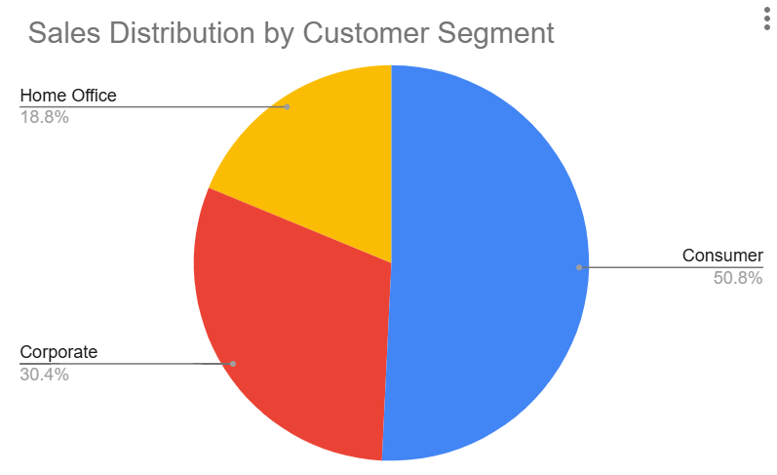

1. **Key Insights:**

Refer to Figure 4 (Pie Chart), which illustrates the sales distribution across the three customer segments.

* The **Consumer** segment dominates sales, accounting for **50.8%** of total revenue, highlighting the importance of individual customers.
* The **Corporate** segment represents a significant **30.4%**, showing strong business client engagement.
* The **Home Office** segment, at **18.8%**, reflects growing demand likely influenced by remote work trends.
* This distribution suggests the company’s sales strategy should continue prioritising Consumers while exploring growth opportunities in Corporate and Home Office segments.
* The pie chart visually reinforces the balanced yet Consumer heavy sales mix, useful for stakeholder presentations.

**Insight 5: Shipping Delay Analysis**

1. **Business Question**

*What is the average shipping delay for different ship modes, and how does delivery speed vary?*

1. **SQL Query**

SELECT

"Ship Mode",

AVG(

julianday(

date(

substr("Ship Date", 7, 4) || '-' ||

substr("Ship Date", 4, 2) || '-' ||

substr("Ship Date", 1, 2)

)

) - julianday(

date(

substr("Order Date", 7, 4) || '-' ||

substr("Order Date", 4, 2) || '-' ||

substr("Order Date", 1, 2)

)

)

) AS avg_shipping_delay_days

FROM superstore

GROUP BY "Ship Mode"

ORDER BY avg_shipping_delay_days DESC;

1. **Table Output**

| **Ship Mode** | **Average Shipping Time (Days)** |
| --- | --- |
| Standard Class | 5.0 |
| Second Class | 3.2 |
| First Class | 2.2 |
| Same Day | 0.0 |

1. **Visualisation:**

**Figure 5:** Bar chart showing Average Shipping by Ship Mode (Days)

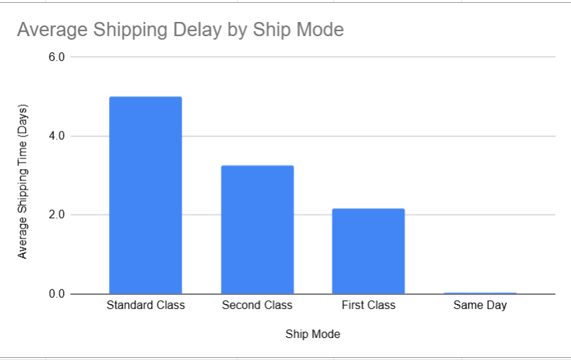

1. **Key Insights:**

Refer to Figure 5: Bar chart showing average shipping time by mode (in days).

* **Same Day** shipping is the fastest option, with an average shipping time of **0 days**, meeting urgent delivery needs.
* **First Class** shipping averages **2.2 days**, offering a quick but less costly alternative to Same Day.
* **Second Class** takes slightly longer at **3.2 days**, balancing cost and speed.
* **Standard Class** is the slowest with an average of **5 days**, likely the most economical but with longer delivery times.
* These variations highlight how shipping mode selection impacts delivery speed and customer experience, suggesting opportunities to optimise shipping options based on customer priorities.

**Conclusion:**

* **Technology** leads in sales, suggesting strong market demand and growth opportunities.
* **Monthly sales** show seasonal fluctuations with an upward trend by 2018, indicating business growth.
* **Consumer customers account for the largest segment (50.8%)**, emphasizing the importance of B2C strategies. However, **Corporate clients (30.4%) still contribute significantly**, supporting the need for a balanced B2C and B2B focus.
* **Shipping times** vary significantly by method, with faster options possibly driving customer satisfaction.
* These insights can inform **targeted marketing**, **inventory planning** and **logistics optimisation** to support strategic decision making.

**Appendix:**

**A1. Monthly Sales Data Table**

| **Year-Month** | **Total Sales (USD)** |
| --- | --- |
| 2015-01 | 14205.71 |
| 2015-02 | 4519.89 |
| 2015-03 | 55205.8 |
| 2015-04 | 27906.85 |
| 2015-05 | 23644.3 |
| 2015-06 | 34322.94 |
| 2015-07 | 33781.54 |
| 2015-08 | 27117.54 |
| 2015-09 | 81623.53 |
| 2015-10 | 31453.39 |
| 2015-11 | 77907.66 |
| 2015-12 | 68167.06 |
| 2016-01 | 18066.96 |
| 2016-02 | 11951.41 |
| 2016-03 | 32339.32 |
| 2016-04 | 34154.47 |
| 2016-05 | 29959.53 |
| 2016-06 | 23599.37 |
| 2016-07 | 28608.26 |
| 2016-08 | 36818.34 |
| 2016-09 | 63133.61 |
| 2016-10 | 31011.74 |
| 2016-11 | 75249.4 |
| 2016-12 | 74543.6 |
| 2017-01 | 18542.49 |
| 2017-02 | 22978.82 |
| 2017-03 | 51165.06 |
| 2017-04 | 38679.77 |
| 2017-05 | 56656.91 |
| 2017-06 | 39724.49 |
| 2017-07 | 38320.78 |
| 2017-08 | 30542.2 |
| 2017-09 | 69193.39 |
| 2017-10 | 59583.03 |
| 2017-11 | 79066.5 |
| 2017-12 | 95739.12 |
| 2018-01 | 43476.47 |
| 2018-02 | 19921 |
| 2018-03 | 58863.41 |
| 2018-04 | 35541.91 |
| 2018-05 | 43825.98 |
| 2018-06 | 48190.73 |
| 2018-07 | 44825.1 |
| 2018-08 | 62837.85 |
| 2018-09 | 86152.89 |
| 2018-10 | 77448.13 |
| 2018-11 | 117938.15 |
| 2018-12 | 83030.39 |