CRM
UserGuide



Table of contents:
1 Introduction 4
2 Definitions and Conventions 5
3 Terminology 6
4 Types of Roles 8
4.1 Roles: 8
4.2 Permission Role Wise: 8
5 CRM Login and Home Pages 11
6 Leads 13
6.1 Creation of a Lead 13
6.2 Editing a Lead 14
6.3 Convert a Lead 14
5.4 Assign a Lead 14
6.5 Schedule a Meeting with Lead 15
6.5.1 Save Meeting 15
6.5.2 Complete Meeting 16
6.6 Log a call with Lead 16
6.7 Add Note 17
6.8 Upload/Attachment 17
6.8.1 Import 18
6.8.2 Upload Attachment 18
6.9 Assigned To /Assigned By Leads 18
6.10 Converted Leads 19
6.11 Search Leads 19
7 Accounts 20
7.1 Creation of an Account 20
7.2 Editing an Account 20
7.3 Search for an Account 21
7.4 Schedule a Meeting with Account 21
7.4.1 Save Meeting 21
7.4.2 Complete Meeting 22
7.5 Log a call Account 23
7.6 Add Note 23
7.7 Upload/Attachment 24
7.7.1 Import 24
7.7.2 Upload Attachment 24
8 CONTACTS 26
8.1 Creating Contact 26
8.2 Editing Contact 26
8.3 Search for Contact 27
8.4 Schedule a Meeting with Contact 27
8.4.1 Save Meeting 27
8.4.2 Complete Meeting 28
8.5 Log a call Contact 29
8.6 Add Note 29
8.7 Send Mail 30
8.8 Upload/Attachment 30
8.8.1 Import 30
8.8.2 Upload Attachment 31
9 Opportunities 32
9.1 Creating an Opportunity 32
9.2 Edit an Opportunity 33
9.3 Search for Opportunity 33
9.4 Schedule a Meeting 33
9.4.1 Save Meeting 33
9.4.2 Complete a Meeting 34
9.5 Log a call 35
9.6 Add Note 36
10 DASHBOARD 37
11 REPORTS 41
11.1 Sales Forecast 41
11.2 Activity Reports 41
11.3 LEAD REPORTS 42
12 TEAM 44
13 Quick Links 45

Introduction
CRM: CRM stands for Customer Relationship Management. CRM is used in an organization to manage customer relationships proficiently. It is a modified method to contact customers and to build long-term relationships with them. It stores customers’ information in a database and further uses it for their benefit. CRM helps in binding strong relationship between organization and customers. It helps in managing issues related to pre-sales, post-sales and support operations.
CRM includes adoption of IT related systems, training of employees and amendment in business processes related to customers. It is not just software but an approach to update and enhance business methods to improve customers’ relationship with the organization.
Organizations intending to improve their customer relations, surely implement CRM for their business processes. CRM helps to gain and retain customers and provide services to them efficiently.

Product Features:
The CRM System has been divided into the following major modules:
- Leads: Through this module user shall add, edit. Convert, assign, and schedule a meeting, Log a call, Upload /Attachment of leads.
- Account: Through this module user shall add, edit, and schedule a meeting, Log a call, Upload /Attachment of accounts.
- Contact: Through this module user shall add, edit, and schedule a meeting, Send a mail , Log a call, Upload /Attachment of Contact
- Opportunity: Through this module user shall add, edit, and schedule a meeting, Log a call, Upload /Attachment of opportunity.
- Dashboard: Through this module user shall be able to generate Dashboard for Leads by Area ,Leads by Status ,Meetings Scheduled ,Comparison b/w Sales Forecasts/Sales Generated ,Leads by Ownership, Meetings Schedule, Leads by Area, Leads by Ownership , Leads By Area , Lead Status, Product Comparison
- Reports: Through this module user shall generate following Reports:
  - Sales Forecasts Reports – Forecast history report, Quarterly forecast
  - Activity Reports – Today’s Calls, Weekly Calls, Monthly Calls
  - Lead Reports – Converted Leads, Today’s Leads, Leads by Ownership
- Quick links: This module basically provides for the ease of the user ,Through this module user shall be able to Add leads, Add Account, Add Contacts ,Add opportunity, Schedule a Meeting, Log a call ,Add Note

Definitions and Conventions
This section gives a glossary of terms used in the rest of the document.
Term | Description
CRM | Customer Relationship Management
Sales Executive(SE) | He is the person who optimize sales
Sales Manager(SM) | Looking after the sales Executives’, Maximizing the sales.
VP Sales(VPS) | Manages overall sales activity of the Company, Sales Strategy, Promotion, Marketing, Campaigning, Sales Optimization.
CXX | CEO,COO,CTO,CIO Leadership team

Terminology
Contact
Contact in CRM means a company (firm) or a person. In CRM environment, the term Contact refers to the client’s info page in CRM.

Company
Each company created in CRM has its card where different information is saved starting from basic information such as ID Number, legal status, address, contact details until displaying a communication history, and business related data.
The business hierarchy in CRM enables to identify relationships among individual companies. In CRM there are 3 business types – other company, Subsidiary company and Branch. A subsidiary company and a branch are controlled by a mother company, however, a branch may be controlled a subsidiary company which, in turn, is controlled by the mother company.

Person
A person in CRM may be recorded in two different ways. Either as an independent contact person or a person linked to an already existing company where (s) he performs a specific job role.
A contact person may be associated with 1 or more companies, e.g. in one company a person could be an owner and in another a director. These relationships can be viewed in the Companies tab in Person page.

Activity
Activities are appointments; tasks, emails and a specific activity forward a message that is a combination of appointment and task.
Activities are recorded either via the Activities option in menu bar or via the Activities tab on the Contact. How to work with activities, please, go to Activity chapter.

Appointment
This activity type is used to record important moments in the past or future actions such as trainings, customer meetings, conferences etc.

Task
Task is such activity type which will require an action from its owner, for instance create a business proposal, prepare a marketing material etc.
The structure of the task is very similar to the appointment one; the only difference is that an expected duration of is preset for each task type.
For each task you will need to complete the deadline, a percentage of its completion and priority. When creating a task an additional information about owner´s workload is displayed (in %) . This totals duration of all tasks scheduled for the particular day and compare it with the maximum workday duration.
When creating a task, you can attach documents in any format by clicking on the Save and load document button. Documents can be attached as well later on while editing a task.

Forward a message
Forward a message is a specific activity that is used in situations when a client calls and a called person is not available. After recording, this activity this one is immediately saved in the caller´s and call party´s calendars and an email to called party is sent.
Mandatory fields are for where you select a called party from the list of CRM users and Subject of the phone call.
Other fields which should be completed are date, hour, caller´s name (selected from the CRM database), phone number, e-mail and priority. Then there is a field that specifies a follow-up action: a client will call again or a called party is supposed to Call back.

Email
Email is an activity type which allows sending emails directly from the CRM environment to a selected contact. The advantage of this procedure is that an email is immediately saved in activity tab within contact. Administrator can set an outgoing address to a general one (eg.business@sprinx.com).

Opportunity
An opportunity in CRM means a business opportunity for the sale of a product or service. It is always linked to a company (firm) or contact person in CRM. Information such as phase, expected turnover, etc. are then followed with every business opportunity. Detailed information about business opportunity is available in Business opportunities.

Campaign
A campaign is a term in CRM that means the summary of information that can be used for business and marketing purposes. A campaign in CRM contains a list of contacts that you wish to address with a specific offer of products or services or a customer satisfaction survey. A campaign may be created in CRM via CRM Browser or CRM Manager, provided that you have pre-defined contacts not yet entered in CRM that you wish to address. More information is available in Campaigns.

Report
A report or statistics is stored in CRM for the monitoring of general information necessary for the assessment of the situation in the company that owns .A report enables you to keep track of information such as the number of business opportunities, their turnover, best-selling products, etc. More information is available in Reports.

Document
A document in CRM is usually an appendix to a contact, business opportunity, etc. Documents in CRM are supported within MS Office or Adobe Reader. (Excel, Word, PowerPoint and other file formats are supported.) A document enables to quickly identify context and record important documents in a well-arranged fashion.

Types of Roles

Roles:
A user can login to the CRM system through four roles.
1. Sales Executive (SE)
2. Sales Manager(SM)
3. VP Sales (VP)
4. CXXX

Permission Role Wise:
 | SE | SM | VPS | CXX
Lead
ADD | Y | Y | Y
Edit | Y | Y | Y
Convert | Y | Y | Y
Assign |  | Y | Y
Schedule a  Meeting | Y | Y | Y
Log a call | Y | Y | Y
Add Note | Y | Y | Y
Upload | Y | Y | Y
ACCOUNT
Add | Y | Y | Y
Edit | Y | Y | Y
Schedule a  Meeting | Y | Y | Y
Log a call | Y | Y | Y
Add Note | Y | Y | Y
Upload | Y | Y | Y
Contact
Add | Y | Y | Y
Edit | Y | Y | Y
Schedule a  Meeting | Y | Y | Y
Log a call | Y | Y | Y
Send Mail | Y | Y | Y
Add Note | Y | Y | Y
Upload | Y | Y | Y
Opportunity
Add | Y | Y | Y
Edit | Y | Y | Y
Schedule a  Meeting | Y | Y | Y
Log a call | Y | Y | Y
Add Note | Y | Y | Y
Dashboard
Leads by Area | Y | Y | Y | Y
Leads by Status | Y | Y | Y | Y
Meeting Scheduled | Y | Y | Y | Y
Compare Sales Forecast &Actual |  | Y | Y | Y
Leads By Ownership |  | Y | Y | Y
Report
Converted leads | Y | Y | Y | Y
Today’s Leads | Y | Y | Y | Y
Leads By ownership |  | Y | Y | Y
Today’s Call | Y | Y | Y | Y
Weekly calls | Y | Y | Y | Y
Monthly Calls | Y | Y | Y | Y
Sales Forecast Quarterly |  | Y | Y | Y
Forecast History Report |  | Y | Y | Y

Note:
- Two Sales Executives can’t see each other activity or leads.
- Sales Manager shall see the records of his sales Executive’s those who are under his team.
- VP sales shall be able to see records of all managers and sales executive’s.
- Roles permission shall be bottom to top approach.
- Sales Manager shall not be able to see each other’s record.
- Sales Manager shall be entitled to assign leads of executives so that VP sales for Sales Manager.
- CXX could be able to see in all records only view permission to all.

CRM Login and Home Pages
This is the login page of the application. As per his role the logged in home page varies.

When logged in as Sales Executive the home page looks like below:

When logged in as Sales Manager & VP Sales the home page looks like below:

When logged in as CEO the home page looks like below:

Leads
Leads are early stage contacts/accounts. When a lead is converted, a contact and an account are created.
Leads can also have a parent. This parent must be an existing account.
The lead page will be displayed with the options to create a lead, edit a lead, to search a lead, to convert a lead into an opportunity, to schedule a meeting, to log a call, to add a note & to upload an attachment.
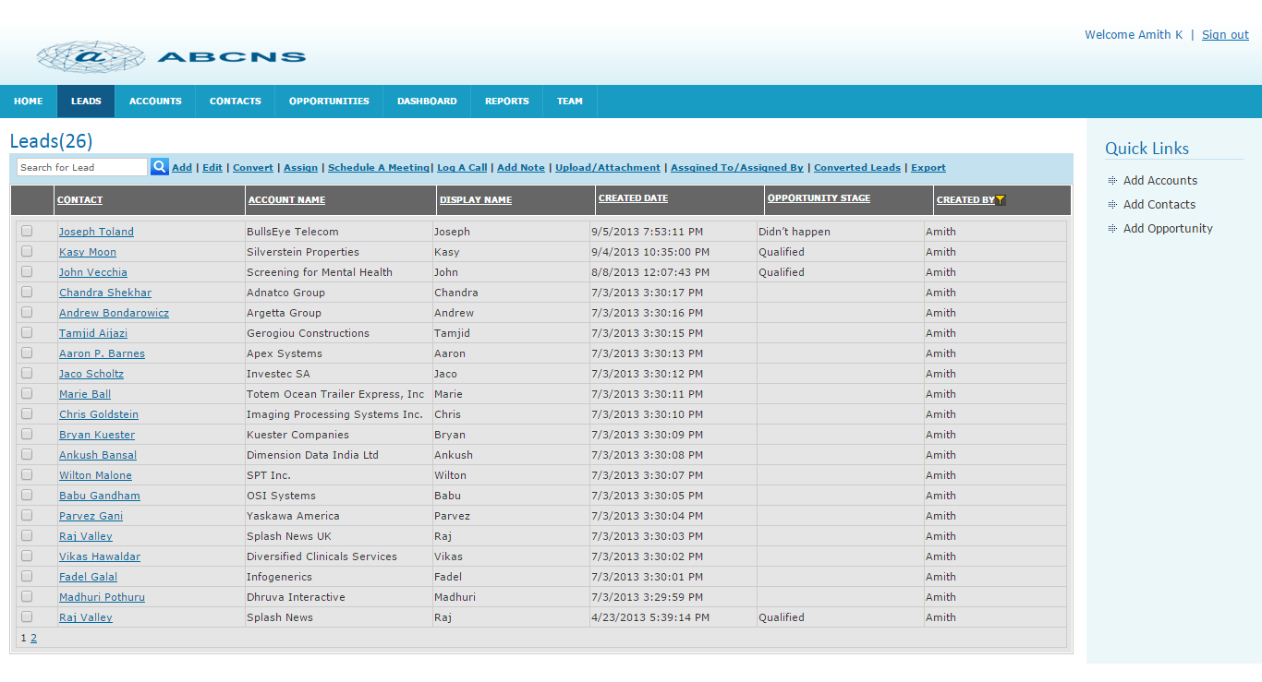

Creation of a Lead
- Enter all mandatory fields in Person division.
- Enter all mandatory fields in Company division.
- Click on Add button to save the created Lead.
- Click on Cancel button to cancel the creation of Lead
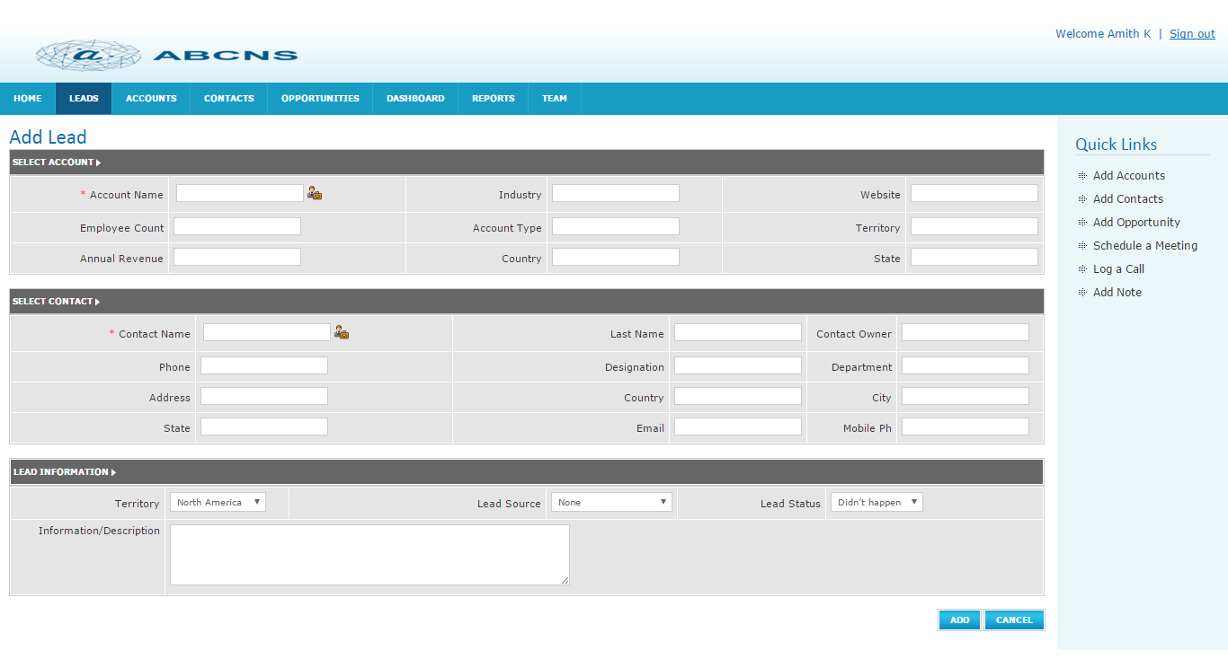

Editing a Lead
- Select any lead to edit.
- If you want to change any previous information, do according to your need.
- Click on the Update button to save the changes.
- Click on Cancel button to cancel the changes.

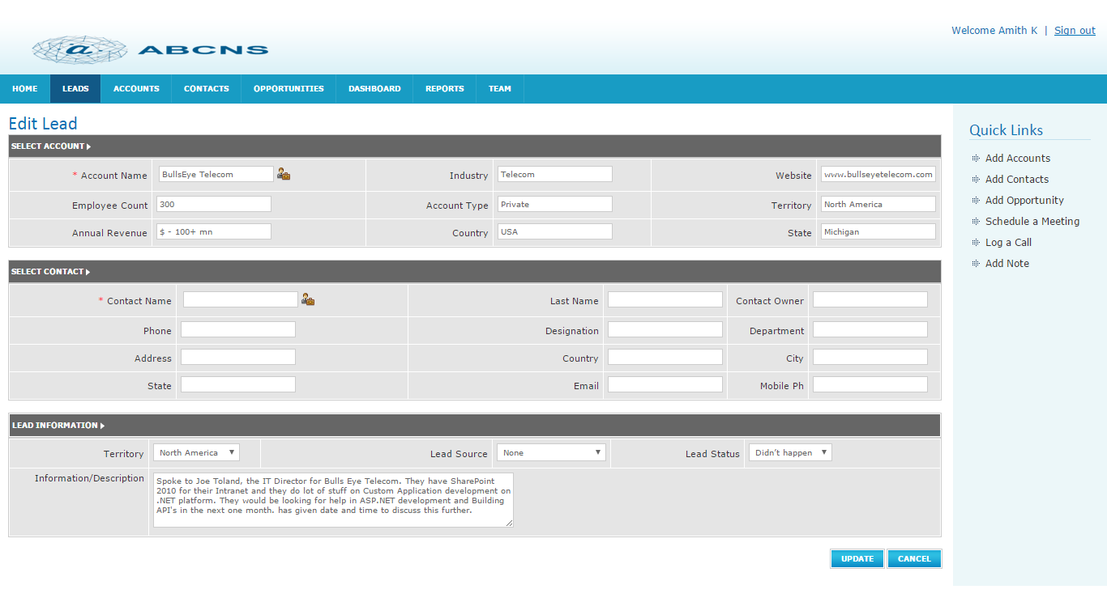

Convert a Lead
This is used to convert a Lead into an Opportunity.
- In the Leads homepage Select the checkbox of the lead you want to convert.
- Click on Convert link. A pop up will be opened with details.
- Click on Convert button in the pop-up.
- Automatically it will be converted into Opportunity and will be shown in Opportunities home page and it will be disappeared from the Leads list.
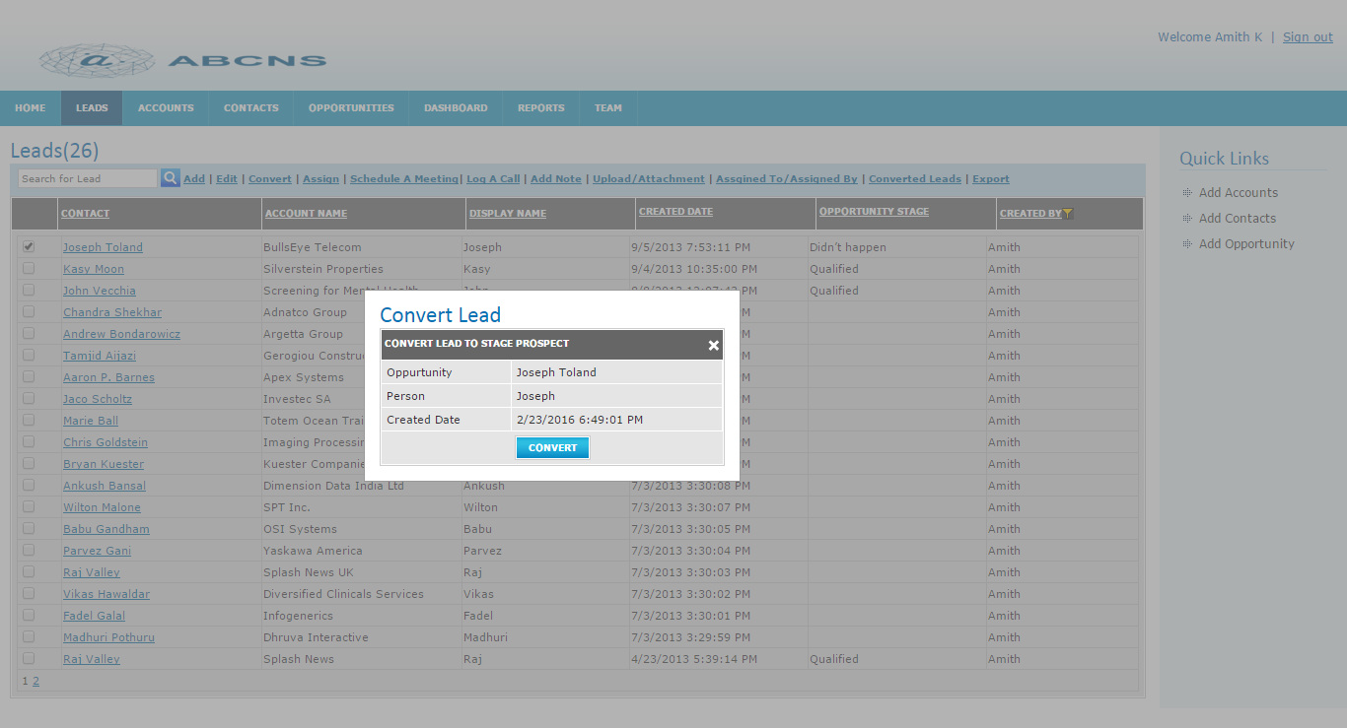

5.4 Assign a Lead
- Select any lead to assign
- Click on Assign Link.
- Choose the person from the dropdown to whom you are going to assign the selected lead.
- Click on Assign button.
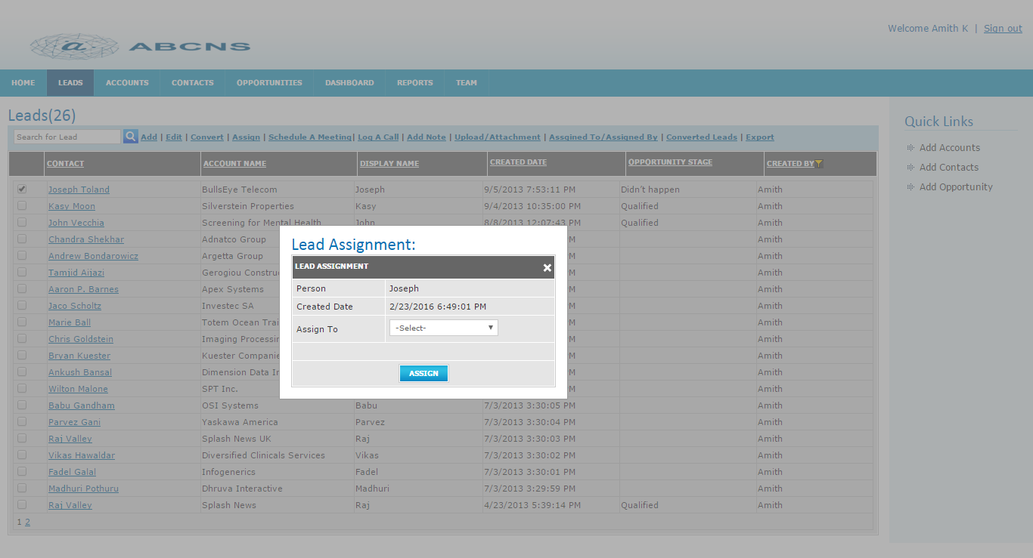

Schedule a Meeting with Lead

Save Meeting
- Select any lead to schedule a meeting
- Click on Schedule a meeting link.
- Enter data.
- Click on save button to save the meeting details.
- Click on Close button to cancel the meeting details.

Complete Meeting
- Select any lead to schedule a meeting
- Click on Schedule a meeting link.
- Enter mandatory fields.
- Click on Complete button to save the meeting details.
- Click on Close button to cancel the meeting details.

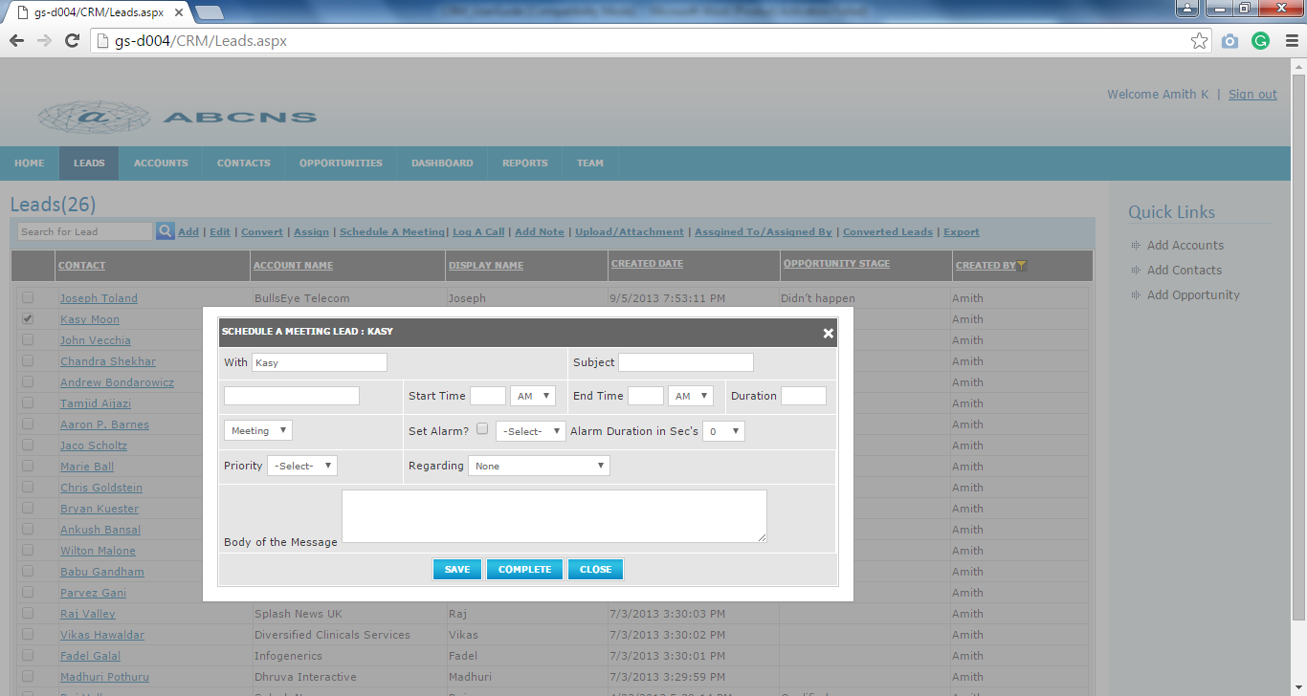
- Complete button helps to complete the meeting.
- If you want to schedule another meeting, click on Follow-up Activities button otherwise click on OK button.

Log a call with Lead
- Select any lead to log a call.
- Click on Log a call link.
- Enter all mandatory fields.
- Click on Follow-up Activity button if you want to schedule a meeting with same lead otherwise, click on OK button to save log call details.
- Click on Close button to cancel the log call details.

Add Note
- Select any lead.
- Click on Add Note link.
- Click on Save button to save the add note details.
- Click on Cancel button to cancel the add note.
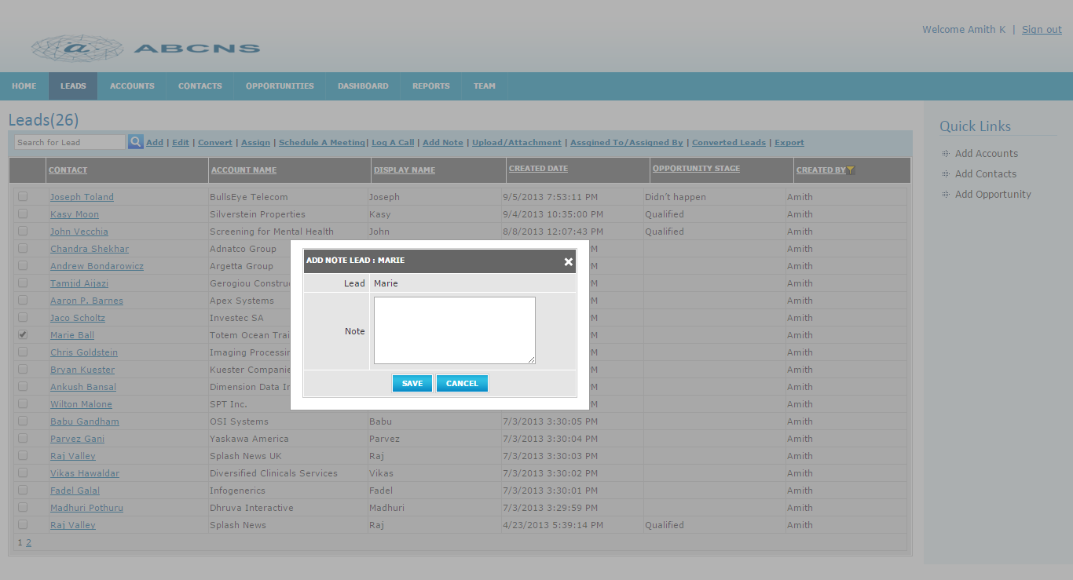

Upload/Attachment
If you select any Account then it works as upload. If you are not selecting any account, then it works as import i.e. the contents of the file will be imported to Accounts home page. This is nothing importing leads from external sources. To import files, file type must .xl or.CSV.

Import
- Click on Upload/Attachment link.
- Click on Browse button.
- Select the file which you want to upload.
- Click on Upload button to upload the content of the selected file.
- Click on the cancel button to cancel the upload.
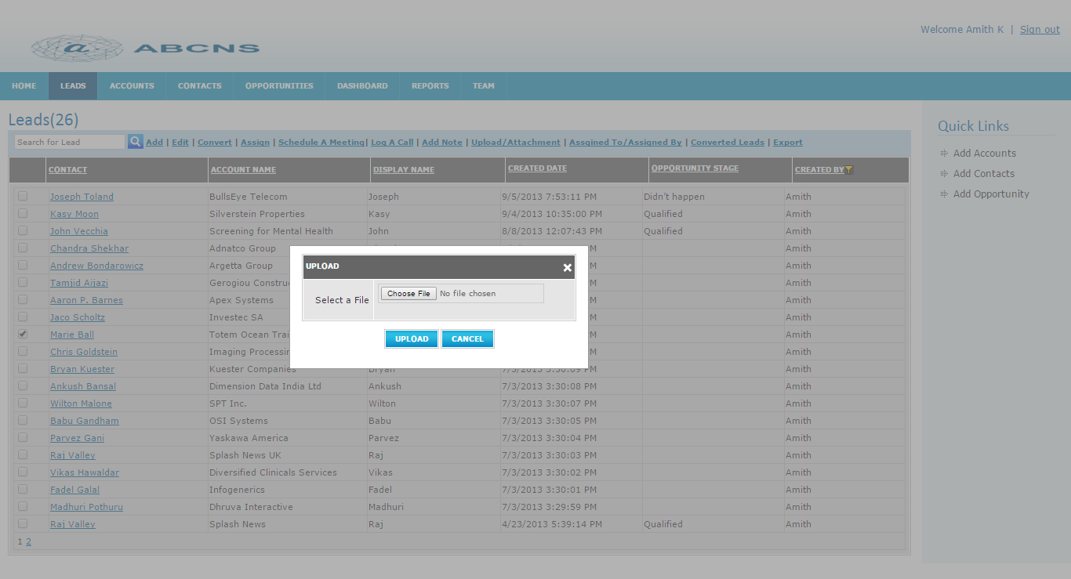

Upload Attachment
- Select any lead to attach a file.
- Click on Upload/Attachment link.
- Click on Browse button.
- Select the file.
- Click on Upload button to save the attachment.
- Click on the cancel button to cancel the Attachment.

Assigned To /Assigned By Leads
- Click on Assigned To/Assigned By link
- It displays Assigned Leads page with all leads assigned by logged in user and assigned to log in the user.

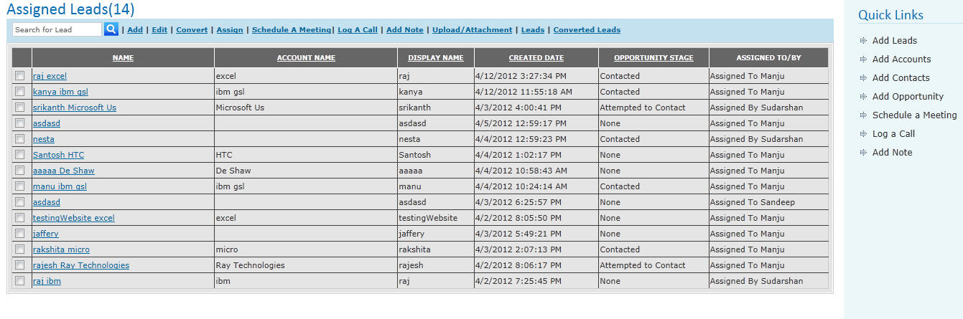

Converted Leads
- Click on Converted Leads link.
- It displays Converted Leads page.
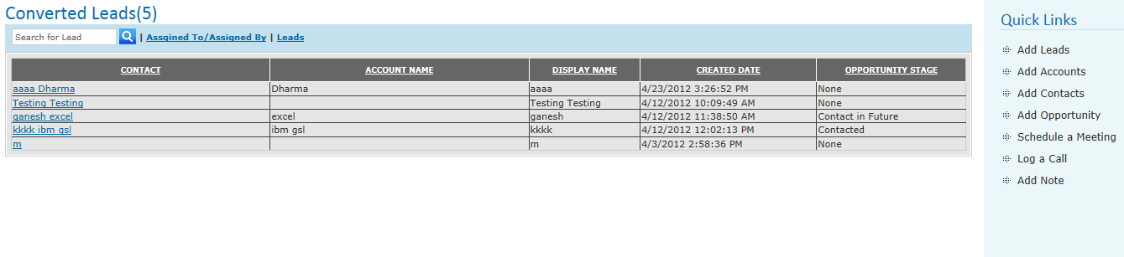

Search Leads
- Enter keyword/letter in the text box to search lead.
- Click on Search icon.
- It displays all leads starting with search letter/word.

Accounts
Accounts are early stage contacts/Leads.
Accounts page will be displayed with the options to create Account, edit Account, to search Account, to schedule a meeting, to log a call, to add a note & to upload an attachment.
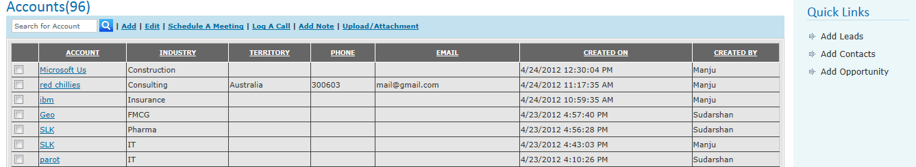

Creation of an Account
- Enter all mandatory fields in Account division.
- Click on Add button to save the created Account.
- Click on Cancel button to cancel the creation of Account.

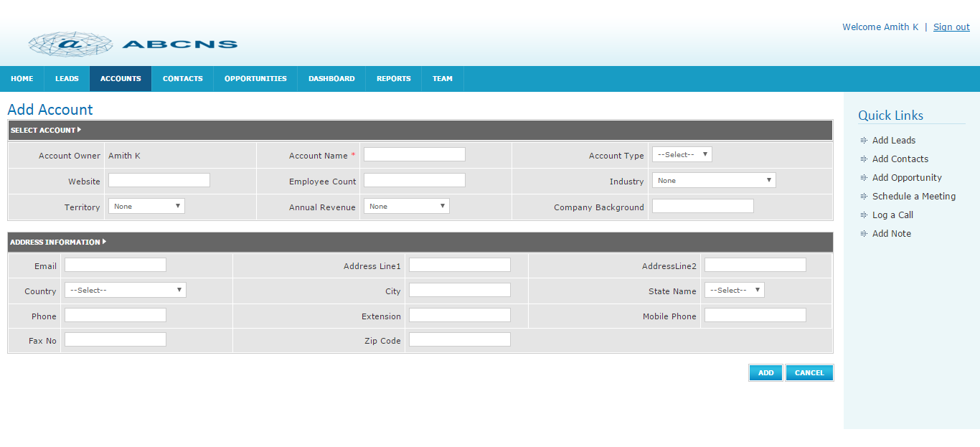

Editing an Account
Editing an account is done by only the owner of the account i.e. the user who has created the account.
- Select any account created by logged in user to edit.
- If you want to change any previous information, do according to your need.
- Click on the Update button to save the changes.
- Click on Cancel button to cancel the changes.
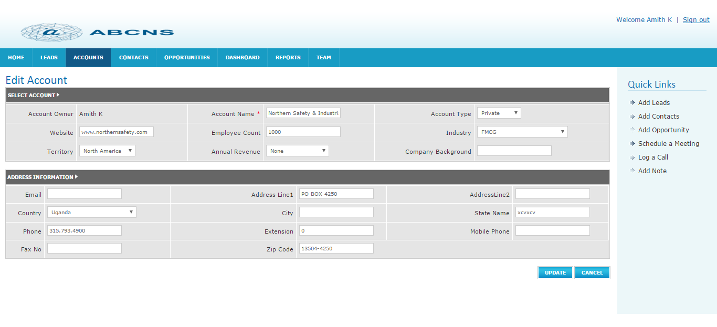

Search for an Account
- Enter keyword/letter in the text box to search account.
- Click on Search icon.
- It displays all accounts starting with search letter/word.

Schedule a Meeting with Account

Save Meeting
- Select any account to schedule a meeting
- Click on Schedule a meeting link.
- Enter data.
- Click on save button to save the meeting details.
- Click on Close button to cancel the meeting details.

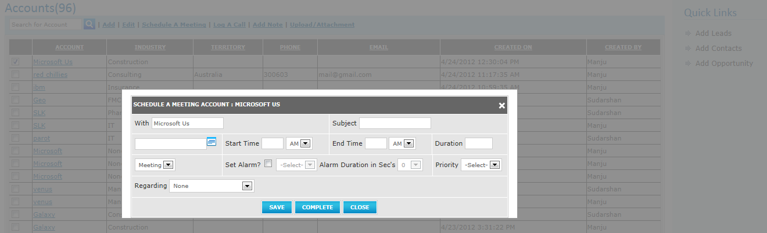

Complete Meeting
- Select any Account to schedule a meeting
- Click on Schedule a meeting link.
- Enter mandatory fields.
- Click on Complete button to save the meeting details.
- Click on Close button to cancel the meeting details.
- When you click on the complete button, the following screen will appear.
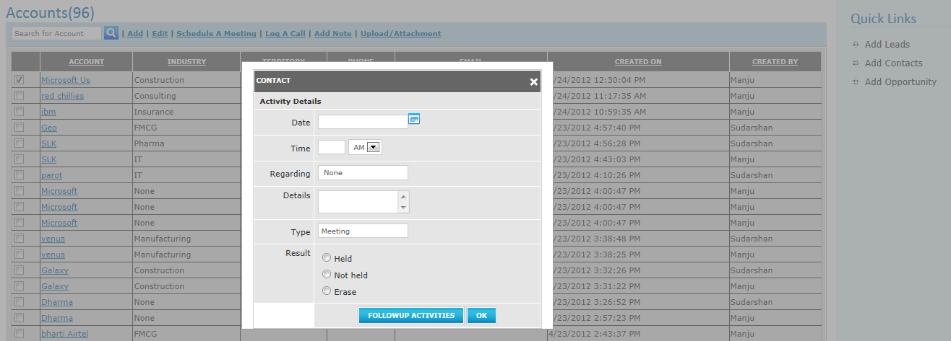

- If you want to schedule another meeting, click on Follow-up Activities button otherwise click on OK button.

Log a call Account
- Select any Account to log a call.
- Click on Log a call link.
- Enter all mandatory fields.
- Click on Follow-up Activity button if you want to schedule a meeting with the same Account otherwise, click on OK button to save log call details.
- Click on Close button to cancel the log call details.
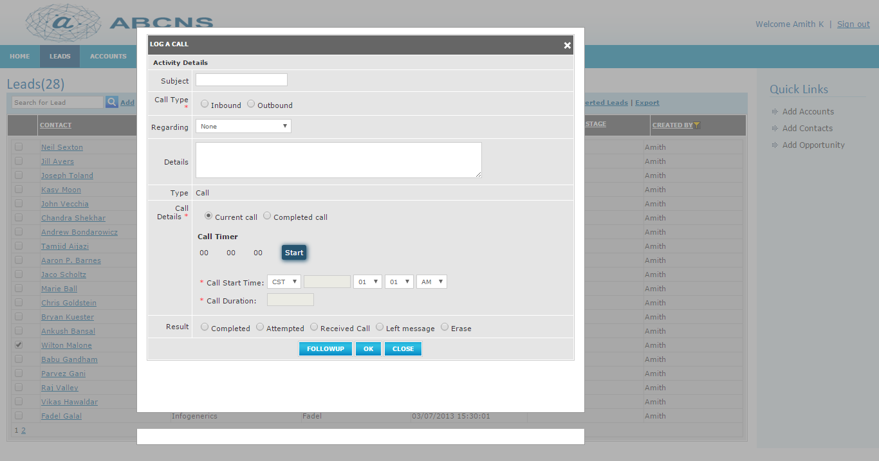

Add Note
- Select any Account.
- Click on Add Note link.
- Click on Save button to save the add note details.
- Click on Cancel button to cancel the add note.
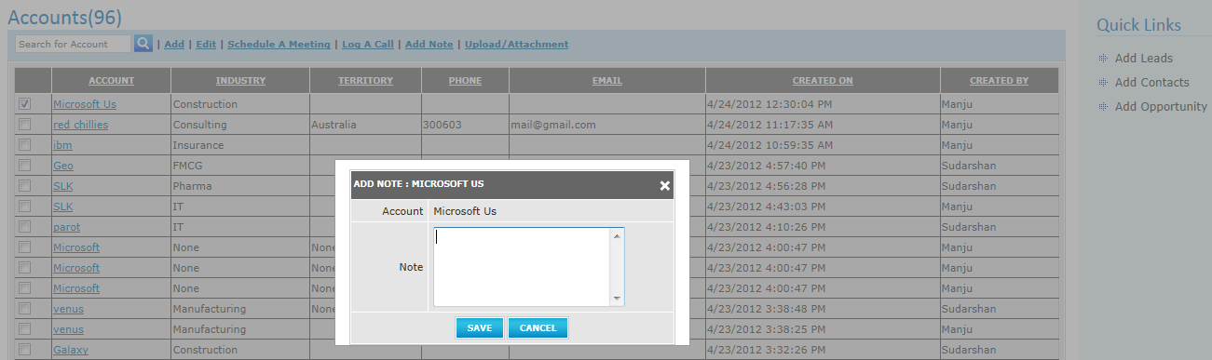

Upload/Attachment
If you select any Account then it works as upload. If you are not selecting any account, then it works as import i.e. the contents of the file will be imported to Accounts home page. This is nothing importing accounts from external sources. To import files, the file types must .xl or.CSV.

Import
- Click on Upload/Attachment link.
- Click on Browse button.
- Select the file which you want to upload.
- Click on Upload button to upload the content of the selected file.
- Click on the cancel button to cancel the upload.

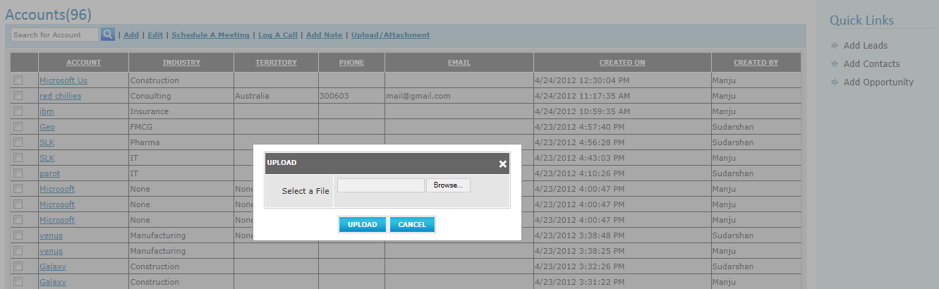

Upload Attachment
- Select any Account to attach a file.
- Click on Upload/Attachment link.
- Click on Browse button.
- Select the file.
- Click on Upload button to save the attachment.
- Click on the cancel button to cancel the Attachment.

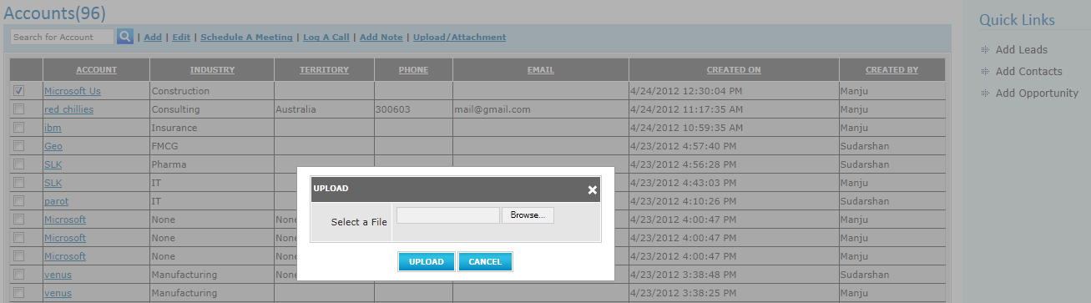

CONTACTS
Contacts are early stage Accounts.
Contacts page will be displayed with the options to create Contact, edit Contact, to search Contact, to schedule a meeting, to log a call, to add a note, to send mail & to upload an attachment.
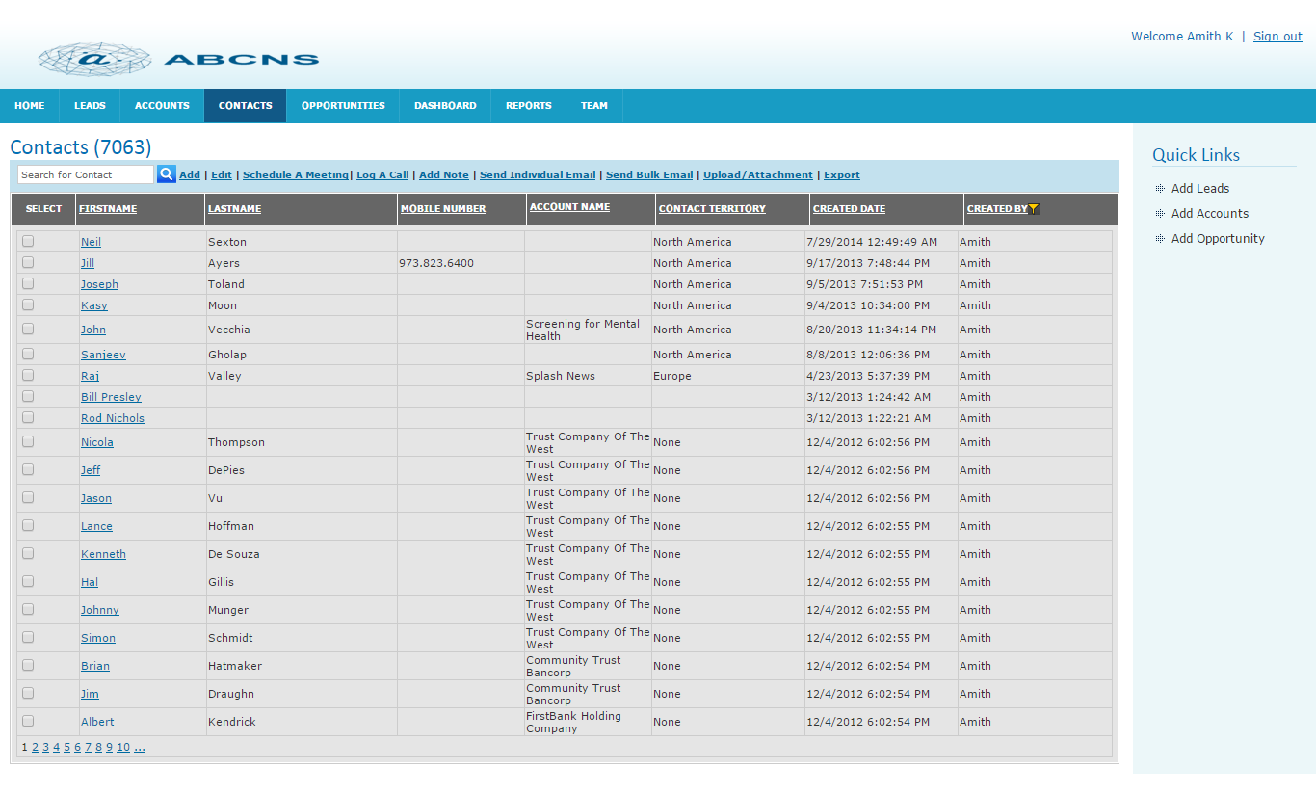

Creating Contact
- Enter all mandatory fields in Contact division.
- Enter all mandatory fields in Company division.
- Click on Add button to save the created Contact.
- Click on Cancel button to cancel the creation of Contact.

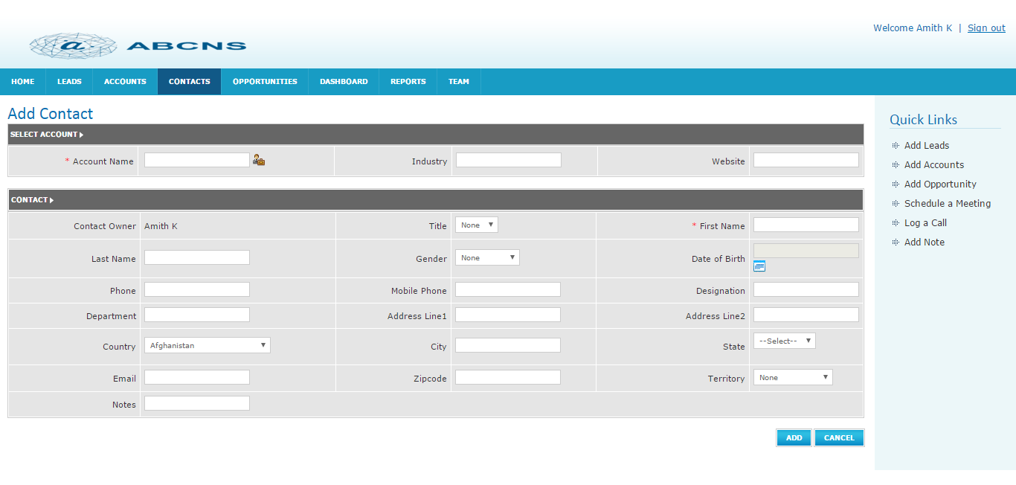

Editing Contact
- Select any contact to edit.
- If you want to change any previous information, do according to your need.
- Click on the Update button to save the changes.
- Click on Cancel button to cancel the changes.
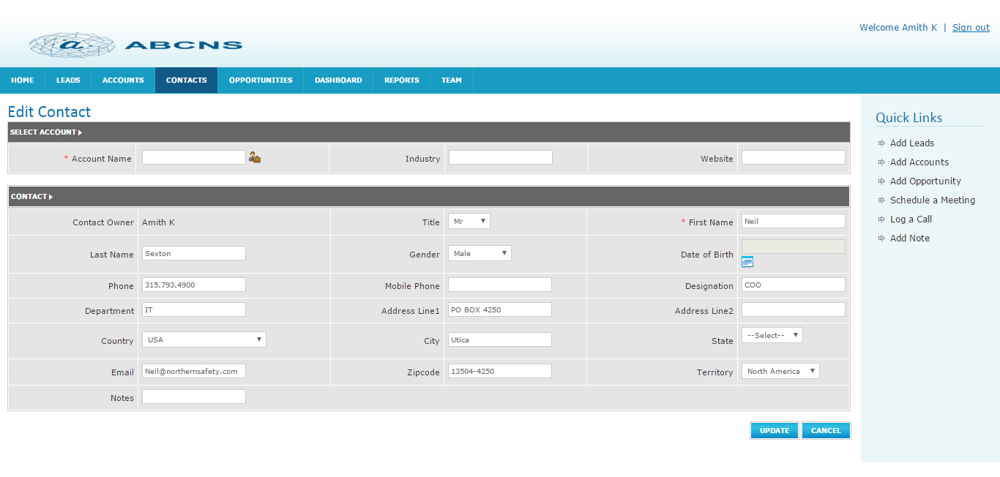

Search for Contact
- Enter keyword/letter in the text box to search contact.
- Click on Search icon.
- It displays all contacts starting with search letter/word.

Schedule a Meeting with Contact

Save Meeting
- Select any contact to schedule a meeting
- Click on Schedule a meeting link.
- Enter data.
- Click on save button to save the meeting details.
- Click on Close button to cancel the meeting details.

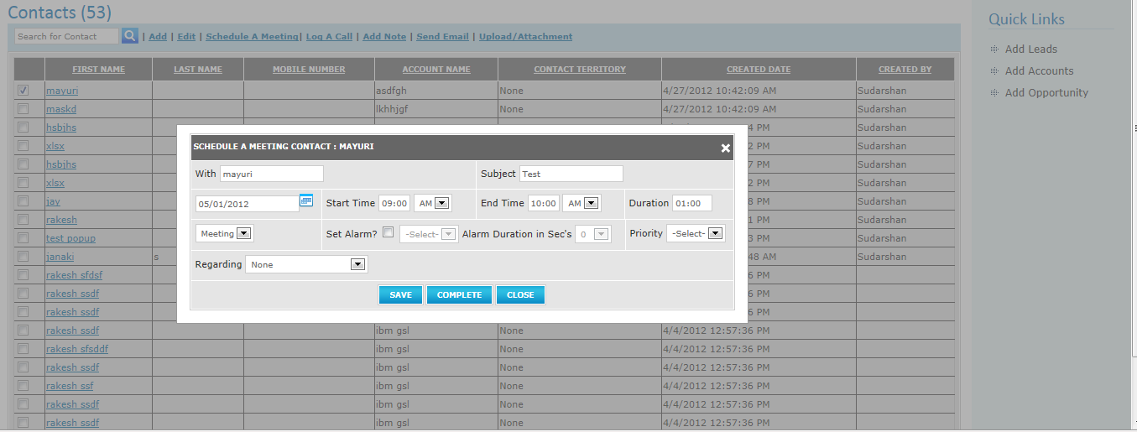

Complete Meeting
- Select any Contact to schedule a meeting
- Click on Schedule a meeting link.
- Enter mandatory fields.
- Click on Complete button to save the meeting details.
- Click on Close button to cancel the meeting details.
- When you click on the complete button, the following screen will appear.
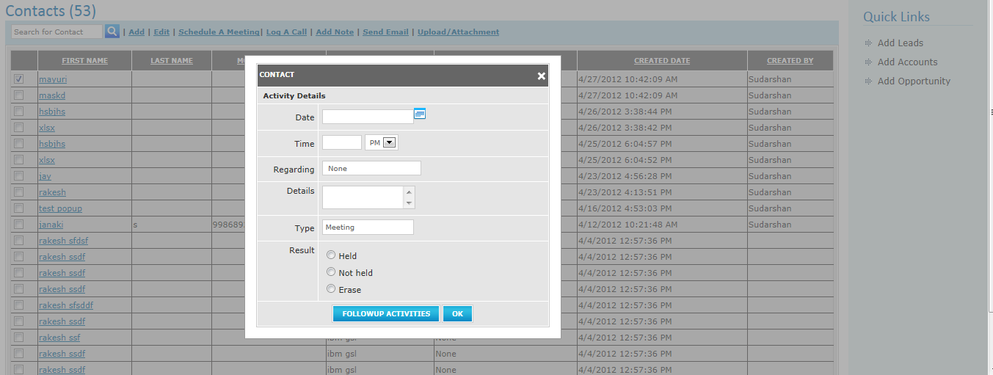

- If you want to schedule another meeting, click on Follow-up Activities button otherwise click on OK button.

Log a call Contact
- Select any Contact to log a call.
- Click on Log a call link.
- Enter all mandatory fields.
- Click on Follow-up Activity button if you want to schedule a meeting with same Contact otherwise click on OK button to save log call details.
- Click on Close button to cancel the log call details.

Add Note
- Select any Contact.
- Click on Add Note link.
- Click on Save button to save the add note details.
- Click on Cancel button to cancel the add note.
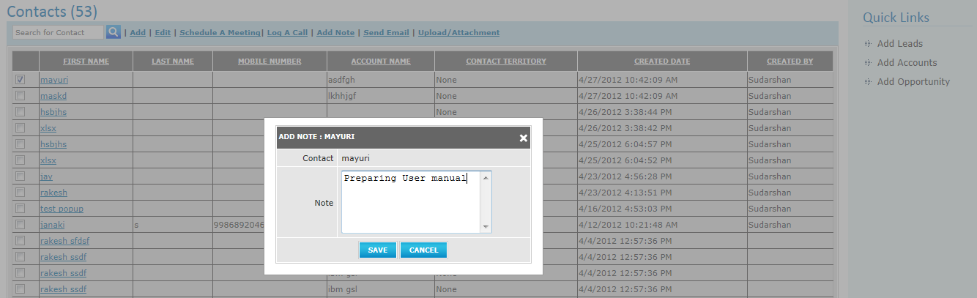

Send Mail
- Select any contact to send mail.
- Click on save button to send mail.
- Click on Cancel button to cancel the send mail.
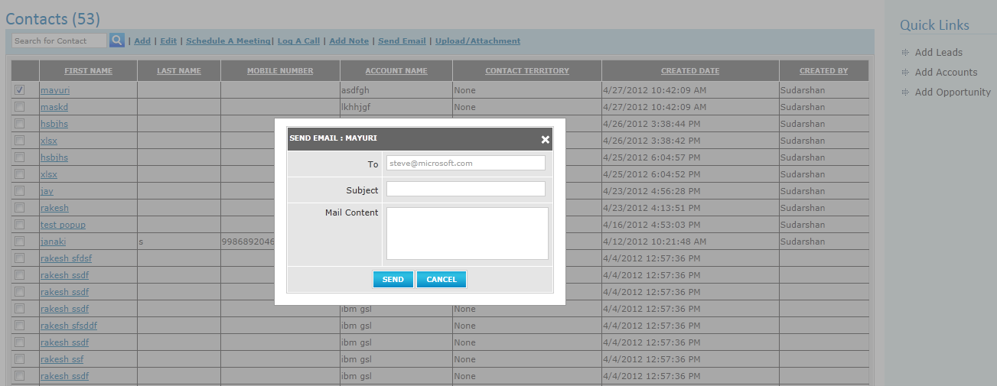

Upload/Attachment
If you select any Contact then it works as upload. If you are not selecting any contact, then it works as import i.e. the contents of the file will be imported to Contacts home page. To import files, the file types must .xl or .CSV.

Import
- Click on Upload/Attachment link.
- Click on Browse button.
- Select the file which you want to upload.
- Click on Upload button to upload the content of the selected file.
- Click on cancel button to cancel the upload.

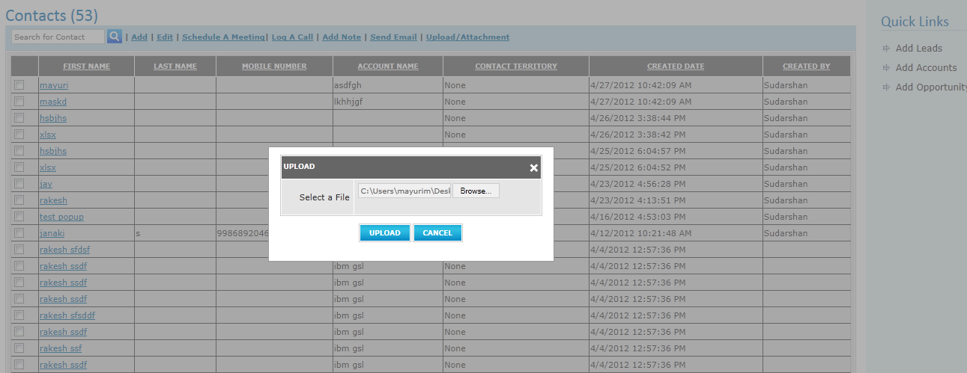

Upload Attachment
- Select any Contact to attach a file.
- Click on Upload/Attachment link.
- Click on Browse button.
- Select the file.
- Click on Upload button to save attachment.
- Click on cancel button to cancel the Attachment.

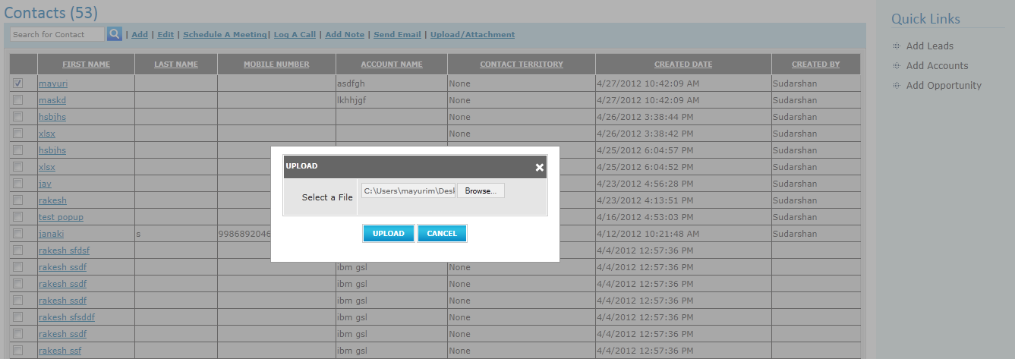

Opportunities
Opportunities page will be displayed with the options to create Opportunity, edit Opportunity, to search Opportunity, to schedule a meeting, to log a call, to add a note.
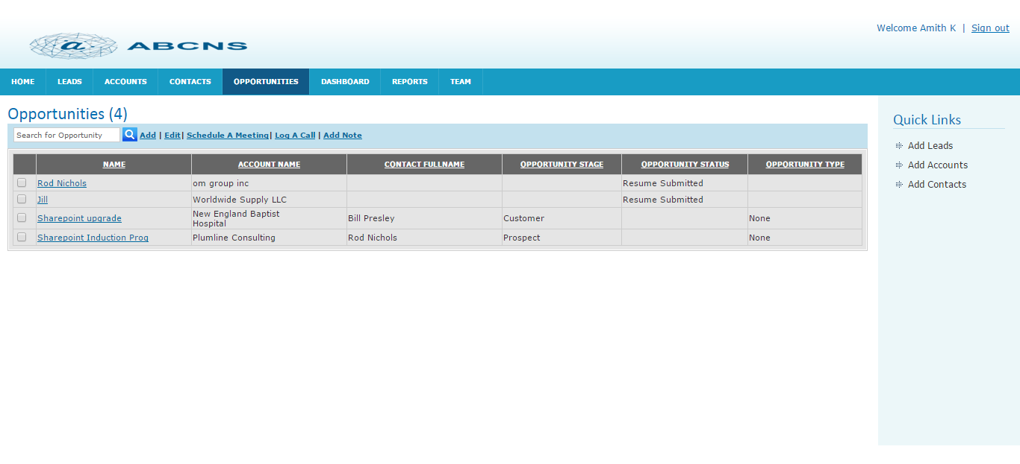

Creating an Opportunity
- Enter all mandatory fields in Opportunities division.
- Enter all mandatory fields in Company division.
- Click on Add button to save the created Opportunity.
- Click on Cancel button to cancel the creation of Opportunity.

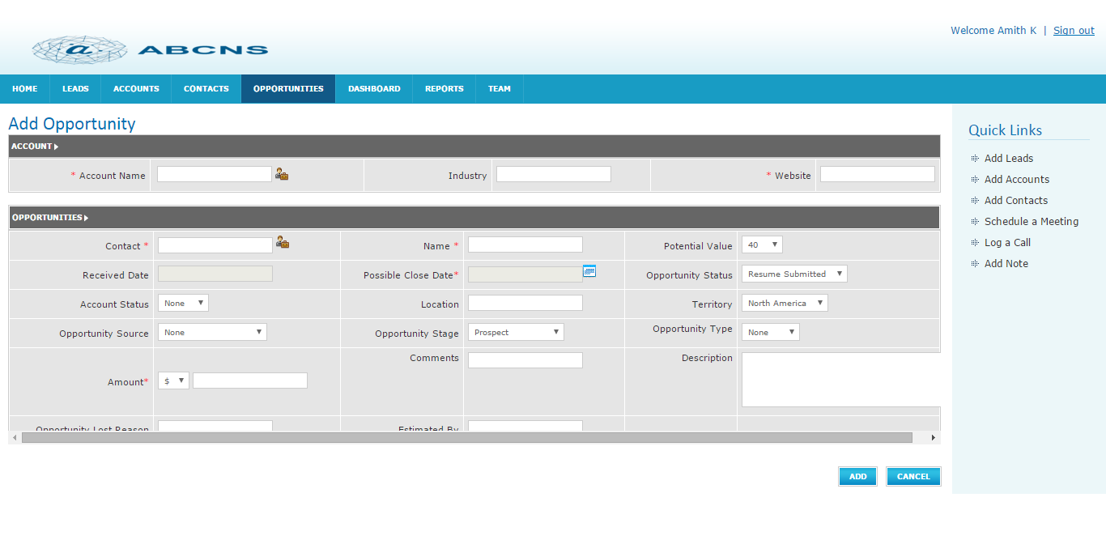

Edit an Opportunity
- Select any Opportunity to edit.
- If you want to change any previous information, do according to your need.
- Click on Update button to save the changes.
- Click on Cancel button to cancel the changes.
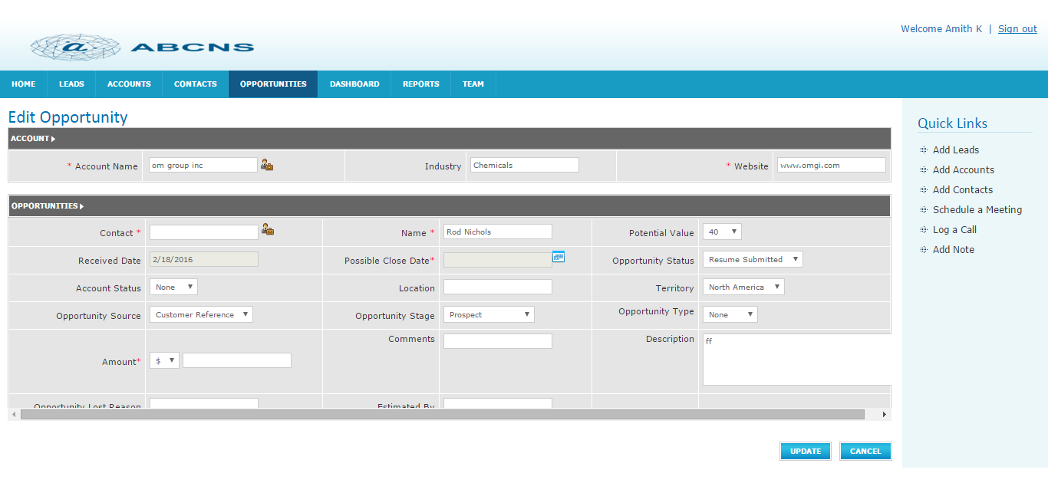

Search for Opportunity
- Enter key word/letter in text box to search Opportunity.
- Click on Search icon.
- It displays all Opportunities starting with search letter/word.
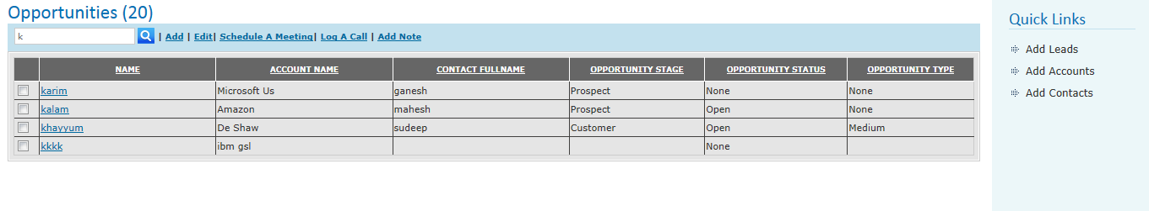

Schedule a Meeting

Save Meeting
- Select any Opportunity to schedule a meeting
- Click on Schedule a meeting link.
- Enter data.
- Click on save button to save the meeting details.
- Click on Close button to cancel the meeting details.

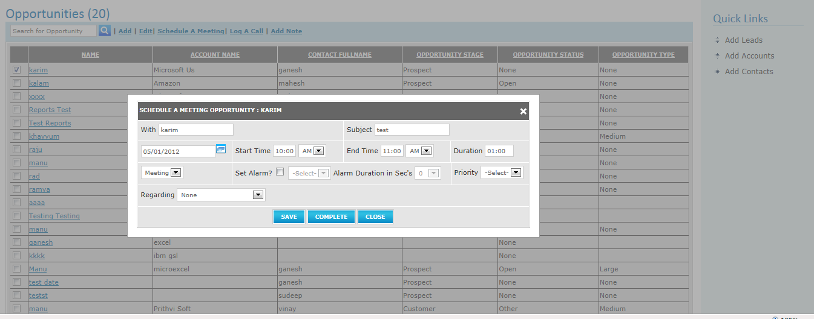

Complete a Meeting
- Select any Opportunity to schedule a meeting
- Click on Schedule a meeting link.
- Enter mandatory fields.
- Click on Complete button to save the meeting details.
- Click on Close button to cancel the meeting details.
- When you click on complete button, the following screen will appear.
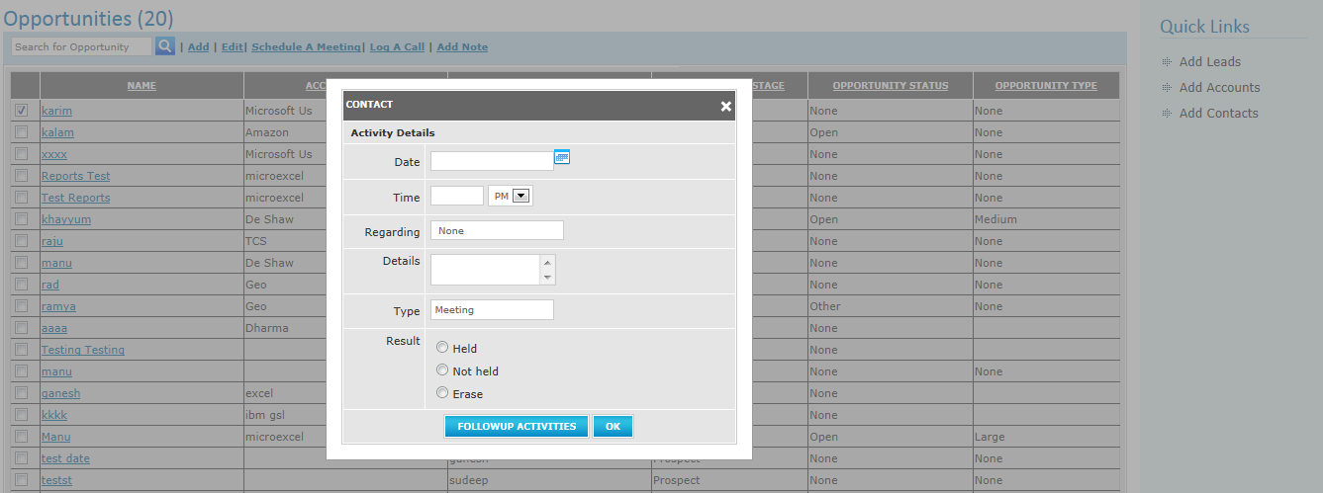

- If you want to schedule another meeting, click on Follow-up Activities button otherwise click on OK button.

Log a call
- Select any Opportunity to log a call.
- Click on Log a call link.
- Enter all mandatory fields.
- Click on Follow-up Activity button if you want to schedule a meeting with same Opportunity otherwise click on OK button to save log call details.
- Click on Close button to cancel the log call details.

Add Note
- Select any Opportunity.
- Click on Add Note link.
- Click on Save button to save the add note details.
- Click on Cancel button to cancel the add note.
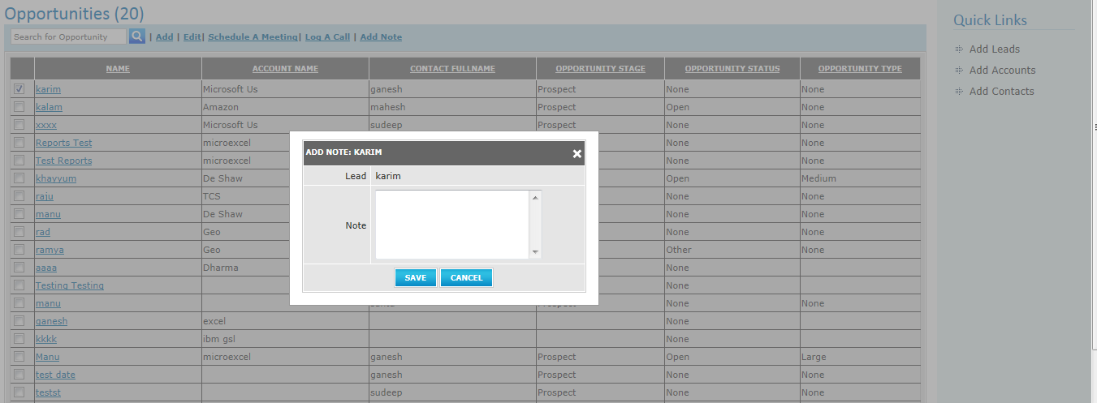

DASHBOARD
Through this module user shall be able to generate Dashboard for Leads by Area, Leads by Status ,Meetings Scheduled ,Comparison b/w Sales Forecasts/Sales Generated ,Leads by Ownership with option to select time period.
- Area wise lead report in pie chart.
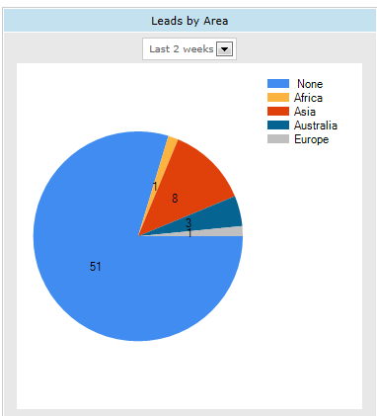

- Meeting Scheduled graph where Leads will be on X-axis and no. of meetings on Y-axis.
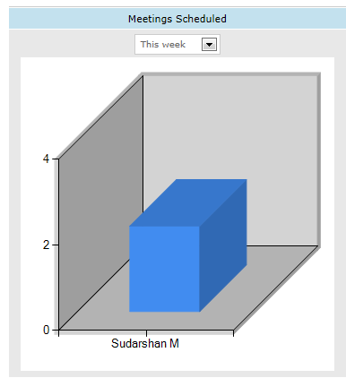

- Status wise lead graph where status will be on X-axis and no. of leads on the Y-axis.
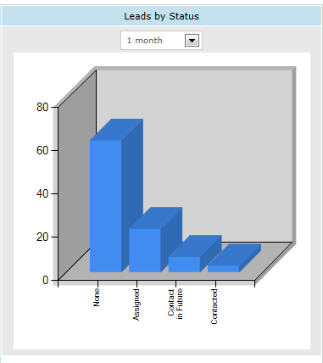
iv) Opportunity by status graph where opportunity status will be on X-axis and no. of opportunities on
Y-axis.
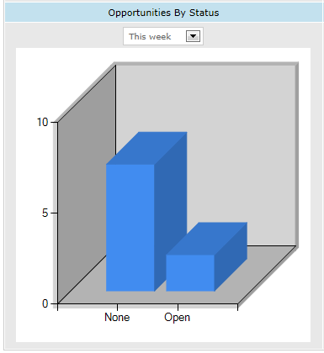

v) Lead by ownership graph which shows Leads according to owner Where Owner Name will be on X-axis and no. of Leads on the Y-axis.
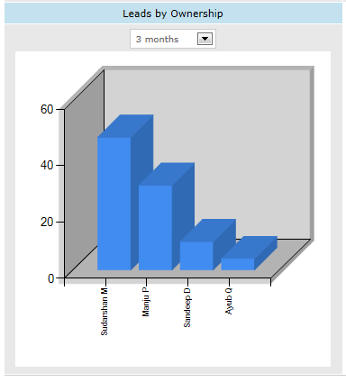
vi) Sales forecast to compare sales forecast and sales generated. It will show comparison in graph. Where quarter will be on X-axis and sales figure on the Y-axis.

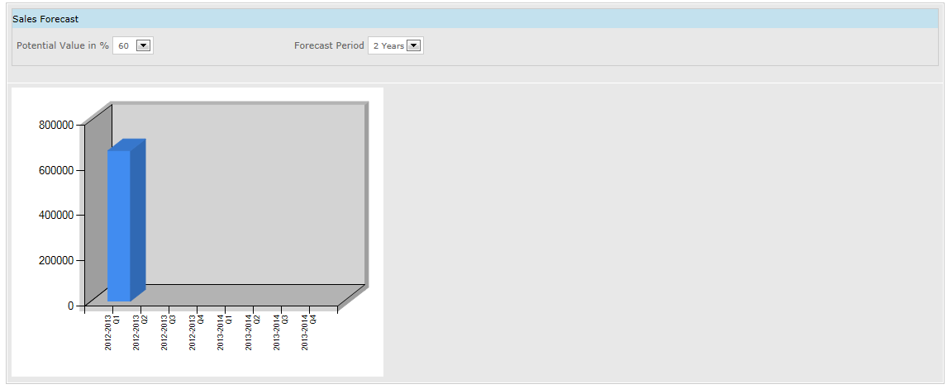

REPORTS
Reports page will contain 3 sub links under this module. It will show all the reports related to sales forecast, log call reports, lead report.

Sales Forecast
It is viewed only by SM, VP Sales and CEO.
- Click on reports tab.
- Click on Sales Forecasts link.
- Click on Forecast link.
- Select year, quarter, and potential value. Default potential value is 10.
- Click on GetReport button to view the sales forecast report.
- Click on Cancel button to return reports home page.

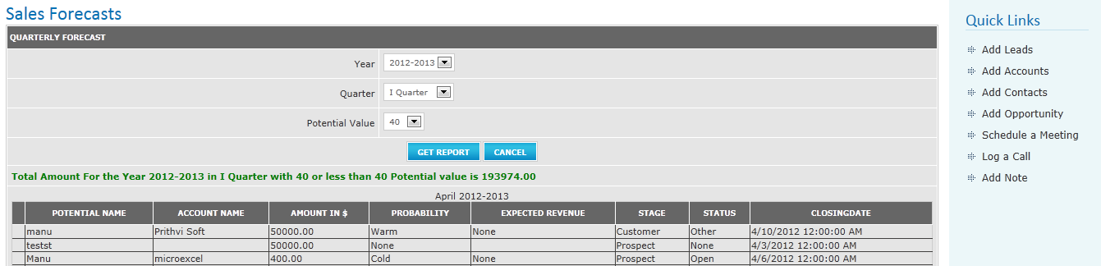

Activity Reports
This report is used to get the Log call reports for today, weekly, Monthly and 6 months calls.
It is viewed by all employees. But Sales Executive can see only his/her reports only SM, VP Sales and CEO can see the reports of themselves and their subordinates also.
For SE:
- Click on Reports tab.
- Click on Activity Reports.
- Click on today call/Weekly call/Monthly call/6 months calls.
- Log call report will be generated according to selected time interval.
- Click on Back button to return to Reports home page.
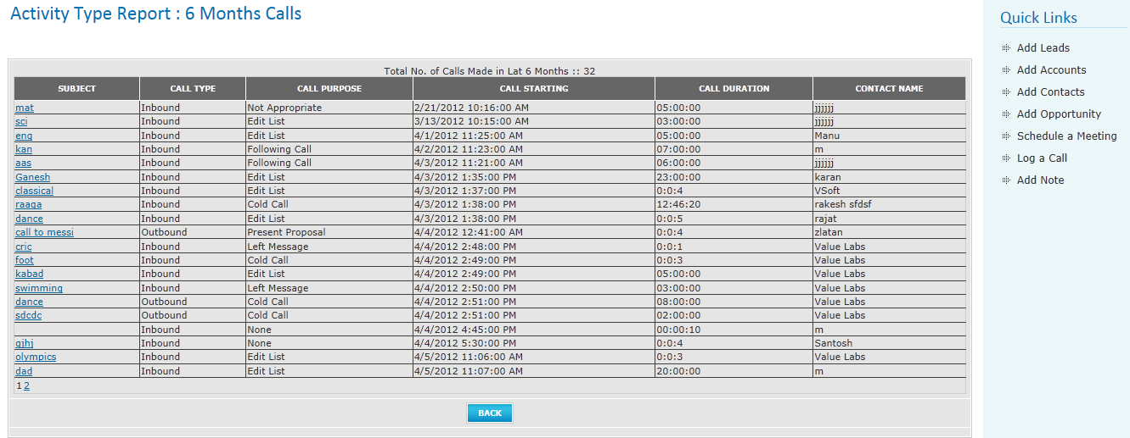

For SM/VP Sales/CEO:
1. Click on Reports tab.
2. Click on Activity Reports.
3. Click on today call/Weekly call/Monthly call/6 months calls.
4. Select employee from the employee dropdown. Default value is logged in user name.
5. Click on Get Details button to get the selected employee log call details.
6. Click on Cancel button to return to Reports home page.

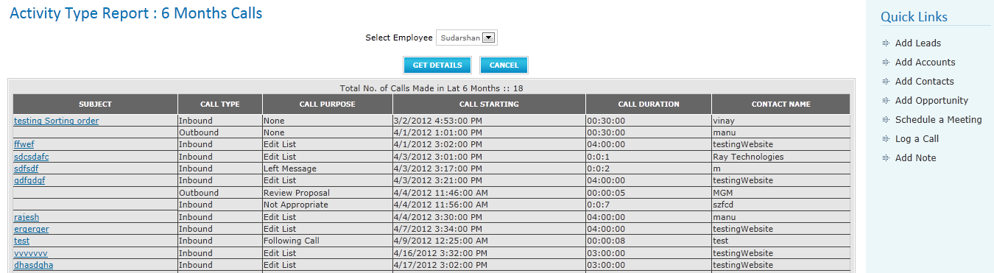

LEAD REPORTS

This report is used to get the details of converted leads, Lead by ownership, today’s Leads.

It is viewed by all employees. But Sales Executive can see only his/her reports only SM, VP Sales and CEO can see the reports of themselves and their team members also.

For SE:
- Click on Reports tab.
- Click on Lead Reports.
- Click on any one of the link under Lead Reports.
- For Converted Leads and Lead By ownership select date range. By default it will show all Leads.
- Click on Run reports button to will generate appropriate report.
- Click on Cancel button to return to Reports home page.

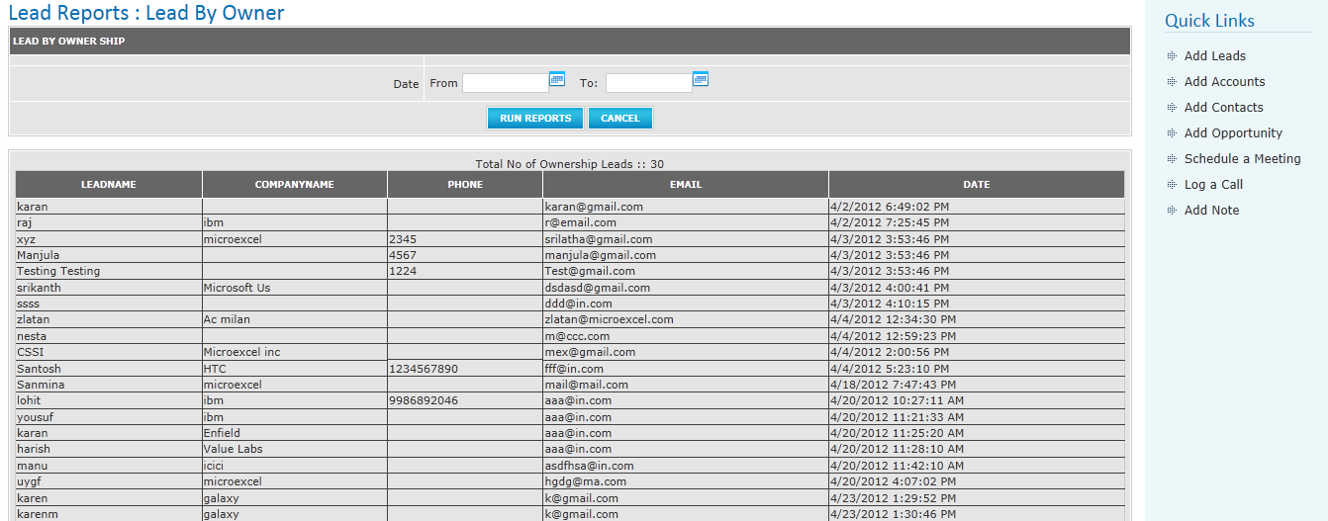

For SM/VP Sales/CEO:
- Click on Reports tab.
- Click on Lead Reports.
- Click on any one of the link under Lead Reports.
- Select any employee from employee dropdown.
- For Converted Leads and Lead By ownership select date range. By default it will show all Leads.
- Click on Run reports button to generate appropriate report.
- Click on Cancel button to return to Reports home page.

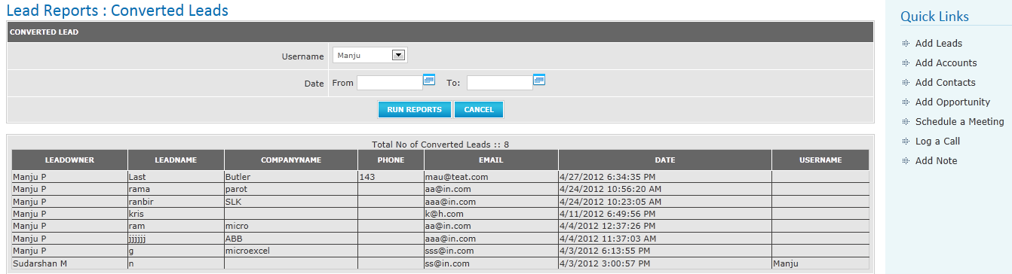

TEAM
Team tab is for SM and VP Sales only. This page contains team members of the logged in user. When you click on any of the team member name , it displays the selected employee leads.

1. Click on Team tab.
2. Click on any employee name.

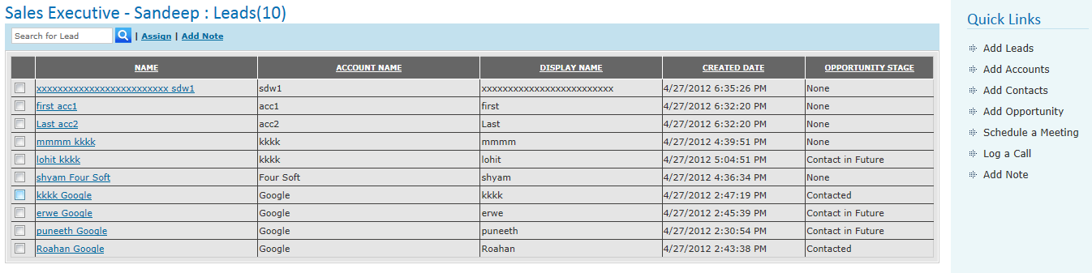

Quick Links
Quick links are nothing but shortcuts. If you click on any of the quick links it will display appropriate page.

