Project Design Document: NagaraMitra
Individual Portfolio Project
Summary
NagaraMitra is a ServiceNow-based grievance platform for a city corporation. A citizen reports a problem once, in their own language, from any channel. The platform routes it to the right ward and department, groups duplicate reports into a single issue, enforces citizen-charter timelines with automatic escalation, and closes a complaint only when the citizen confirms the fix. In the version I am building, rule-based logic classifies complaints and matches duplicates, and approved Telugu, Hindi and English templates carry status updates to citizens, while officers stay in control of every decision. Now Assist features (Smart Categorization, duplicate grouping, multilingual messages and a weekly brief for the Commissioner) are planned if available.

Contents
- Project & Problem Context
- Solution Innovation
- Implementation & Feasibility
- Impact & Metrics
- Project Owner
- Diagrams & Visual Aids
- References

Project & Problem Context

Project Information
Field | Details
Project type | Individual portfolio project
Build environment | Free ServiceNow Personal Developer Instance (Brazil release)

Problem Statement
- The challenge: A city corporation receives complaints about water, roads, streetlights and sanitation through the helpline, walk-ins, social media and apps. These channels are not connected, so the same issue is reported many times, complaints reach the wrong ward or department, and officers close them without the citizen confirming the fix.
- What goes wrong today: (1) Duplicates: one broken drain produces many separate tickets, each handled and counted on its own. (2) Misrouting: complaints bounce between departments and lose days. (3) Unconfirmed closure: a complaint marked closed may still be unresolved, so citizens complain again.
- Why it matters: Delays in basic services affect daily life and health, repeat complaints waste officer time, and the Commissioner has no reliable view of recurring hotspots or officer performance. When trust drops, citizens stop reporting.
- Stakeholders: Citizens, helpline and call-centre agents, ward and department officers, zonal officers and the Commissioner, and auditors or elected representatives who need a clear audit trail.

Solution Innovation

My Approach
- One front door: Citizens file a complaint on the portal or mobile page (text, photo and GPS location), through the Virtual Agent, by calling the helpline (an agent enters it), or by email and social media. Every channel creates the same Grievance record.
- Understand it: Rule-based categorisation reads the free-text complaint and suggests the category and department. Planned if available: Now Assist Smart Categorization. If Now Assist is used, names, phone numbers and addresses are masked before any text reaches a generative skill.
- Route it by place: The GPS location is matched to a ward and zone in my Ward table, and a Flow Designer workflow assigns the complaint to that ward's officer group in the right department.
- Group duplicates: Rule-based matching compares each new complaint with open complaints of the same category in the same ward and nearby location, and links matches to one parent Issue. The Issue keeps a report count, and the officer approves the grouping. Planned if available: a custom Now Assist Skill Kit skill for duplicate grouping.
- Enforce timelines: Every category carries a citizen-charter SLA. A missed deadline escalates the case automatically from ward officer to zonal officer to Commissioner.
- Close the loop: The officer resolves the case with photo proof and the citizen is asked to confirm. Confirmation closes it; rejection reopens it.
- Keep citizens informed: Each status message is sent from an approved template in the citizen's chosen language (Telugu, Hindi or English). Planned if available: Now Assist drafts the messages.
- Give leaders visibility: Dashboards show ward-wise pendency, repeat hotspots and officer performance. Planned if available: Now Assist drafts a weekly executive brief.
- Methodology: I build a working end-to-end flow first (submit, categorize, route, resolve, confirm) and then layer the analytics and, if available, the Now Assist features on top, so a working demo always exists.

Innovation & Differentiation
- Issue-centred, not ticket-centred: Most portals log every complaint as a separate ticket. I group duplicates into one Issue, so the report count becomes a priority signal and the problem is fixed once.
- Hotspot intelligence: Each complaint links to a Civic Asset (a drain, a pole, a pipe). When the same asset keeps generating complaints, the platform flags it for a permanent fix instead of another patch.
- Citizen-verified closure: A department cannot close a complaint on its own. The citizen confirms, which directly removes the 'closed but not fixed' problem.
- Language inclusion: Status updates reach citizens in the language they choose, not only English.
- Responsible AI by design: Suggestions come from rules (or from Now Assist, if used) and officers decide. If Now Assist is used, personal data is masked before generative skills run. Every rule- or AI-assisted action is recorded in the audit trail.
- Built on platform features: The design uses Flow Designer and dashboards rather than heavy custom code, with Now Assist and Skill Kit as optional additions, so a municipal IT team can maintain it.

Why This Matters
- Faster resolution: Correct routing the first time and automatic escalation remove avoidable delays.
- Less duplicated effort: One Issue replaces many tickets, which frees officer time for actual repairs.
- Trust and accountability: Citizens can track status and confirm fixes, and every action is auditable.
- Better decisions: The Commissioner sees where problems repeat and which wards are falling behind.
- Inclusion: Citizens who prefer Telugu or Hindi receive the same quality of service.

Implementation & Feasibility

Technical Stack
Component | Technology / Module
Front-end and back-end elements that will be included | Front-end: Citizen portal and mobile-responsive complaint page (Service Portal / UI Builder) with photo upload and GPS capture; Agent and Officer Workspace for staff.  Back-end: Custom scoped application with tables for Grievance, Issue, Ward, Zone, Department, Officer, Category and Civic Asset; business rules, Script Includes, roles and ACLs.
ServiceNow modules that will be used | Custom scoped application (built in Studio), Virtual Agent, Flow Designer, SLA definitions, Notifications, Dashboards and Reports. Now Assist is optional and planned if available.
ServiceNow features that will be part of this solution | Built version: rule-based categorisation (category and department suggested from the complaint text); rule-based duplicate matching (same category, same ward, nearby location, officer approval); approved Telugu, Hindi and English message templates; Flow Designer escalation flows; SLA timers; role-based access; audit history. Planned if available (Now Assist): Smart Categorization; Skill Kit (duplicate grouping, multilingual status messages, weekly executive brief); Now Assist in Virtual Agent.
High level design | Three layers: (1) channels capture the complaint; (2) the NagaraMitra application holds the data, the rule-based logic and Flow Designer workflows, with Now Assist skills as an optional addition; (3) outcomes reach officers, citizens and the Commissioner. See Figure 1 (architecture), Figure 2 (complaint lifecycle) and Figure 3 (data model).
Supporting Tools/Languages | JavaScript (server and client scripts, GlideRecord), REST APIs for email and social intake and for ward lookup from GPS coordinates, draw.io or Figma for diagrams and wireframes, update sets for version control.

Project Timeline
- Plan: A four-week plan starting 21 October 2026. Each week ends with a working, testable increment.
Week | What gets done | Depends on
Week 1: Foundation | Create the application, tables, roles and ACLs. Load sample wards, departments, officers, categories, civic assets and test complaints. Build the first routing flow. | Instance access
Week 2: Intake and routing | Complaint form with photo and GPS, Virtual Agent intake, rule-based categorisation, geo-routing flow. | Week 1 data
Week 3: SLAs, escalation and closure | SLA timers, auto-escalation, citizen-confirmed closure. | Weeks 1 and 2
Week 4: Polish and delivery | Portal polish, dashboards, README, screenshots and demo video. | Weeks 1 to 3

Feasibility Assessment
- Realistic scope: Every feature maps to an element named in the problem statement, and the core build uses standard platform capabilities (tables, flows, portal, dashboards) rather than custom integrations. The working end-to-end flow comes first and the Now Assist features are optional additions, planned if available.
- Skills and resources: I hold both the CSA and CAD certifications and am building every part myself on a free ServiceNow Personal Developer Instance (Brazil release). I will create my own sample data, so no external data is needed.
- Risk - AI availability: Now Assist features may differ on a Personal Developer Instance. I will confirm availability on day one of the build. The built version does not depend on them: it uses rule-based categorisation, rule-based duplicate matching (same category, same ward, nearby location, officer approval) and approved Telugu, Hindi and English message templates. Now Assist features are added only if available.
- Risk - wrong grouping: Matching may group unrelated complaints, so the officer approves every grouping and can undo it.
- Risk - translation quality: I will use approved templates for status messages in Telugu, Hindi and English and review sample output before the demo.
- Risk - time: The MVP-first plan, with each week ending in a working increment, keeps this solo build on track.
- Risk - privacy: If Now Assist is used, personal data is masked before any AI call. Citizen details are visible only to authorised roles.

Impact & Metrics

Measurable Outcomes
KPI | What it measures | Target (goal to validate)
Duplicate reduction | Complaints linked to an existing Issue instead of handled separately | At least 30% fewer separate work items
First-time routing accuracy | Complaints reaching the right ward and department without reassignment | 90% or more
SLA compliance | Complaints resolved within the citizen-charter timeline | 85% or more
Time to resolve | Average days from complaint to confirmed closure | 25% lower than baseline
Confirmed closure | Closures confirmed by the citizen; reopen rate tracked | 100% of closures need confirmation
Citizen satisfaction | Rating given after closure | 4 out of 5 or higher

- Note: These KPIs are goals to validate with sample data, not achieved results. None has been measured yet. Baselines come from sample data in the demo and, in a real pilot, from existing records.

Real-World Applicability
- Path to production: Pilot in one zone of a city corporation with real ward and department data, connect the existing helpline and social channels, then extend city-wide.
- Scale: Wards, departments, categories and timelines are data, not code, so another city (for example, other city corporations in Andhra Pradesh) can be onboarded by loading its own structure.
- Beyond city complaints: The Issue and Civic Asset approach suits water boards, electricity utilities and any public body with large volumes of repeat complaints.
- Governance: The audit trail, role-based access, PII masking (for any AI use) and human approval of suggestions match public-sector accountability needs.

Project Owner
I am building NagaraMitra alone as a personal portfolio project.
- Name: Suma Priya Vaddi
- Background: Final-year B.Tech CSE (AI-ML) student
- Certifications: ServiceNow CSA and CAD

Visual aids
The figures below show the architecture, the complaint lifecycle, the data model and sample screens of NagaraMitra. They show the full design, including the Now Assist features, which are planned if available. The built version uses the rule-based categorisation, rule-based duplicate matching and approved message templates described above in their place.
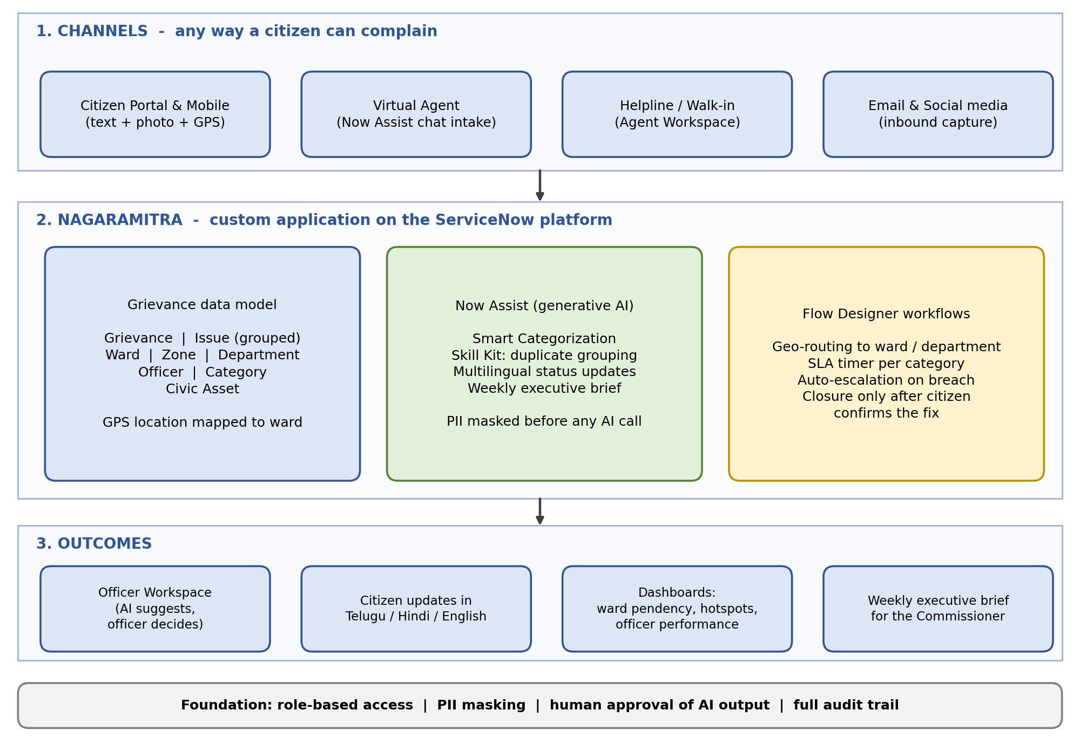
Figure 1: High-level architecture of NagaraMitra
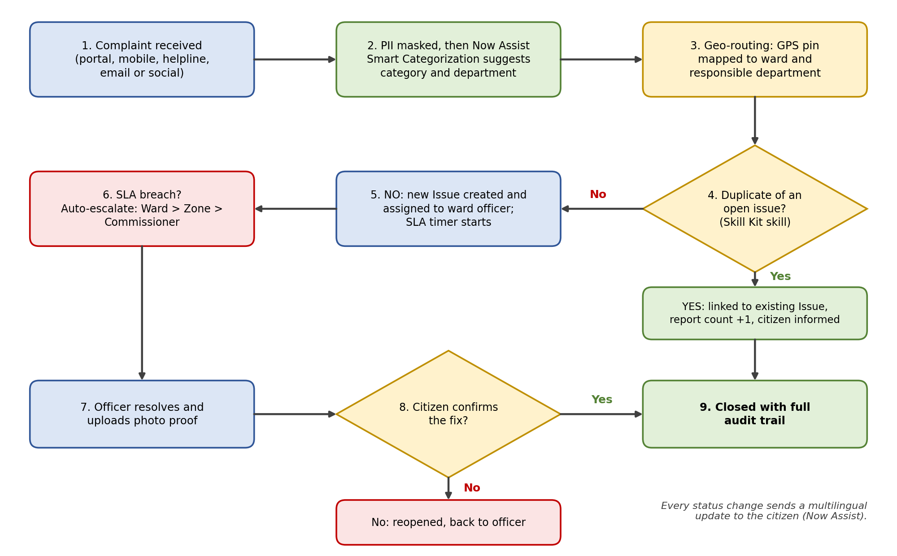
Figure 2: Complaint lifecycle from submission to confirmed closure
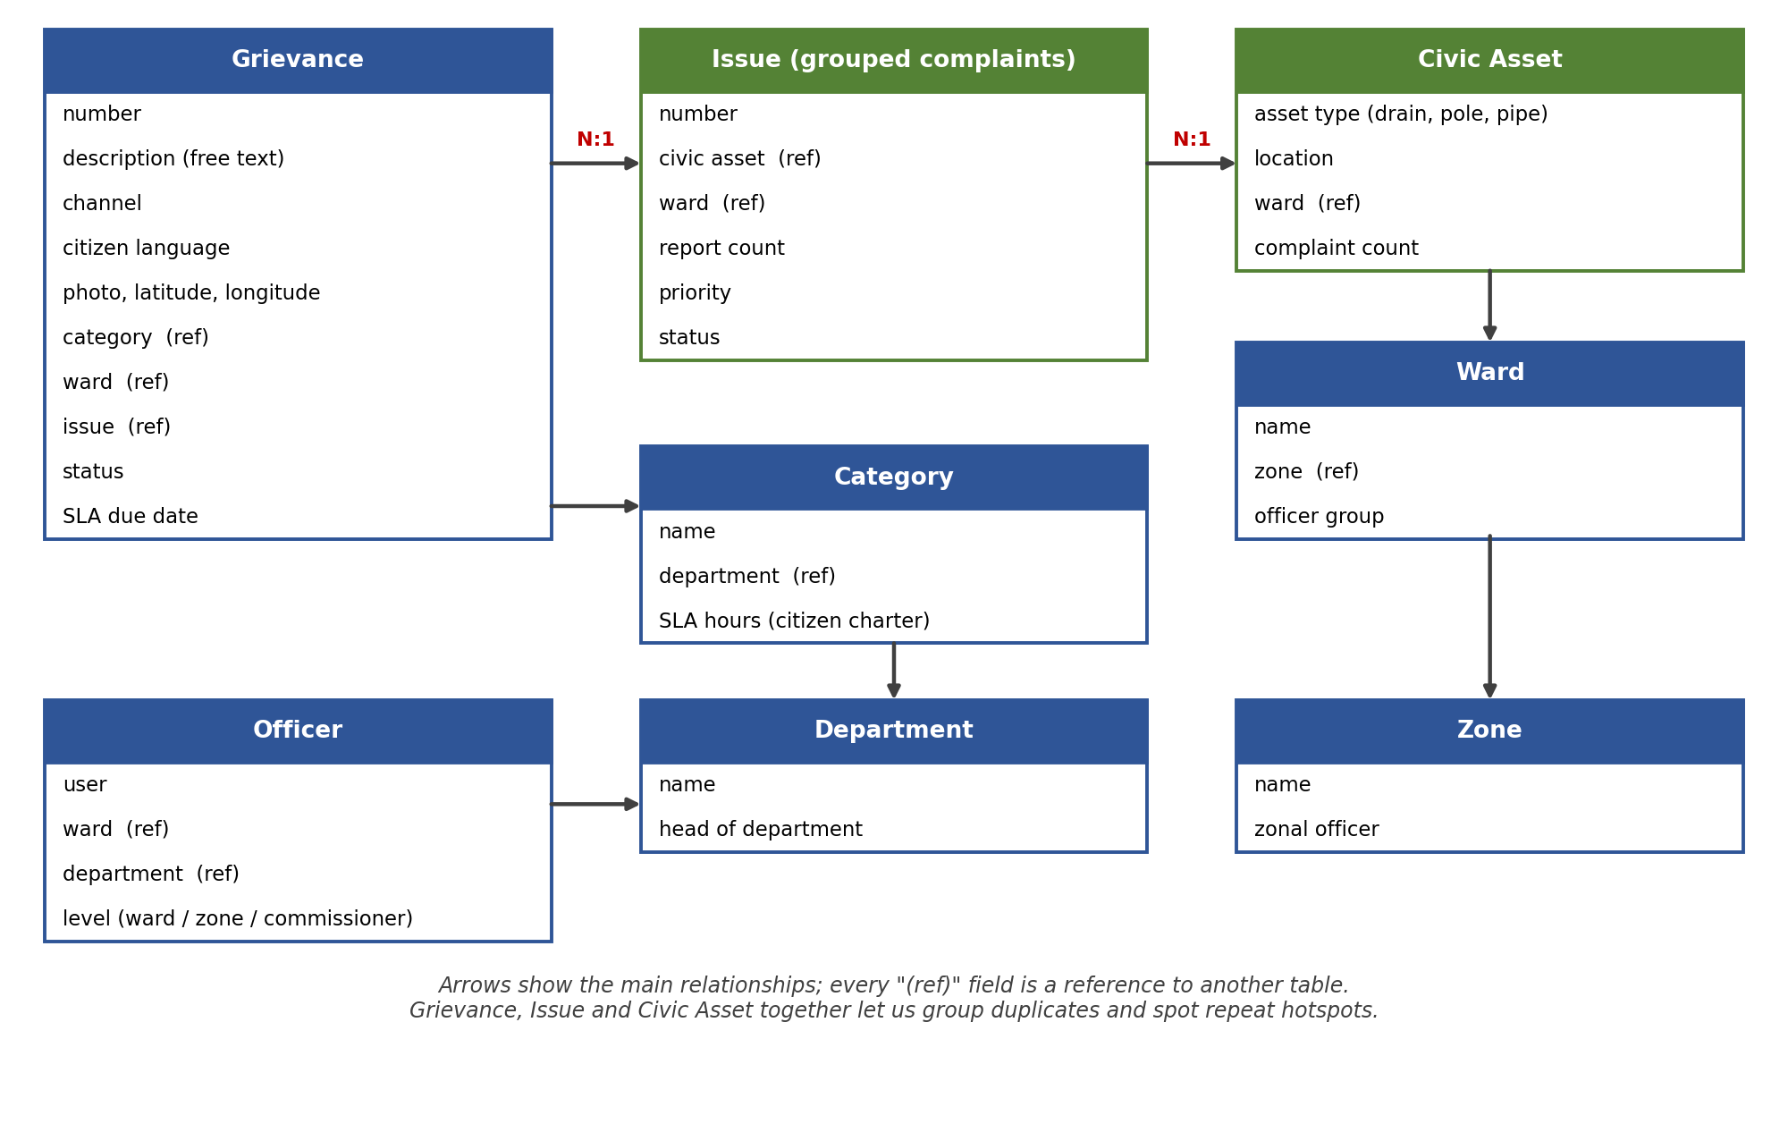
Figure 3: Data model (main tables and relationships)
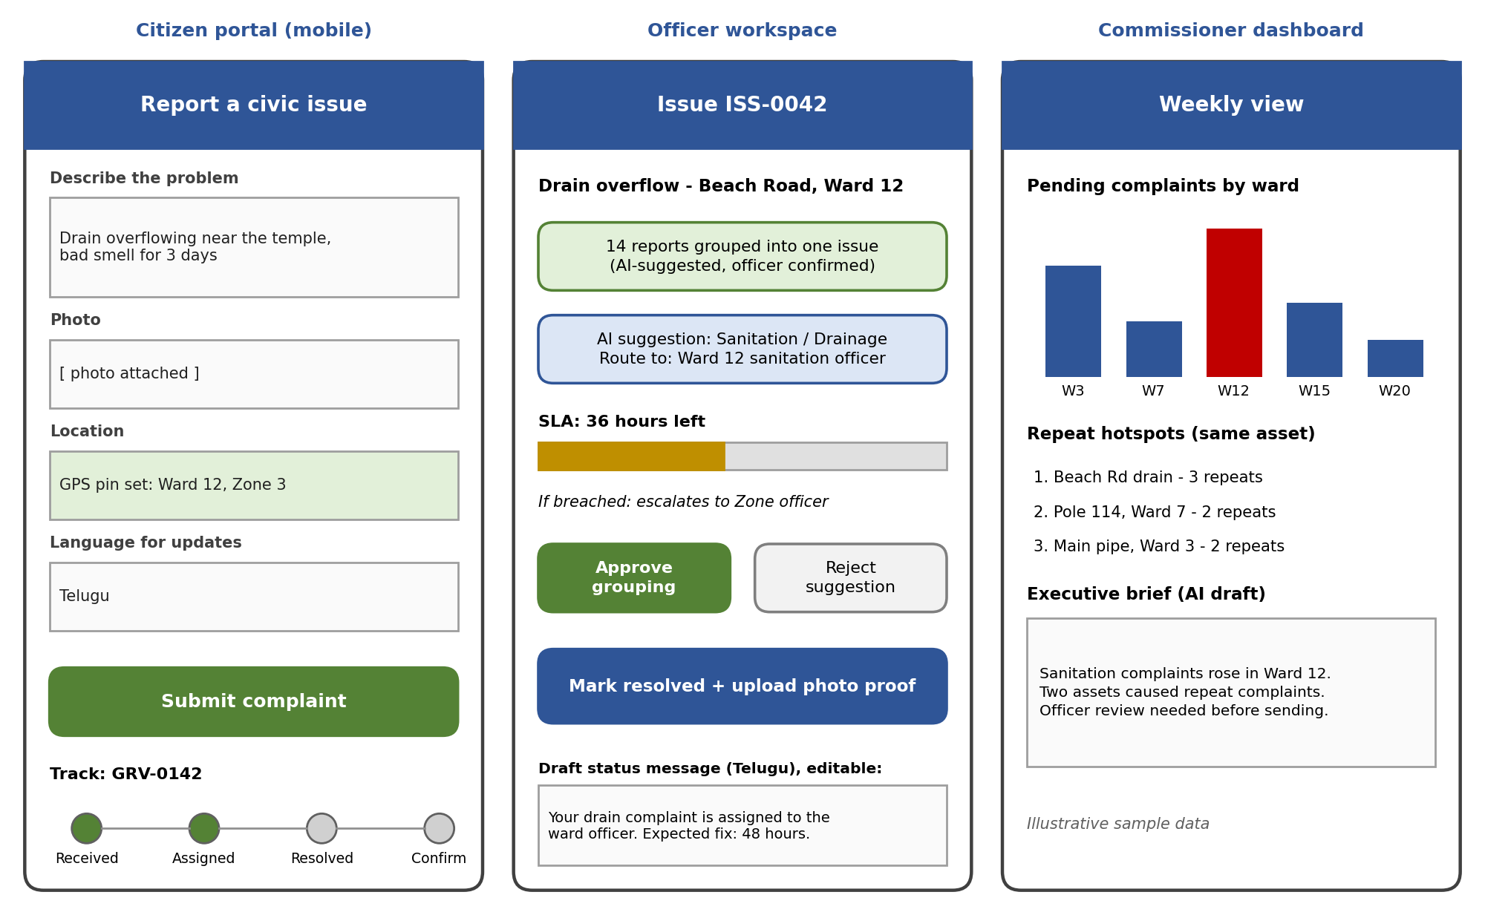
Figure 4: Mock-ups of the citizen portal, officer workspace and Commissioner dashboard

References
- ServiceNow Documentation: https://docs.servicenow.com
- ServiceNow Developer: https://developer.servicenow.com

