Breast Cancer Diagnosis Using an End-to-End Machine Learning Pipeline
CSTE 3207 — Machine Learning Project
Team Members: [Student 1], [Student 2], [Student 3]
Department/University: [Fill in]

Abstract
This project develops an end-to-end supervised machine learning pipeline for classifying breast tumor samples as malignant or benign. The study uses the Breast Cancer Wisconsin (Diagnostic) dataset, containing 569 samples and 30 numeric predictive features. Following the project guideline, the workflow includes problem formulation, exploratory data analysis, preprocessing, feature engineering, baseline and advanced modeling, hyperparameter tuning, cross-validation, quantitative evaluation, and error analysis. A majority-class Dummy Classifier is used as the baseline, while Logistic Regression, Random Forest, and Support Vector Machine models are evaluated. Median imputation and feature scaling are implemented inside leakage-safe pipelines, and three ratio-based features are engineered. Randomized stratified train/test splitting and five-fold stratified cross-validation are used. The best test-set model in this run was Logistic Regression, achieving accuracy 0.982, precision 1.000, recall 0.952, F1-score 0.976, and ROC-AUC 0.996. The results show that systematic preprocessing and tuning provide a strong classification pipeline, while error analysis highlights the remaining cases that are difficult to separate. The model is intended for academic evaluation rather than clinical decision-making.

1. Introduction & Related Work
Breast tumor diagnosis is a binary classification problem in which a tumor can be categorized as malignant or benign. Machine learning can learn relationships between measurable characteristics of cell nuclei and the diagnosis label. The Wisconsin Diagnostic dataset is a standard benchmark for this type of classification. The original UCI description states that its features are computed from digitized fine-needle-aspirate images of breast masses.
Prior work has evaluated multiple machine learning methods on the same dataset, including Support Vector Machines and neural-network-based methods. This project focuses not only on accuracy but on the complete pipeline required by the course guideline: data exploration, rigorous preprocessing, model comparison, tuning, cross-validation, and error analysis.

2. Dataset & Exploratory Data Analysis
The dataset contains 569 observations and 30 continuous predictive features. The target has two classes: malignant and benign. The class distribution is 212 malignant and 357 benign samples. The features describe measurements such as radius, texture, perimeter, area, smoothness, compactness, concavity, concave points, symmetry, and fractal dimension, with mean, standard-error, and worst-value groups.
The original dataset contains 0 missing values. Although the supplied data are complete, the modeling pipeline includes median imputation so that the workflow remains robust if missing numeric values appear in a future copy. Potential outliers were inspected using boxplots rather than automatically deleting observations.
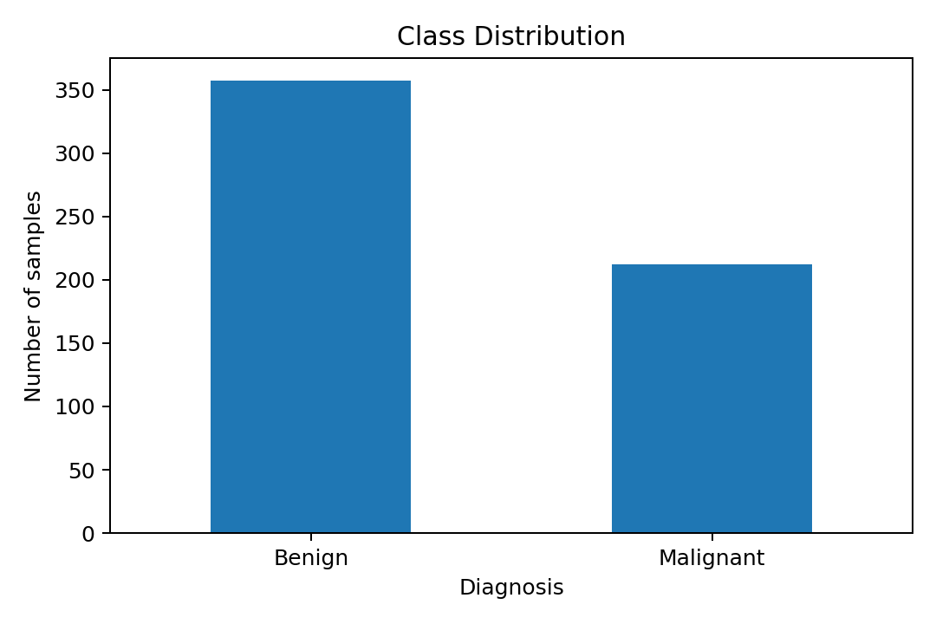
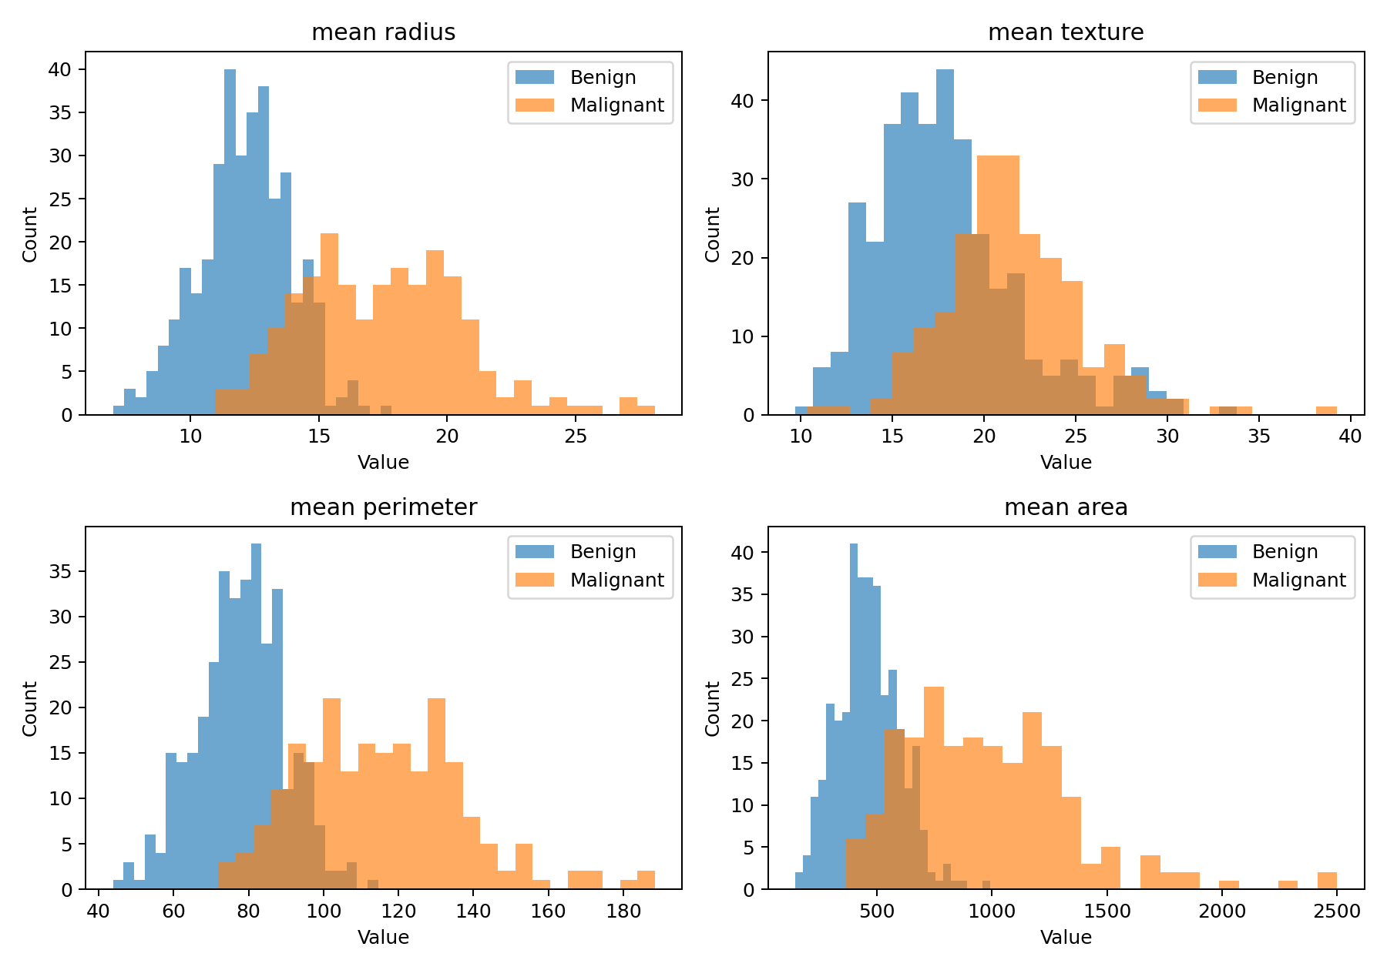
Figure 1. Class distribution and selected feature distributions.
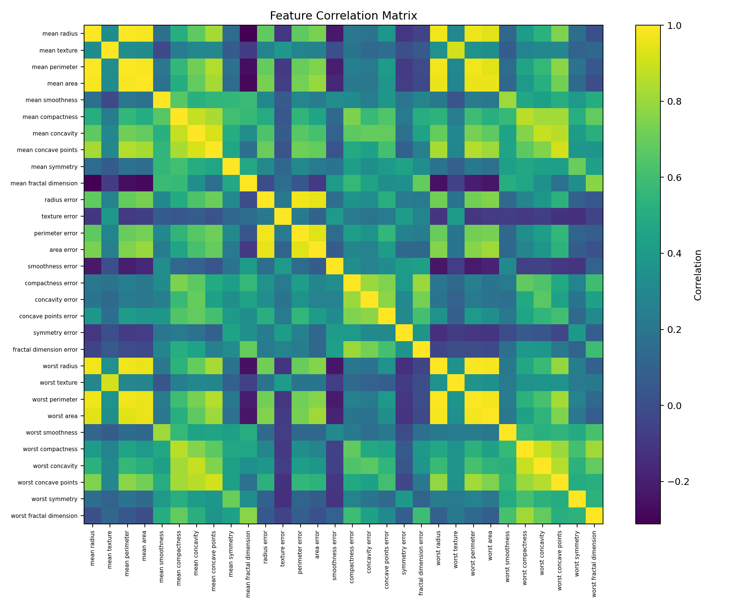
Figure 2. Correlation matrix of numeric predictors. Strong correlations are visible among several geometric measurements.

3. Methodology
The task is supervised binary classification. The data are divided into 80% training and 20% test sets using stratification and random state 42. Three engineered features are added: area-to-perimeter ratio, concavity-to-compactness ratio, and worst-radius-to-mean-radius ratio. These features provide compact relational measurements while retaining the original variables.
Median imputation is performed inside every pipeline. Logistic Regression and SVM additionally use StandardScaler because their optimization is sensitive to feature scale. The baseline is a Dummy Classifier using the majority class. Logistic Regression is treated as a simple interpretable learning model, while Random Forest and SVM are the advanced candidates. Random Forest uses tree ensembles and SVM uses an RBF kernel.
Hyperparameter tuning is performed only on the training data using GridSearchCV with five-fold stratified cross-validation and F1-score as the selection metric. The selected Random Forest parameters were {'model__max_depth': None, 'model__min_samples_split': 2, 'model__n_estimators': 400}. The selected SVM parameters were {'model__C': 10, 'model__gamma': 'scale', 'model__kernel': 'rbf'}. Keeping imputation, scaling, and model fitting inside the cross-validation pipeline prevents preprocessing leakage.

4. Experiments & Results
Table 1 compares the baseline and candidate models on the held-out test set.
Model | Accuracy | Precision | Recall | F1 | ROC-AUC
Logistic Regression | 0.982 | 1.000 | 0.952 | 0.976 | 0.996
Tuned SVM | 0.974 | 1.000 | 0.929 | 0.963 | 0.995
Tuned Random Forest | 0.965 | 1.000 | 0.905 | 0.950 | 0.997
Dummy Baseline | 0.632 | 0.000 | 0.000 | 0.000 | 0.500
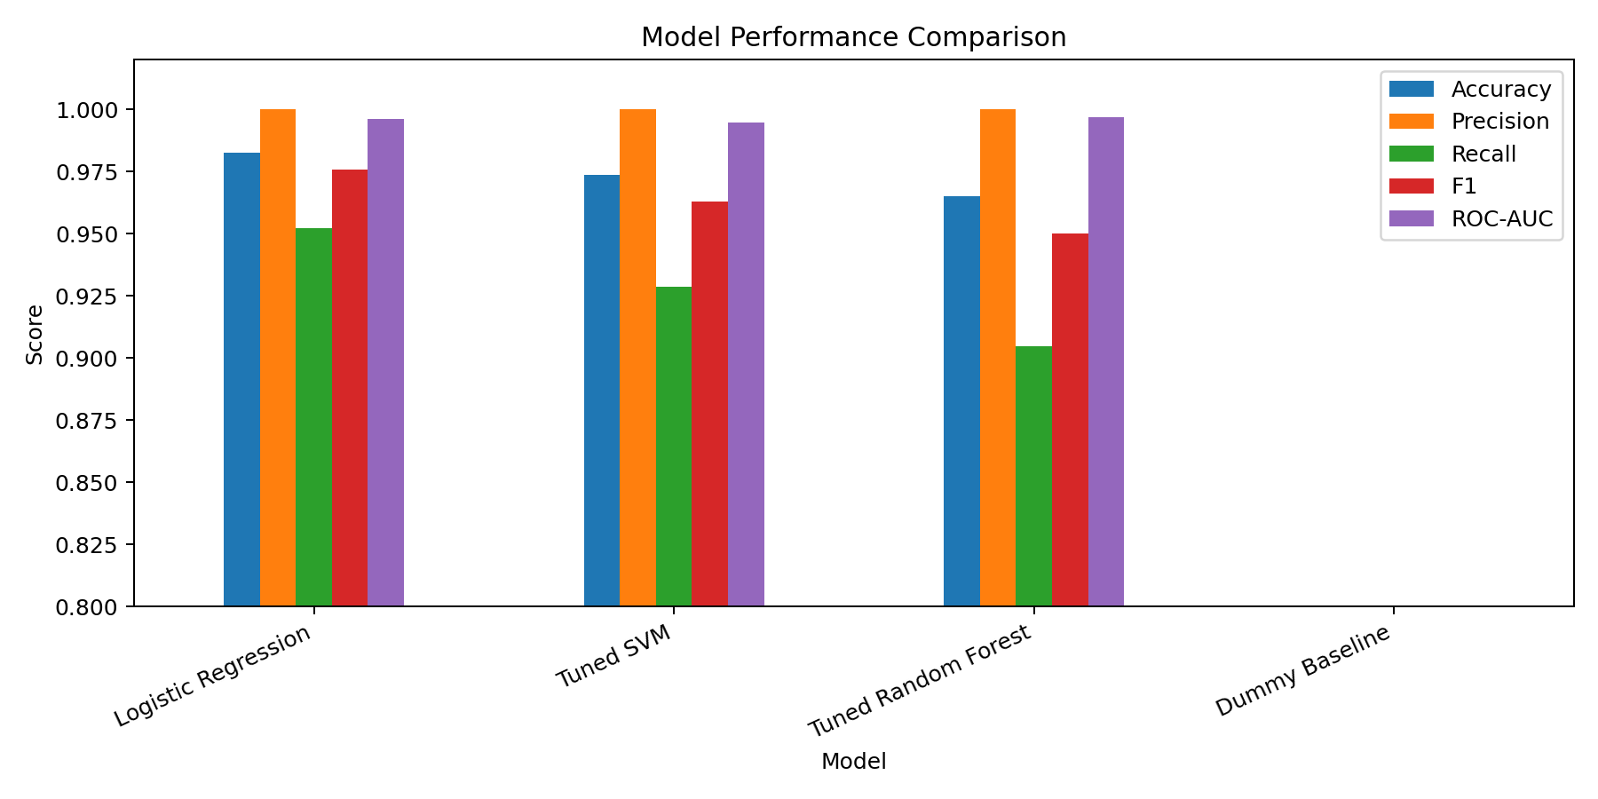
Figure 3. Quantitative comparison of baseline and advanced models.
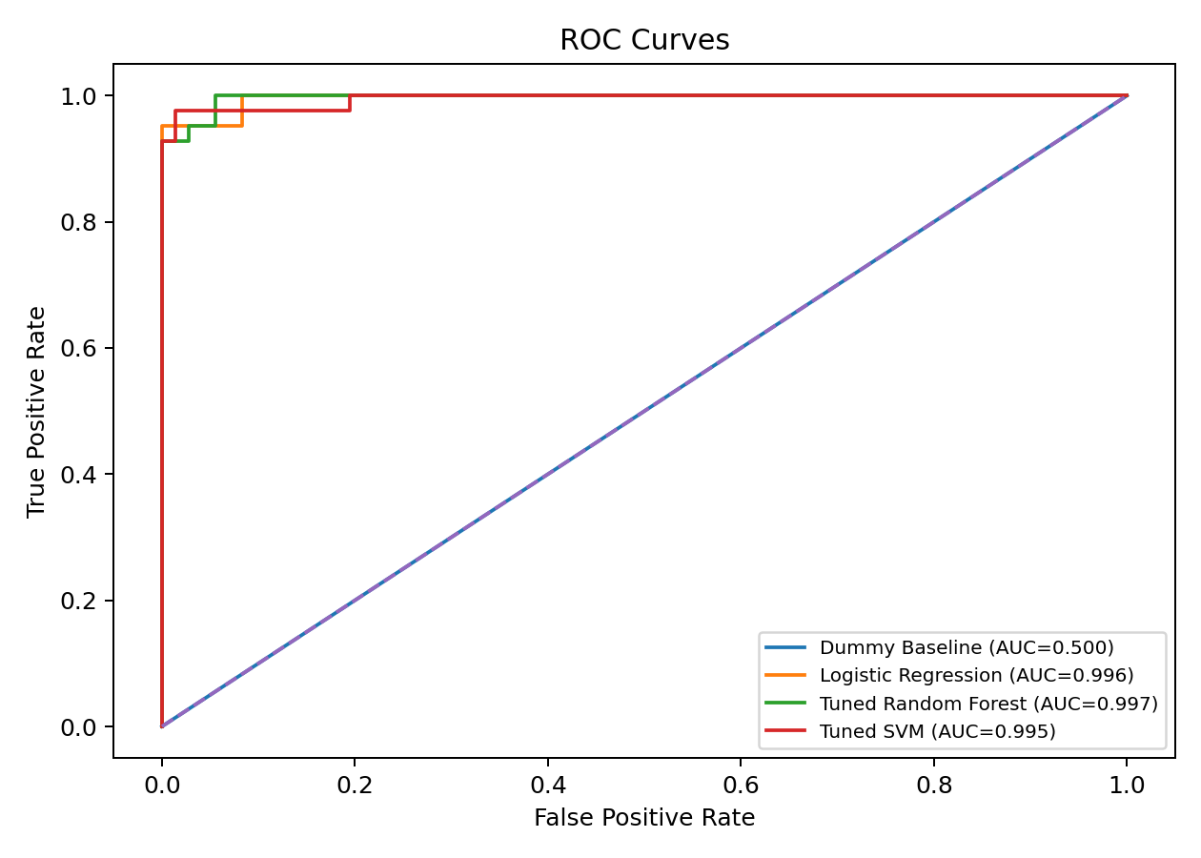
Figure 4. ROC curves for the evaluated models.

5. Discussion & Error Analysis
The strongest test-set performance in this run came from Logistic Regression. Its confusion matrix is shown below. Recall is especially important when the positive class represents malignant tumors because false negatives are potentially more consequential than false positives in a diagnostic screening context. However, the model should not be interpreted as a medical diagnostic device.
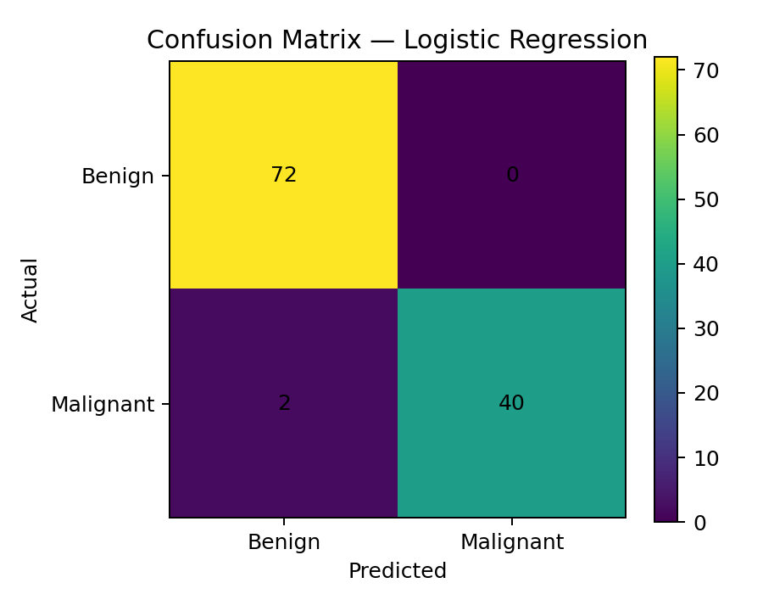
Figure 5. Confusion matrix for the best-performing model.
The held-out test set contained 2 misclassified cases for the best model. These cases illustrate that some samples have overlapping feature patterns and cannot be separated perfectly by the learned decision boundary. Error analysis should therefore consider both false negatives and false positives rather than relying only on overall accuracy.
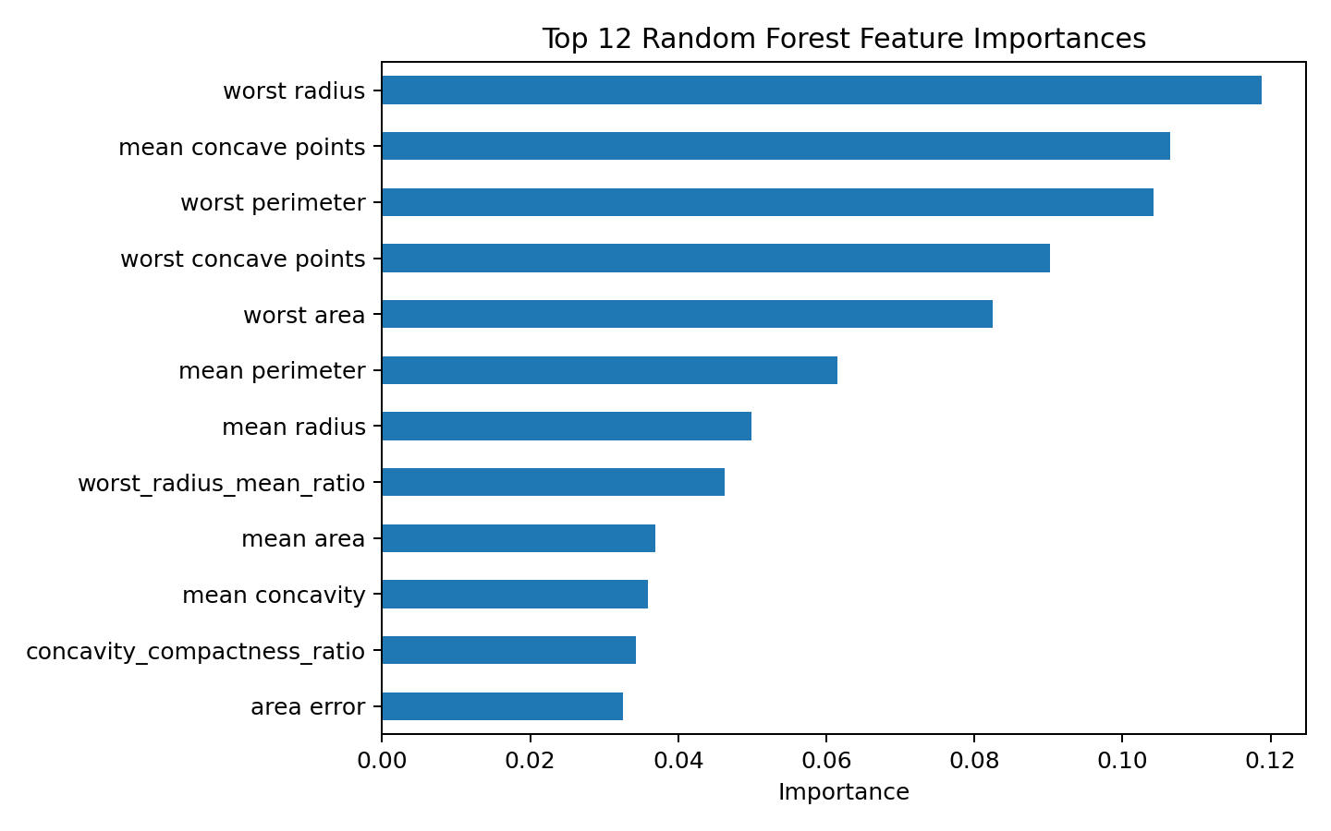
Figure 6. Top Random Forest feature importances. Feature importance indicates predictive usefulness within the fitted model, not causality.
Limitations include the relatively small dataset, possible sampling and measurement biases inherited from the original collection, and the fact that the benchmark does not represent all clinical populations. External validation on independent clinical data would be necessary before any real-world use.

6. Conclusion & Future Work
This project implemented all major stages requested by the course guideline: problem formulation, EDA, preprocessing, feature engineering, baseline and advanced modeling, hyperparameter tuning with five-fold cross-validation, evaluation, and error analysis. The best model achieved an F1-score of 0.976 and ROC-AUC of 0.996 on the held-out test set. Future work could include calibrated probabilities, nested cross-validation, dimensionality reduction, class-weighted optimization, external validation, and comparison with gradient boosting or neural networks.

7. Author Contributions
Student 1: Dataset preparation, exploratory data analysis, and preprocessing.
Student 2: Model development, hyperparameter tuning, and evaluation.
Student 3: Error analysis, report writing, and presentation preparation.
Replace the placeholders with the actual names and redistribute these contributions if the team has only two members.

References
1. UCI Machine Learning Repository, “Breast Cancer Wisconsin (Diagnostic),” Dataset 17.
2. F. Pedregosa et al., “Scikit-learn: Machine Learning in Python,” Journal of Machine Learning Research, vol. 12, pp. 2825–2830, 2011.
3. A. F. Agarap, “On Breast Cancer Detection: An Application of Machine Learning Algorithms on the Wisconsin Diagnostic Dataset,” arXiv:1711.07831, 2017.
4. CSTE 3207 Project Guideline supplied for the course, requiring an end-to-end ML pipeline, EDA, preprocessing, baseline/advanced models, tuning, evaluation, and a 5–6 page IEEE-style report.

