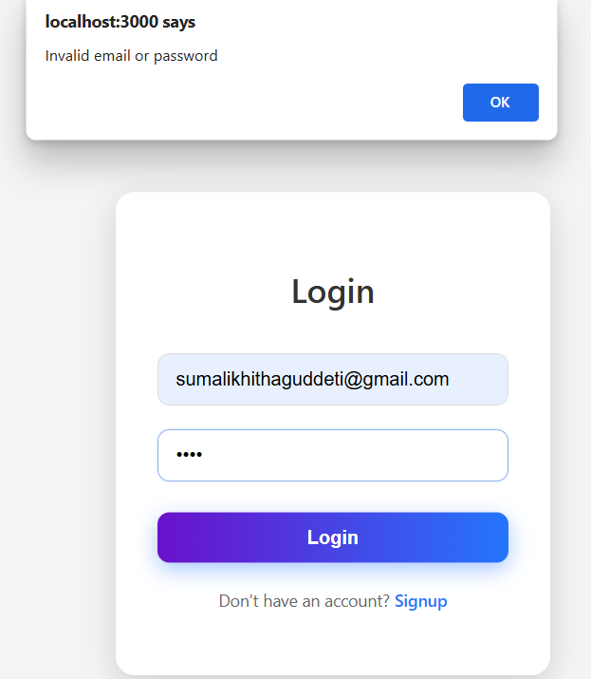Test Cases for Login and Signup

|  |  |  |  |
| --- | --- | --- | --- |
| **Test Case** | **Input** | **Expected Output** | **Result** |
| Login with correct username and password | Valid credentials | Login successful | Pass |
| Login with incorrect username | Invalid username | Error: User not found | Fail |
| Login with incorrect password | Valid username,  wrong password | Error: Incorrect password | Fail |
|  |  |  |  |
| Login with empty username | No username entered | Error: Username required | Fail |
| Login with empty password | No password entered | Error: Password require | Fail  **Sign up test cases** |
| Signup with new username | Unique username and valid password | Signup successful | Pass |
|  |  |  |  |
| Signup with weak password | Valid username, weak password | Error: Weak password | Fail |
| Signup with empty fields | No username or password entered | Error: Fields required | Fail |
| Login after successful signup | Newly registered credentials | Login successful | Pass |

