**GE Corporate Treasury**

Disclaimer

NOTICE: The information contained in this document is not to be used for any purpose other than the purposes for which this document is furnished by the General Electric Company, nor is this document (in whole or in part) to be reproduced or furnished to third parties or made public without the prior express written permission of the General Electric Company.

Name of the Document

Table of Contents

Document Version Control 1

When to execute 2

Prerequisites 2

Who executes 2

SOP Steps to Execute 2

Notification Prior to Executing SOP 2

Steps to execute 2

Expected Results 2

Expected Duration 2

Required Approvals 2

Validation 2

Final Verification / Notification Immediately 2

Risk Analysis 2

In Case of SOP Failures 2

Glossary 2

## Document Version Control

|  |  |  |  |
| --- | --- | --- | --- |
| **Version Number** | **Updated By** | **Updated Date** | Description of Change |
| 1.0 | Kavya Venkata Sai Suma(503084820) | 08/03/2020 | Initial version |

## When to execute

*On demand – Need to update the password for the master account in all the PGP servers, once the master account password has been reset by application owner.*

## Prerequisites

*We need all PGP nodes server access to update the password*

## Who executes

## *@CAPITAL Treasury AS PGP L2 Support*

## SOP Steps to Execute

#### Steps to execute

1.Stop all the Scheduler tasks for PGP Interfaces.

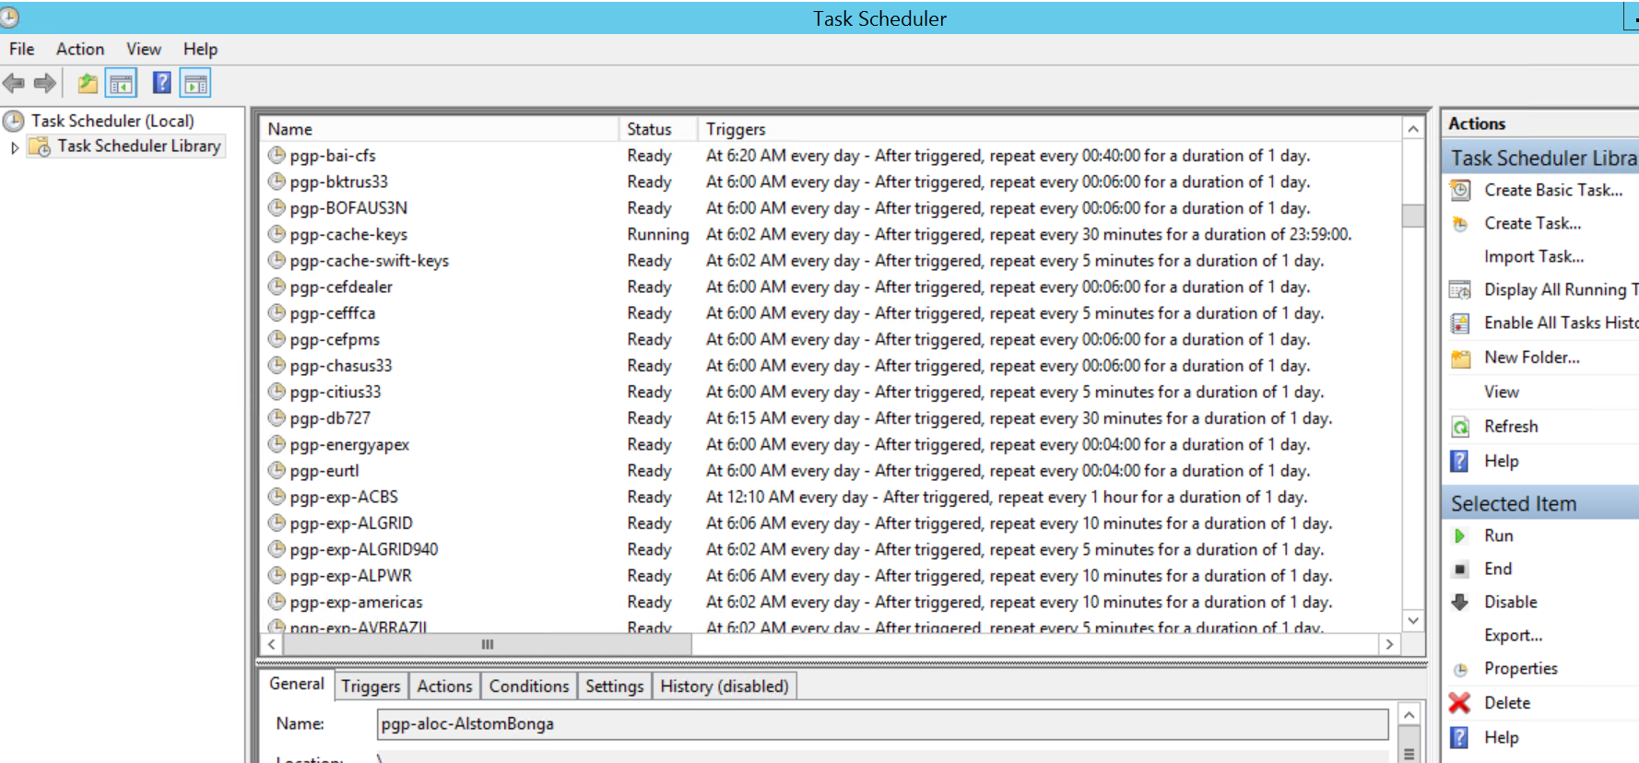

2.After Password Update, Login into all PGP nodes with master account using updated password

3.Open the task scheduler, Select any one of the interface (check in the security options, if it interface is running with PGP master account)

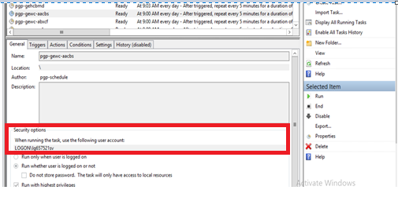

4.click on change User or Group Button .

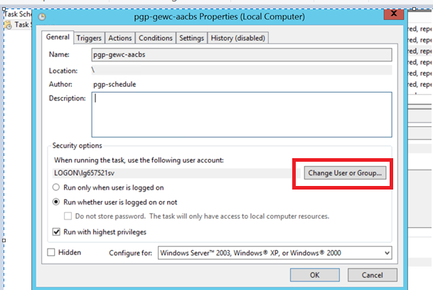

5.After clicking the button, a pop up will be displayed as shown in below picture, Enter the PGP master account UserName in the text area field for label: **Enter the object name to select(examples):**

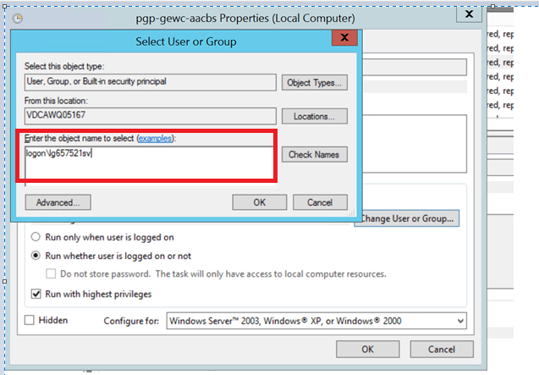

6.After entering the account, Click on Check Names

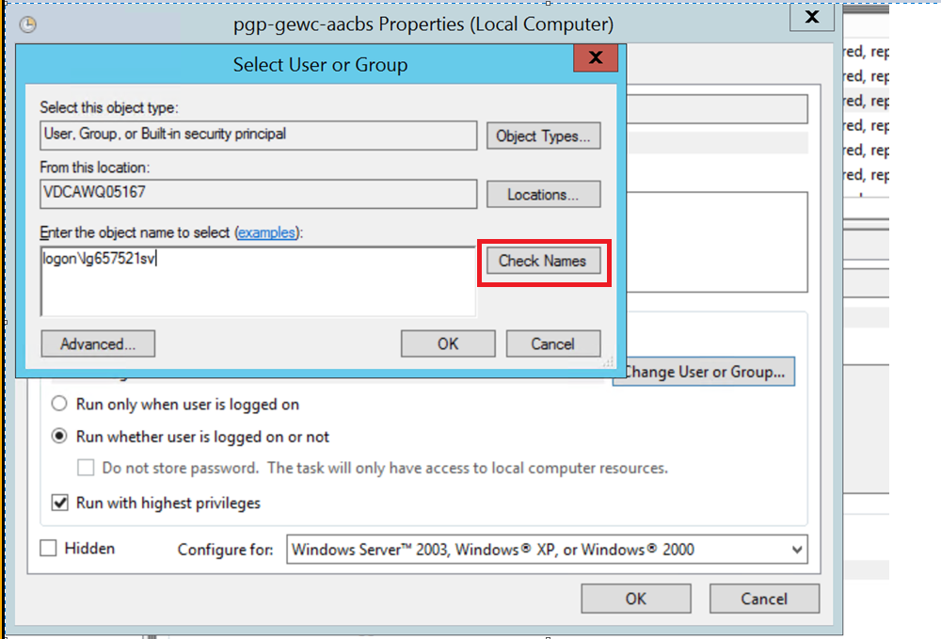

7. It should be displayed as in highlighted part. Click on “OK” button

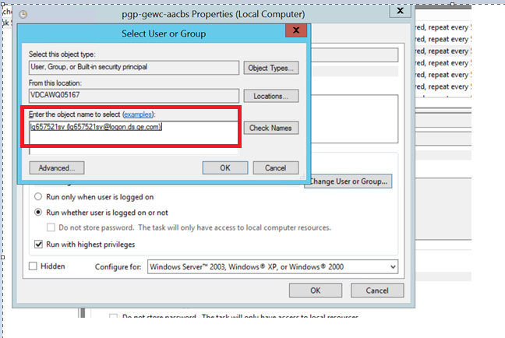

8.click on “OK” button on the below displayed prompt

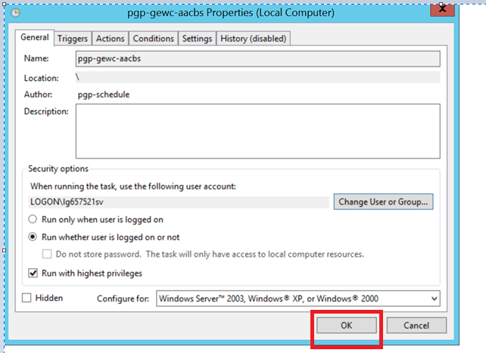

9.After clicking on “OK” button, a pop up will be displayed asking for Account Information.Enter the new password after reseting the PGP master account password

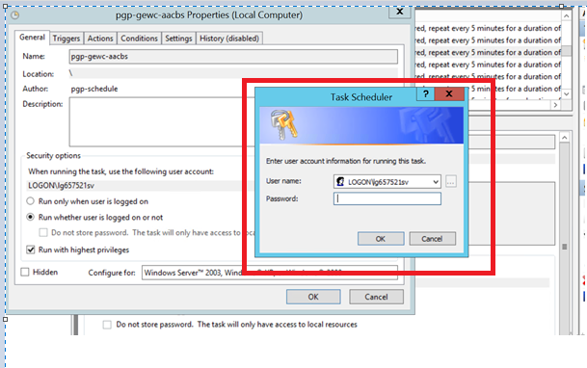

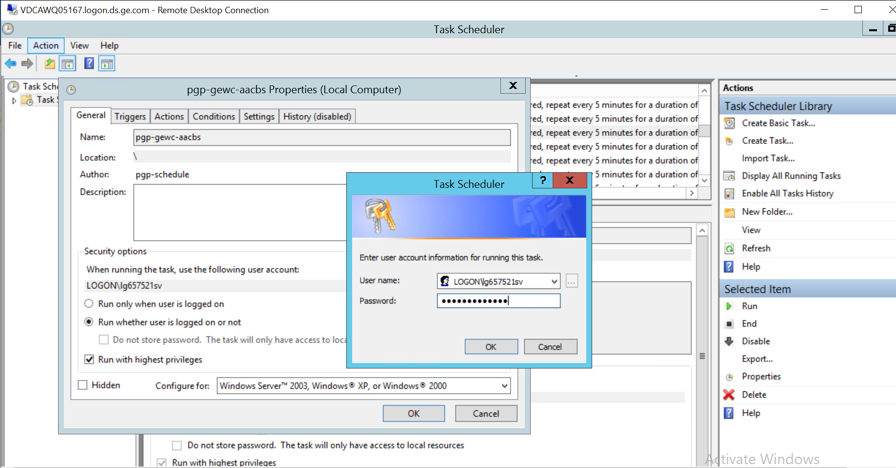

10.After entering the password click on “OK”.

11.Make the interface (=Selected interface for updating the new password) to ready state. Validate if it is running without any issues.

12.After that, Enable all the scheduler tasks PGP Interfaces that are previously stopped for this activity.

#### Expected Results

*All the tasks and services updated with new password on all PGP nodes*

*We expect all the PGP scheduler tasks are working as predefined*

#### Expected Duration

*2 hours*

#### Required Approvals

*Application Owner (PGP)*

#### Validation

*All scheduled tasks should be running after updatind the password to any on of the tadsk a way of validating the process.*

#### Final Verification / Notification Immediately

*@CAPITAL Treasury AS PGP L2 Support*

## Risk Analysis

*If the Password is not updated properly the PGP servers will be not able to connected and stops running tasks with further fails to process the payments*

## In Case of SOP Failures

Please reach out PGP L2 Support (@CAPITAL Treasury AS PGP L2 Support)