Integrating Bochs environment with gdb

I did not use the SourceForge site to download Bochs 2.6.8 since we could easily integrate gdb with the existing bochs. The steps and screenshots for the same are listed below:

- Added the “-g” flag to our existing makefile to generate required debugging information to be used by the GDB debugger later.

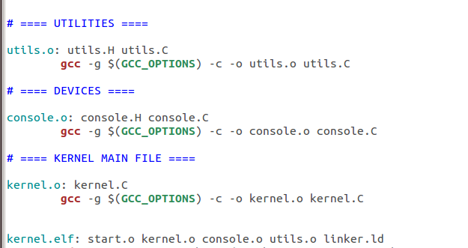

- Now we need to link the above listed object files to produce an executable. We edit the linker.ld file to retain the debugging information and get the ELF Output by not mentioning any output format in the linker file.

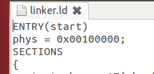

3. Now we rename the “kernel.bin” file to “kernel.elf” and make the appropriate changes in makefile
and copykernel files being used. Then we make the makefile and run the copykernel commands.

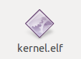

4. Now we enable the GDB stub in the Bochs configuration file:

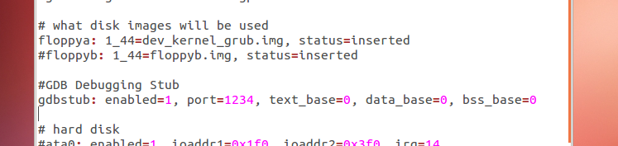

- Loading Bochs:

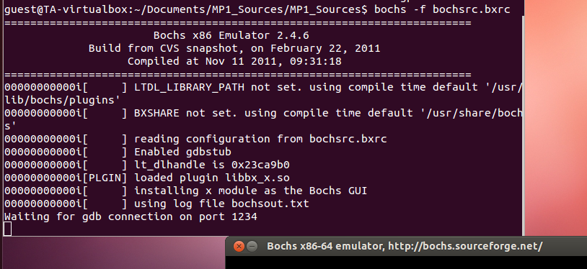
- Connecting from GDB (and adding breakpoint at main())

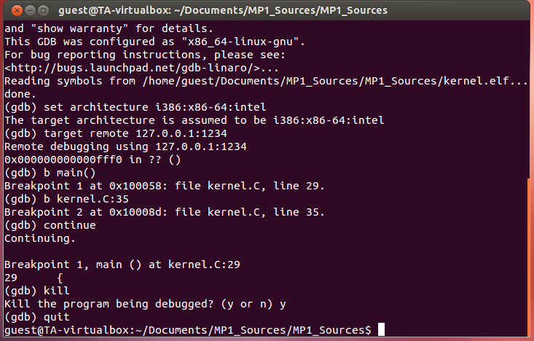

Final Output (GDB tool in action)

