EAP-TLS original

usertype string;

const req, shd, ccs: string;

const mastersecret, clientfinished, serverfinished, keyexpansionclient, keyexpansionserver, accesslevel, success: string;

hashfunction h, prf;

macro m=( SID, ni, nr, {CerR,pk(R)}sk(CA), req, shd, {CerI, pk(I)}sk(CA), {PMS}pk(R));

macro m1= {h(m)}sk(I);

macro ms= prf(PMS, mastersecret,ni, nr);

macro mc= ( {CerI, pk(I)}sk(CA), {PMS}pk(R));

macro m2= prf (ms, serverfinished, h(SID, ni, nr, {CerR,pk(R)}sk(CA), req, shd, mc, {h( SID, ni, nr, {CerR,pk(R)}sk(CA), req, shd, mc)}sk(I), ccs));

macro m3= prf (ms, clientfinished, h(SID, ni, nr, {CerR,pk(R)}sk(CA), req, shd, mc, {h( SID, ni, nr, {CerR,pk(R)}sk(CA), req, shd, mc)}sk(I),prf (ms, serverfinished, h(SID, ni, nr, {CerR,pk(R)}sk(CA), req, shd, mc), {h(SID, ni, nr, {CerR,pk(R)}sk(CA), req, shd, mc )}sk(I), ccs)));

macro clientkey=prf(ms, keyexpansionclient, ni, nr);

macro serverkey= prf(ms, keyexpansionserver, ni, nr);

protocol eaptls (I,R,CA)

{

role I

{

const SID, CerI, CerR,PMS: Data;

fresh ni: Nonce;

var nr:Nonce;

send_1 (I, R, SID, ni);

recv_4 (R, I, SID, nr, {CerR,pk(R)}sk(CA), req, shd);

send_5 (I, CA, I);

recv_6 (CA, I, {I, {CerI, pk(I)}pk(I)}sk(CA));

send_7 (I, R, {CerI, pk(I)}sk(CA), {PMS}pk(R));

send_8 (I,R , {h( SID, ni, nr, {CerR,pk(R)}sk(CA), req, shd, {CerI, pk(I)}sk(CA), {PMS}pk(R) )}sk(I));

recv_9 (R, I, ccs);

recv_10 (R, I, prf (ms, serverfinished, h(m, m1)));

match (m2, prf (ms, serverfinished, h(m, m1)));

send_11 (I, R, prf (ms, clientfinished, h(m, m1, m2)));

recv_12 (R, I, {accesslevel}serverkey);

send_13 (I, R, {success}clientkey);

claim_I1 (I, Secret, CerR);

claim_I2 (I, Secret, CerI);

claim_I3 (I, Secret, PMS);

claim_I4 (I, Secret, ms);

claim_I5 (I, Secret, clientkey);

claim_I6 (I, Secret, serverkey);

claim_I7 (I, Nisynch);

claim_I8 (I, Niagree);

}

role R

{

const SID, CerI, CerR, PMS: Data;

fresh nr: Nonce;

var ni:Nonce;

recv_1 (I, R, SID, ni);

send_2 (R, CA, R);

recv_3 (CA, R, {R, {CerR,pk(R)}pk(R)}sk(CA));

send_4 (R, I, SID, nr, {CerR,pk(R)}sk(CA), req, shd);

recv_7 (I, R, {CerI, pk(I)}sk(CA), {PMS}pk(R));

recv_8 (I,R , {h( SID, ni, nr, {CerR,pk(R)}sk(CA), req, shd, {CerI, pk(I)}sk(CA), {PMS}pk(R) )}sk(I));

match(m1, {h( SID, ni, nr, {CerR,pk(R)}sk(CA), req, shd, {CerI, pk(I)}sk(CA), {PMS}pk(R))}sk(I));

send_9 (R, I, ccs);

send_10 (R, I, prf (ms, serverfinished, h(m , m1)));

recv_11 (I, R, prf (ms, clientfinished, h(m, m1, m2)));

match (m3, prf (ms, clientfinished, h(m, m1, m2)));

send_12 (R, I, {accesslevel}serverkey);

recv_13 (I, R, {success}clientkey);

claim_R1 (R, Secret, CerR);

claim_R2 (R, Secret, CerI);

claim_R3 (R, Secret, PMS);

claim_R4 (R, Secret, ms);

claim_R5 (R, Secret, clientkey);

claim_R6 (R, Secret, serverkey);

claim_R7 (R, Nisynch);

claim_R8 (R, Niagree);

}

role CA

{

const CerI, CerR: Data;

recv_2 (R, CA, R);

send_3 (CA, R, {R, {CerR, pk(R)}pk(R)}sk(CA));

recv_5 (I, CA, I);

send_6 (CA, I, {I, {CerI, pk(I)}pk(I)}sk(CA));

claim_CA1 (CA, Secret, CerR);

claim_CA2 (CA, Secret, CerI);

}

}

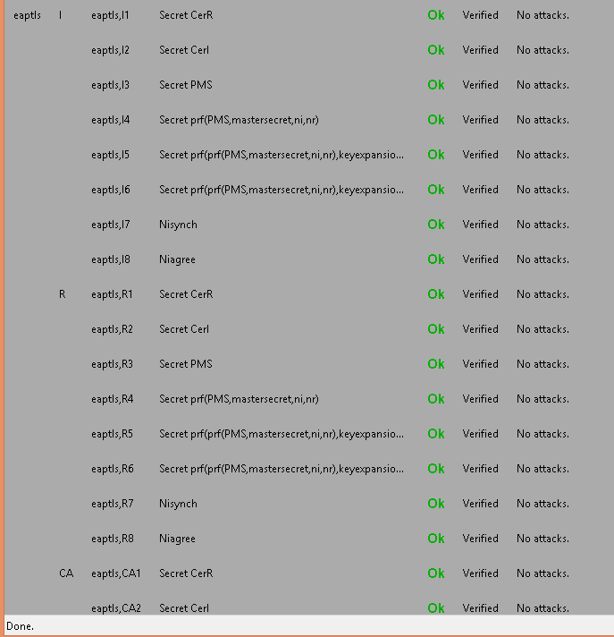

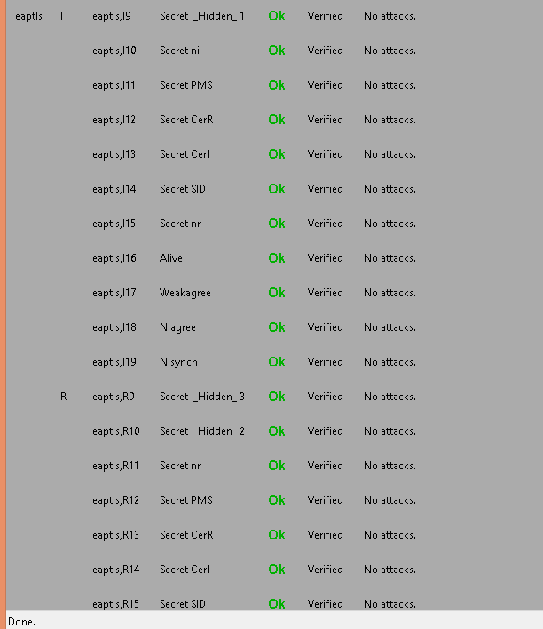

EAP-TLS modified

usertype string;

const req, shd, ccs: string;

const mastersecret, clientfinished, serverfinished, keyexpansionclient, keyexpansionserver, accesslevel, success: string;

hashfunction h, prf;

macro m=( SID, ni, nr, {CerR,pk(R)}sk(CA), req, shd, {CerI, pk(I)}sk(CA), {PMS}pk(R));

macro m1= {h( SID, ni, nr, {CerR,pk(R)}sk(CA), req, shd, {CerI, pk(I)}sk(CA), {PMS}pk(R))}sk(I);

macro ms= prf(PMS, mastersecret,ni, nr);

macro mc= ( {CerI, pk(I)}sk(CA), {PMS}pk(R));

macro m2= prf (ms, serverfinished, h(SID, ni, nr, {CerR,pk(R)}sk(CA), req, shd, mc, {h( SID, ni, nr, {CerR,pk(R)}sk(CA), req, shd, mc)}sk(I), ccs));

macro m3= prf (ms, clientfinished, h(SID, ni, nr, {CerR,pk(R)}sk(CA), req, shd, mc, {h( SID, ni, nr, {CerR,pk(R)}sk(CA), req, shd, mc)}sk(I),prf (ms, serverfinished, h(SID, ni, nr, {CerR,pk(R)}sk(CA), req, shd, mc), {h(SID, ni, nr, {CerR,pk(R)}sk(CA), req, shd, mc )}sk(I), ccs)));

macro clientkey=prf(ms, keyexpansionclient, ni, nr);

macro serverkey= prf(ms, keyexpansionserver, ni, nr);

protocol eaptls (I,R,CA)

{

role I

{

const SID, CerI, CerR,PMS: Data;

fresh ni: Nonce;

var nr:Nonce;

send_1 (I, R, SID, ni);

recv_4 (R, I, SID, nr, {CerR,pk(R)}sk(CA), req, shd);

send_5 (I, CA, I);

recv_6 (CA, I, {I, {CerI, pk(I)}pk(I)}sk(CA));

send_7 (I, R, {CerI, pk(I)}sk(CA), {PMS}pk(R));

send_8 (I,R , {h( SID, ni, nr, {CerR,pk(R)}sk(CA), req, shd, {CerI, pk(I)}sk(CA), {PMS}pk(R) )}sk(I));

recv_9 (R, I, ccs);

recv_10 (R, I, prf(ms, serverfinished, h(m, m1)));

match (m2, prf(ms, serverfinished, h(m, m1)));

send_11 (I, R, prf(ms, clientfinished, h(m, m1, m2)));

recv_12 (R, I, {accesslevel}serverkey);

send_13 (I, R, {success}clientkey);

claim_I1 (I, Secret, CerR);

claim_I2 (I, Secret, CerI);

claim_I3 (I, Secret, PMS);

claim_I4 (I, Secret, ms);

claim_I5 (I, Secret, clientkey);

claim_I6 (I, Secret, serverkey);

claim_I7 (I, Nisynch);

claim_I8 (I, Niagree);

}

role R

{

const SID, CerI, CerR, PMS: Data;

fresh nr: Nonce;

var ni:Nonce;

recv_1 (I, R, SID, ni);

send_2 (R, CA, R);

recv_3 (CA, R, {R, {CerR, pk(R)}pk(R)}sk(CA));

send_4 (R, I, SID, nr, {CerR,pk(R)}sk(CA), req, shd);

recv_7 (I, R, {CerI, pk(I)}sk(CA), {PMS}pk(R));

recv_8 (I,R , {h( SID, ni, nr, {CerR,pk(R)}sk(CA), req, shd, {CerI, pk(I)}sk(CA), {PMS}pk(R) )}sk(I));

match(m1, {h( SID, ni, nr, {CerR,pk(R)}sk(CA), req, shd, {CerI, pk(I)}sk(CA), {PMS}pk(R))}sk(I));

send_9 (R, I, ccs);

send_10 (R, I, prf(ms, serverfinished, h(m, m1)));

recv_11 (I, R, prf (ms, clientfinished, h(m, m1, m2)));

match (m3, prf(ms, clientfinished, h(m, m1, m2)));

send_12 (R, I, {accesslevel}serverkey);

recv_13 (I, R, {success}clientkey);

claim_R1 (R, Secret, CerR);

claim_R2 (R, Secret, CerI);

claim_R3 (R, Secret, PMS);

claim_R4 (R, Secret, ms);

claim_R5 (R, Secret, clientkey);

claim_R6 (R, Secret, serverkey);

claim_R7 (R, Nisynch);

claim_R8 (R, Niagree);

}

role CA

{

const CerI, CerR: Data;

recv_2 (R, CA, R);

send_3 (CA, R, {R, {CerR, pk(R)}pk(R)}sk(CA));

recv_5 (I, CA, I);

send_6 (CA, I, {I, {CerI, pk(I)}pk(I)}sk(CA));

claim_CA1 (CA, Secret, CerR);

claim_CA2 (CA, Secret, CerI);

}

}

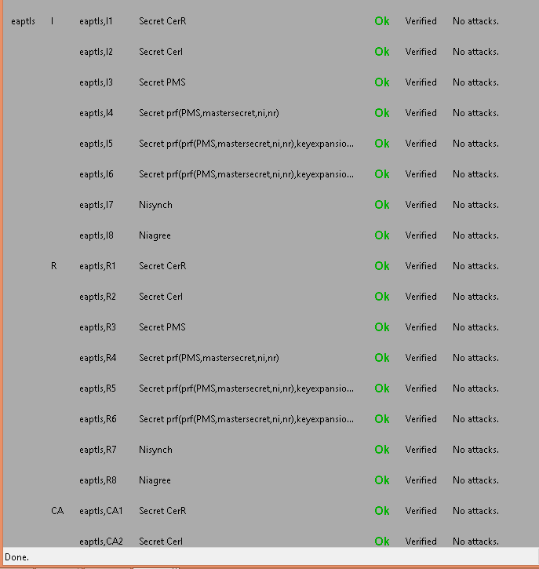

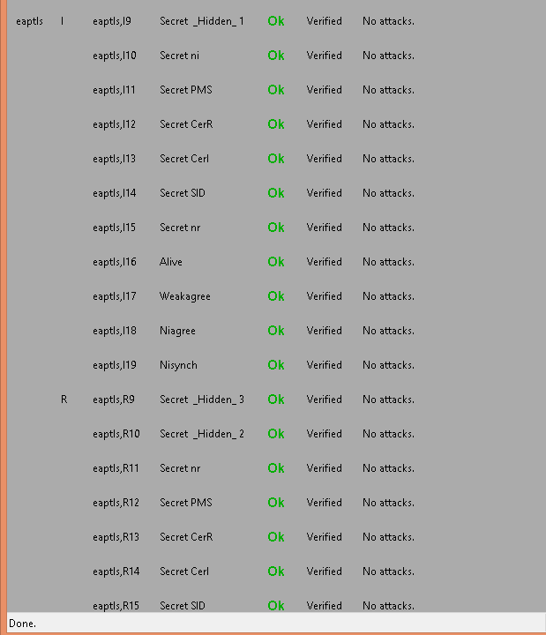

clc;

clear;

trsae= 0.1667 %rsaencryption

trsad= 0.1667 %rsadecryption

thmacsha256= 0.0714

tsha1= 0.0384; %sha

tsha256= 0.05 %sha256

tmd5= 0.05263; %md5

tdese= 0.29165; %desencryption

tdesd= 0.29165; %desdecryption

%EAP-TLS AUTHENTICATION

eaptlso_a = [trsae,tsha1+trsae,5*thmacsha256+2*thmacsha256, 2*thmacsha256,14*thmacsha256+tdesd,tdese];

eaptlso_b= [trsad,tsha1+trsae,5*thmacsha256+2*thmacsha256, 2*thmacsha256,14*thmacsha256+tdese,tdesd];

eaptlso=[trsae,trsad,tsha1+trsae,tsha1+trsad, 5*thmacsha256+2*thmacsha256, 5*thmacsha256+2*thmacsha256,2*thmacsha256,2*thmacsha256,14*thmacsha256+tdese,14*thmacsha256+tdesd+tdese,tdesd];

%total===============================

for tmp = 2:length(eaptlso_a);

eaptlso_a (tmp)= eaptlso_a (tmp-1)+ eaptlso_a (tmp);

end

for tmp = 2:length(eaptlso);

eaptlso (tmp)= eaptlso (tmp-1)+ eaptlso (tmp);

end

%EAP-TLS AUTHENTICATION Modified

eaptlsm_a = [trsae, tsha1+trsae, 2*thmacsha256+tsha1+thmacsha256, 4*thmacsha256+6*tsha1+tdesd,tdese];

eaptlsm_b= [trsad,tsha1+trsad, 2*thmacsha256+tsha1+thmacsha256, 4*thmacsha256+6*tsha1+tdese, tdesd];

eaptlsm=[trsae, trsad,tsha1+trsae, tsha1+trsad, 3*thmacsha256+tsha256+thmacsha256,3*thmacsha256+tsha256+thmacsha256,10*thmacsha256+tdese,10*thmacsha256+tdesd+tdese,tdesd];

%total===============================

for tmp = 2:length(eaptlsm_a);

eaptlsm_a (tmp)= eaptlsm_a (tmp-1)+ eaptlsm_a (tmp);

end

for tmp = 2:length(eaptlsm);

eaptlsm (tmp)= eaptlsm (tmp-1)+ eaptlsm (tmp);

end

total_number = 100000;

unkown_attacks= 0;

y_eaptlso = zeros(1,10);

y_eaptlsm= zeros(1,10);

left_time_eaptlso= 0;

left_time_eaptlsm=0;

n=1;

for x=0:0.1:0.9

left_time_eaptlso= total_number*(1-x)*eaptlso_a(length(eaptlso_a));

left_time_eaptlsm= total_number*(1-x)*eaptlsm_a(length(eaptlsm_a));

unknown_attacks = uint16(total_number*x);

unexpected_delay_eaptlso = randi([1,length(eaptlso_a)],1,unknown_attacks);

unexpected_delay_eaptlsm = randi([1,length(eaptlsm_a)],1,unknown_attacks);

attack_total_delay_eaptlso= 0;

attack_total_delay_eaptlsm= 0;

for i=1:unknown_attacks

attack_total_delay_eaptlso = attack_total_delay_eaptlso + eaptlso_a(unexpected_delay_eaptlso(i));

attack_total_delay_eaptlsm=attack_total_delay_eaptlsm+eaptlsm_a(unexpected_delay_eaptlsm(i));

end

y_eaptlso(n)=(left_time_eaptlso+attack_total_delay_eaptlso)/(total_number*(1-x));

y_eaptlsm(n)=(left_time_eaptlsm+attack_total_delay_eaptlsm)/(total_number*(1-x));

n=n+1;

end

x=0:0.1:0.9;

%figure;

plot(x,y_eaptlso,'-k', x, y_eaptlsm,'-.k');

set(gca,'XTick',0:0.1:1);

set(gca, 'xticklabel', {'0','0.1','0.2','0.3','0.4','0.5','0.6','0.7','0.8','0.9','1'});

xlabel('Ratio of unknown to known attacks’,'fontsize',12);

ylabel('Total Time Delay (ms)','fontsize',12);

legend({'EAP-TLSo', 'EAP-TLSm'},'FontSize',12,'FontWeight','bold');

axis([0,0.9,0,10]);

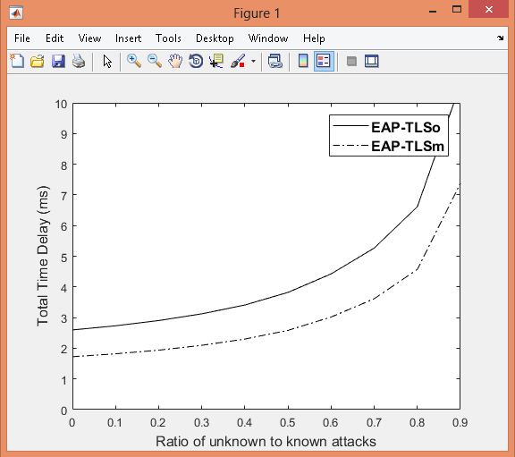

Significant changes:

PRF:

PRF(secret, label, seed) = P_<hash>(secret, label + seed)

P_hash(secret, seed) = HMAC_hash(secret, A(1) + seed) +

HMAC_hash(secret, A(2) + seed) +

HMAC_hash(secret, A(3) + seed) + ...

where + indicates concatenation.

A() is defined as:

A(0) = seed

A(i) = HMAC_hash(secret, A(i-1))

Here, older versions use md5+sha1 for calculating A(i), we will be using hmacsha256 for the same, even if not applied to EAP-TLS/EAP-TTLS/EAP-PEAP in some cases.

Here, a significant difference is obtained by starting with A(0) itself and then incrementing. (reduces one hashing in each step)

P_hash(secret, seed) = HMAC_hash(secret, A(0) + seed) +

HMAC_hash(secret, A(1) + seed) +

HMAC_hash(secret, A(2) + seed) + ...

where + indicates concatenation.

A() is defined as:

A(0) = seed

A(i) = sha1(secret, A(i-1))

key_block = PRF(SecurityParameters.master_secret,

"key expansion",

SecurityParameters.server_random +

SecurityParameters.client_random);

until enough output has been generated. Then, the key_block is

partitioned as follows:

client_write_MAC_key[SecurityParameters.mac_key_length]

server_write_MAC_key[SecurityParameters.mac_key_length]

client_write_key[SecurityParameters.enc_key_length]

server_write_key[SecurityParameters.enc_key_length]

client_write_IV[SecurityParameters.fixed_iv_length]

server_write_IV[SecurityParameters.fixed_iv_length]

finished

PRF(master_secret, finished_label, Hash(handshake_messages))

[0..verify_data_length-1];