PEAP original

hashfunction prf;

hashfunction h1;

hashfunction h;

usertype String;

const ccs, csu, shd, mastersecret, password : String;

const PEAPsuccess, accesslevel, clientfinished, serverfinished, peapkeyingmaterial,uiname,urname : String;

macro ms= prf (pms, mastersecret, (ni1, nr1));

macro finishedi= prf (ms, clientfinished, h1(SID, ni1, nr1, csu, {CerR, pk(R)}sk(CA), shd, {pms}pk(R)));

macro finishedr= prf(ms, serverfinished, h1(SID, ni1, nr1, csu, {CerR, pk(R)}sk(CA), shd, {pms}pk(R), finishedi));

macro ikey= prf ( ms, peapkeyingmaterial, (ni1, nr1));

macro skey= prf ( ms, peapkeyingmaterial, (ni1, nr1));

protocol peap1(I, R, CA)

{

role I

{

const SID, ID, CerR, pms: Data;

fresh ni1: Nonce;

var nr1, n: Nonce;

send_1 (I, R, SID, ni1, csu);

recv_4 (R, I, SID, nr1, csu, {CerR, pk(R)}sk(CA), shd);

send_5 (I, R, {pms}pk(R), ccs);

send_6 (I,R, finishedi);

recv_7 (R, I, ccs,finishedr);

match ( prf(ms, serverfinished, h1(SID, ni1, nr1, csu, {CerR, pk(R)}sk(CA), shd, {pms}pk(R), finishedi)), finishedr);

send_8 (I,R, {uiname}ikey);

recv_9 (R, I, {ID, n, uiname}skey);

send_10 (I, R, {ID, h(n, password), urname}ikey);

recv_11 (R, I, {PEAPsuccess, accesslevel}skey);

claim_i1 (I, Secret, CerR);

claim_i2 (I, Secret, pms);

claim_i3 (I, Secret, ms);

claim_i4 (I, Secret, ikey);

claim_i5 (I, Secret, skey);

claim_i6 (I, Secret, password);

claim_i1 (I, Niagree);

claim_i2 (I, Nisynch);

}

role R

{

const SID, ID, CerR, pms: Data;

fresh nr1, n: Nonce;

var ni1: Nonce;

recv_1 (I, R, SID, ni1, csu);

send_2 (R, CA, R);

recv_3 (CA, R, {R, {CerR, pk(R)}pk(R)} sk(CA));

send_4 (R, I, SID, nr1, csu, {CerR, pk(R)}sk(CA), shd);

recv_5 (I, R, {pms}pk(R), ccs);

recv_6 (I,R, finishedi);

match (prf (ms, clientfinished, h(SID, ni1, nr1, csu, {CerR, pk(R)}sk(CA), shd, {pms}pk(R))), finishedi);

send_7 (R, I, ccs, finishedr);

recv_8 (I,R, {uiname}ikey);

send_9 (R, I, {ID, n, uiname}skey);

recv_10 (I, R, {ID, h(n, password), urname}ikey);

match (h(n,password), h(n,password));

send_11(R, I, {PEAPsuccess, accesslevel}skey);

claim_r1 (R, Secret, CerR);

claim_r2 (R, Secret, pms);

claim_r3 (R, Secret, ms);

claim_r4 (R, Secret, ikey);

claim_r5 (R, Secret, skey);

claim_r6 (R, Secret, password);

claim_r1 (R, Niagree);

claim_r2 (R, Nisynch);

}

role CA

{

const CerR: Data;

recv_2(R, CA, R);

send_3 (CA, R, {R, {CerR, pk(R)}pk(R)} sk(CA));

claim_ca1 (CA, Secret, CerR);

}

}

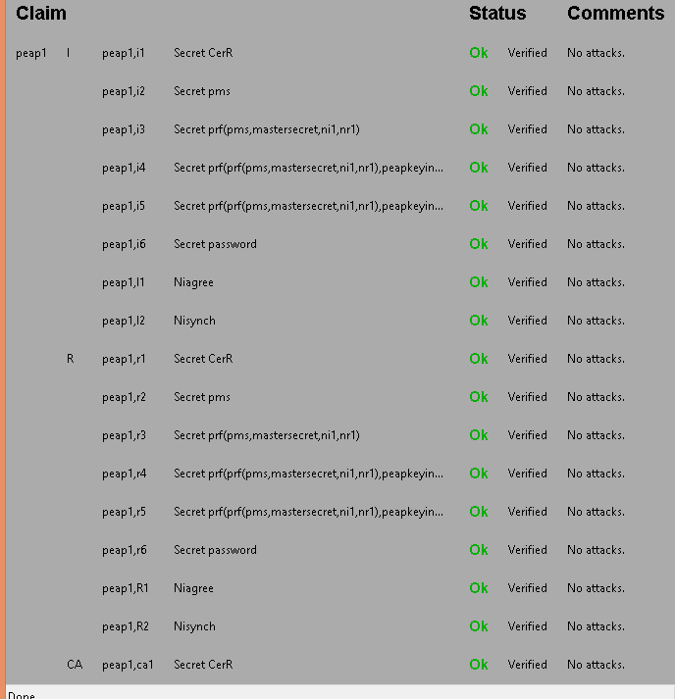

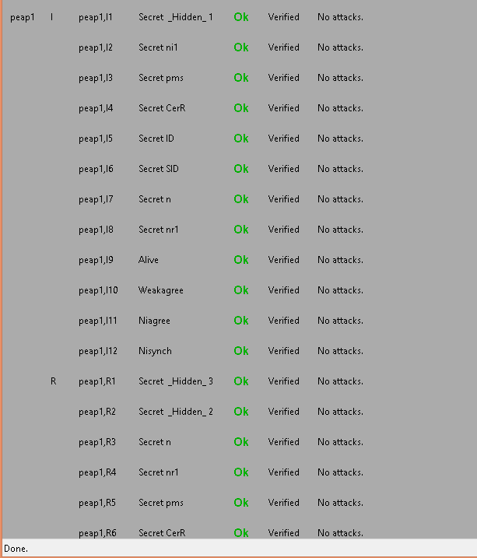

PEAP modified

hashfunction prf;

hashfunction h1;

hashfunction h;

usertype String;

const ccs, csu, shd, mastersecret, password : String;

const PEAPsuccess, accesslevel, clientfinished, serverfinished, peapkeyingmaterial,uiname,urname : String;

macro ms= prf (pms, mastersecret, (ni1, nr1));

macro finishedi= h1 (ms, clientfinished, (SID, ni1, nr1, csu, {CerR, pk(R)}sk(CA), shd, {pms}pk(R)));

macro finishedr= h1(ms, serverfinished, (SID, ni1, nr1, csu, {CerR, pk(R)}sk(CA), shd, {pms}pk(R), finishedi));

macro ikey= prf ( ms, peapkeyingmaterial, (ni1, nr1));

macro skey= prf ( ms, peapkeyingmaterial, (ni1, nr1));

macro hash= h(n, password);

protocol peap1(I, R, CA)

{

role I

{

const SID, ID, CerR, pms: Data;

fresh ni1: Nonce;

var nr1, n: Nonce;

send_1 (I, R, SID, ni1, csu);

recv_4 (R, I, SID, nr1, csu, {CerR, pk(R)}sk(CA), shd);

send_5 (I, R, {pms}pk(R), ccs);

send_6 (I,R, finishedi);

recv_7 (R, I, ccs,finishedr);

match ( h1(ms, serverfinished, (SID, ni1, nr1, csu, {CerR, pk(R)}sk(CA), shd, {pms}pk(R), finishedi)), finishedr);

send_8 (I,R, {uiname}ikey);

recv_9 (R, I, {ID, n, uiname}skey);

send_10 (I, R, {ID, h(n, password), urname}ikey);

recv_11 (R, I, {PEAPsuccess, accesslevel}skey);

claim_i1 (I, Secret, CerR);

claim_i2 (I, Secret, pms);

claim_i3 (I, Secret, ms);

claim_i4 (I, Secret, ikey);

claim_i5 (I, Secret, skey);

claim_i6 (I, Secret, password);

claim_i7 (I, Niagree);

claim_i8 (I, Nisynch);

}

role R

{

const SID, ID, CerR, pms: Data;

fresh nr1, n: Nonce;

var ni1: Nonce;

recv_1 (I, R, SID, ni1, csu);

send_2 (R, CA, R);

recv_3 (CA, R, {R, {CerR, pk(R)}pk(R)} sk(CA));

send_4 (R, I, SID, nr1, csu, {CerR, pk(R)}sk(CA), shd);

recv_5 (I, R, {pms}pk(R), ccs);

recv_6 (I,R, finishedi);

match (h1 (ms, clientfinished, (SID, ni1, nr1, csu, {CerR, pk(R)}sk(CA), shd, {pms}pk(R))), finishedi);

send_7 (R, I, ccs, finishedr);

recv_8 (I,R, {uiname}ikey);

send_9 (R, I, {ID, n, uiname}skey);

recv_10 (I, R, {ID, h(n, password), urname}ikey);

match (hash, h(n,password));

send_11(R, I, {PEAPsuccess, accesslevel}skey);

claim_r1 (R, Secret, CerR);

claim_r2 (R, Secret, pms);

claim_r3 (R, Secret, ms);

claim_r4 (R, Secret, ikey);

claim_r5 (R, Secret, skey);

claim_r6 (R, Secret, password);

claim_r7 (R, Niagree);

claim_r8 (R, Nisynch);

}

role CA

{

const CerR: Data;

recv_2(R, CA, R);

send_3 (CA, R, {R, {CerR, pk(R)}pk(R)} sk(CA));

claim_ca1 (CA, Secret, CerR);

}

}

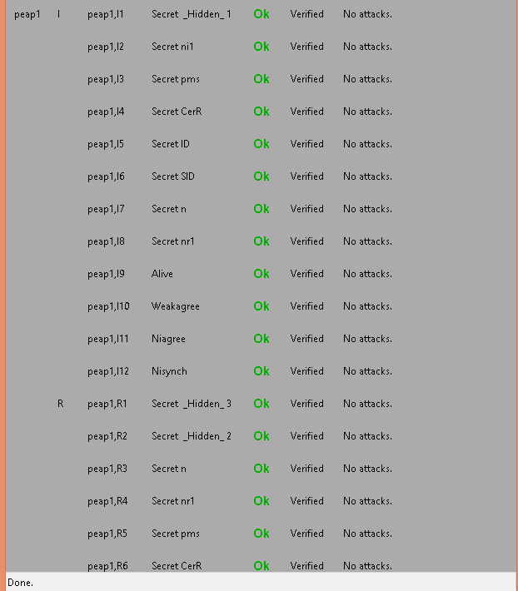

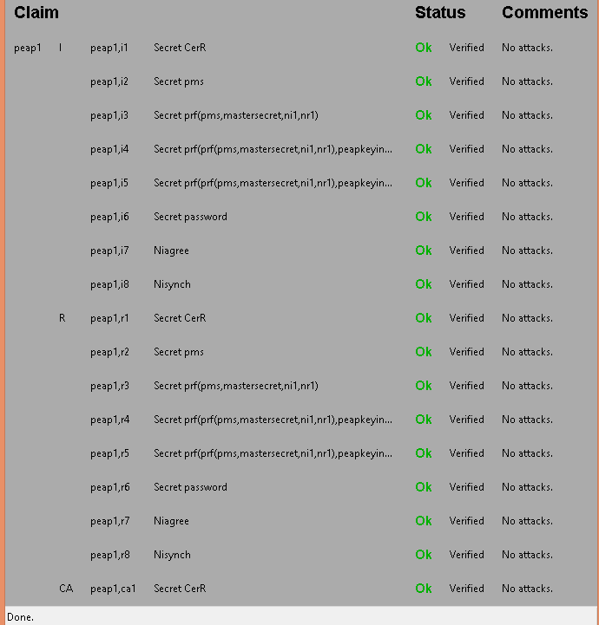

MATLAB simulation of PEAP

clc;

clear;

trsae= 0.1667 %rsaencryption

trsad= 0.1667 %rsadecryption

thmacsha256= 0.0714

tsha1= 0.0384; %sha

tsha256= 0.05 %sha256

tmd5= 0.05263; %md5

tdese= 0.29165; %desencryption

tdesd= 0.29165; %desdecryption

%PEAP AUTHENTICATION

peapo_a = [trsae,5*thmacsha256+2*thmacsha256, 2*thmacsha256,14*thmacsha256+tdese,tdesd, tmd5+tdese, tdesd];

peapo_b= [trsad,5*thmacsha256+2*thmacsha256, 2*thmacsha256,14*thmacsha256+tdesd, tdese,tdesd+tmd5, tdese];

peapo=[trsae,trsad,5*thmacsha256+2*thmacsha256, 5*thmacsha256+ 2*thmacsha256, 2*thmacsha256,2*thmacsha256, 14*thmacsha256 + tdese,14*thmacsha256+tdesd, tdese, tdesd, tmd5+tdese,tdesd+tmd5,tdese,tdesd];

%total===============================

for tmp = 2:length(peapo_a);

peapo_a (tmp)= peapo_a (tmp-1)+ peapo_a (tmp);

end

for tmp = 2:length(peapo);

peapo (tmp)= peapo (tmp-1)+ peapo (tmp);

end

%PEAP AUTHENTICATION Modified

peapm_a = [trsae, 2*thmacsha256+tsha1+thmacsha256,thmacsha256, 4*thmacsha256+6*tsha1+tdese, tdesd, tmd5+tdese, tdesd];

peapm_b= [trsad, 2*thmacsha256+tsha1+thmacsha256,thmacsha256, 4*thmacsha256+6*tsha1+tdesd, tdese, tmd5+tdesd, tdese];

peapm=[trsae, trsad, 2*thmacsha256+tsha1+thmacsha256, 2*thmacsha256+tsha1+thmacsha256, thmacsha256, thmacsha256, 4*thmacsha256+6*tsha1+tdese, 4*thmacsha256+6*tsha1+tdesd,tdese, tdesd, tmd5+tdese, tmd5+tdesd, tdese, tdesd];

%total===============================

for tmp = 2:length(peapm_a);

peapm_a (tmp)= peapm_a (tmp-1)+ peapm_a (tmp);

end

for tmp = 2:length(peapm);

peapm (tmp)= peapm (tmp-1)+ peapm (tmp);

end

total_number = 100000;

unkown_attacks= 0;

y_peapo = zeros(1,10);

y_peapm= zeros(1,10);

left_time_peapo= 0;

left_time_peapm=0;

n=1;

for x=0:0.1:0.9

left_time_peapo= total_number*(1-x)*peapo_a(length(peapo_a));

left_time_peapm= total_number*(1-x)*peapm_a(length(peapm_a));

unknown_attacks = uint16(total_number*x);

unexpected_delay_peapo = randi([1,length(peapo_a)],1,unknown_attacks);

unexpected_delay_peapm = randi([1,length(peapm_a)],1,unknown_attacks);

attack_total_delay_peapo= 0;

attack_total_delay_peapm= 0;

for i=1:unknown_attacks

attack_total_delay_peapo = attack_total_delay_peapo + peapo_a(unexpected_delay_peapo(i));

attack_total_delay_peapm=attack_total_delay_peapm+peapm_a(unexpected_delay_peapm(i));

end

y_peapo(n)=(left_time_peapo+attack_total_delay_peapo)/(total_number*(1-x));

y_peapm(n)=(left_time_peapm+attack_total_delay_peapm)/(total_number*(1-x));

n=n+1;

end

x=0:0.1:0.9;

%figure;

plot(x,y_peapo,'-k', x, y_peapm,'-.k');

set(gca,'XTick',0:0.1:1);

set(gca, 'xticklabel', {'0','0.1','0.2','0.3','0.4','0.5','0.6','0.7','0.8','0.9','1'});

xlabel('Ratio of unknown to known attacks’,'fontsize',12);

ylabel('Total Time Delay (ms)','fontsize',12);

legend({'PEAPo', 'PEAPm'},'FontSize',12,'FontWeight','bold');

axis([0,0.9,0,10]);

