**AMERICAN INTERNATIONAL**

**UNIVERSITY-BANGLADESH**

**Faculty of Engineering**

|  |  |  |  |  |
| --- | --- | --- | --- | --- |
| Assign./Case Title: | The Rotary Blood Bank Database Management System | | | |
| Assign./Case No: | 1 | | Date of Submission: | 20 September 2020 |
| Course Title: | Introduction to Data Base | | | |
| Course Code: | CSC2108 | | Section: | [I] |
| Semester: | Fall | 2019-20 | Degree Program: | BSc [CSE] |
| Course Teacher: | RIFAT TASNIM ANANNYA | | | |

**Declaration and Statement of Authorship:**

1. I/we hold a copy of this Assignment/Case-Study, which can be produced if the original is lost/damaged.
2. This Assignment/Case-Study is my/our original work and no part of it has been copied from any other student’s work or from any other source except where due acknowledgement is made.
3. No part of this Assignment/Case-Study has been written for me/us by any other person except where such collaboration has been authorized by the concerned teacher and is clearly acknowledged in the assignment.
4. I/we have not previously submitted or currently submitting this work for any other course/unit.
5. This work may be reproduced,communicated,compared and archived for the purpose of detecting plagiarism.
6. I/we givepermissionforacopyofmy/ourmarkedworktoberetainedbythe Faculty forreviewand comparison,including review by external examiners.
7. I/we understand thatPlagiarism is the presentation of the work, idea or creation of another person as though it is your own. It is a formofcheatingandisaveryseriousacademicoffencethatmayleadtoexpulsionfromtheUniversity. Plagiarizedmaterialcanbedrawnfrom,andpresentedin,written,graphicandvisualform,includingelectronicdata,andoralpresentations.Plagiarismoccurswhentheoriginofthematerialusedisnotappropriately cited.
8. I/we also understand that enabling plagiarism is the act of assisting or allowing another person to plagiarize or to copy my/our work.

*\* Student(s) must complete all details except the faculty use part.*

** Please submit all assignments to your course teacher or the office of the concerned teacher.

|  |  |
| --- | --- |
| Group Name/No.: | N/A |

|  |  |  |
| --- | --- | --- |
| ***Faculty use only*** | | |
| FACULTYCOMMENTS | **Marks Obtained** |  |
| Click here to enter text. |
| Click here to enter text. | **Total Marks** |  |
| Click here to enter text. |
|  |



The Rotary Blood Bank database management system

September 20, 2020

**Synopsis:  
Bangladesh** has seen the rise of road accidents and surgeries in recent years, the demand for blood has risen significantly. It becomes really difficult to find the required blood group and as a result patient’s life are put at stake at a regular basis. Furthermore, people willing to donate blood are difficult to come by. The only way to get rid of this major problem is to design a system which stores all the information regarding a blood group and their availability in one place. In order to solve this issue the Government of Bangladesh has assigned the task of designing a database management system to me and my friends. Basically this database management system will connect some blood banks in Bangladesh, store all the details of blood and their availability. The Government of Bangladesh was willing to pay a hefty sum of money in return. Considering our trip to Dubai in few months and the expenses of travel, we all agreed.

The requirements for the database management system is given below:

**Requirements**:

* The blood donors are uniquely identified by DID. Furthermore, they have a name, phone number, address, age and sex.
* Each blood has a unique code. The blood type and cost must be recorded too.
* Every Blood Bank has many blood collectors. The name, address and phone number of the blood collectorsmust be recorded. A counter number must be included with the details of the blood collectors while appointing.
* The record of each hospital that orders blood from the Blood Bank must be kept which includes name, location and telephone number.
* Every Blood Bankhas a manager and the details of the manager includes name, salary,email id and manager id.
* The Blood Banksare identified by a unique BNO and blood type. Moreover, a record of total number of orders must be kept.
* Several patients apply medication to every hospital where the information of patients are recorded. The information includes name, age, blood type and a unique SSID.
* Each donor donates a certain type of blood.Hundreds of donors donates blood to every Blood Bank every month.
* Different types of blood are stored in aBlood Bank.
* While donating blood, every donor is registered by ablood collector.Each blood collector registers several donors.
* Many hospitals orders blood from a single Blood Bank.
* EveryBlood Bank is completely under the supervision of a manager.

**ER-Diagram:**



**Normalization**

* **Donate-** (DID, D_age, D_address, D_name, sex, D_phone, Code, Blood_type, cost, Quantity)

**1NF:**

D_Phone is a multivalued attribute

**2NF:**

DID, D_age, D_address, D_name, sex, D_phone

Code, Blood_type, cost, Quantity

**3NF:**

DID, D_age, D_address, D_name, sex, D_phone

Code, Blood_type

BID, cost, Quantity

**Table list for Donate:**

1. DID, D_age, D_address, D_name, sex, Code
2. Code, Blood_type, BID
3. BID, cost, Quantity
4. D_no, DID,Code
5. DID,D_phone

* **Stored:** (Code, Blood_type, Cost, Quantity, BNO, Orders)

**1NF:**

There is no multivalued attribute

**2NF:**

Code, Blood_type, Cost, Quantity

BNO, Orders

**3NF:**

Code, Blood_type  
BID, cost, Quantity  
 BNO, Orders

**Table list for Stored:**

1. Code, Blood_type, BID, BNO
2. BID, cost, Quantity
3. BNO, Orders

* **Registers-** (DID, D_age, D_address, D_name, Sex, D_Phone, Counter_no, Rec_name, Rec_address, Rec_phone)

**1NF:**

D_Phone is a multivalued attribute

**2NF:**

DID, D_age, D_address, D_name, Sex, D_Phone

Counter_no, Rec_name, Rec_address, Rec_phone

**3NF:**

DID, D_age, D_address, D_name, Sex, D_Phone

Counter_no, Rec_name, Rec_address, Rec_phone

**Table list for registers:**

9. DID, D_age, D_address, D_name, Sex,Counter_no

10.Counter_no, Rec_name, Rec_address, Rec_phone

11. DID, D_Phone

* **Works-**(Counter_no, Rec_name, Rec_address, Rec_phone, BNO, Orders)

**1NF:**

There is no multivalued attribute

**2NF:**

Counter_no, Rec_name, Rec_address, Rec_phone

BNO, Orders

**3NF:**

Counter_no, Rec_name, Rec_address, Rec_phone

BNO, Orders

**Table list for works:**

12.Counter_no, Rec_name, Rec_address, Rec_phone, BNO

13. BNO, Orders

* **Orders**-(H_Name, location, telephone, BNO, Orders)

**1NF:**

Telephone is a multivalued attribute

**2NF:**

H_Name, location, telephone

BNO, Orders

**3NF:**

H_Name, location, telephone

BNO, Orders

**Table list for orders:**

14.H_Name, location, BNO

15. BNO, Orders

16. H_Name, telephone

* **Apply medication to**-(Patients_SSID, Patients_name,Blood_group, Patients_age, H_Name, location, telephone)

**1NF:**

Telephone is a multivalued attribute

**2NF:**

Patients_SSID, Patients_name,Blood_group, Patients_age

H_Name, location, telephone

**3NF:**

Patients_SSID, Patients_name, Blood_group, Patients_age

H_Name, location, telephone

**Table list for Apply medication to:**

17. Patients_SSID, Patients_name,Blood_group, Patients_age, H_Name

18.H_Name, location

19.H_Name, telephone

* **Manages**-(BNO, Orders, Mgr_ID, Email_ID, Mgr_name, Salary)

**1NF:**

There is no multivalued attribute

**2NF:**

BNO, Orders

Mgr_ID, Mgr_name, Email_ID, Salary

**3NF:**

BNO, Orders

Mgr_ID, Mgr_name, Email_ID, Salary

**Table list for Manages:**

20. BNO, Orders, Mgr_ID

21. Mgr_ID, Mgr_name, Email_ID, Salary

**Selected Table List:**

1. DID, D_age, D_address, D_name, sex, Code, Counter_no
2. BID, cost, Quantity
3. D_no, DID, Code
4. DID,D_phone
5. Code, Blood_type, BID, BNO
6. Counter_no, Rec_name, Rec_address, Rec_phone, BNO
7. H_Name, location, BNO
8. H_Name, telephone
9. Patients_SSID,Patients_name,Blood_group, Patients_age, H_Name
10. BNO, Orders, Mgr_ID
11. Mgr_ID, Mgr_name, Email_ID, Salary

**Table Names:**

**1.**Donor

**2.**Blood_Price

**3.**DonorBlood_info

**4.**Donor_Phonebook

**5.**Blood

**6.**Blood_Collector

**7.**Hospital

**8.**Hospital_Phonebook

**9.**Patients

**10.**Blood_Bank

**11.**Manager

**Table Creation & Insertion:**

**1.Donor:**

**Creation:**

Create sequence Donor_test **Table:**Donor (Description)

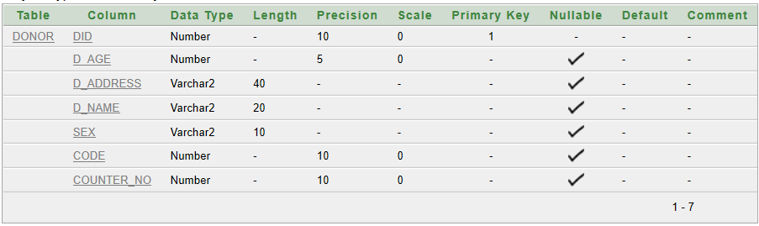Start with 3

Increment by 1

Maxvalue 999999

Nocycle

Nocache

Create table Donor (

DID number(10),

D_age number(5),

D_address varchar2(40),

D_name varchar2(20),

Sex varchar2(10),

Code number(10),

Counter_no number(10))

Alter table Donor add constraint p14 primary key (DID)

Alter table Donor add constraint p15 foreign key (Code) references Blood (Code)

Alter table Donor add constraint p16 foreign key (Counter_no) references Blood_Collector (Counter_no)

DescDonor

**Insertion:**

Insert into Donor (DID, D_age, D_address, D_name, Sex, Code, Counter_no)

Values (Donor_test.nextval, 21, 'Winterfell', 'Ned Stark', 'M', 20, 501)

Insert into Donor (DID, D_age, D_address, D_name, Sex, Code, Counter_no)

Values (Donor_test.nextval, 50, 'Casterly Rock', 'TywinLanniseter', 'M', 21, 502)

Insert into Donor (DID, D_age, D_address, D_name, Sex, Code, Counter_no)

Values (Donor_test.nextval, 21, 'Kings Landing', 'Jamie Lannister', 'M', 23, 503)

Insert into Donor (DID, D_age, D_address, D_name, Sex, Code, Counter_no)

Values (Donor_test.nextval, 25, 'Dorne', 'Oberyn Martell', 'M', 22, 504)

Select * from Donor **Table:**Donor

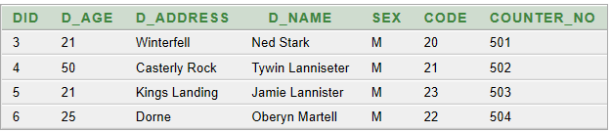

**2.Blood_Price:**

**Creation:**

Create sequence Blood_Price_test

Start with 5

Increment by 2

Maxvalue 999999

Nocycle

Nocache **Table:**Blood_Price (Description)

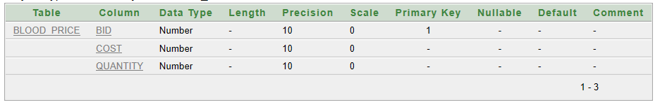

Create table Blood_Price (

BID number(10),

Cost number(10),

Quantity number(10)

)

Alter table Blood_Price add constraint p18 primary key (BID)

Alter table Blood_Price modify (Cost NOT NULL)

Alter table Blood_Price modify (Quantity NOT NULL)

DescBlood_Price

**Insertion:**

Insert into Blood_Price (BID,cost,Quantity)

Values (Blood_Price_test.nextval, 500, 2)

Insert into Blood_Price (BID,cost,Quantity)**Table:**Blood_Price

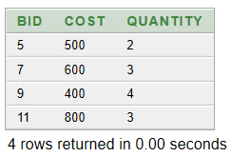Values (Blood_Price_test.nextval, 600, 3)

Insert into Blood_Price (BID,cost,Quantity)

Values (Blood_Price_test.nextval, 400, 4)

Insert into Blood_Price (BID,cost,Quantity)

Values (Blood_Price_test.nextval, 800, 3)

Select * from Blood_Price

**3.DonorBlood_info:**

**Creation:**

Create sequence DonorBlood_info_test

Start with 100 **Table:**DonorBlood_info(Description)

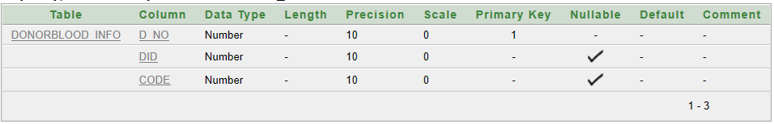Increment by 2

Maxvalue 999999

Nocycle

Nocache

Create table DonorBlood_info (

D_no number(10),

DID number(10),

Code number(10)

)

Alter table DonorBlood_info add constraint p19 primary key (D_no)

Alter table DonorBlood_info add constraint p20 foreign key (DID) references Donor (DID)

Alter table DonorBlood_info add constraint p21 foreign key (Code) references Blood (Code)

DescDonorBlood_info

**Insertion:**

Insert into DonorBlood_info(D_no, DID, Code)

Values (DonorBlood_info_test.nextval, 3, 20)

Insert into DonorBlood_info (D_no, DID, Code)

Values (DonorBlood_info_test.nextval, 4, 21)

Insert into DonorBlood_info (D_no, DID, Code)

Values (DonorBlood_info_test.nextval, 5, 23)

Insert into DonorBlood_info (D_no, DID, Code)

Values (DonorBlood_info_test.nextval, 6, 22)

Select * from DonorBlood_info

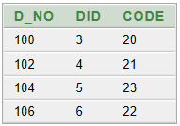 **Table:**DonorBlood_info

**4.Donor_Phonebook:**

**Creation:**

Create table Donor_Phonebook (

DID number(10),

D_phone number(20)

)

Alter table Donor_Phonebook add constraint p22 primary key (DID, D_phone)

Alter table Donor_Phonebook add constraint p23 unique (D_phone)

Alter table Donor_Phonebook modify (D_phone NOT NULL)

DescDonor_Phonebook

**Table:**Donor_Phonebook(Description)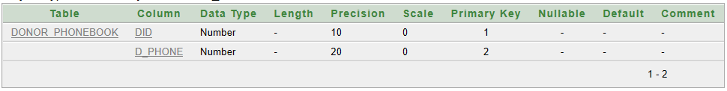

**Insertion:**

Insert into Donor_PhonebookValues (3,118882)

Insert into Donor_PhonebookValues (4,119993)

Insert into Donor_PhonebookValues (5,117771)

Insert into Donor_PhonebookValues (6,114448)

Select * from Donor_Phonebook

**Table:**Donor_Phonebook

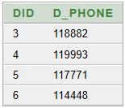

**5.Blood:**

**Creation:**

Create sequence Blood_test

Start with 20

Increment by 1 **Table:**Blood(Description)

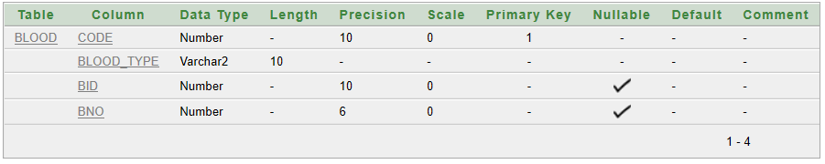Maxvalue 999999

Nocycle

Nocache

Create table Blood (

Code number(10),

Blood_type varchar2(10),

BID number (10),

BNO number (6)

)

Alter table Blood add constraint p17 primary key (Code)

Alter table Blood modify (Blood_type NOT NULL)

DescBlood

**Insertion:**

Insert into Blood (Code, Blood_type, BID, BNO)

Values (Blood_test.nextval, 'A+', 5, 1001)

Insert into Blood (Code, Blood_type, BID, BNO)

Values (Blood_test.nextval, 'O+', 7, 1002)

Insert into Blood (Code, Blood_type, BID, BNO)

Values (Blood_test.nextval, 'B-', 9, 1003)

Insert into Blood (Code, Blood_type, BID, BNO) **Table:**Blood

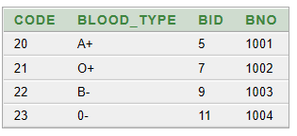Values (Blood_test.nextval, '0-', 11, 1004)

Select * from Blood

**6.Blood_Collector:**

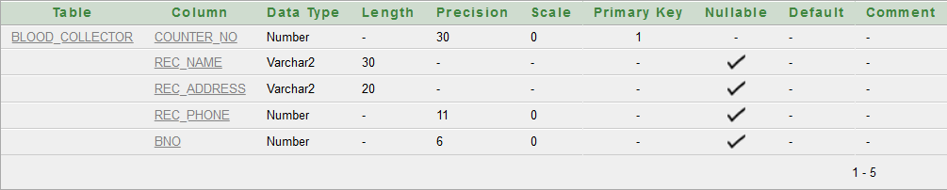**Creation:**Create sequence collector_test  
Start with 501 **Table:**Blood_Collector (Description)  
Increment by 1  
Maxvalue 510   
Nocycle  
Nocache

Create table Blood_Collector (  
Counter_no number (30),  
Rec_name varchar2 (30),  
Rec_address varchar2 (5),  
Rec_Phone number (11),  
BNO Number (6))

Alter table Blood_Collector add constraint p11 primary key (Counter_no)  
Alter table Blood_Collector add constraint p12 foreign key (BNO) references Blood_Bank (BNO)   
Alter table Blood_Collector add constraint p13 unique (Rec_phone)

DescBlood_Collector

**Insertion:**

Insert into Blood_Collector (Counter_no, Rec_name, Rec_address, Rec_Phone, BNO)   
Values (Collector_test.nextval, 'Earl Kalf', 'Hedeby', 900151, 1001)

Insert into Blood_Collector (Counter_no, Rec_name, Rec_address, Rec_Phone, BNO)   
Values (Collector_test.nextval, 'Earl Ingstead','Hedeby', 900123, 1001)

Insert into Blood_Collector (Counter_no, Rec_name, Rec_address, Rec_Phone, BNO)   
Values (Collector_test.nextval, 'King Harlf', 'Black', 900089, 1002)

Insert into Blood_Collector (Counter_no, Rec_name, Rec_address, Rec_Phone, BNO)   
Values (Collector_test.nextval, 'Lagartha', 'Katagat', 900003, 1003)

Insert into Blood_Collector (Counter_no, Rec_name, Rec_address, Rec_Phone, BNO)   
Values (Collector_test.nextval, 'Judith', 'Wessex', 900678, 1004)

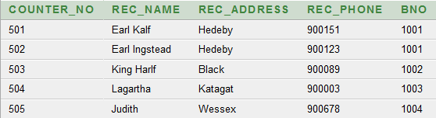Select*  
From Blood_Collector**Table:**Blood_Collector

**7. Hospital:**

**Creation:**

Create table Hospital (  
H_name varchar2 (30),  
Location varchar2 (30),  
BNO number (6))

Alter table Hospital add constraint p5 primary key (H_name)

Alter table Hospital add constraint p6 foreign key (BNO) references Blood_Bank (BNO)

Alter table Hospital modify Location default 'No Location'

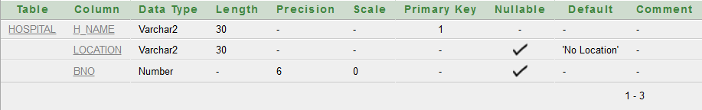DescBlood_Bank**Table:**Hospital (Description)

**Insertion:**

Insert into Hospital (H_name, Location, BNO)

Values('Apollo Hospital', 'Bashundhara', 1002)

Insert into Hospital (H_name, Location, BNO)

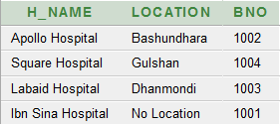Values('Square Hospital', 'Gulshan', 1004)  
**Table:** Hospital

Insert into Hospital (H_name, Location, BNO)

Values('Labaid Hospital', 'Dhanmondi', 1003)

Insert into Hospital (H_name, BNO)

Values ('IbnSina Hospital', 1001)

Select*  
From Hospital

**8.Hospital_Phonebook:**

**Creation:**

Create table Hospital_Phonebook(

H_name varchar2(30),

Telephone number (11)

)

Alter table Hospital_Phonebook add constraint p7 primary key(H_name, Telephone)

Alter table Hospital_Phonebook add constraint p8 unique(Telephone)

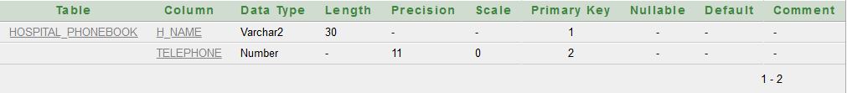DescHospital_Phonebook  
**Table:**Hospital_Phonebook (Description)

**Insertion:**

Insert into Hospital_Phonebook (H_name, Telephone)

Values ('Apollo Hospital', 01700201201)

Insert into Hospital_Phonebook (H_name, Telephone)

Values ('Square Hospital', 01700245245)

Insert into Hospital_Phonebook (H_name, Telephone)

Values ('Labaid Hospital', 01700345200)

Insert into Hospital_Phonebook (H_name, Telephone)

Values ('IbnSina Hospital', 01700908900)

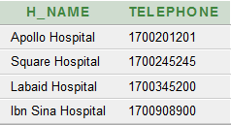**Table:**Hospital_Phonebook

Select*

From Hospital_Phonebook

**9. Patients:**

**Creation:**

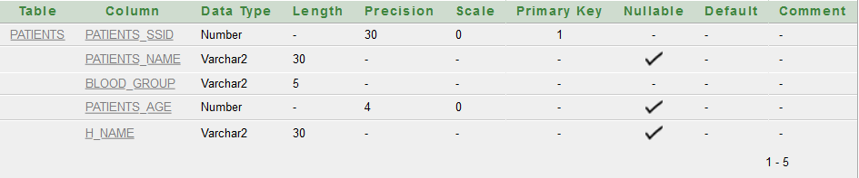Create sequence Patients_test  
Start with 21001  
Increment by 1  
Maxvalue 21010 **Table:** Patients (Description)  
Nocycle  
Nocache

Create table Patients (  
Patients_SSID number (30),  
Patients_name varchar2 (30),  
Blood_group varchar2 (5),  
Patients_age number (4),  
H_name varchar2 (30))

Alter table Patients add constraint p9 primary key(Patients_SSID)  
Alter table Patients add constraint p10 Foreign key (H_NAME) references Hospital (H_name)   
Alter table Patients modify (BLOOD_GROUP NOT NULL)

Desc Patients

**Insertion:**

Insert into Patients(Patients_SSID, Patients_name, Blood_group, Patients_age, H_name)   
Values(Patients_test.nextval, 'Ubbe', 'A+', 25, 'Apollo Hospital')

Insert into Patients(Patients_SSID, Patients_name, Blood_group, Patients_age, H_name)   
Values(Patients_test.nextval, 'Ivar', 'O-', 22, 'Square Hospital')

Insert into Patients(Patients_SSID, Patients_name, Blood_group, Patients_age, H_name)   
Values(Patients_test.nextval, 'Hvitserk', 'O+', 24,'Labaid Hospital')

Insert into Patients(Patients_SSID, Patients_name, Blood_group, Patients_age, H_name)   
Values(Patients_test.nextval, 'Helga', 'AB+', 45, 'IbnSina Hospital')

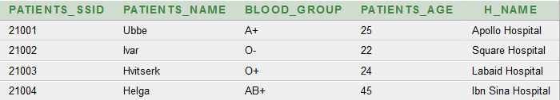Select*  
From Patients  
**Table:** Patients

**10.Blood_Bank:**

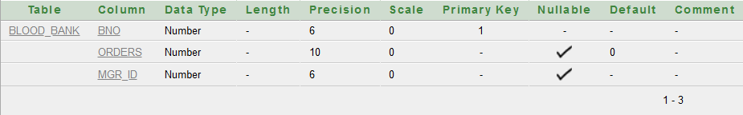**Creation:**Create sequence Blood_bank_testStart with 1001**Table:**Blood_Bank (Description)Increment by 1Maxvalue 1010NocycleNocache

Create table Blood_Bank (  
BNO number (6),  
Orders number (10),  
Mgr_ID number(6))

Alter table Blood_Bank add constraint p3 primary key (BNO)  
Alter table Blood_Bank add constraint p4 Foreign key (Mgr_ID)references Manager (Mgr_ID)  
Alter table Blood_Bank modify Orders default 0

DescBlood_Bank

**Insertion:**

Insert into Blood_Bank (BNO, Orders, Mgr_ID)   
Values(Blood_Bank_test.nextval,10, 1)

Insert into Blood_Bank (BNO, Orders, Mgr_ID)   
Values(Blood_Bank_test.nextval,20, 2)

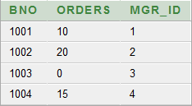Insert into Blood_Bank (BNO,Mgr_ID) **Table:**Blood_Bank  
Values(Blood_Bank_test.nextval, 3)

Insert into Blood_Bank (BNO, Orders,Mgr_ID)   
Values(Blood_Bank_test.nextval,15, 4)

Select*  
From Blood_Bank

**11.Manager:**

**Creation:**

Create sequence Manager_test

Start with 1

Increment by 1

Maxvalue 10**Table:** Manager (Description)

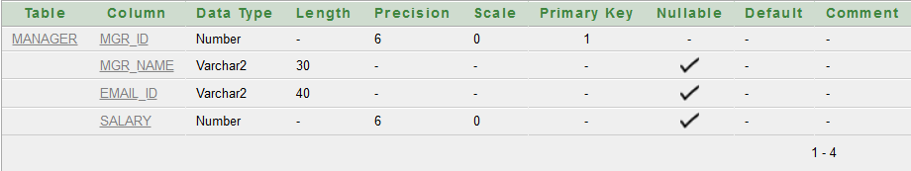nocycle

nocache

Create table Manager (

Mgr_ID number (6),

Mgr_name varchar2 (30),

Email_ID varchar2 (40),

Salary number (6)

)

Alter table Manager add constraint p1 primary key (Mgr_ID)

Alter table Manager add constraint p2 unique (Email_ID)

Desc Manager

**Insertion:**

Insert into Manager(Mgr_ID, Mgr_name, Email_ID, Salary)

Values(Manager_test.nextval,'Rangner','rangner@gmail.com',145000)

Insert into Manager(Mgr_ID, Mgr_name, Email_ID, Salary)

Values(Manager_test.nextval,'Rollo','rollo@gmail.com',165000)

Insert into Manager(Mgr_ID, Mgr_name, Email_ID, Salary)

Values(Manager_test.nextval,'Floki','floki@gmail.com',155000)

Insert into Manager(Mgr_ID, Mgr_name, Email_ID, Salary)

Values(Manager_test.nextval,'Bion','bion@gmail.com',105000)

Select\***Table:** Manager

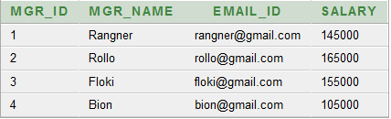From Manager

**Queries:**1. Find the Counter No, Receptionist Name and Address from blood collector who have same Address as king kalf. Excludes Earl Kalf.   
  
Answer:

*Select counter_no,rec_name,rec_address*

*From blood_collectorWhererec_address = (select rec_address  
from blood_collector  
where rec_name='Earl Kalf') and rec_name<> 'Earl Kalf’*

2. Find the Patient name, location, hospital name from patients and Hospital. Where patient name starts with ‘H’ and ends with ‘k’.  
  
Answer:  
  
*Select patients_name,location,Patients.H_name  
 From Patients,Hospital  
 Where patients.H_name=hospital.H_name  
 And Patients_name like 'H%k'*

3. Find the Manager name from Blood Bank and Manager, where orders greater than 10 and BNO=1004.  
  
Answer:  
  
*Select Mgr_name  
 from Blood_bank, Manager  
 Where Blood_bank.mgr_id = Manager.mgr_id  
 and orders>10 and BNO = 1004*

4. Create a view named Blood sample with code and Blood type from Blood  
  
Answer:  
  
*create view Blood_sample as  
 Select code,blood_type  
 From blood  
 With check option constraint c90*

5. Show all the Manager name, Email id, Annual salary “Yearly salary”, from Manager.

Answer:  
  
*Select Mgr_name,Email_id,Salary*12 "Annual Salary"  
 From Manager*

6. Show minimum age of patients from every Blood_Group and order by Blood_Group.  
  
Answer:  
  
*Select min (patients_age)  
 from patients  
 group by blood_group  
 order by blood_group*

7.Display the names of donors who have A+ blood and are at least 20 years old.

Answer:

*Select D_Name  
from Donor  
where code= (Select code  
from blood  
where blood_type='A+')  
and D_age>=20*

8.Display the blood group and quantity available which has the second least price.

Answer:

*Select Blood_Type  
from Blood  
where Bid = (Select Bid  
from Blood_Price  
where cost = (Select min (cost)   
from Blood_Price  
where cost > (Select min (cost)   
FromBlood_Price)))*

9.Display the name of blood collector who registered Ned Stark. Also display the counter number in which he was registered.

Answer:

*Select Rec_Name  
from Blood_Collector  
where counter_no = (Select counter_no  
from donor where D_Name='Ned Stark')*

10.Display the name, age, DID and Address of the youngest blood donor.

Answer:

*Select D_Name,D_Age,D_Address  
from donor  
where D_Age = (Select min(D_age)  
from Donor)*

11.Display all the blood types along with their price and quantity available at the blood bank with BNO=1003

Answer:

*Select b.Blood_Type, bp.cost, bp.quantity  
FromBlood_Pricebp,Blood b  
where bp.BID = b.BID*

12.Display the name and address of the donors who have the most expensive blood type.

Answer:

*Select D_Name, D_Address  
from Donor  
Where code= (Select code   
from Blood  
Where BID= (Select BID  
from Blood_Price  
where cost = (Select max (cost)   
from Blood_Price)))*

**Relational Algebra**:

1. Find Out all details of Manager whose Salary = 145000.

Answer:

*σSalary =145000 (Manager)*

2. Find out patients name whose Hospital is Square Hospital.

Answer:

*ΠPATIENTS_NAME [σH_name=”Square Hospital” (Patients)]*

3. Find out patients name, Hospital name, Hospital Location whose name is Ubbe.

Answer:

*ΠPATIENTS_NAME, H_NAME, LOCATION [σPATIENTS_NAME =”Ubbe”(PATIENTS⟗HOSPITAL)]*

4.Find out donor name, did and age of donors who are registered to counter number 501.

Answer:

*ΠD_NAME, D_AGE, D_ADDRESS[σCOUNTER_NO =501 (DONOR)]*

5. Find the Receptionist Name from blood collector whose Address is Hedeby and counter no greater than 503.

Answer:

*ΠREC_NAME [σREC_ADDRESS =”Hedeby” and COUNTER_NO>503(BLOOD_COLLECTOR)]*

**Conclusion:**

This database management system will surely solve the unavailability of blood and save many lives. Moreover, this system will save a lot of time, money and efforts. The people of Bangladesh will surely be benefited from this system as this innovative medium brings not one but several blood banks into one place and the details of blood can be kept safe in an ordered way.