***LAB 08: Pipe, Grep, wc and Sort Command in Linux/Unix***

**Theory:**

**What is pipes?**

* The pipe (|) is an operator used to connect two or more commands.
* It is used to send the output of one command to another command for further processing.

**‘less’, 'pg' and 'more' commands:**

* When you use 'cat' command to view a file which spans multiple pages, the prompt quickly jumps to the last page of the file, and you do not see the content in the middle.
* To avoid this, you can pipe the output of the 'cat' command to 'less' which will show you only one scroll length of content at a time.

**Syntax:**

* Instead of less command we also use 'pg' and 'more' commands

**The 'grep' command:**

* grep command will scan the document for the desired information and present the result in a format you want.

**Syntax:**

grep search_string

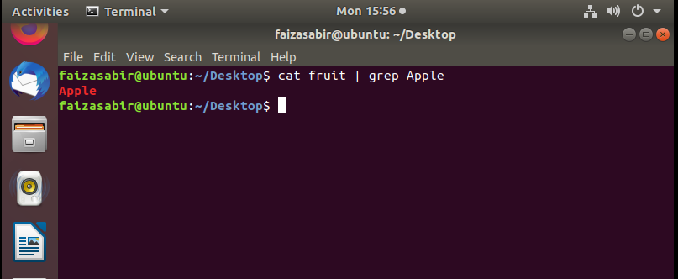

**Options:**

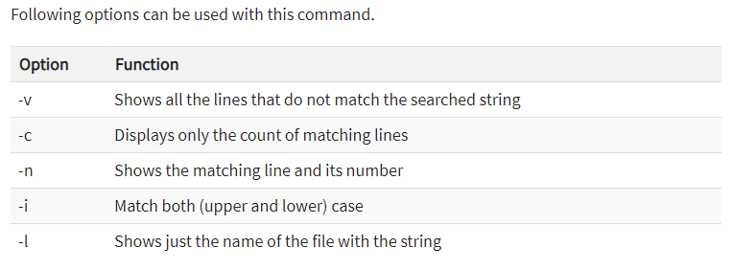

**Sort command:**

* Sort is a command which will rearrange the lines in a text file so that they are sorted, numerically and alphabetically.

Syntax:

sort option Filename

**Options:**

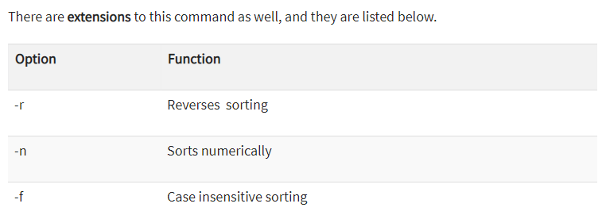

**Wc command:**

* The wc (word count) command in Unix/Linux operating systems is used to find out number of newline count, word count, byte and characters count in a files specified by the file arguments.

The syntax of wc command as shown below.

wc [option] filename

**options:**

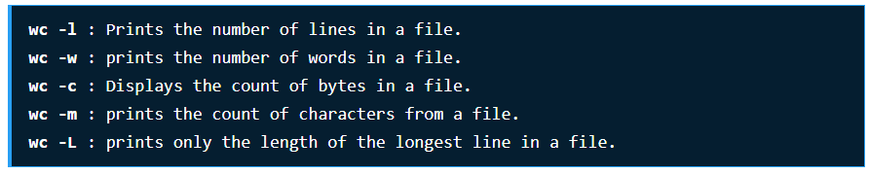

**Lab task**

1. Add different type of text in a text file and then sort the text in reverse order.
2. Show the number of lines in a specific file.
3. Write the functionality of pipes in Linux.
4. Add different type of text in a text file and then scan the document by using -n option.
5. Display the number of bytes in a text file.