**Lab Task 2**

**Q1. Run all these commands and print the output of these commands.**

**1) who**

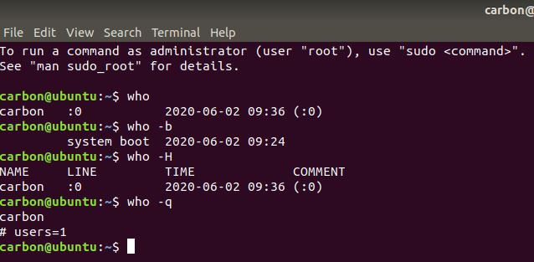

**2) touch**

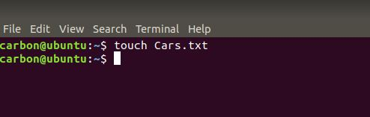

**3) cat**

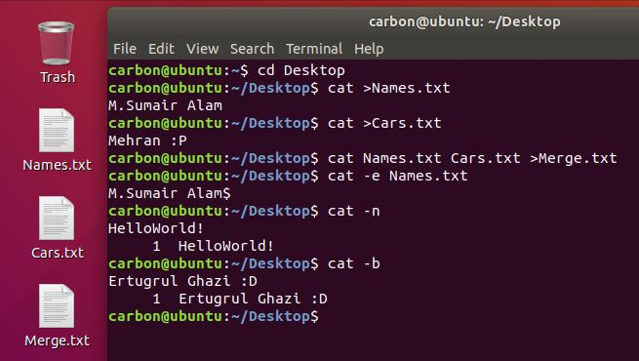

**4) df**

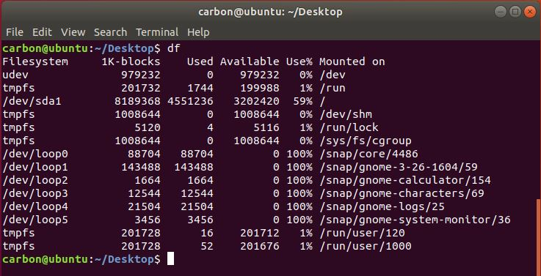

**5) ps**

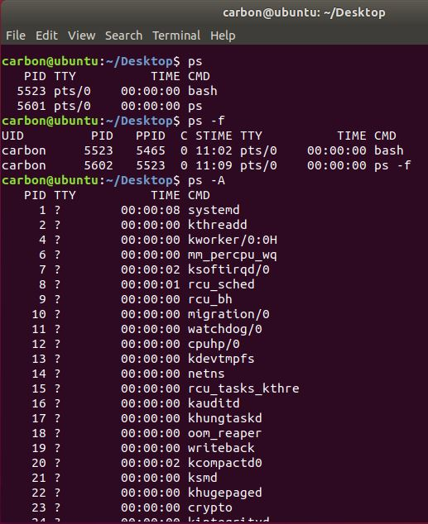

**6) uname**

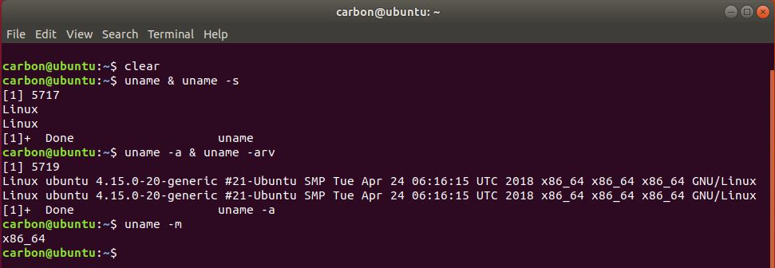

**7) locate**

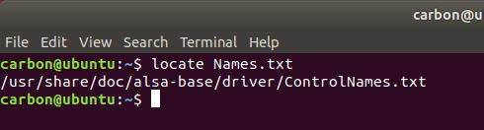

**8) cd**

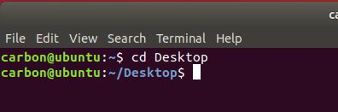

**9) which**

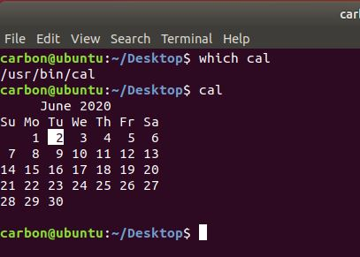

**Q2. Make two text file using touch command and then merge the contents of these files.**

**Output:**

