***LAB 6:Conditional Statements | Shell Script***

**Theory:**

Conditional Statements: There are total 5 conditional statements which can be used in bash programming

1. if statement
2. if-else statement
3. if..elif..else..fi statement (Else If ladder)
4. switch statement
5. **if statement:**

This block will process if specified condition is true.

* ***Syntax:***

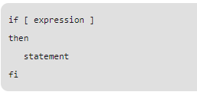

**Example**

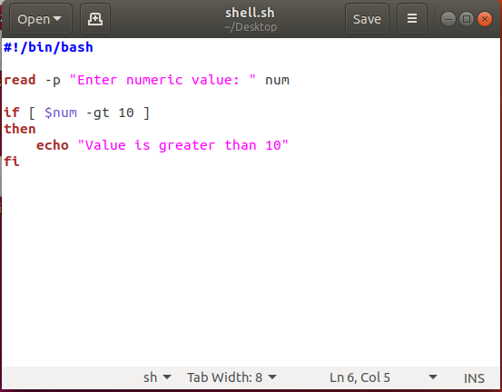

1. **if-else Statement:**

If specified condition is not true in if part then else part will be execute.

* ***Syntax:***

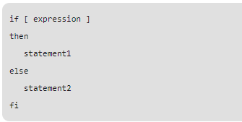

**Example:**

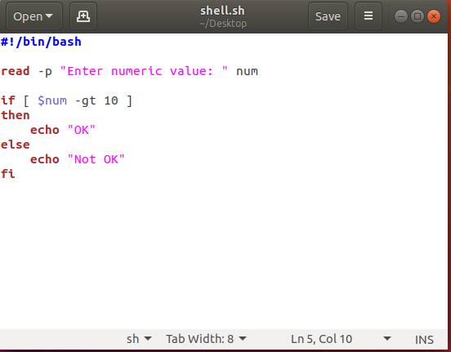

1. **if..elif..else..fi statement (Else If ladder):**

To use multiple conditions in one if-else block, then elif keyword is used in shell. If expression1 is true then it executes statement 1 and 2, and this process continues. If none of the condition is true then it processes else part.

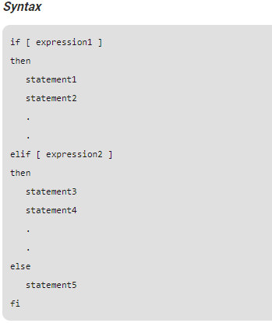

**Example:**

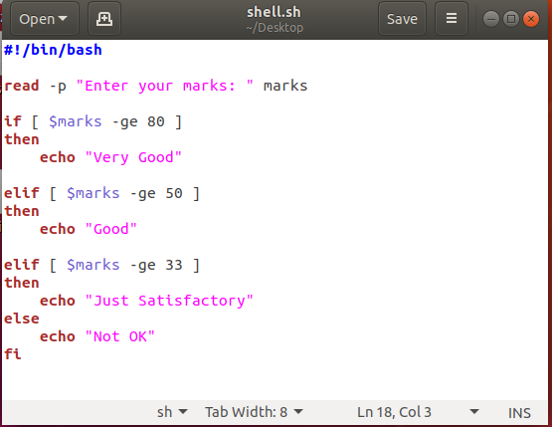

1. **switch statement:**

case statement works as a switch statement if specified value match with the pattern then it will execute a block of that particular pattern  
When a match is found all of the associated statements until the double semicolon (;;) is executed.  
A case will be terminated when the last command is executed.  
If there is no match, the exit status of the case is zero.

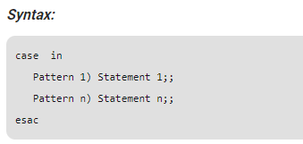

**Lab Task**

1. Write a script to make a calculator by using a switch case.
2. Write a script to identify the even odd number by using if else statement.
3. Write a script to make mark sheet for 5 subjects using if else statement.