**Lab Task 5**

**Q1. Write a script to display the user bio data by using read command.**

**Source Code:**

#!/bin/sh

echo -n "Enter Name: "

read name

echo -n "Enter Father Name: "

read fname

echo -n "Enter Gender: "

read gender

echo -n "Enter Age: "

read age

echo -n "Enter Religion: "

read religion

echo -n "Enter Education: "

read education

**Output:**

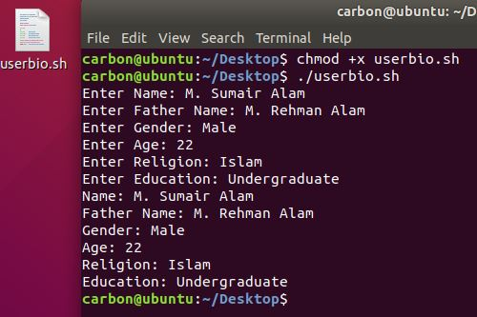

**Q2. Write a script to make user login using –sp and –t.**

**Source Code:**

!/bin/sh

read -t 10 -p "Enter Username : " username

read -sp "Enter Password : " pass

if(( $username=="admin" && $pass=="12345" ))

then

echo -e "\nSuccessful Login"

else

echo -e "\nUnsuccessful Login"

fi

**Output:**

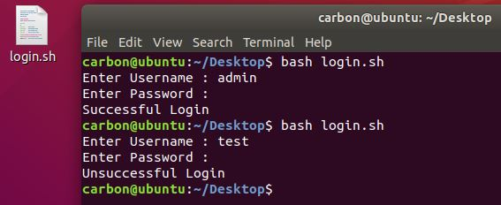

**Q3. Difference between –s and –p in shell scripting.**

**-s vs –p:**

They'll both say the same in this case, though:

-p file

True if file exists and is a named pipe (FIFO).

-s file

True if file exists and has a size greater than zero.

**Q4. Write a script to find the area of a triangle.**

**Source Code:**

#!/bin/sh

echo -n "Enter base of a triangle : "

read b

echo -n "Enter height of a triangle : "

read h

area=$(echo "scale=2;(1/2) * $b *$h"|bc)

echo "Area of a triangle is $area"

**Output:**

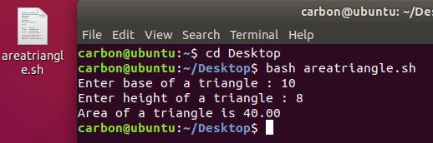

**Q5. Write the functionality of REPLY variable.**

**Functionality of REPLY Variable:**

The basic usage of read looks at input from the command line, and stores it in the REPLY variable. After you start the read command, your terminal will go down a line and allow you to type anything you want. As soon as you hit Enter, the input will be saved into the REPLY variable. You can then echo this variable to verify it has actually stored your text.