**Lab task 4**

**Q1. Differentiate between kernel and shell.**

|  |  |
| --- | --- |
| KERNEL | SHELL |
| A computer program which acts as the core of the computer’s operating system and has the control over everything in the system. | A computer program which works as the interface to access the services provided by the operating system. |
| Core of the system that controls all the tasks of the system. | Interface between the kernel and user. |
| Does not have types. | Has types such as Bourne shell, C shell, Bourne Again Shell, etc. |

**Q2. Differentiate between the user defined variable and system defined variables.**

**System Defined Variable vs User Defined Variable:**

The system variables are tightly typed variable. These are also known as global specific variable. The system variable can be initialized somewhere in global and contains the value of system variables until the server restarts. This value will destroy whenever you restart the MySQL server. The predefined system variable is prefixed with symbol @@. However the user defined variable is also known as session-specific variable. It is a type of loosely typed variable which can be initialized somewhere in session and contains the value of user defined variable until session ends. The user defined variable is prefixed with symbol @.

**Q3. Write a script to print your address using user defined variable.**

**Source Code:**

#!/bin/sh

address=”House no L-692, Sector 5/C-3 North Karachi, Karachi.

echo “Address: ”$address

**Output:**

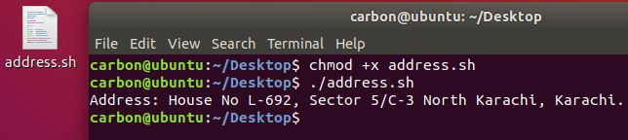

**Q4. Write a script to print calendar by using system defined variable.**

**Source Code:**

cal

**Output:**

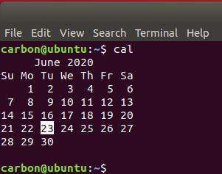

**Q5. Write a script to add two numbers by using a user defined variable.**

**Source Code:**

#!/bin/sh

echo –n “Enter the first number: “

read num1

echo –n “Enter the second number: “

read num2

sum=$(( $num1 + num2 ))

echo “Sum: $sum”

**Output:**

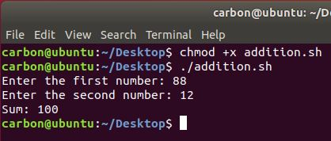

**Q6. Write a script to print your complete bio data by using user defined variable.**

**Source Code:**

#!/bin/sh

name="Muhammad Sumair Alam"

fname="Muhammad Rehman Alam"

gender="Male"

age="21 years"

religion="Islam"

education="Undergraduate"

echo -n "Name: $name\n"

echo -n "Father Name: $fname\n"

echo -n "Gender: $gender\n"

echo -n "Age: $age\n"

echo -n "Religion: $religion\n"

echo -n "Education: $education\n"

**Output:**

