**Lab Task 3**

1) Make a file and add permissions on it in which only file’s owner can read and write the file’s content by using symbolic mode.

**Output:**

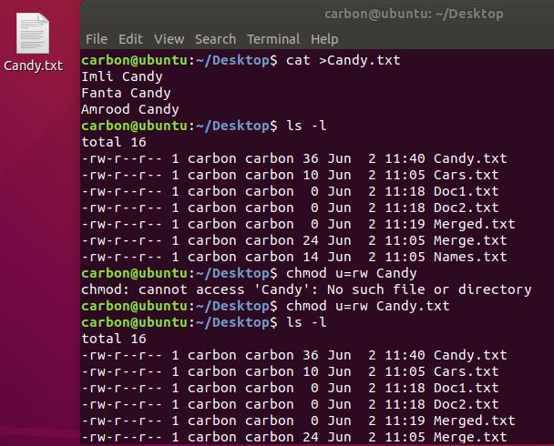

2) Make a file and add permission on it by using absolute mode.

**Output:**

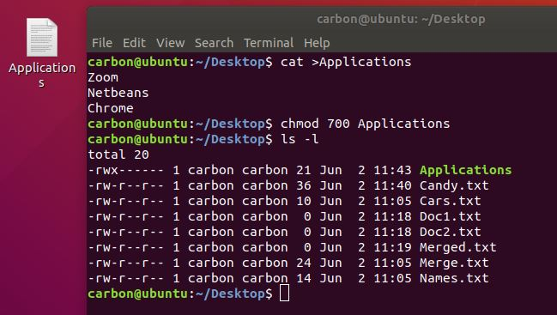

3) Run the chgrp command and define its purpose. Chgrp command is used to change the owner of a group.

**Output:**

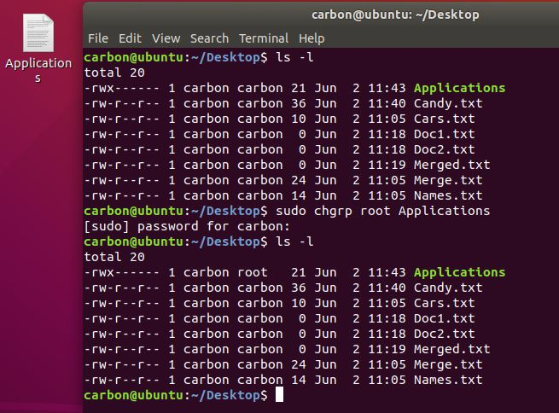

4) Change the ownership of the file through super user.

**Output:**

