INDUS GATEWAY WEBSITE
FEEDBACK AND SUGGESTIONS
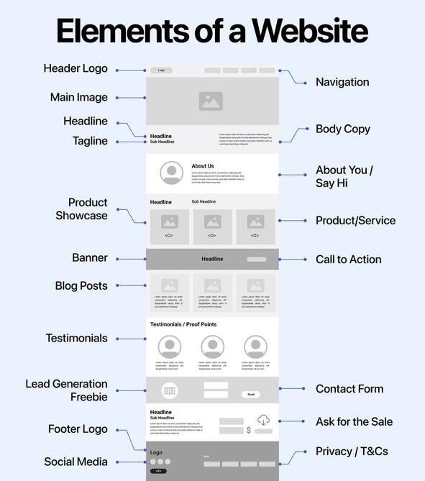
High-performing websites aren’t random designs, they’re structured for conversion.
HERE’S WHAT ACTUALLY MATTERS:
↪️ Clear navigation (no confusion, no friction)
↪️ A strong headline that grabs attention instantly
↪️ Value-driven body copy (not just filler text)
↪️ Product/service sections built for real user intent
↪️ Blog posts/Testimonials that build instant trust (Optional)
↪️ A CTA that tells users exactly what to do next
↪️ Lead capture that feels natural, not forced

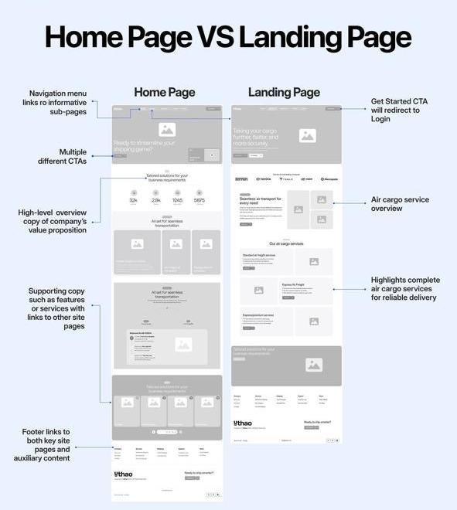
Home Page VS Landing Page
Most people use them interchangeably.
But they serve completely different purposes.
𝐇𝐨𝐦𝐞 𝐏𝐚𝐠𝐞 • Built for exploration
- Includes multiple CTAs
- Helps users navigate the website
- Gives a broad overview of the brand
𝐋𝐚𝐧𝐝𝐢𝐧𝐠 𝐏𝐚𝐠𝐞
- Built for one specific goal
- Focused on conversions
- Removes distractions
- Guides users toward a single CTA
𝐀 𝐡𝐨𝐦𝐞𝐩𝐚𝐠𝐞 𝐢𝐧𝐟𝐨𝐫𝐦𝐬.
𝐀 𝐥𝐚𝐧𝐝𝐢𝐧𝐠 𝐩𝐚𝐠𝐞 𝐜𝐨𝐧𝐯𝐞𝐫𝐭𝐬.
The best-performing brands know when to use each strategically.
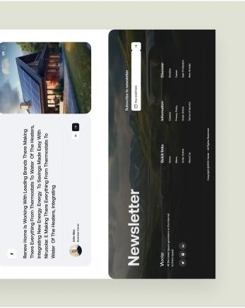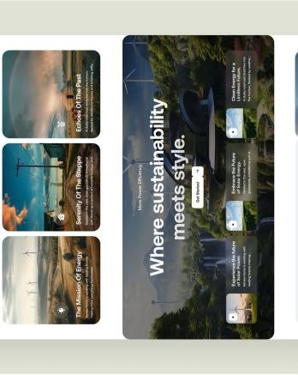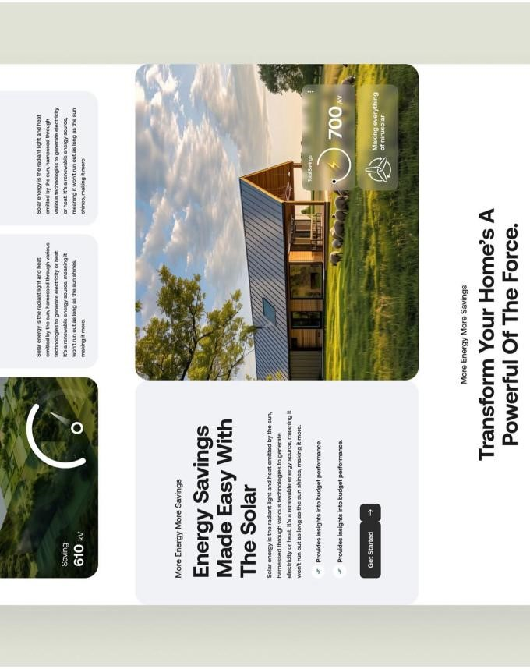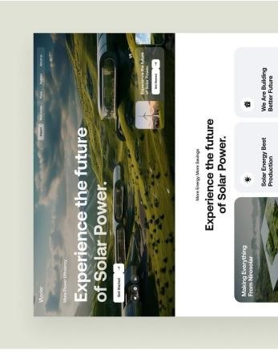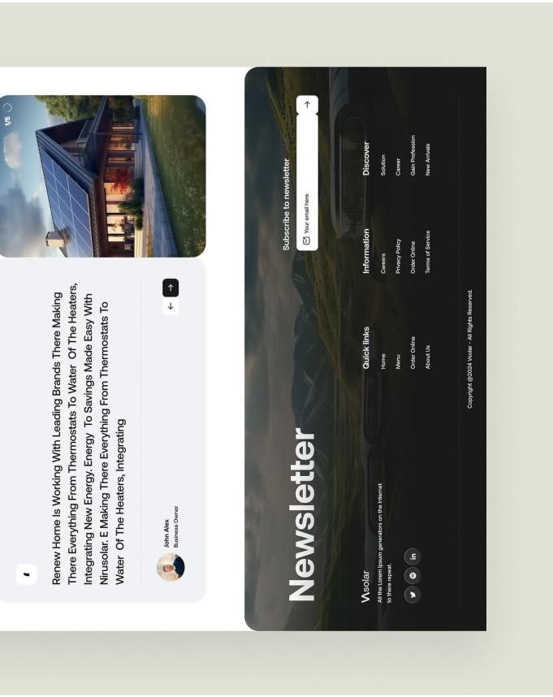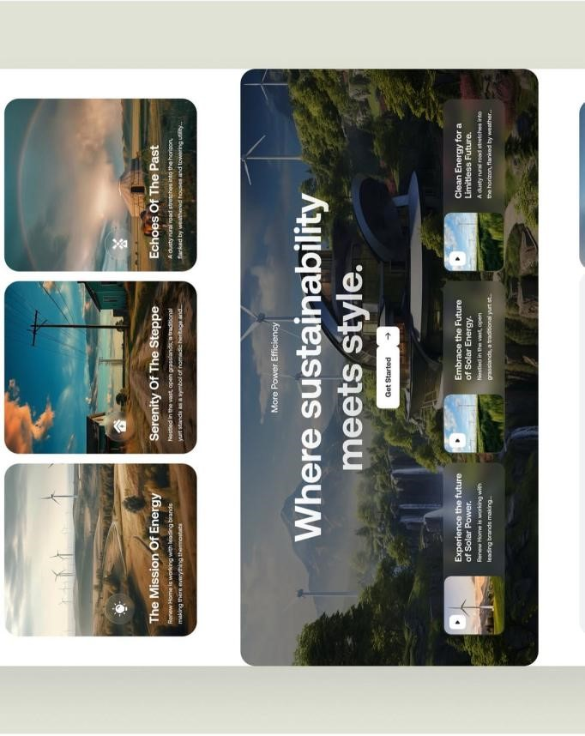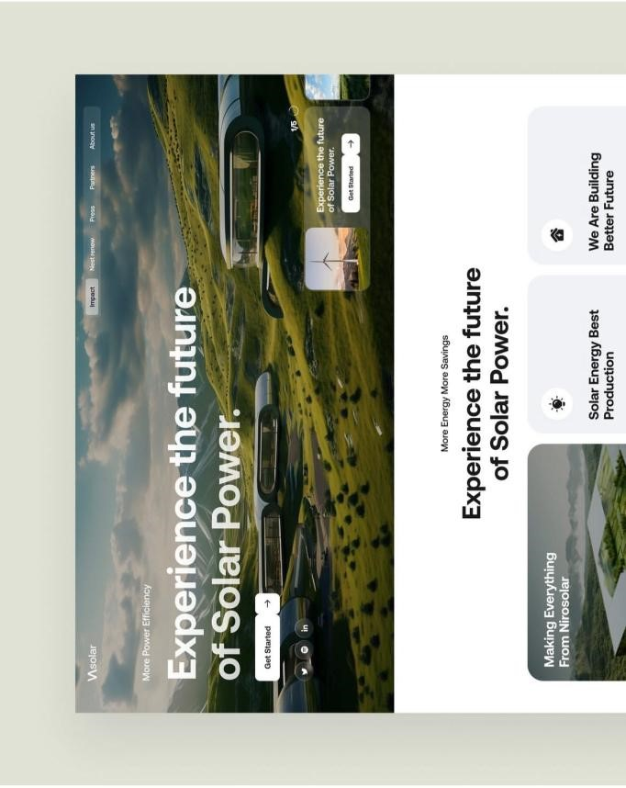
INSPIRATION
Full Website Layout – Zoomed in version
Full Website Layout
PRO TIP ON WEBSITE:
One thing that can make a huge difference is page speed and mobile responsiveness; even the best structure can lose conversions if the site feels slow or hard to use on mobile.
Website Link: https://storied-dango-928eb1.netlify.app/
Feedback on Current Website/Layout:
I reviewed the site: Indus Gateway – Vendor-Neutral Connectivity Aggregation. The concept is strong and relevant, especially for carriers, ISPs, and enterprise connectivity buyers looking for a neutral marketplace approach. However, the website currently feels more like a product concept page than a commercial lead-generation website.
Overall Score: 5.8/10
Area | Score
Design | 8/10
Messaging | 5/10
Trust Building | 4/10
Lead Generation | 4/10
Conversion Optimization | 3/10
Enterprise Readiness | 5/10
SUGGESTIONS
ON IMPROVEMENT AREAS

Design

Look & Feel
- Dark navy and light grey or similar Pantone shades
- Clean enterprise design
- Real photography
- Minimal animations • Executive audience
Best for:
- Enterprises
- Government
- Banking
Homepage Flow

Homepage Flow
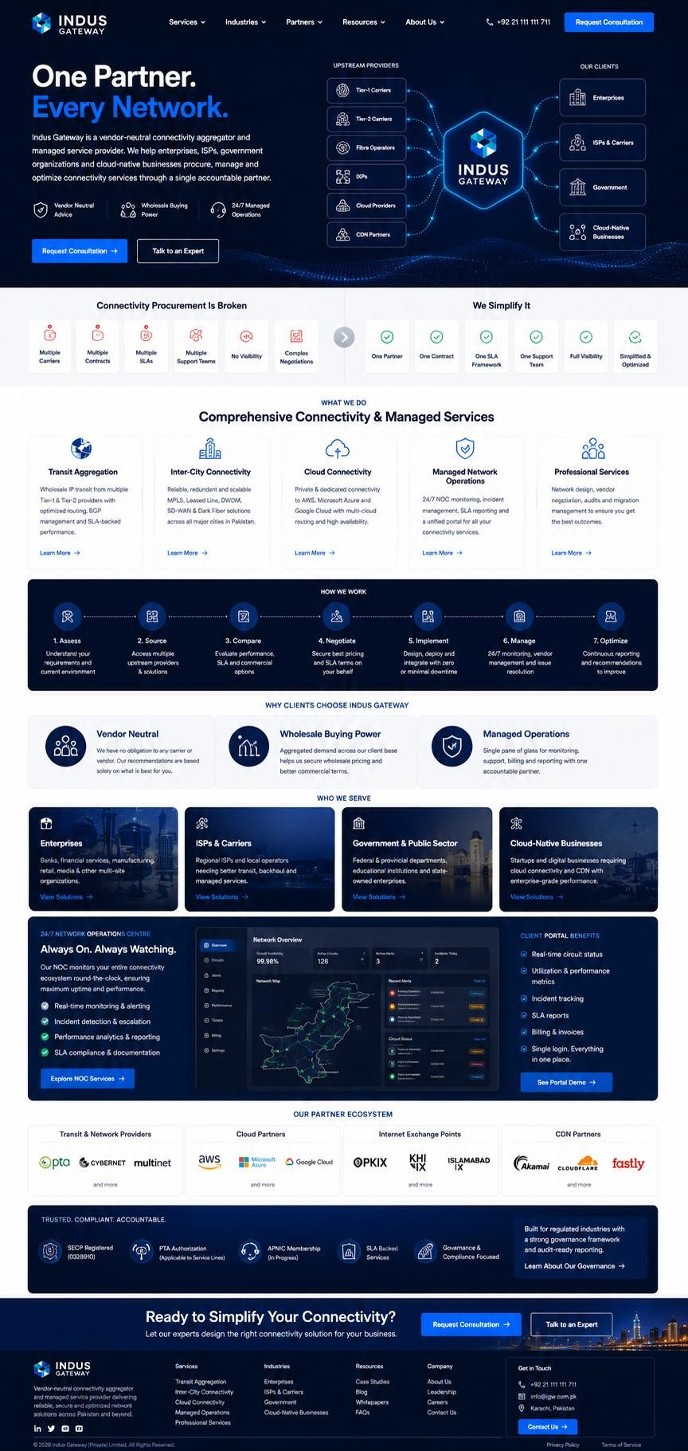
Hero (Section 1) ↓ Problem Statement (Section 2) ↓ Services (What we do) (Section 3) ↓ How We Work (Optional) (Section 4) ↓ USP (Why clients choose IG) (Section 5) ↓ Industries (Who we serve) (Section 6) ↓
SAMPLE
LAYOU
T
Partner Ecosystem (Optional) / Value Additions being offered (Section 7) ↓
Governance & Compliance
(Optional) (Section 8) ↓ Contact

Homepage (Hero)
Headline
One Partner. Every Network.

Subheading/Sub Text
Indus Gateway is a vendor-neutral connectivity aggregator and managed services provider that helps enterprises, ISPs, government organizations, and cloud-native businesses procure, manage, and optimize network services through a single accountable partner.

CTA
Request Consultation
Explore Services

Problem Statement
Connectivity Procurement Is Broken
Managing connectivity across multiple providers creates unnecessary complexity.
- Multiple contracts
- Multiple SLAs
- Multiple support teams
- Limited visibility
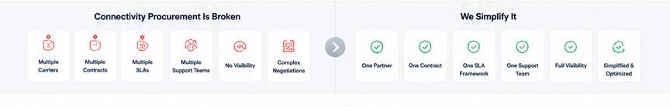
- Lengthy negotiations
- Increased operational burden
We Simplify It
With Indus Gateway, you get:
- One partner
- One support team
- One operational framework
- One management portal
- One accountable relationship
Services (What we do)

Comprehensive Connectivity & Managed Services

Transit Aggregation
Access wholesale IP transit capacity from multiple upstream providers with SLA-backed performance and managed routing.
Inter-City Connectivity
Reliable connectivity across Pakistan through leased lines, MPLS, SD-WAN and dark fiber solutions.
Cloud Connectivity
Private connections to AWS, Microsoft Azure and Google Cloud for secure, low-latency performance.
Managed Network Operations
24/7 monitoring, vendor management, incident handling and performance reporting.
Professional Services
Network audits, vendor negotiations, migration planning and connectivity consulting.

How we work (Optional)
Assess
Understand your business and technical requirements.
Source
Engage multiple providers on your behalf.

Compare
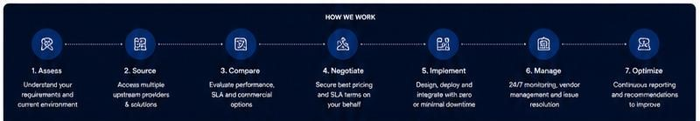
Evaluate pricing, performance and SLA options.
Negotiate
Secure competitive commercial terms.
Implement
Coordinate deployment and activation.
Manage
Provide ongoing monitoring and support.
Optimize
Continuously improve performance and resilience.

USP (Why Organizations Choose Indus Gateway)
Vendor Neutral
Recommendations are based on your requirements—not ours.
Wholesale Buying Power
Benefit from aggregated demand and stronger commercial terms.
Managed Operations
One partner managing all provider relationships and service delivery.

Industries (Who we serve)
Enterprises
Multi-site connectivity and cloud access.
ISPs & Carriers
Transit, routing, and backbone connectivity.
Government & Public Sector
Reliable, compliant, and locally accountable services.

Cloud-Native Businesses
Enterprise-grade connectivity without procurement complexity.

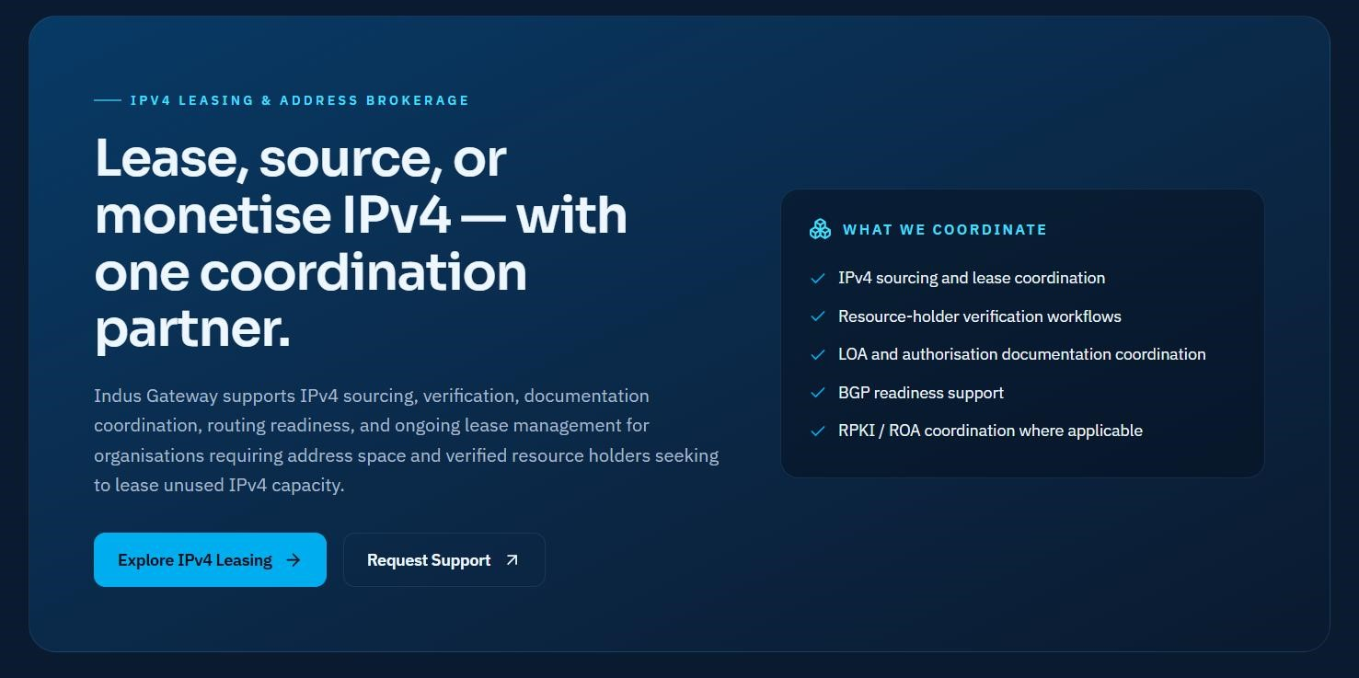
Partner Ecosystem (Optional) / Value Additions being offered

Governance & Compliance (Optional)
Trusted. Compliant. Accountable.
- SECP Registered
- PTA Authorized Services
- APNIC Resource Management
- SLA-Based Service Delivery
- Governance-Focused Operations

SECTION 9 Governance & Compliance (Optional)
Ready to Simplify Your Connectivity?
Let our experts design the right connectivity strategy for your business.
[ Request Consultation ]
[ Explore services ]
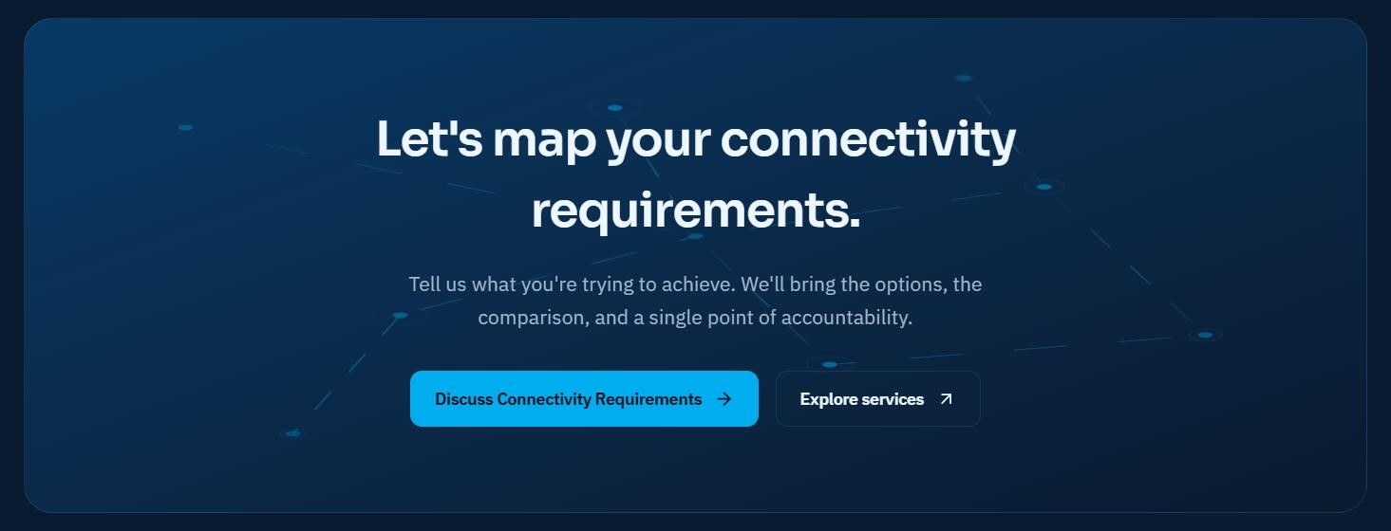

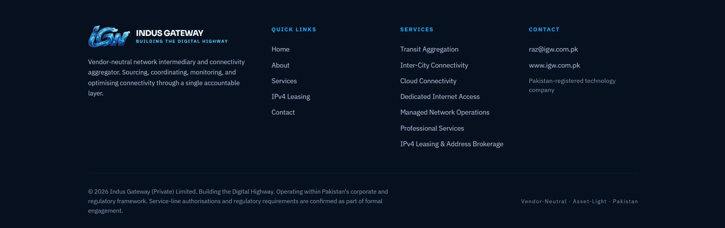
FOOTER

