AI TRAVEL PLANNER
Using Gemini Prompting Techniques
Detailed Project Report
Comparing Zero-Shot, Few-Shot, and Structured Reasoning Prompting
Prepared by: Sumaira
Program: AI & Data Science — SMIT
Assignment: Prompt Engineering — AI Travel Planner

Table of Contents
1. Objective
2. Scenario & Sample Input
3. System Architecture
4. Prompt Engineering Methodology
4.1 Zero-Shot Prompting
4.2 Few-Shot Prompting
4.3 Structured Reasoning Prompting
5. Comparative Analysis
6. Application Walkthrough
7. Bonus Features
8. Challenges & Learnings
9. Conclusion

1. Objective
This project builds an AI-powered Travel Planner that uses the Google Gemini API to generate a personalized travel itinerary from a traveler's stated preferences. The core learning goal of the assignment is not the itinerary itself, but observing how three different prompting techniques — Zero-Shot, Few-Shot, and Structured Reasoning — change the quality, consistency, and depth of Gemini's output for the exact same input.
To make that comparison fair and repeatable, the application accepts one set of trip details and lets the user pick which technique to run, or run all three at once and view the results side by side.

2. Scenario & Sample Input
The user supplies six fields: name, destination, number of travel days, budget, interests, and travel style. The table below shows the example used throughout this report and the accompanying presentation, matching the assignment brief.
Field | Example value used in this report
Name | Alex
Destination | Dubai
Number of days | 4
Budget | $800
Interests | Food, Beaches, Shopping
Travel style | Family

3. System Architecture
The application is a full-stack Python + web project. A FastAPI backend owns the prompt-building logic and the Gemini API call; a vanilla HTML/CSS/JS frontend collects the trip details and renders the response as a set of "boarding pass" cards, one per technique.
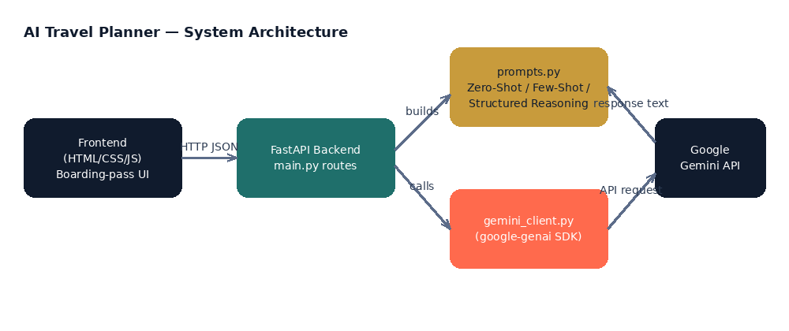

3.1 Backend (Python / FastAPI)
- main.py — defines the REST routes and orchestrates request → prompt → Gemini → response
- prompts.py — the three prompting-technique builders described in Section 4; this is the heart of the assignment
- gemini_client.py — a small wrapper around the google-genai SDK, isolating API-key handling and error handling
- Pydantic models validate every incoming request (name, destination, days 1–30, budget > 0, interests list, travel style, technique)

3.2 Frontend (HTML / CSS / JS)
- A left-hand "ticket stub" panel collects the trip details and technique choice
- A right-hand results panel renders each generated plan as a boarding-pass card, using Markdown-to-HTML rendering for the itinerary body
- A "Compare all 3" action calls the /api/itinerary/compare route and lays all three technique outputs out side by side
- Each card includes a "View prompt used" action, so the exact text sent to Gemini is auditable — useful for grading and debugging

4. Prompt Engineering Methodology
All three techniques share the same traveler-details block and the same output-format instructions (a fixed Markdown structure: Trip Overview, Day-by-Day Itinerary, Budget Summary, Final Tip). Holding those constant means the only variable being tested between runs is the prompting strategy itself, which is what this assignment is meant to isolate.

4.1 Zero-Shot Prompting
Gemini receives only a direct instruction plus the traveler's raw details — no worked examples of what a good answer looks like. It must independently decide how to analyze preferences, pick attractions, and structure the day-by-day plan.
Prompt skeleton used:
You are a professional travel planning assistant.
Without referring to any prior examples, analyze the traveler's
preferences below, suggest suitable places to visit, create a
day-by-day itinerary, and recommend activities that fit within
the stated budget.
Traveler name: Alex
Destination: Dubai
Trip length: 4 day(s)
Total budget: $800
Interests: Food, Beaches, Shopping
Travel style: Family
[+ shared output-format instructions]
Observed behavior: fastest and cheapest to run (shortest prompt), but the itinerary's structure and level of detail can vary more between runs since there is no template to anchor to.

4.2 Few-Shot Prompting
Before the real request, Gemini is shown three fully worked example travelers — different destinations, budgets, interests, and travel styles — each with a sample plan in the exact target format. It is then asked to produce a new plan for the real traveler in the same style.
Example travelers included in the prompt:
- Sara — Bangkok, 3 days, $450, Food & Shopping, Solo
- The Ahmed Family — Istanbul, 5 days, $1500, History & Food, Family
- Jordan — Costa Rica, 6 days, $1200, Adventure & Nature, Friends
Observed behavior: output format is the most consistent of the three techniques, since Gemini is pattern-matching against concrete examples rather than inventing structure. The trade-off is a longer, more expensive prompt.

4.3 Structured Reasoning Prompting
Gemini is given an explicit six-step checklist to follow internally, but is told not to reveal that reasoning — only to use it to arrive at a better final answer. This is deliberately different from asking the model to "think step by step" out loud; the assignment specifically asks for short justifications, not exposed chain-of-thought.
- Analyze the traveler's preferences
- Consider the available budget
- Consider the number of travel days
- Select suitable attractions and activities
- Create a day-by-day itinerary
- Prepare a brief, one-sentence justification for each day's main recommendation
The prompt explicitly instructs: "do NOT show your internal reasoning, step numbers, or working" and asks for a short "Why:" line after each day instead of exposed deliberation.
Observed behavior: output includes visible, concise justifications per day without a wall of reasoning text, and the itinerary tends to more directly reference budget and day-count limits than the zero-shot version.

5. Comparative Analysis
The table below summarizes the practical differences observed between the three techniques when run against the same trip.
Aspect | Zero-Shot | Few-Shot | Structured Reasoning
Examples given | None | 3 worked traveler examples | None — a 6-step checklist instead
Consistency of format | Variable — Gemini invents its own structure | High — mirrors example format closely | High — steps force a fixed shape
Depth of justification | Rarely explains "why" | Sometimes echoes example reasoning style | Explicit short "why" per day, by design
Prompt length / cost | Shortest, cheapest | Longest (examples add tokens) | Medium — longer than zero-shot, shorter than few-shot
Risk of drifting off-format | Highest | Low, thanks to pattern-matching | Lowest — steps constrain the output
Best suited for | Quick, low-stakes drafts | Matching a specific house style | Trips needing transparent, justified picks

Overall, Zero-Shot is the cheapest and fastest option and works well for quick, low-stakes drafts. Few-Shot produces the most consistently formatted output because it has a concrete pattern to imitate, at the cost of a longer prompt. Structured Reasoning gives the best balance for this use case: it keeps the prompt shorter than Few-Shot while still producing itineraries that are visibly grounded in the stated budget and day count, with a short justification for each day's main pick.

6. Application Walkthrough
The screen below shows the two-panel layout: the left "ticket stub" collects trip details and the prompting technique, and the right panel renders the result as a boarding-pass card matching the chosen technique.
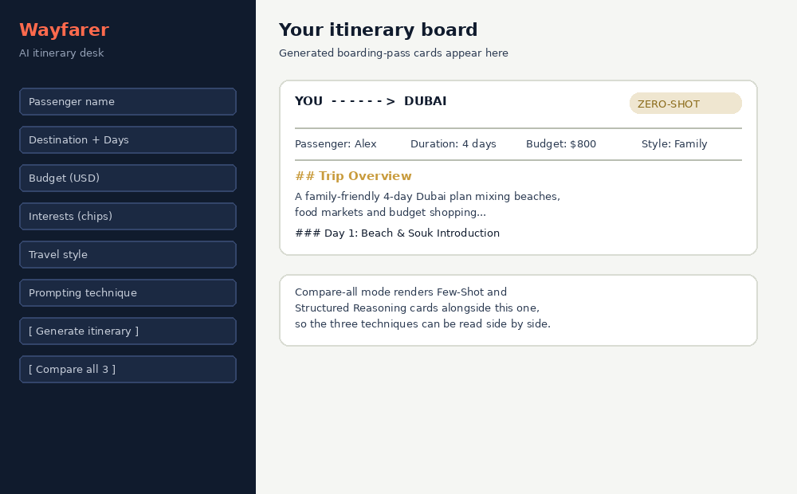
Available API routes:
Method | Route | Purpose
GET | /api/health | Liveness check; reports whether GEMINI_API_KEY is configured
GET | /api/techniques | Returns metadata describing the 3 prompting techniques
POST | /api/itinerary | Generates one itinerary for the chosen technique
POST | /api/itinerary/compare | Generates all 3 itineraries for the same trip in one call

7. Bonus Features
- Compare-all mode: runs the same trip through all three techniques in one click and displays the results side by side
- "View prompt used": every result card can reveal the exact prompt text sent to Gemini, for transparency and grading
- Print/export styling: each boarding-pass card has a dedicated print stylesheet
- Recent-trips history strip showing the last few generated trips in the session
- Input validation on both the frontend (interest chips, segmented travel-style control) and backend (Pydantic constraints on days, budget, and field lengths)

8. Challenges & Learnings
- Keeping the three prompts fair: all three share identical output-format instructions so that formatting differences don't get mistaken for reasoning-quality differences
- Following the assignment's constraint to avoid asking Gemini to expose chain-of-thought for the Structured Reasoning prompt, while still surfacing short, useful justifications
- Designing example travelers for the Few-Shot prompt that are varied enough (different destinations, budgets, group sizes) to teach a general pattern rather than a single memorized answer

9. Conclusion
This project demonstrates, with a working full-stack application, how prompt design alone — without changing the underlying model — measurably changes an LLM's output structure, consistency, and depth of justification. Zero-Shot is the simplest and cheapest baseline; Few-Shot trades prompt length for format consistency; Structured Reasoning trades a modest prompt-length increase for itineraries that are visibly tied to the traveler's constraints and briefly justified, which best matches what a real travel-planning product would want to ship.

