SmartTask AI
An AI Task Organizer using LangGraph and Gemini
Project Report
Technologies: Python, LangGraph, Google Gemini, FastAPI, HTML/CSS/JavaScript
Student name: ____________________ Roll no.: ______________

1. Introduction
People rarely write their to-do lists in a clean, structured format. Instead they think and speak in sentences such as "I need to finish my assignment tomorrow, buy groceries today, and prepare for my meeting next week." Such a sentence hides three separate tasks, three different deadlines and an implicit order of importance.
SmartTask AI is a small AI assistant that reads this kind of informal message and turns it into an organized, prioritized to-do list. A large language model (Google Gemini) understands the language, while LangGraph controls the order in which the steps run. The result is shown to the user through a simple web interface served by FastAPI.

2. Problem Statement
Manually converting free-form text into a task list is slow and easy to get wrong, and unprioritized lists make it hard to decide what to do first. The goal of this project is to automate three steps:
- Identify each individual task and its deadline inside a natural-language message.
- Assign every task a priority level: High, Medium or Low.
- Present the result as a clean, readable to-do list.

3. Objectives
- Design a multi-step AI workflow using LangGraph with a shared state.
- Use Gemini with structured output so that results are reliable and machine-readable.
- Expose the workflow through a REST API built with FastAPI.
- Build a simple, responsive frontend so non-technical users can try the system.

4. Technologies Used
Technology | Role in the project
Python 3 | Main programming language of the backend
LangGraph | Defines the workflow as a graph of nodes and manages shared state
Google Gemini (via langchain-google-genai) | Large language model used for task extraction and prioritization
Pydantic | Defines schemas for structured LLM output and API validation
FastAPI + Uvicorn | REST API server and static hosting of the frontend
HTML / CSS / JavaScript | Frontend user interface

5. System Architecture
The system follows a linear workflow. The user's message enters the graph, passes through three nodes and leaves as an organized to-do list. Each node reads from and writes to a shared state object, which is how LangGraph passes data between steps.
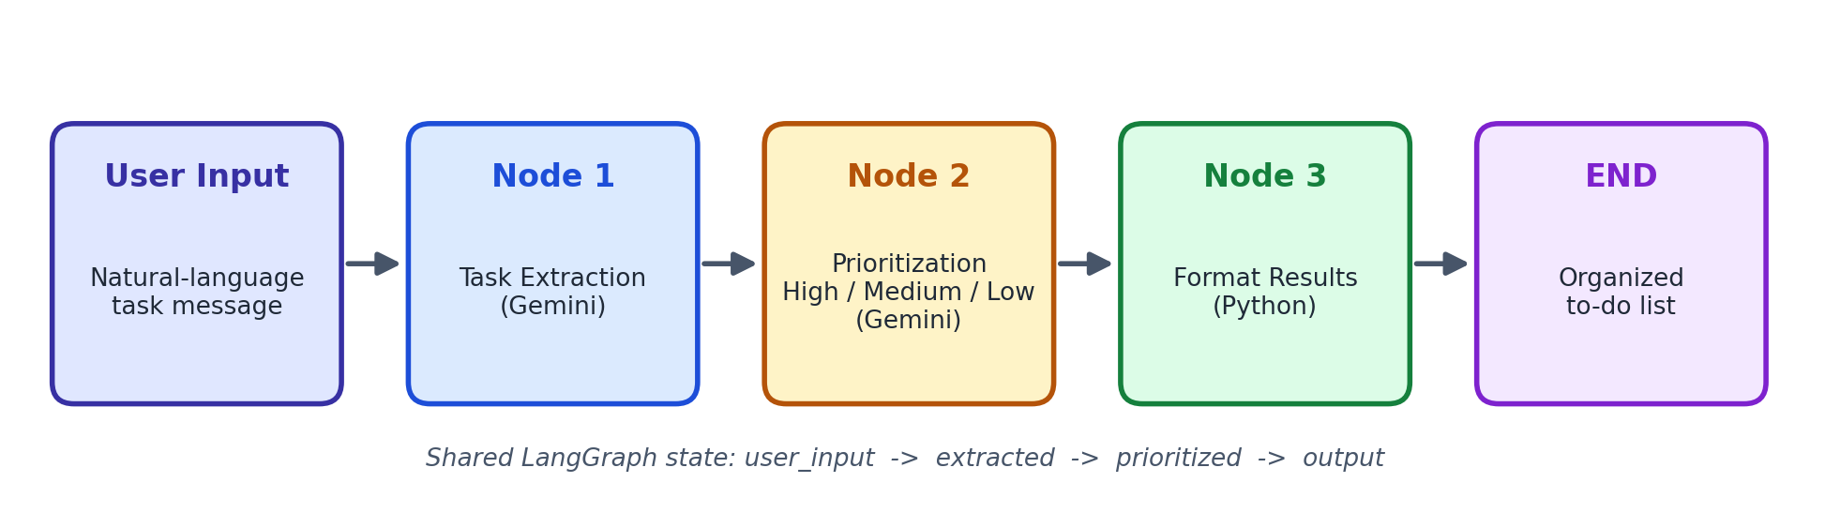
Figure 1: SmartTask AI workflow

5.1 Shared state
The graph state is a Python TypedDict with four fields:
Field | Written by | Content
user_input | API request | The raw message typed by the user
extracted | Node 1 | List of tasks with title and optional deadline
prioritized | Node 2 | Same tasks plus priority and a short reason
output | Node 3 | Final human-readable to-do list text

5.2 Node 1: Task extraction
Gemini receives the user's message together with a system prompt that tells it to split the message into separate, action-oriented tasks and to copy any deadline phrase (for example "tomorrow" or "next week"). The model is called with structured output bound to a Pydantic schema, so the response is always valid data rather than free text that would need fragile parsing.

5.3 Node 2: Task prioritization
The extracted tasks are sent to Gemini again with a prioritization prompt. The prompt defines the levels: High for urgent items due today or tomorrow, Medium for items due within roughly a week, and Low for items with no near deadline. Gemini returns each task with its priority and a one-sentence reason, which makes the decision transparent to the user.

5.4 Node 3: Format results
This node is plain Python and does not call the LLM, because formatting is deterministic. It groups tasks by priority (High first, then Medium, then Low), numbers them and adds the deadline and reason. Using code instead of the model here makes the output predictable and saves an API call.

6. Implementation

6.1 Project structure
smarttask-ai/
backend/app/graph.py LangGraph workflow (3 nodes)
backend/app/schemas.py Pydantic models
backend/app/main.py FastAPI application
backend/requirements.txt
frontend/index.html Web user interface
README.md

6.2 Building the graph
The three node functions are registered in a StateGraph and connected with edges from START to END:
graph = StateGraph(TaskState)
graph.add_node("extract_tasks", extract_tasks)
graph.add_node("prioritize_tasks", prioritize_tasks)
graph.add_node("format_results", format_results)
graph.add_edge(START, "extract_tasks")
graph.add_edge("extract_tasks", "prioritize_tasks")
graph.add_edge("prioritize_tasks", "format_results")
graph.add_edge("format_results", END)
workflow = graph.compile()

6.3 REST API
FastAPI exposes one main endpoint. Input is validated by Pydantic (a message between 3 and 2000 characters). Errors such as a missing API key or a Gemini failure are converted into clear HTTP error messages that the frontend displays.
Method | Endpoint | Purpose
POST | /api/organize | Runs the workflow and returns the prioritized tasks and formatted text
GET | /api/health | Simple health check
GET | / | Serves the web interface
GET | /docs | Automatic interactive API documentation (Swagger)

6.4 Frontend
The frontend is a single HTML page with no external dependencies. The user types or selects an example message and presses the button. The page sends the request to the API and shows the tasks in three colored columns (High, Medium, Low). Each task has a checkbox, a deadline tag and the reason for its priority, and the whole list can be copied as text. User-provided text is inserted with textContent, which prevents script injection.

7. Setup and Execution
- Create a free Gemini API key at https://aistudio.google.com/app/apikey.
- Create a virtual environment and run pip install -r requirements.txt inside the backend folder.
- Copy .env.example to .env and set GOOGLE_API_KEY.
- Start the server with uvicorn app.main:app --reload and open http://127.0.0.1:8000.

8. Example
Input message:
I need to finish my assignment tomorrow, buy groceries today,
and prepare for my meeting next week.

Expected organized output (the exact wording of reasons may vary slightly between runs):
Priority | Task | Deadline
High | Buy groceries | today
High | Finish assignment | tomorrow
Medium | Prepare for meeting | next week

9. Testing
The following test cases should be run after adding the API key. Results depend on the live Gemini model, so the table lists the expected behavior.
# | Test case | Expected behavior
1 | Message with three tasks and different deadlines | Three tasks extracted, urgent ones marked High
2 | Message with one task and no deadline | One task, deadline empty, priority Low or Medium
3 | Message with no real task (for example "hello") | Message saying no tasks were found
4 | Empty or very short message | Validation error shown in the UI
5 | Missing API key in .env | Clear error message about GOOGLE_API_KEY

10. Limitations
- Priority is judged by the language model, so it can differ from a person's own opinion.
- Relative dates such as "tomorrow" are kept as text and are not converted to calendar dates.
- The tasks are not stored; each request is independent.
- The system needs an internet connection and a valid Gemini API key.

11. Future Improvements
- Convert relative dates into real dates and sort by due date.
- Store tasks in a database and add user accounts.
- Add reminders and calendar export.
- Let users correct a priority and learn from the corrections.
- Support Urdu and mixed-language input.

12. Conclusion
SmartTask AI shows how a language model and a workflow engine can work together to solve an everyday problem. LangGraph keeps the process clear and extensible, Gemini handles the language understanding, and FastAPI with a lightweight frontend makes the result easy to use. The same graph structure can later be extended with more nodes, such as scheduling or reminders, without changing the existing ones.

