**Profit of a company**

Data file: profit_reason_long.csv

The data file has the following structure:

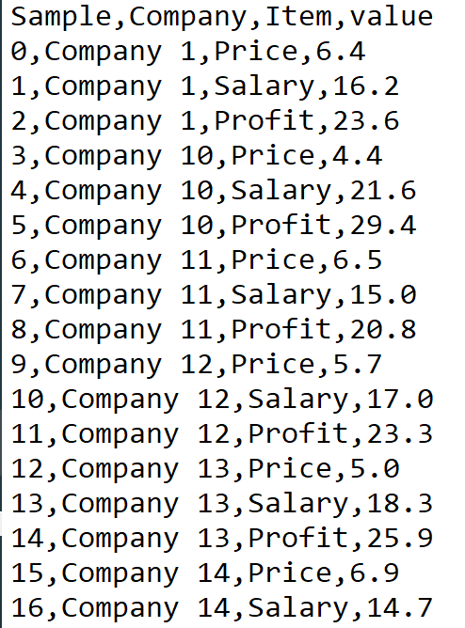

Each row indicates a sample taken at a certain time. The items when pivoted (cross tabbed) would like like the following:

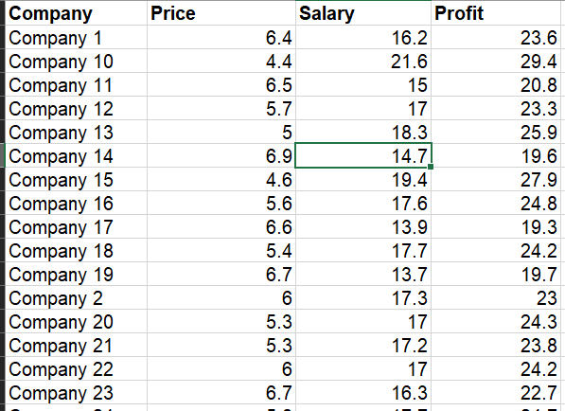

**Explanation:**

Company: Name of the company

Price: The average price of the products of the company

Salary: Average salary of the employees

Profit: Average profit of the company

**Your task:**

Transform the data.

Arrive at some inference about what is more related to profit? - Price of the items or the Salary of the employees?