SQL Mini Project
Retail Store
Project Objective:

- Design and build a normalized relational schema for a retail store covering customers, products, orders, order items, payments, and product reviews.

- Translate real business questions from stakeholders (marketing, inventory, finance, category management) into precise SQL queries.

- Apply the full SQL toolkit progressively — filtering, aggregation, multi-table joins, subqueries, and set operations — to answer those questions.

- Produce query outputs that are verified against real, loaded data rather than only theoretically correct SQL.

Entity Relationship Diagram (ERD)
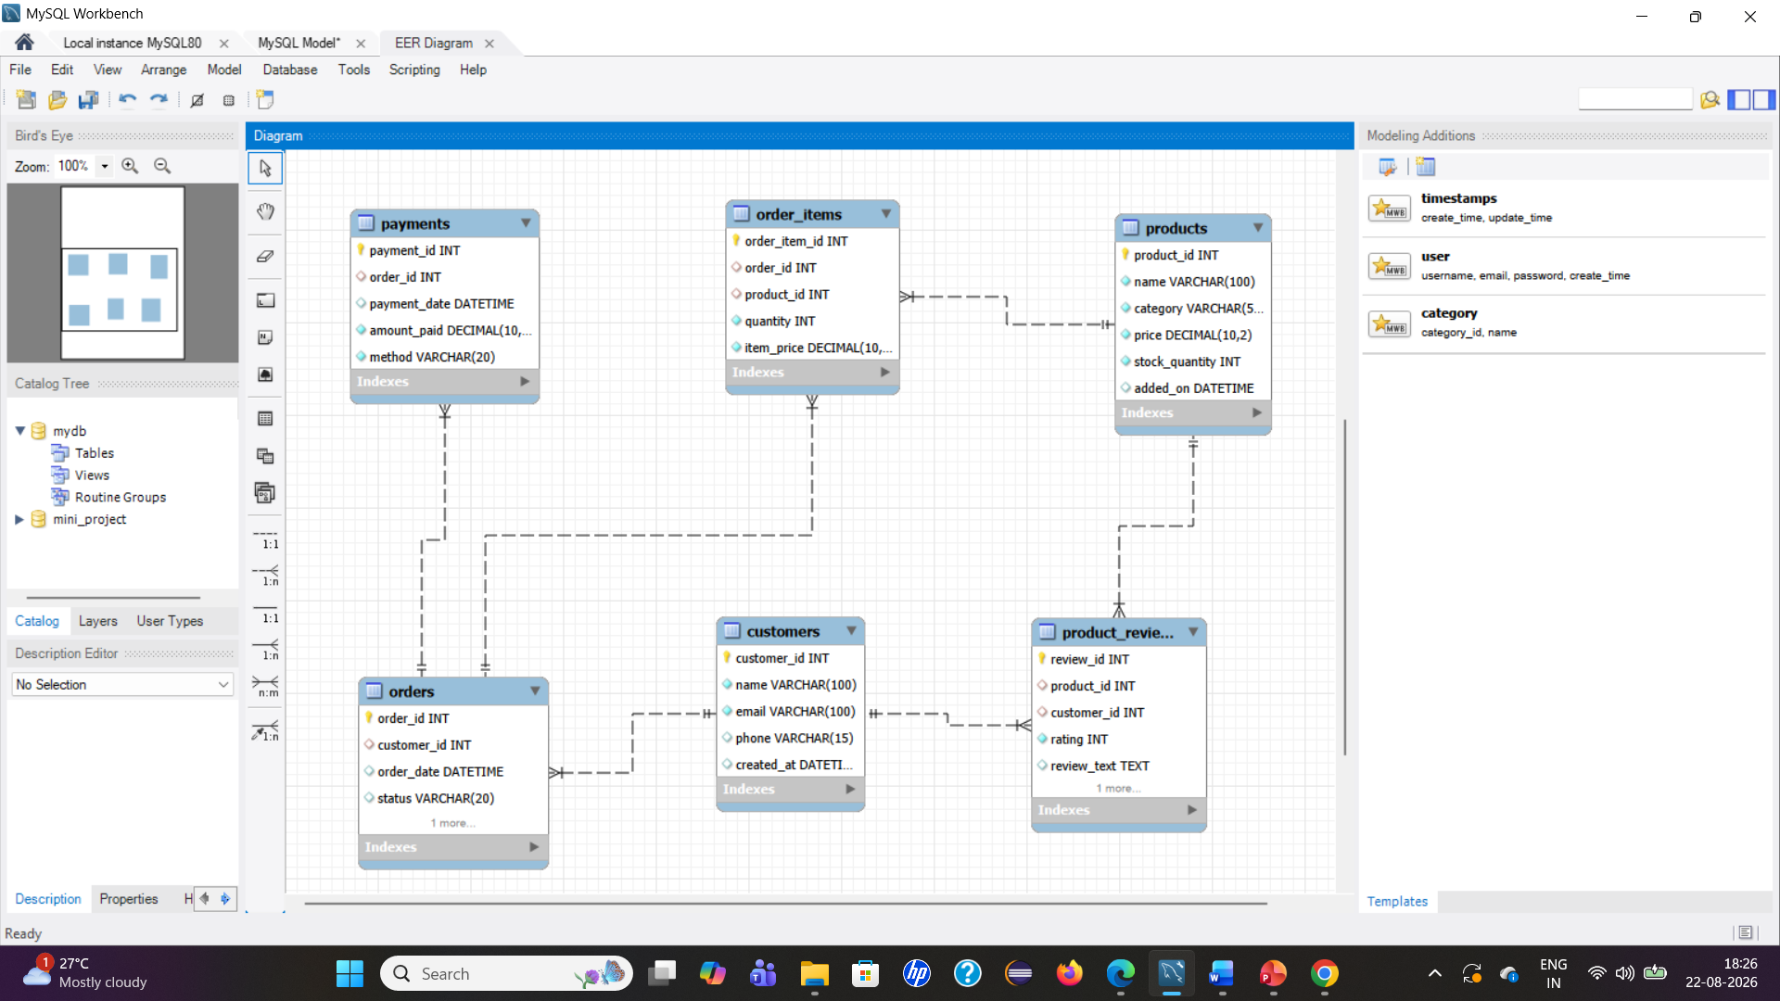

Level 1 — Basics

- Retrieve customer names and emails for email marketing
Query: select name, email
from customers;
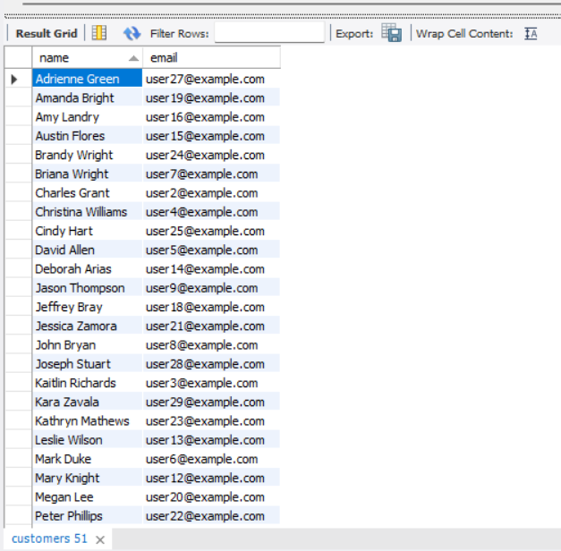

2.View complete product catalog with all available details
Query: select *
from products;

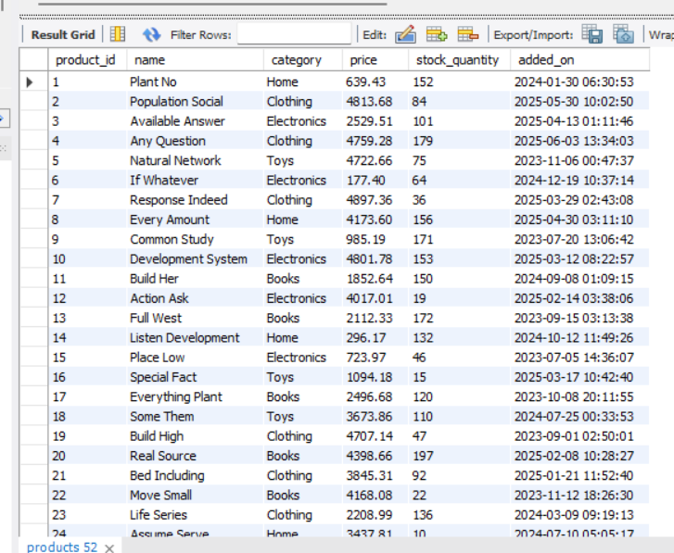

3. List all unique product categories
Query: select distinct category
from products;
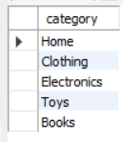

4. Show all products priced above ₹1,000
Query: select *
from products
where price>1000;
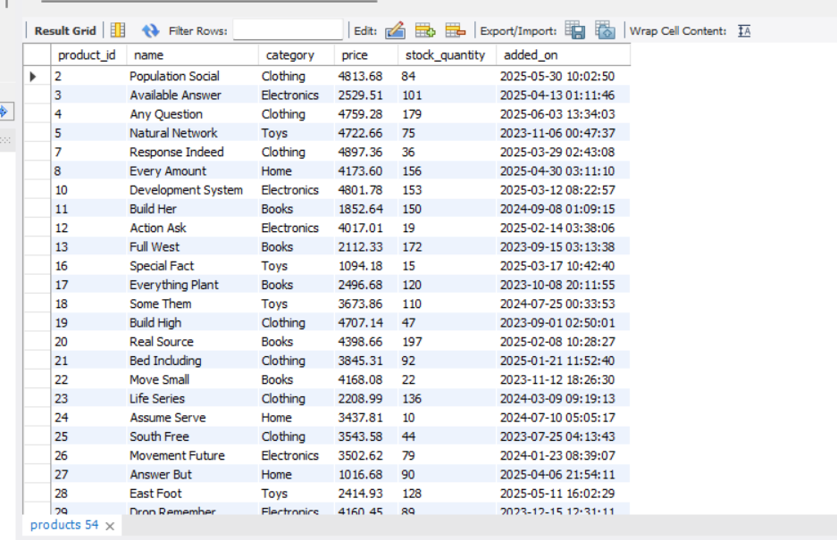

5. Display products within a mid-range price bracket (₹2,000 to ₹5,000)
Query: select *
from products
where price between 2000 and 5000;

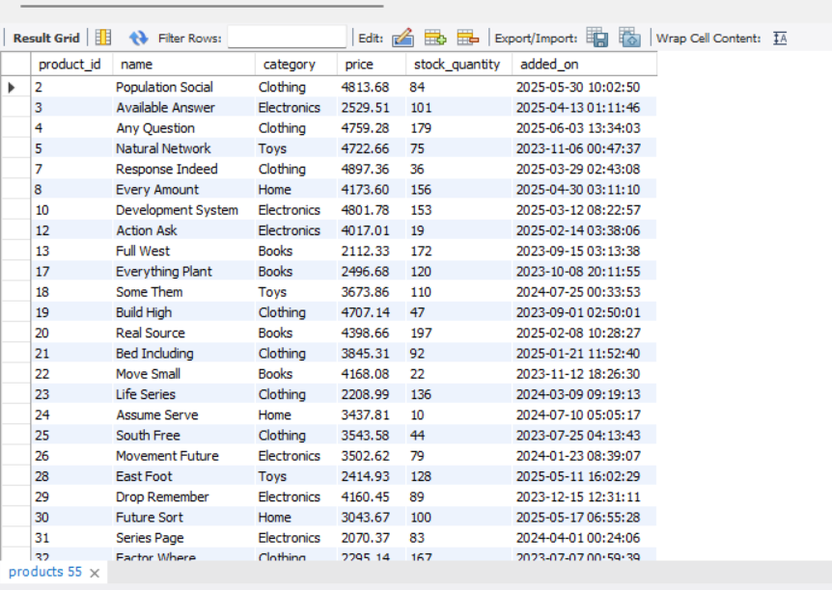

6. Fetch data for specific customer IDs (e.g., from loyalty program list)
Query : select *
from customers
where customer_id in(2,6,8);
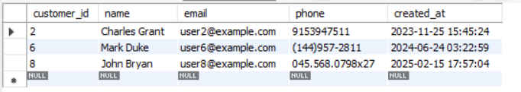

7. Identify customers whose names start with the letter ‘A’
Query : select *
from customers
where name like "A%";

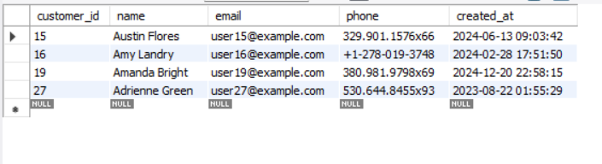

8. List electronics products priced under ₹3,000
Query: select *
from products
where category="Electronics" and price<3000;

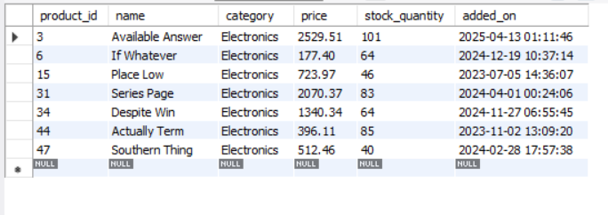

9. Display product names and prices in descending order of price
Query: select name,price
from products
order by price desc;
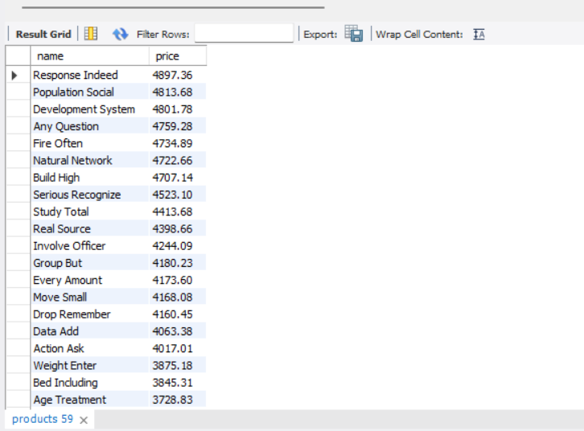

10. Display product names and prices, sorted by price and then by name
Query: select name,price
from products
order by price desc,name asc;
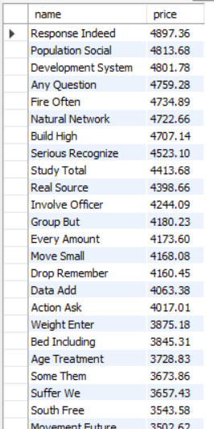

Level 2: Filtering and Formatting

1.Retrieve orders where customer information is missing (possibly due to data migration or deletion)
Query: select *from orders
where customer_id is null;

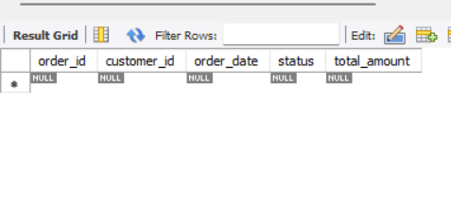

2.Display customer names and emails using column aliases for frontend readability
Query: select name as Customer_name,email as Customer_email
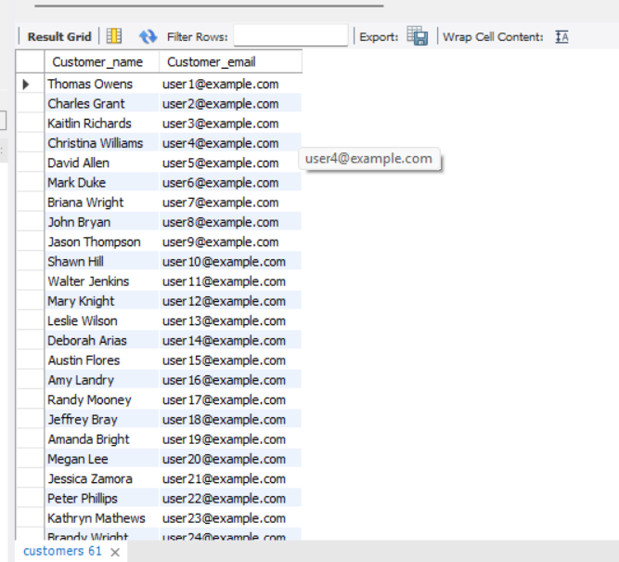
from customers;

3. Calculate total value per item ordered by multiplying quantity and item price
Query: select order_item_id,order_id,quantity,item_price,
(quantity*item_price) as Total_item_value
from order_items;
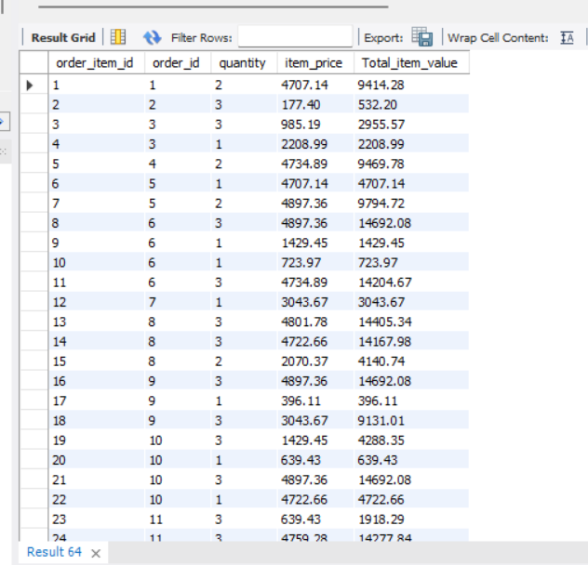

4.Combine customer name and phone number in a single column
Query : select name,phone,concat(name,"--",phone) as name_phone
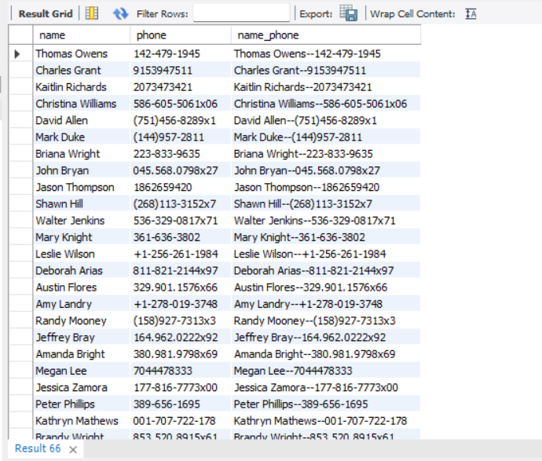
from customers;

5. Extract only the date part from order timestamps for date-wise reporting
Query: select order_id,Date(order_date) as order_day
from orders;

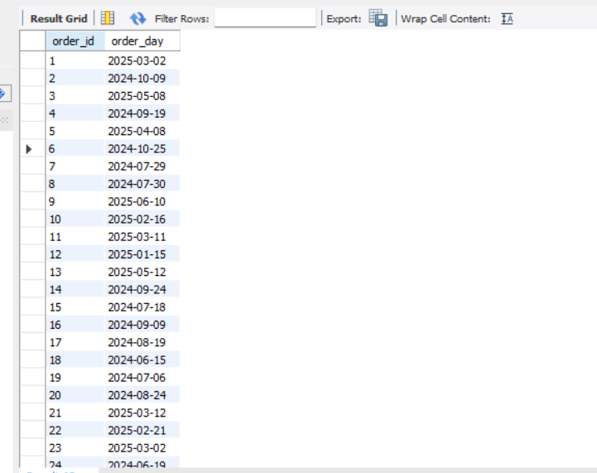
6. List products that do not have any stock left
Query: select * from products
where stock_quantity is null;
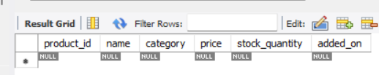

Level 3: Aggregations
1.Count the total number of orders placed
select count(*) as total_orders
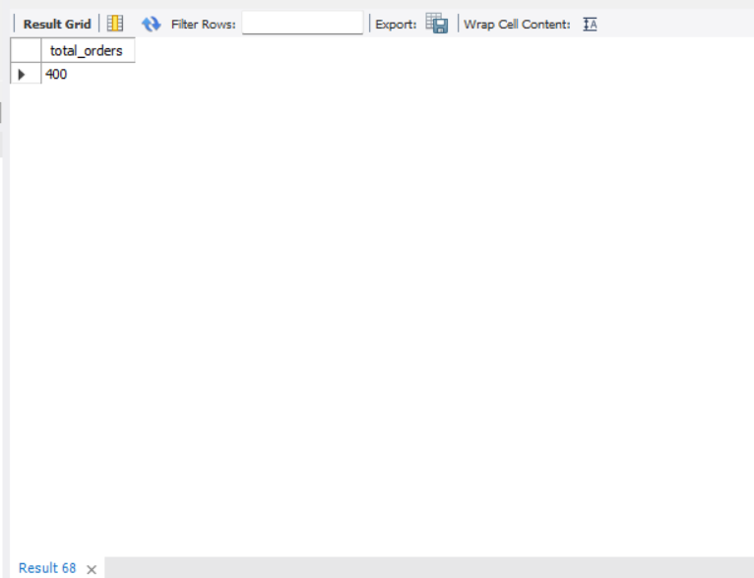
from orders;

2.Calculate the total revenue collected from all orders
Query: select round(sum(total_amount),2) as Total_Revenue
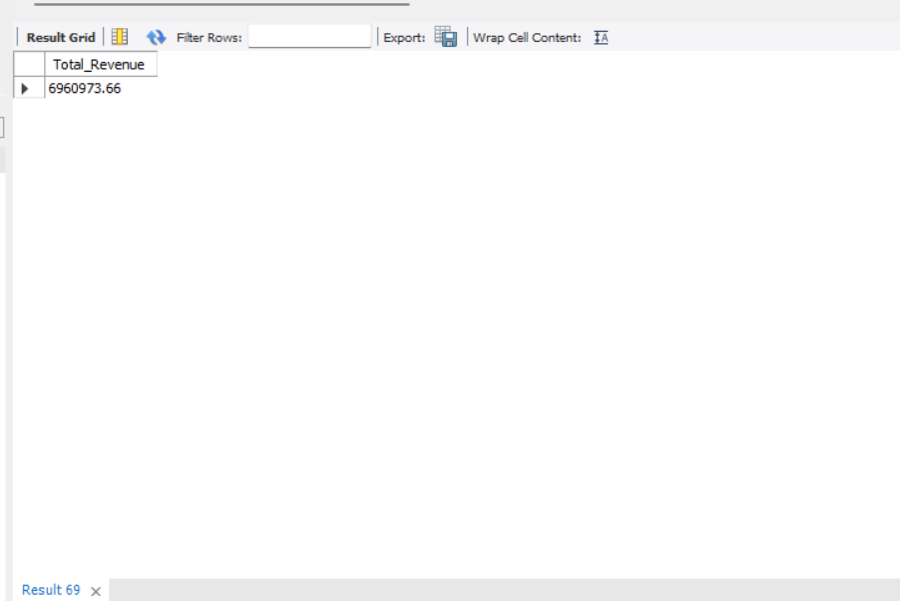
from orders;

3.Calculate the average order value
Query: select round(avg(total_amount),2) as Average_order_value
from orders;

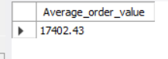

4.Count the number of customers who have placed at least one order
select count(distinct customer_id) as _customers_
from orders
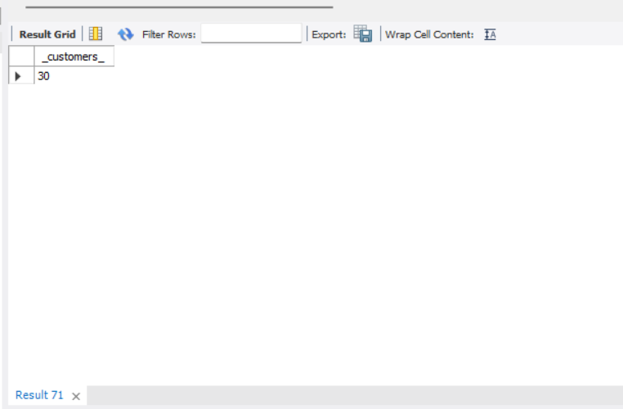
where order_id>=1;

5.Find the number of orders placed by each customer
Query: select customer_id,count(*) as number_orders
from orders
group by customer_id;
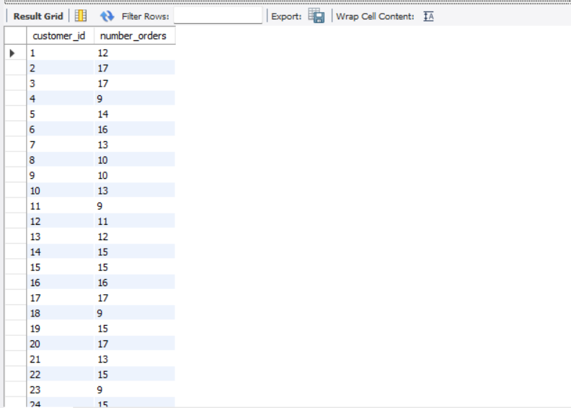

6.Find total sales amount made by each customer
Query: select customer_id,sum(total_amount) as total_spent
from orders group by customer_id;
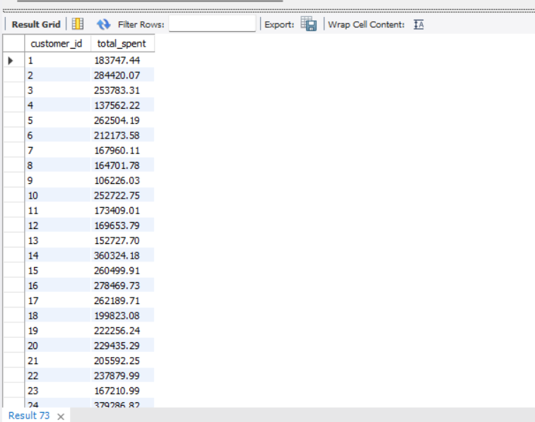

7.List the number of products sold per category.
Query: select p.category, SUM(oi.quantity) AS units_sold
from order_items oi JOIN products p ON oi.product_id = p.product_id
group by p.category;
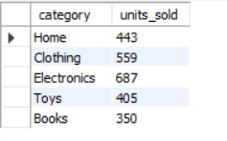

8.Find the average item price per category
Query: select category,round(avg(price),2) as Average_item_price
from products
group by category;

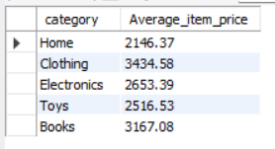
9.Show number of orders placed per day
Query: select Date(order_date) as order_day,count(*) as number_orders
from orders
group by Date(order_date)
order by order_day;

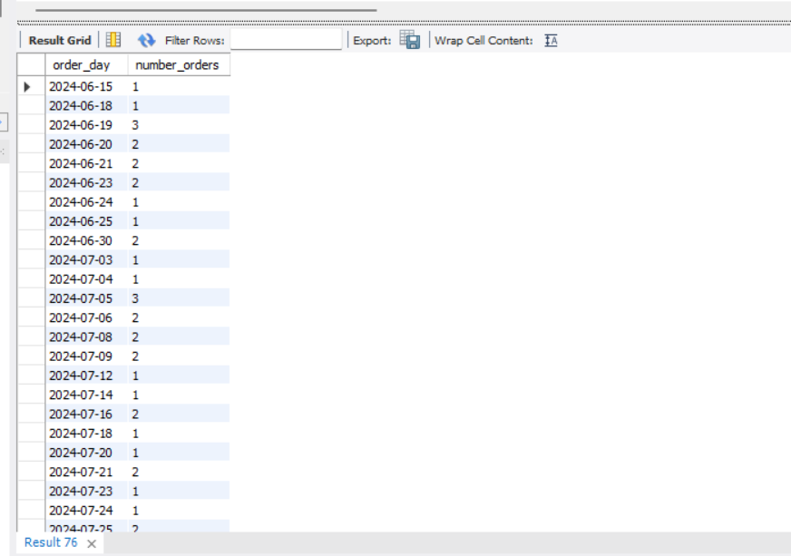
10. List total payments received per payment method
Query: select method,sum(amount_paid) as total_payments
from payments
group by method;
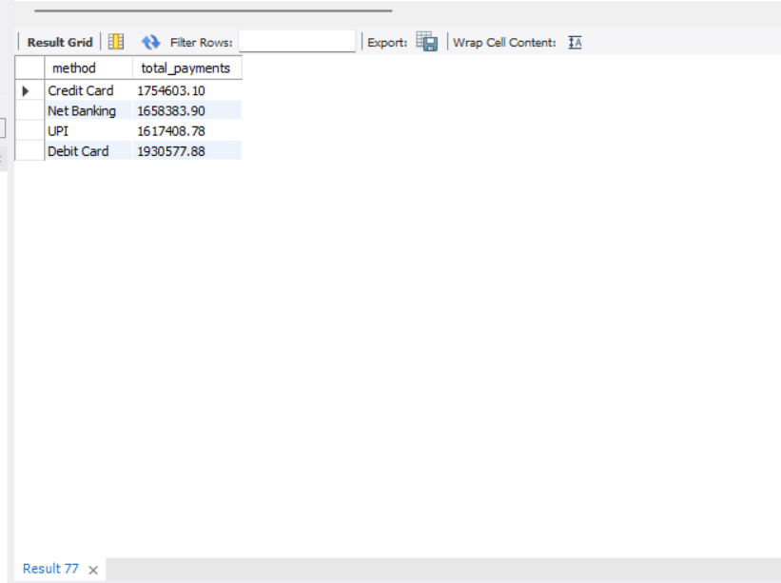

Level 4: Multi-Table Queries (JOINS)

1.Retrieve order details along with the customer name
Query: select c.name,o.order_id,o.order_date,o.total_amount,o.status
from customers c inner join orders o
on c.customer_id=o.customer_id;

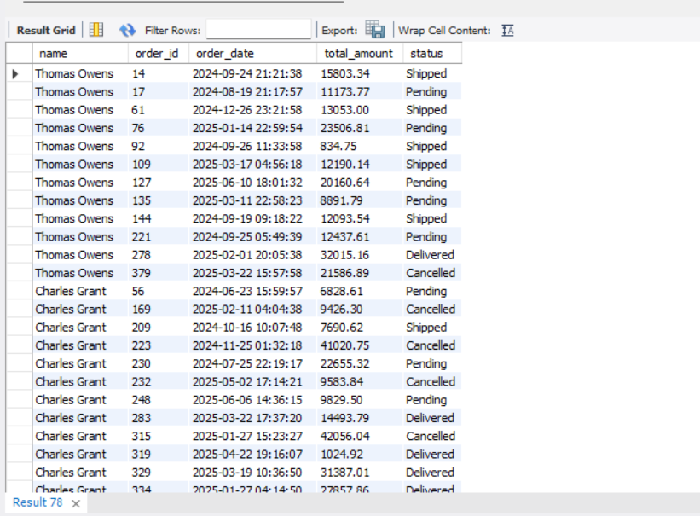

2. Get list of products that have been sold.
Query: select distinct p.product_id, p.name, p.category
from products p inner join order_items oi
on p.product_id = oi.product_id;

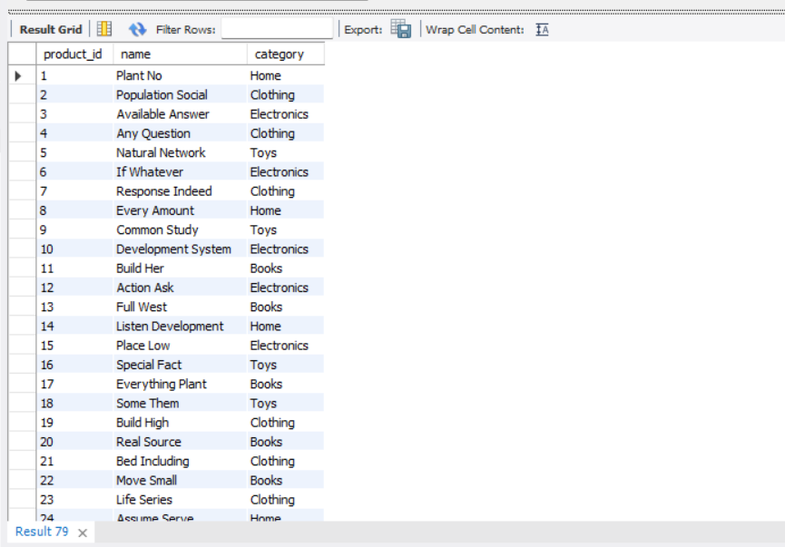

3. List all orders with their payment method
Query:select o.order_id,p.method,o.order_date
from orders o inner join payments p
on o.order_id=p.order_id;

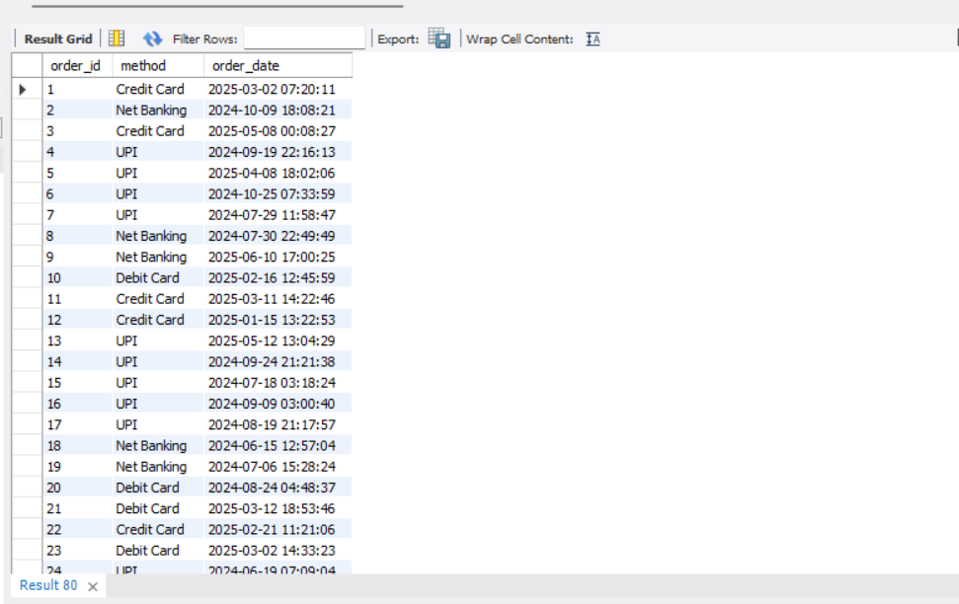

4. Get list of customers and their orders.
Query: select c.customer_id,c.name,o.order_id
from customers c left join orders o
on c.customer_id=o.customer_id;
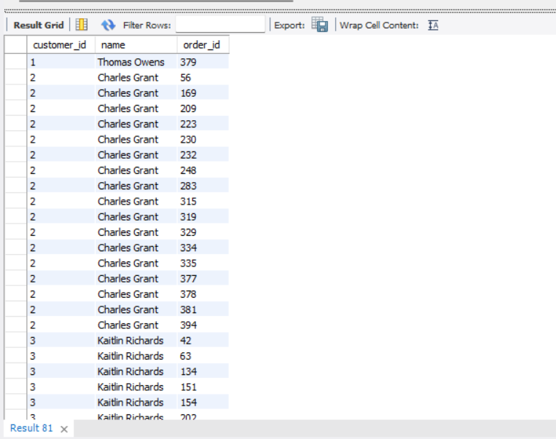

5. List all products along with order item quantity.
Query: select p.product_id,p.category,oi.quantity
from products p left join order_items oi
on p.product_id=oi.product_id;

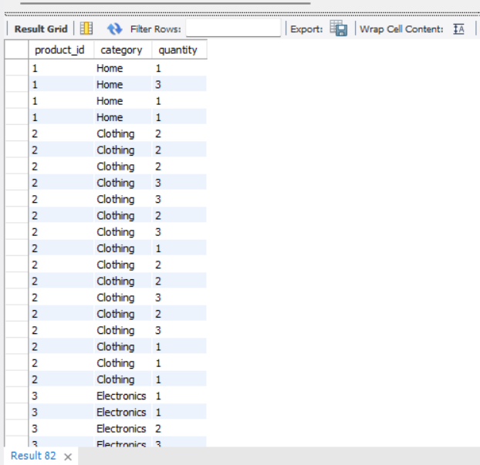

6.List all payments including those with no matching orders
Query: select p.payment_id,p.method,o.order_id,p.amount_paid
from orders o right join payments p
on o.order_id=p.order_id;

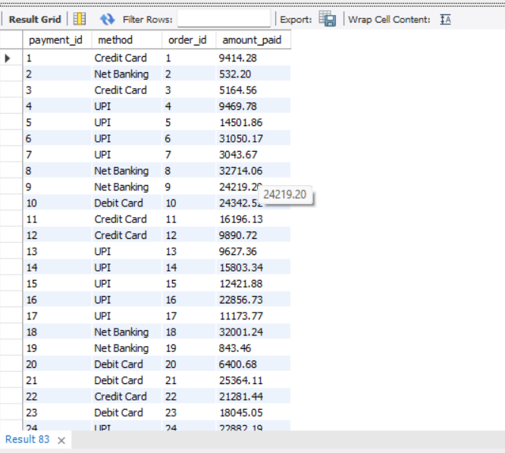

7.Combine data from three tables: customer, order, and payment
Query: SELECT c.name AS customer_name, o.order_id, o.total_amount, p.method, p.amount_paid FROM customers c JOIN orders o
ON c.customer_id = o.customer_id
JOIN payments p ON o.order_id = p.order_id;
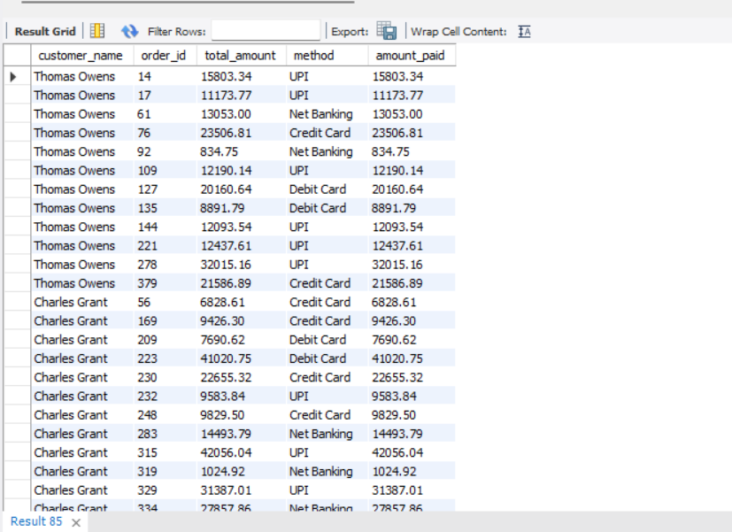

Level 5: Subqueries (Inner Queries)

1.List all products priced above the average product price
Query: select *
from products
where price>
(select round(avg(price),2) as Average_amt from products);

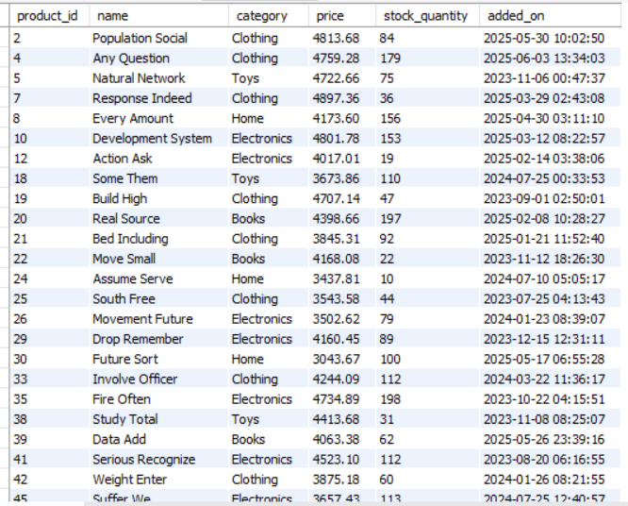

2.Find customers who have placed at least one order
Query: select *
from customers
where customer_id in
(select distinct customer_id from orders);

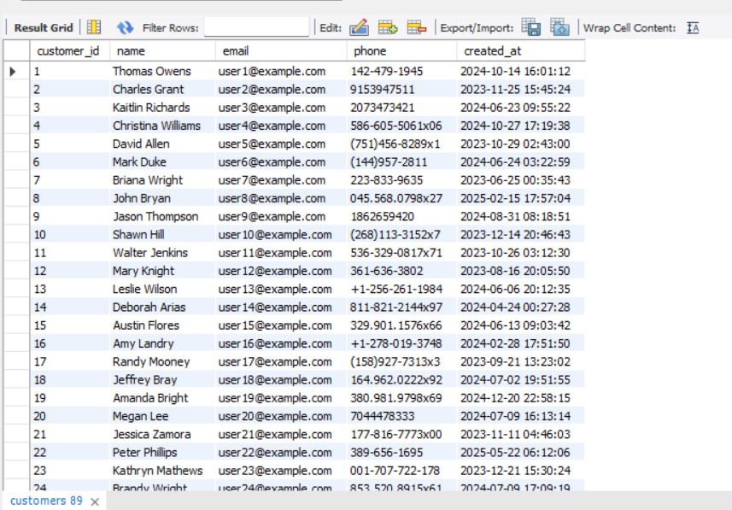

3. Show orders whose total amount is above the average for that customer
Query: select *
from orders o
where total_amount>
(select avg(total_amount) from orders
where customer_id=o.customer_id);
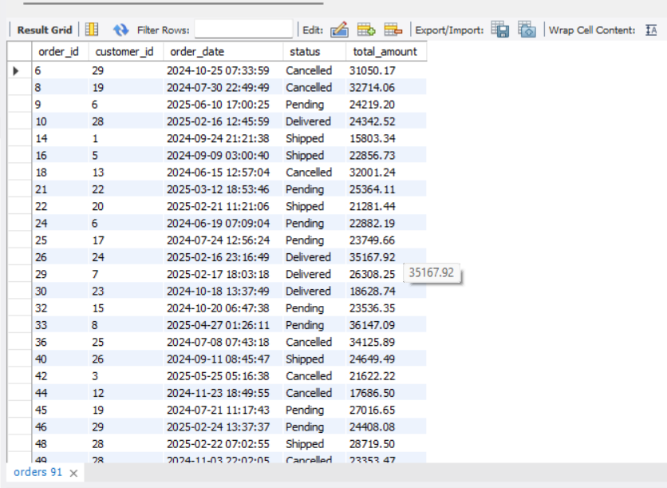

4.Display customers who haven’t placed any orders
Query: select *
from customers
where customer_id not in (select customer_id from orders
where customer_id is not null);
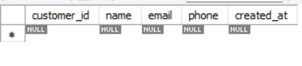

5.Show products that were never ordered
Query: select *
from products
where product_id not in
(select distinct product_id from order_items);
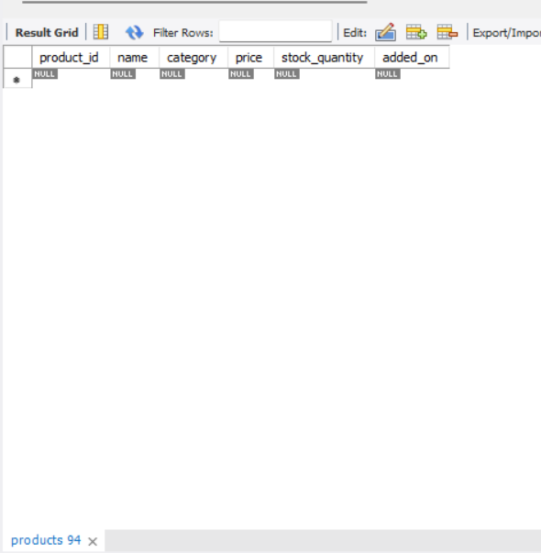

6.Show highest value order per customer
Query: select *
from orders o
where o.total_amount= (select max(o2.total_amount) from orders o2
where o2.customer_id=o.customer_id);

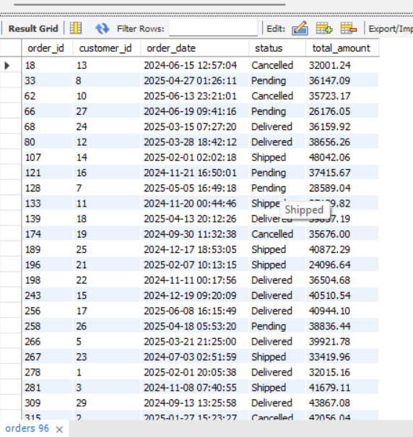

7.Highest Order Per Customer (Including Names)
Query: SELECT c.name AS customer_name, o.order_id, o.total_amount
FROM orders o JOIN customers c ON c.customer_id = o.customer_id
WHERE o.total_amount = (SELECT MAX(o2.total_amount) FROM orders o2
WHERE o2.customer_id = o.customer_id);
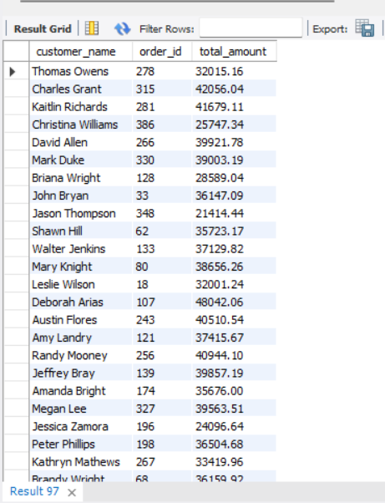

Level 6: Set Operations

1.List all customers who have either placed an order or written a product review
Query: select name
from customers
where customer_id in (select distinct customer_id from orders
Union
select distinct customer_id from product_reviews);

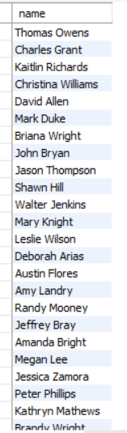

2.List all customers who have placed an order as well as reviewed a product
Query: select distinct customer_id from orders
where customer_id in
(select customer_id from product_reviews);

(Or)

SELECT DISTINCT c.name
FROM customers c
WHERE c.customer_id IN (SELECT customer_id FROM orders)
AND c.customer_id IN (SELECT customer_id FROM product_reviews);

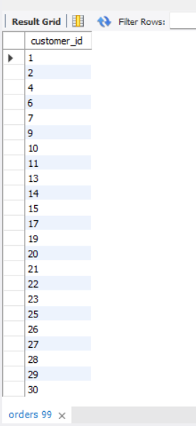
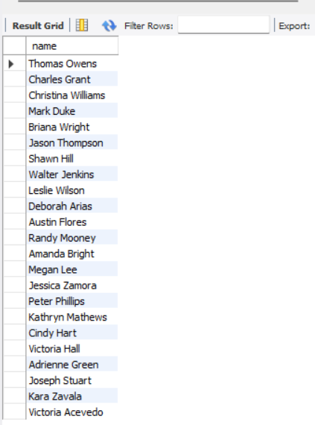
(or)

