COMP40004 WEB DEVELOPMENT AND OPERATING SYSTEMS

By: Sumaiya- CB014630

Description

The project of creating a website for grocery supermarkets presented several challenges, with the primary one being the need to ensure the website was suitable for both mobile and desktop platforms. However, with guidance from my lecturer and insights gained from YouTube tutorials, I was able to navigate these challenges effectively.

To begin, I sketched out wireframes to visualize the layout, though translating these into HTML and CSS posed difficulties initially. Through a process of trial and error, I overcame these obstacles, with the concept of flexbox proving particularly helpful in achieving the desired layout flexibility.

Overall, this project has been a valuable learning experience, highlighting the importance of perseverance and utilizing available resources to overcome technical challenges in web development.

Wireframes of home page (mobile).

Wireframes of home page (desktop).

Wireframes of about us page (mobile).

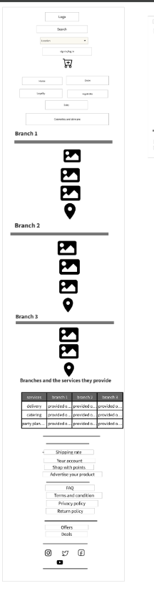

Wireframes of about us page (desktop).

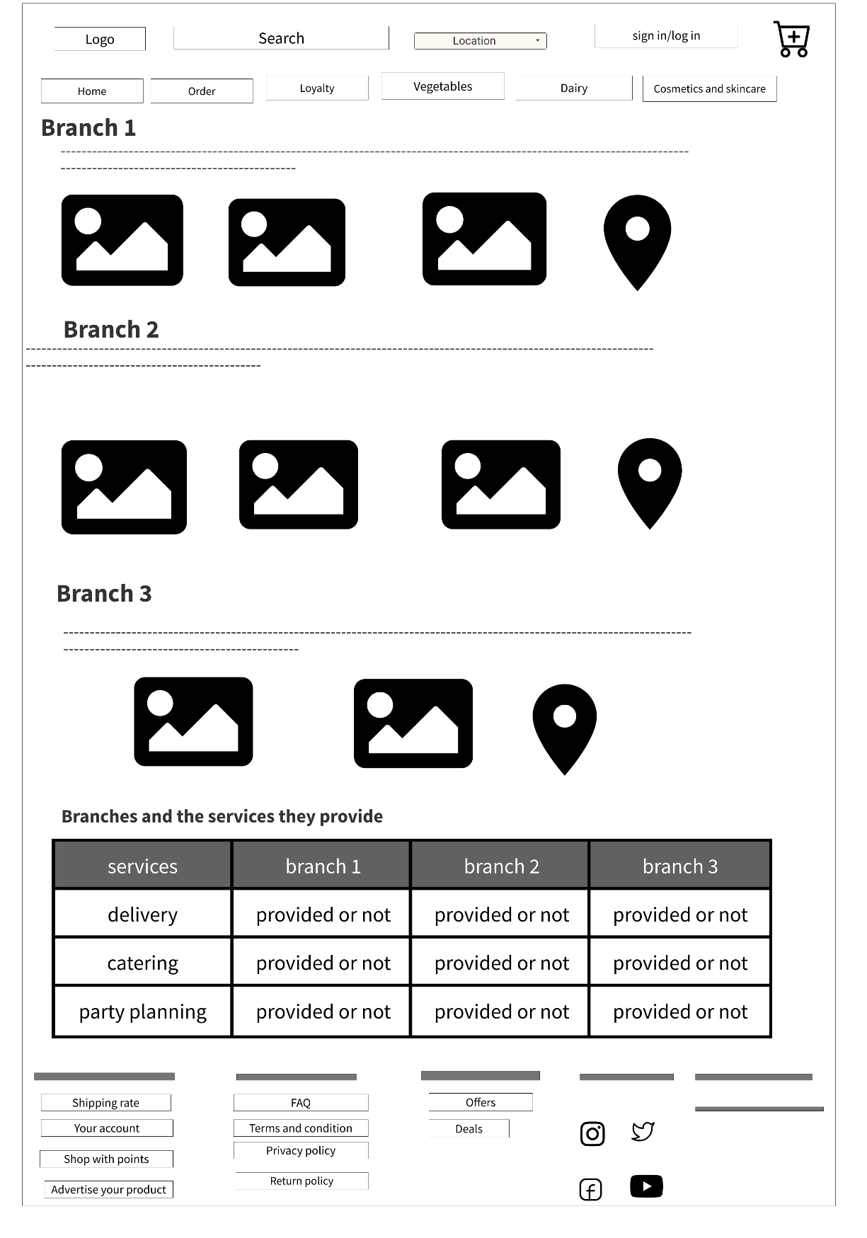

Wireframes of dairy page (mobile).

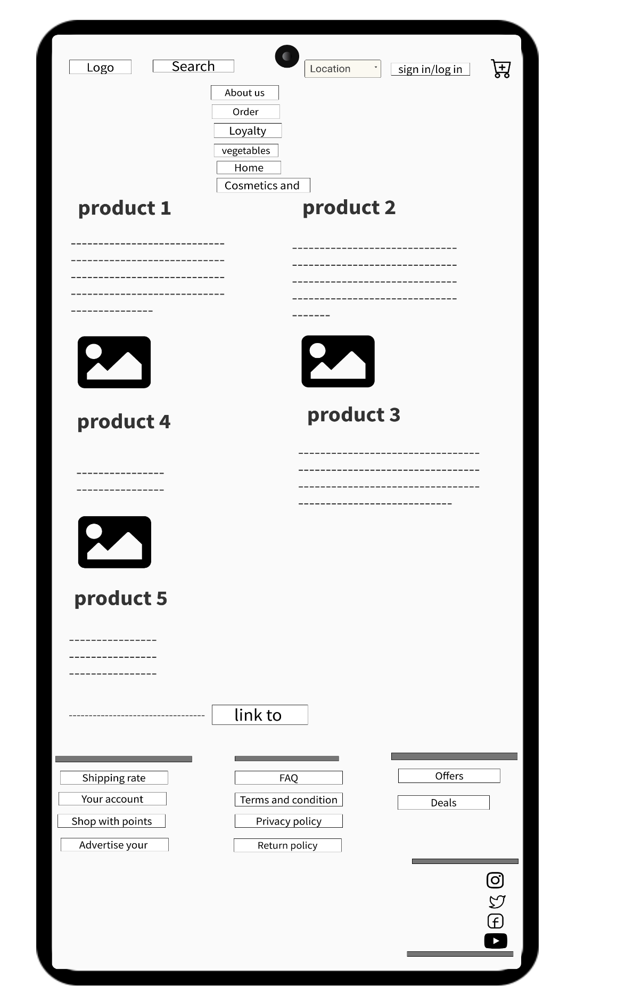

Wireframes of dairy page (desktop).

Wireframes of vegetables page (mobile)

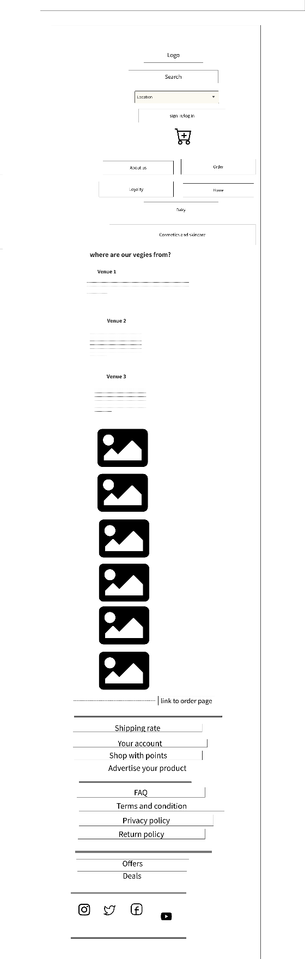

Wireframes of vegetables page (desktop)

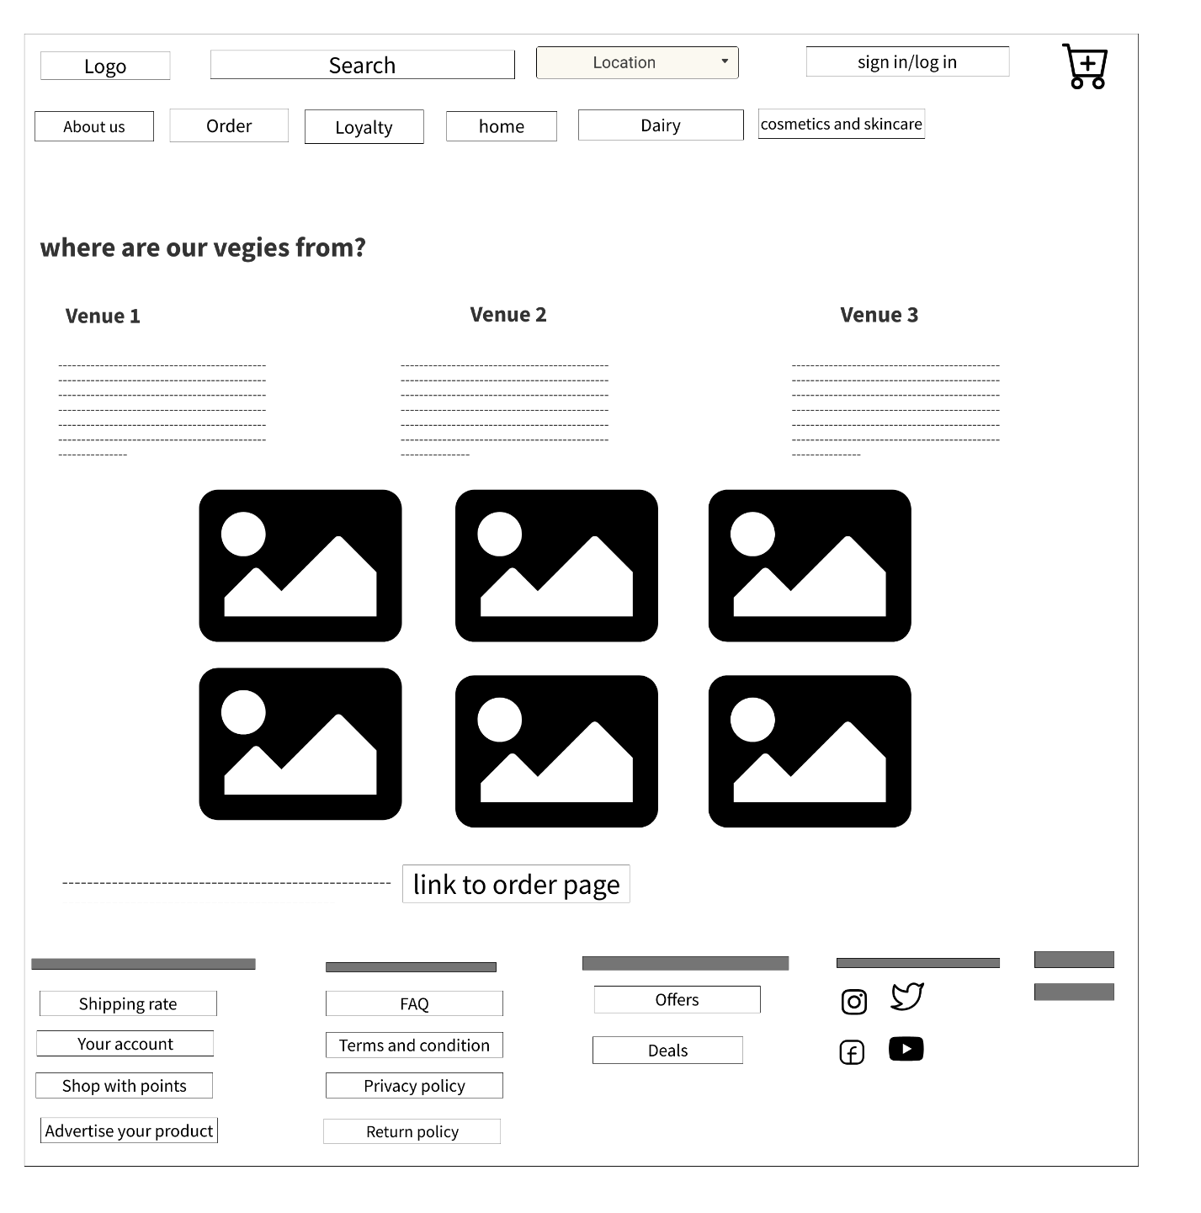

Wireframes of cosmetics and skincare page (mobile)

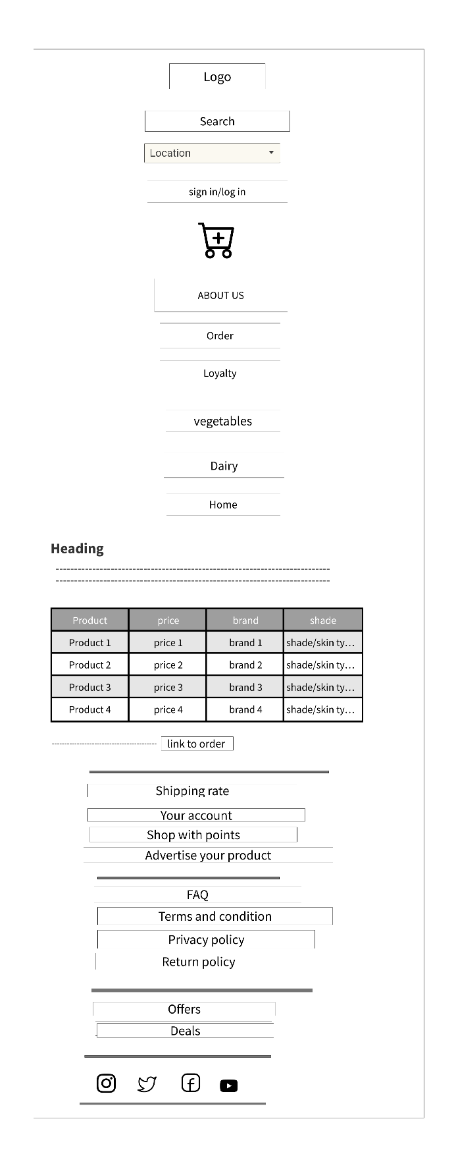

Wireframes of cosmetics and skincare page (desktop)

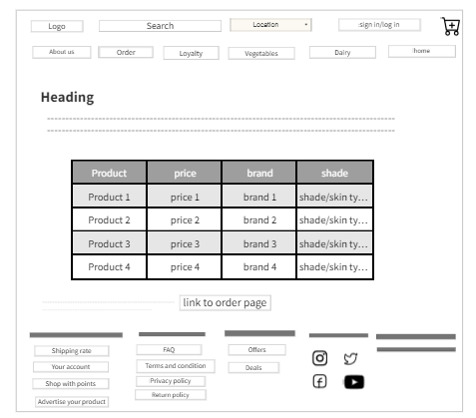

Wireframes of order page (mobile)

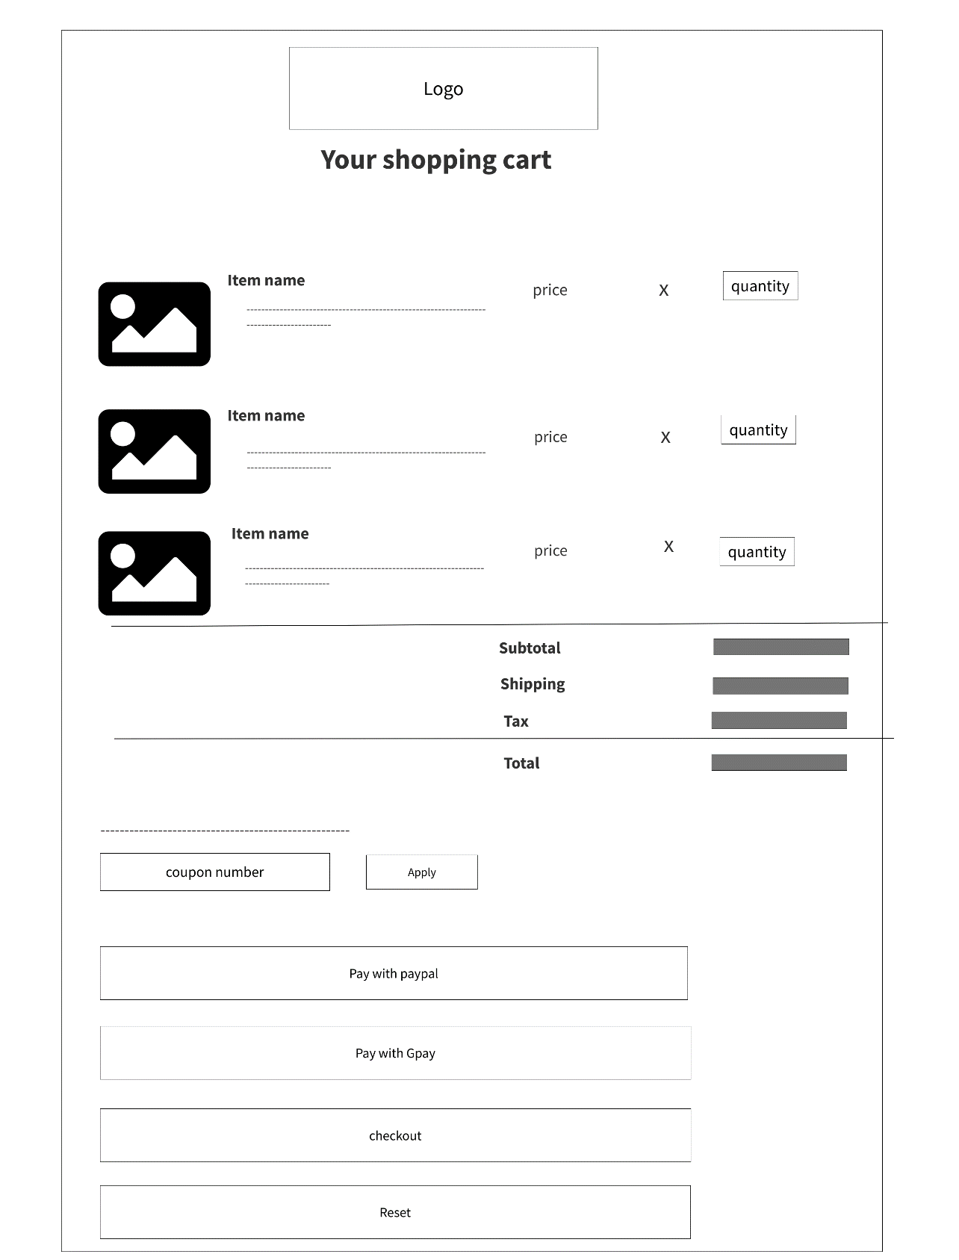

Wireframes of order page (desktop)

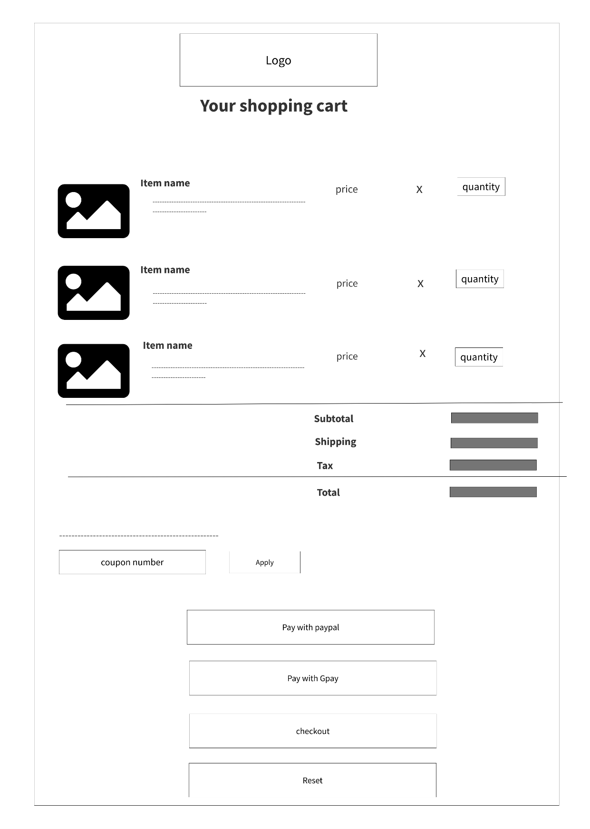

Wireframes of loyalty page (mobile)

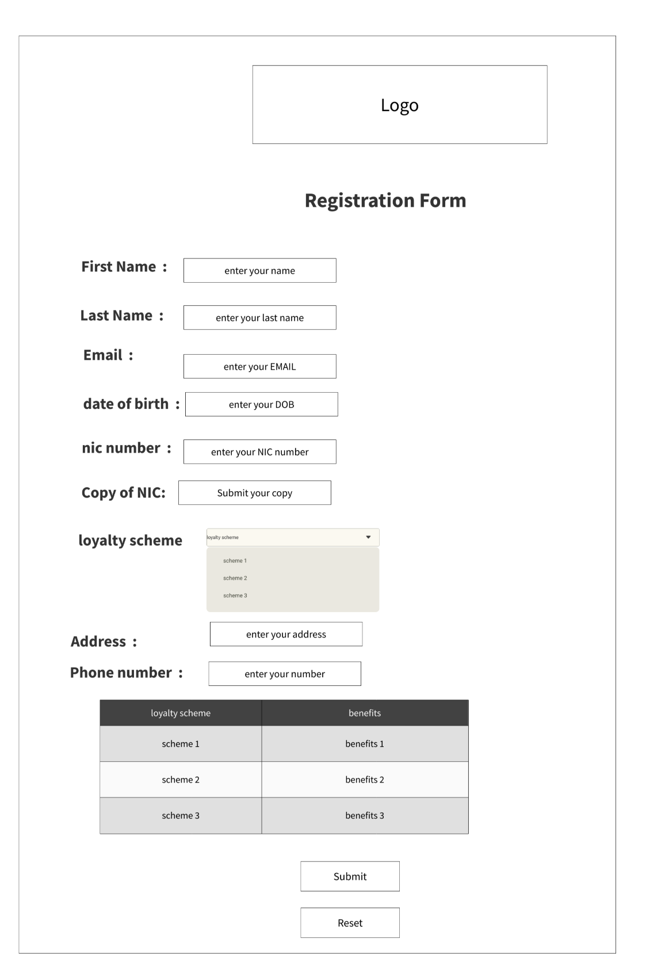

Wireframes of loyalty page (desktop)

