TABLET COUNTNG AND BOTTLE FILLING SYSTEM
Sumaiya mansoor khan(2024601)
Safia malik(2024555)
ELECTRICAL ENGINEERING
GIKI

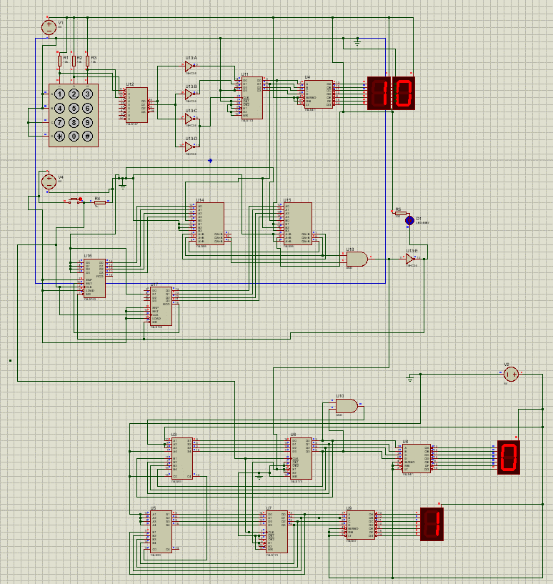
— This project presents the design and simulation of a digital tablet counting and monitoring system using combinational and sequential logic circuits. The system allows a user to enter a preset number of tablets per bottle using a keypad. The entered value is encoded, stored, displayed, and compared with the actual tablet count. Tablet counting is simulated using a push-button input, and cumulative tablet usage is calculated using cascaded adders and registers. The complete system is implemented and verified using Proteus simulation, demonstrating reliable preset comparison and cumulative counting functionality.

Keywords
Tablet Counter, Digital Logic Design, Encoder, Register, Comparator, Cascaded Counters, BCD Display, Proteus Simulation, Verilog

Introduction
Tablet counting is an essential process in pharmaceutical packaging systems where accuracy and repeatability are critical. Digital logic circuits provide an effective solution for implementing such systems without the complexity of software-based controllers. This project focuses on designing a preset-based tablet counting system using standard TTL logic components. The system allows the user to set a target tablet count, compares it with the actual count, and maintains a cumulative record of tablets dispensed.

Overall System Description
The system consists of the following major blocks:
- Preset entry using a keypad
- Decimal-to-binary encoding
- Preset value storage using registers
- Tablet counting using cascaded counters
- Comparison of preset and actual values
- Cumulative addition using cascaded adders
- Display using BCD-to-seven-segment decoders
Preset Entry and Encoding

- Proteous simulation
A matrix keypad is used to enter the preset number of tablets per bottle. In the implemented design, all keypad rows are grounded, limiting functional inputs to keys 1, 2, and 3. These inputs are sufficient to demonstrate the system operation.
The keypad output is connected to a 74LS147 priority encoder, which converts the decimal input into a 4-bit Binary Coded Decimal (BCD) representation. As the encoder outputs are active-low, the signals are passed through a 74HC04 hex inverter to obtain active-high logic signals.

Tablet Counting and Comparator
Tablet detection is simulated using a push-button, where each press increments a cascaded counter. The counter output represents the actual tablet count. A digital comparator continuously compares the preset value with the counter output. When both values are equal, an LED indicator is activated.
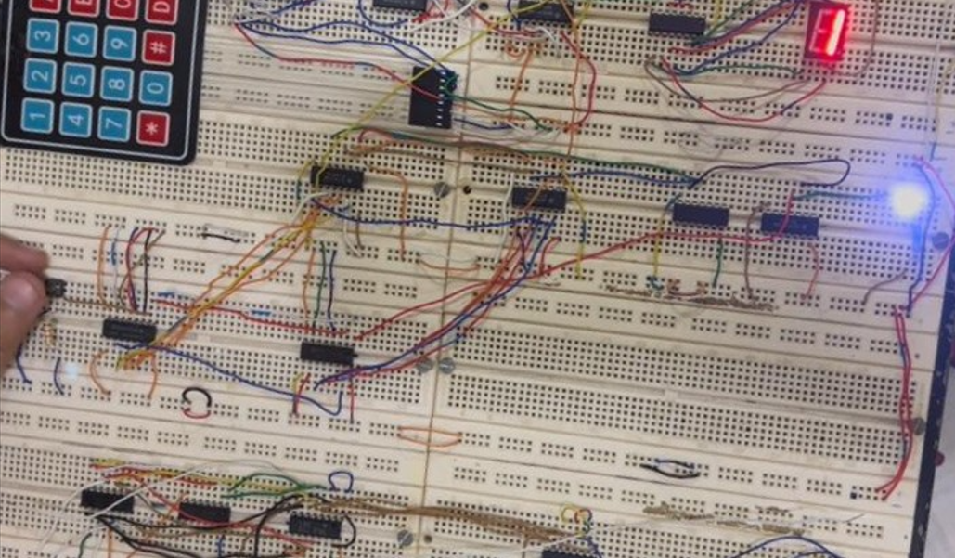
- Comparator.

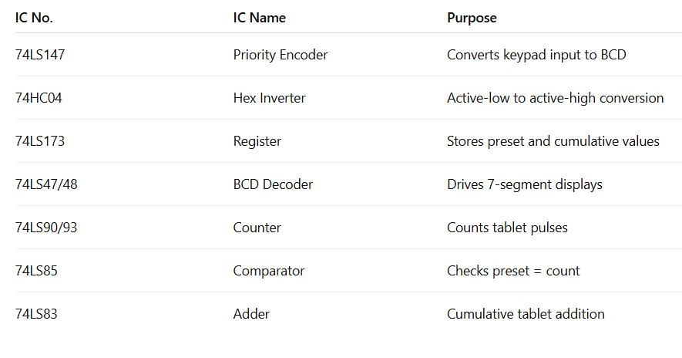 Cumulative Tablet Counting
The counter output is fed to cascaded binary adders to compute the total number of tablets dispensed. The adder output is stored in a register and fed back to the adder input, enabling cumulative addition across multiple bottles.

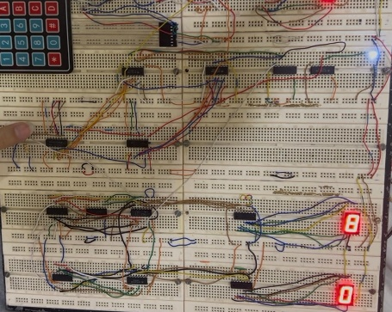

- Cummulative sum.

Display of Results
The cumulative tablet count is decoded and displayed using BCD-to-seven-segment displays. The upper display shows the target tablets per bottle, while the lower display shows the cumulative number of tablets dispensed.

Verilog HDL Implementation
The complete system is also modeled using Verilog HDL. Individual modules are created for encoding, counting, comparison, addition, storage, and display. The Verilog simulation produces results consistent with the Proteus implementation and demonstrates the scalability of the design for FPGA realization.
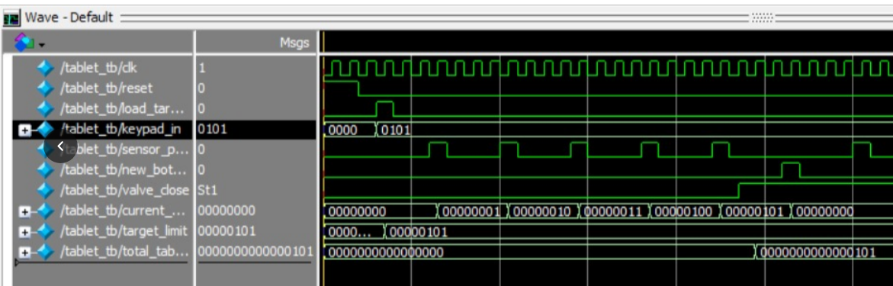
- Verilog wave

Limitations
- Only keypad inputs 1–3 are supported
- Push-button used instead of a real tablet sensor
- Mechanical components are not included
- Intended for simulation and academic demonstration

. Future Scope
Future improvements include full keypad support, sensor-based tablet detection, automatic bottle handling, microcontroller or FPGA implementation, and enhanced display capability.

Conclusion
The project successfully demonstrates a digital tablet counting system using basic logic circuits and Verilog HDL. Preset-based counting, comparison, and cumulative tracking are accurately achieved. The combined Proteus and Verilog implementation validates the effectiveness of the proposed design.

References
[1] M. M. Mano and C. R. Kime, Logic and Computer Design Fundamentals, Pearson.
[2] R. J. Tocci et al., Digital Systems, Pearson.
[3] Texas Instruments, 74LS/74HC Series Datasheets.
[4] Labcenter Electronics, Proteus Design Suite.

