## horizontal line



CSE472 : Machine Learning Sessional

Project name : Credit Card Fraud Detection

**───────────────────────────────────**

175040

175048

Section -A2

# Problem Definition

The digital payments market is soaring as the world shifts towards online and card-based payment methods at a faster rate. With such a shift comes the growing issue of cybersecurity and fraud, which is more common than ever. Hence, enhancing credit card fraud detection is a priority for all banks and financial organizations.

In this project, we want to build a machine learning model to detect fraud in credit card transactions using our dataset.

# Dataset

**Link :**[kaggle_credit_card_fraud_dataset](https://paperswithcode.com/dataset/kaggle-credit-card-fraud-dataset)

**Statistics :** This dataset presents transactions that occurred in two days, which contains 492 frauds out of 284,807 transactions. The dataset is highly unbalanced, the positive class (frauds) account for 0.172% of all transactions.

# Paper Link

**Paper :** [XBNet : An Extremely Boosted Neural Network](https://arxiv.org/pdf/2106.05239)

# Proposed Solution(XBNet architecture)

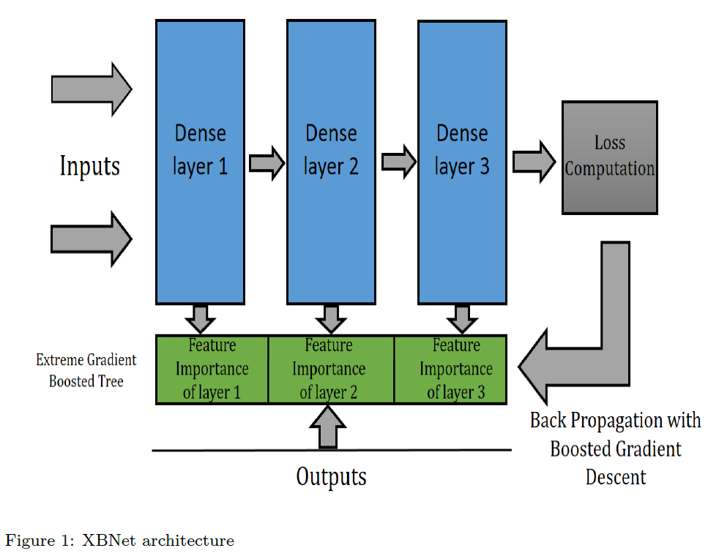

This architecture attempts to combine gradient boosted trees with feed-forward

neural networks. It updates the weights of each layer in the neural network in two steps:

(1) Update weights by gradient descent.

(2) Update weights by using feature importance, of a gradient boosted tree in

every intermediate layer

Each layer has two components, the weight vector and the matrix containing the feature importances. The configuration of each layer is such that during training of a particular layer the weights are first calculated during forward propagation, which is followed by training of an XGBoost model taking inputs as the nodes of that layer, the feature importance of this ensemble model is stored in a matrix as they are required again during back-propagation. The weights are updated on the basis of gradient descent during back-propagation then they are adjusted according to the matrix of feature importances that was calculated during forward propagation.

# 

# Performance metrices

The dataset is highly imbalanced. There are 2,84,808 samples and only 492 of them are detected as fraud cases.

As confusion matrix accuracy is not meaningful for unbalanced classification, we will use the Area Under the Precision-Recall Curve (AUPRC) as our performance metric.

The area under the precision-recall curve (AUPRC or AUC-PR) is a performance metric used for evaluating the accuracy of a binary classifier. The precision-recall curve is a plot of precision (the number of true positive predictions divided by the sum of true and false positive predictions) versus recall (the number of true positive predictions divided by the sum of true positive and false negative predictions) for various threshold settings of the classifier. The area under this curve represents the average precision across all recall levels, and provides a comprehensive summary of the classifier's performance, taking both precision and recall into account. A high AUPRC value indicates a classifier that has a high precision and high recall, while a low value indicates that the classifier struggles to balance precision and recall. AUC-PR is the go-to metric for calibrating the trade-off between recall and specificity.