Note app using Node.js and Vue.js

Introduction:
This is a practice assignment to create a web app named ‘Notes’, which is to be implemented by both Sumaiya Azad and Mir Mahathir Mohammad. The task specified for both of them are written below.
Person | Task | Framework
Sumaiya Azad | Design the server, storage and back-end of the notes app | Node.js
Mir Mahathir Mohammad | Design the GUI and front-end of the application | Vue.js

Features:
-This is a web application where users can write notes.
-A person must create an account in order to begin. This is also the start page of the app.

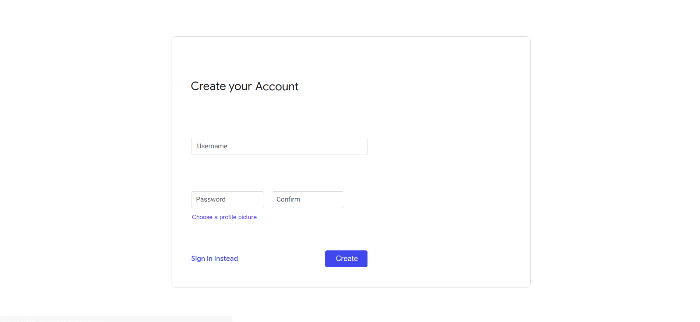
Image 1 Sign up page

-The user must upload a profile picture to complete the sign up process.

-A user must sign in to use the app.

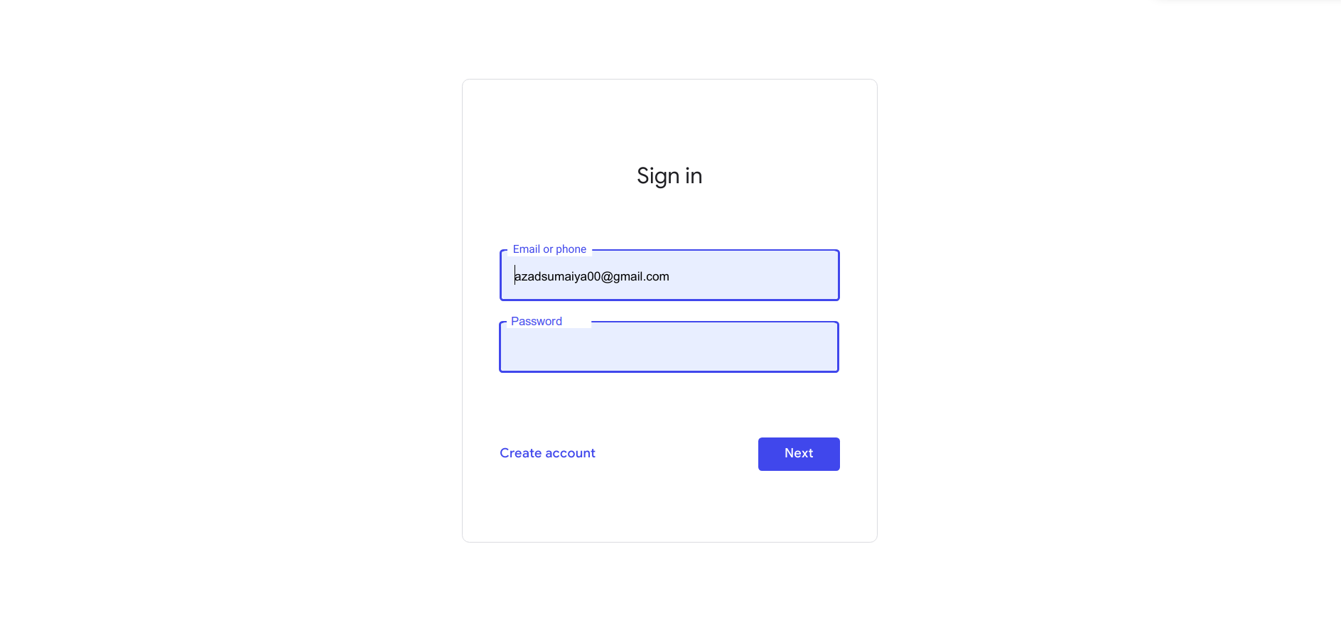
Image 2 Sign In page

- After successful sign in, the user will be directed to the home page shown below.

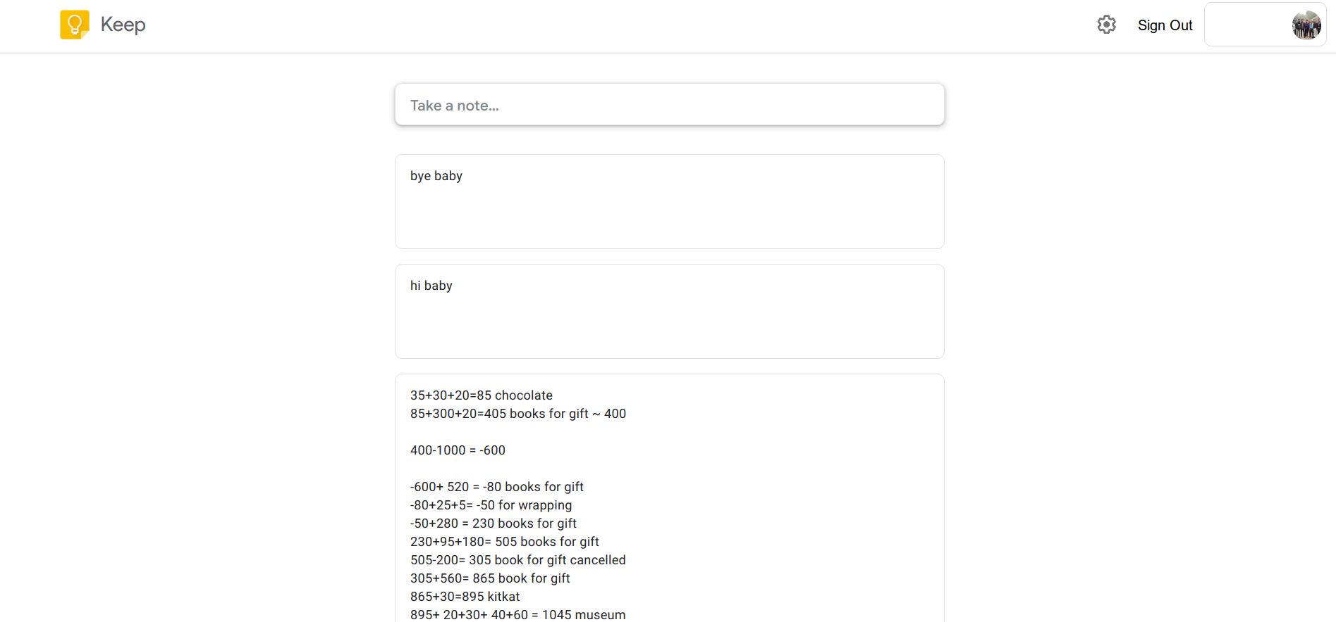
Image 3 Home page

-When the user clicks on ‘Take a note...’ box or any of the previously written notes- he/she will be redirected to the page shown below
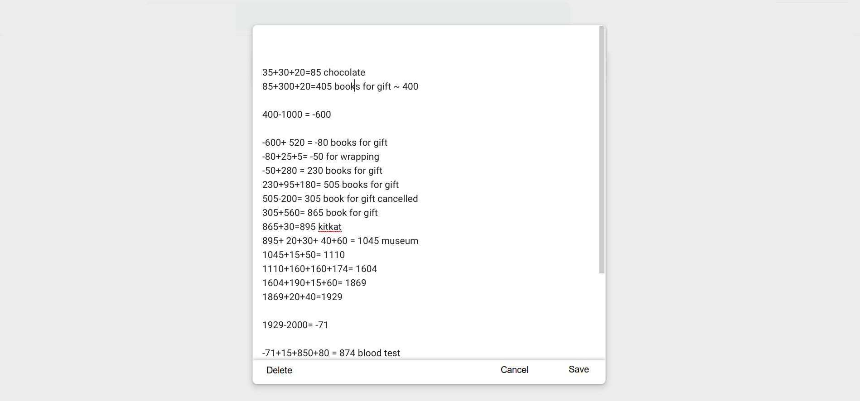
Image 4 Edit page
In case of creating a note, the text field will appear blank, but in case of editing an existing note, the field will contain the previously written note.

- The user can cancel the editing, delete the note or save the note.

-The user will be able to update his/ her password/ profile picture from the settings menu.

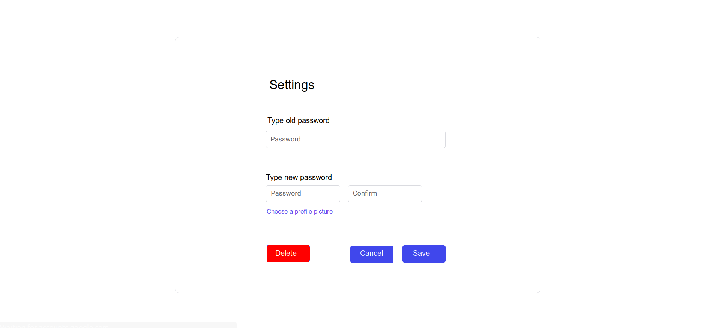
-The user will also be able to delete his/ her account permanently.

The whole frontend must be built using Vue.js. And the whole back-end and storage of the notes should be implemented using node.js.

Deadline:
The deadline will be fixed by project manager baby pakhi Bhootuu pudding Taaha. But she will be advised to follow every bit of the advises her hubby tells her regarding the project. And Taaha is requested to kiss her hubby as much as her hubby wants.

