Numerical Methods Lab 4

Hermite and Newton’s Divided Difference Interpolation [C02]

i. Open the colab file shared in BUX.

ii. Create a copy of that shared file in your drive.

iii. Rename the colab filename using the format **Name-ID-Lab Section**

**Lab Introduction**

**Part 1: Hermite Interpolation**

For the case of Hermite Interpolation, we look for a polynomial that matches both f′(xi) and f(xi) at the nodes xi=x0,…,xn. Say you have n+1 data points, (x0,y0),(x1,y1),x2,y2),…,(xn,yn) and you happen to know the first-order derivative at all of these points, namely, (x0,y′0),(x1,y′1),(x2,y′2),…,(xn,y′n) . According to hermite interpolation, since there are 2n+2 conditions; n+1 for f(xi) plus n+1 for f′(xi) ; you can fit a polynomial of order 2n+1 .

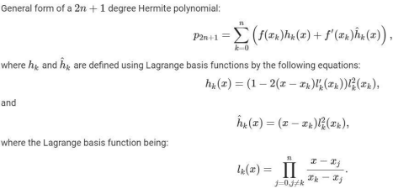

**Part 2: Newton’s Divided Difference Interpolation**

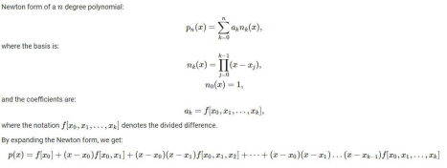

**[Task 1] – 4 marks**

Function l(k, x) has already been defined for you.

You have to implement the functions: **h(k, x) and h_hat(k, x) and hermit(x, y, y_prime)** First two methods implement the Hermit Basis to be used for interpolation using Hermite Polynomials and third method calculates the Hermite polynomial from a set of given nodes and their corresponding derivatives.

You will have to remove the “raise NotImplementedError()”.

**[Task 2] – 3 marks**

1. You have to implement the **calc_div_diff(x,y)** function which takes input x and y, and calculates all the divided differences. You may use the lambda function difference() inside the calc_div_diff(x,y) function to calculate the divided differences.

2. You have to implement the **__call__()** function which takes an input x, and calculates y using all the difference coefficients. x can be a single value or a numpy. In this case, it is a numpy array. You will have to remove the “raise NotImplementedError()” .

**[Task 3]- 1.5 marks**

**Problem related Newton’s Divided Difference interpolation:**

Suppose, you have three nodes (−1, 3.5 ), ( 0, 1.2 ), ( 1, 2.8 ). Using Newton's Divided Difference method, print out the value of the interpolating polynomial at x = 0.5.

You have to solve the given problem using **Newtons_Divided_Differences class**.

**[Task 4]- 1.5 marks**

**Problem related Hermite interpolation:**

Suppose, consider the following data set:

| *x* | *f(x)* | *f’(x)* |
| --- | --- | --- |
| 0 | 2 | 1 |
| 1 | 4 | -1 |
| 3 | 5 | -2 |

Using Hermit basis, print out the interpolating polynomial and find the value at x = [0.75,1.65,2.50].

You have to solve the given problem using **hermit function**.