**PROJECT DOCUMENTATION**

“Rhythmic Tunes: Melody Companion**”**

Team ID: NM2025TMID371

Team Leader: Tharani G& [gtharani1102@gmail.com](mailto:gtharani1102@gmail.com)

Team Members: Roselin Kaviya D & [roselinkaviya2006@gmail.com](mailto:roselinkaviya2006@gmail.com)

Team Members: Kanchana R & [kanchanagomathi6@gmail.com](mailto:kanchanagomathi6@gmail.com)

Team Members: Sumaiya Parveen M & [sumaiyaparveen.msp@gmail.com](mailto:sumaiyaparveen.msp@gmail.com)

Team Members: Vaishnavi M & [vaishu842853@gmail.com](mailto:vaishu842853@gmail.com)

INTRODUCTION

Music has always been an integral part of human culture, evolving alongside technology to meet the changing preferences of listeners. In the digital era, streaming platforms and music applications have transformed how people discover, interact with, and enjoy music. The demand for personalized and interactive music experiences has significantly increased, pushing developers to design solutions that focus not only on content delivery but also on user engagement and convenience.

The application is designed with a strong emphasis on frontend development, ensuring that users interact with a clean, intuitive, and responsive interface across a variety of devices. Features such as curated playlists, recommendations, and easy navigation are carefully crafted to improve user satisfaction. Aesthetic design and usability are central considerations, bridging the gap between technology and entertainment.

In the backend, Mongo DB serves as the database solution, providing flexibility and efficiency in managing vast and diverse music-related data. Unlike traditional relational databases, Mongo DB supports unstructured formats, which makes it suitable for handling complex user activity logs, metadata, and playlist structures. This enables Rhythmic Tunes to adapt quickly to user needs while maintaining fast performance and scalability.

By combining an engaging frontend with powerful database capabilities, Rhythmic Tunes positions itself as more than just another music platform. It becomes a personalized companion, offering listeners a tailored musical journey while showcasing the potential of modern web technologies in reimagining entertainment experiences. Rhythmic Tunes: Your Melodic Companion is a project that aims to fill this space by offering a modern and adaptive music exploration platform

**2. SOURCE CODE**

<!DOCTYPE html> index.html

<html lang="en">

<head>

<meta charset="UTF-8" />

<meta name="viewport" content="width=device-width, initial-scale=1.0"/>

<title>Rhythmic Tunes – Your Melodic Companion</title>

<link rel="stylesheet" href="style.css" />

</head>

<body>

<header>

<h1>Rhythmic Tunes</h1>

<p>Your Melodic Companion</p>

</header>

<nav>

<ul>

<li><a href="#playlist">Playlist</a></li>

<li><a href="#favorites">Favorites</a></li>

<li><a href="#about">About</a></li>

</ul>

</nav>

<section id="search-bar">

<input type="text" id="search-input" placeholder="Search songs..." onkeyup="searchSongs()" />

</section>

<section id="playlist">

<h2>Playlist</h2>

<div class="songs" id="songs-list">

<!-- Song cards -->

<div class="song-card" data-title="Dreamscape">

<img src="images/song1.jpg" alt="Dreamscape">

<h3>Dreamscape</h3>

<audio controls>

<source src="songs/song1.mp3" type="audio/mpeg">

</audio>

<button onclick="addToFavorites('Dreamscape', 'images/song1.jpg', 'songs/song1.mp3')">Add to Favorites</button>

</div>

<div class="song-card" data-title="Ocean Breeze">

<img src="images/song2.jpg" alt="Ocean Breeze">

<h3>Ocean Breeze</h3>

<audio controls>

<source src="songs/song2.mp3" type="audio/mpeg">

</audio>

<button onclick="addToFavorites('Ocean Breeze', 'images/song2.jpg', 'songs/song2.mp3')">Add to Favorites</button>

</div>

<div class="song-card" data-title="Mountain Echoes">

<img src="images/song3.jpg" alt="Mountain Echoes">

<h3>Mountain Echoes</h3>

<audio controls>

<source src="songs/song3.mp3" type="audio/mpeg">

</audio>

<button onclick="addToFavorites('Mountain Echoes', 'images/song3.jpg', 'songs/song3.mp3')">Add to Favorites</button>

</div>

<div class="song-card" data-title="City Lights">

<img src="images/song4.jpg" alt="City Lights">

<h3>City Lights</h3>

<audio controls>

<source src="songs/song4.mp3" type="audio/mpeg">

</audio>

<button onclick="addToFavorites('City Lights', 'images/song4.jpg', 'songs/song4.mp3')">Add to Favorites</button>

</div>

<div class="song-card" data-title="Forest Whispers">

<img src="images/song5.jpg" alt="Forest Whispers">

<h3>Forest Whispers</h3>

<audio controls>

<source src="songs/song5.mp3" type="audio/mpeg">

</audio>

<button onclick="addToFavorites('Forest Whispers', 'images/song5.jpg', 'songs/song5.mp3')">Add to Favorites</button>

</div>

</div>

</section>

<section id="favorites">

<h2>Your Favorites</h2>

<div id="favorites-list">

<p>No favorites yet.</p>

</div>

</section>

<section id="about">

<h2>About Rhythmic Tunes</h2>

<p>Explore melodies with images, create playlists, add your favorite songs, and easily search through them. Enjoy music your way!</p>

</section>

<script src="script.js"></script>

</body>

</html>style.css

body {

font-family: Arial, sans-serif;

margin: 0;

background: #f0f2f5;

color: #333;

}

header {

text-align: center;

padding: 20px;

background: #4e54c8;

color: white;

}

nav {

background: #2c3e50;

}

nav ul {

list-style: none;

display: flex;

justify-content: center;

margin: 0;

padding: 0;

}

nav ul li {

margin: 0 15px;

}

nav ul li a {

color: white;

text-decoration: none;

padding: 15px;

display: block;

}

nav ul li a:hover {

background: #34495e;

}

#search-bar {

text-align: center;

margin: 20px;

}

#search-input {

width: 80%;

max-width: 400px;

padding: 10px;

font-size: 16px;

}

section {

padding: 20px;

max-width: 1000px;

margin: auto;

}

.songs {

display: flex;

gap: 20px;

flex-wrap: wrap;

justify-content: center;

}

.song-card {

background: white;

border: 1px solid #ddd;

border-radius: 8px;

width: 220px;

text-align: center;

box-shadow: 2px 2px 8px rgba(0,0,0,0.1);

padding: 10px;

}

.song-card img {

width: 100%;

border-radius: 5px;

}

.song-card button {

margin-top: 10px;

padding: 8px 12px;

border: none;

background: #4e54c8;

color: white;

border-radius: 4px;

cursor: pointer;

}

.song-card button:hover {

background: #3b3f99;

}

#favorites-list {

display: flex;

flex-wrap: wrap;

gap: 15px;

justify-content: center;

}

.favorite-item {

background: white;

border: 1px solid #ddd;

border-radius: 8px;

width: 200px;

text-align: center;

box-shadow: 2px 2px 6px rgba(0,0,0,0.1);

padding: 10px;

}

.favorite-item img {

width: 100%;

border-radius: 5px;

}

script.js

function addToFavorites(name, imageSrc, songSrc) {

const list = document.getElementById('favorites-list');

if (list.querySelector('p')) {

list.innerHTML = '';

}

const item = document.createElement('div');

item.className = 'favorite-item';

item.innerHTML = `

<img src="${imageSrc}" alt="${name}">

<h4>${name}</h4>

<audio controls>

<source src="${songSrc}" type="audio/mpeg">

Your browser does not support the audio element.

</audio>

`;

list.appendChild(item);

}

function searchSongs() {

const input = document.getElementById('search-input');

const filter = input.value.toLowerCase();

const songs = document.querySelectorAll('#songs-list .song-card');

songs.forEach(song => {

const title = song.getAttribute('data-title').toLowerCase();

if (title.includes(filter)) {

song.style.display = '';

} else {

song.style.display = 'none';

}

});

}

Screenshots

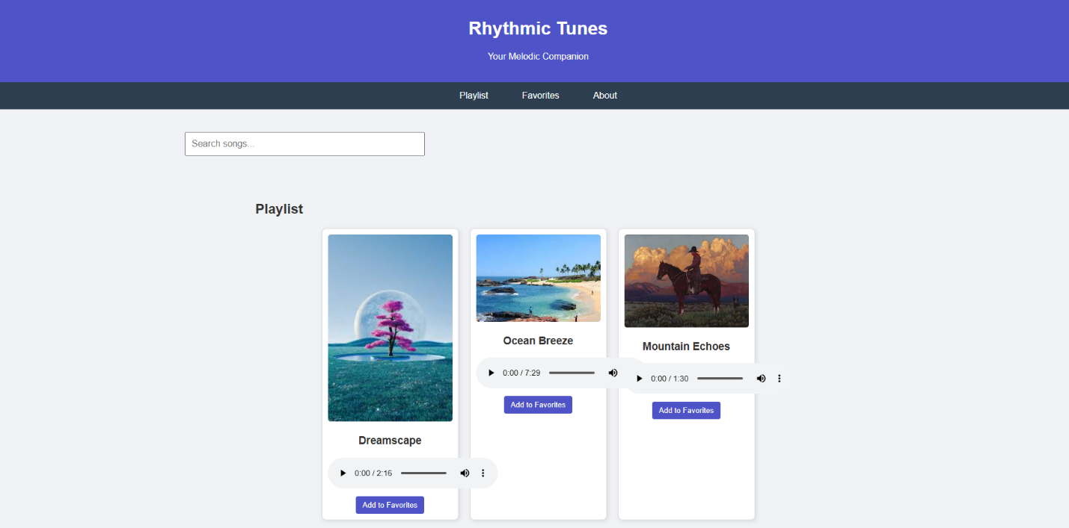

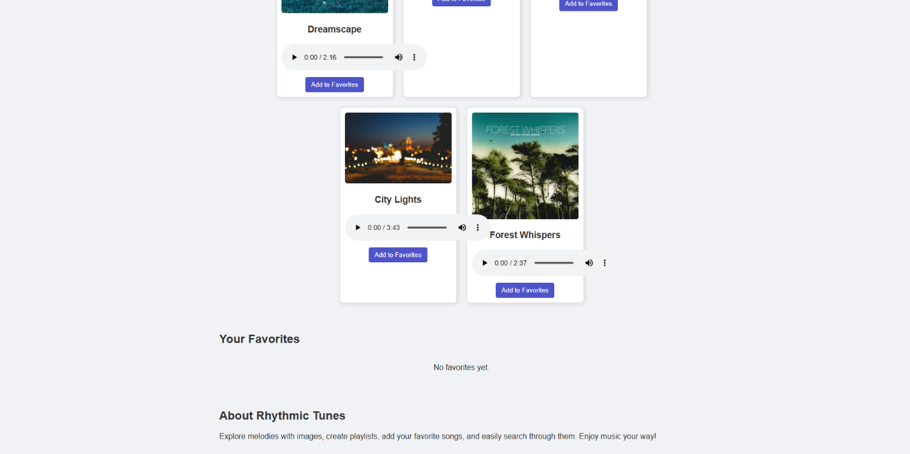

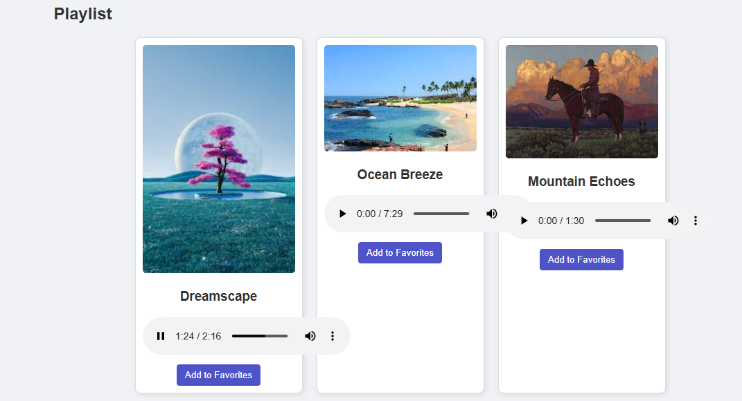

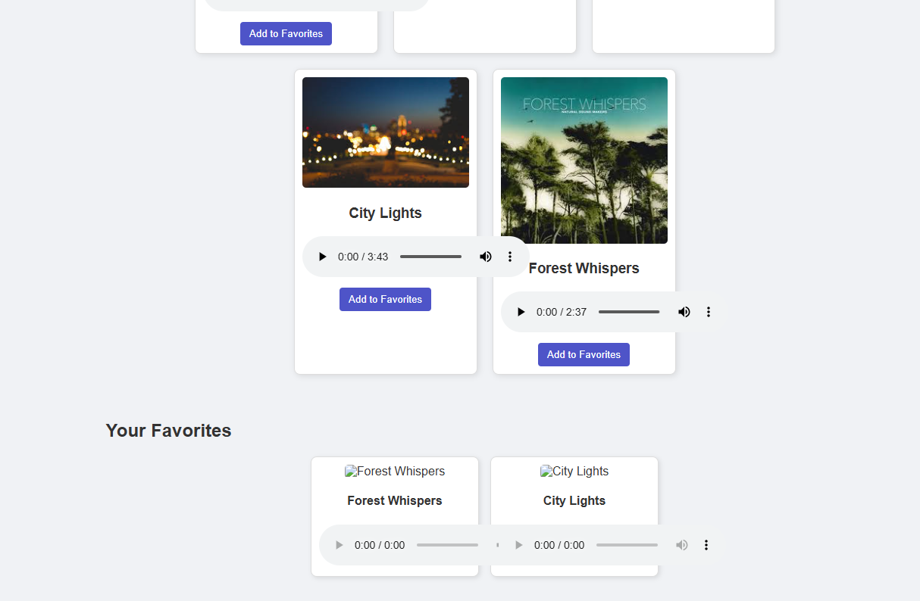

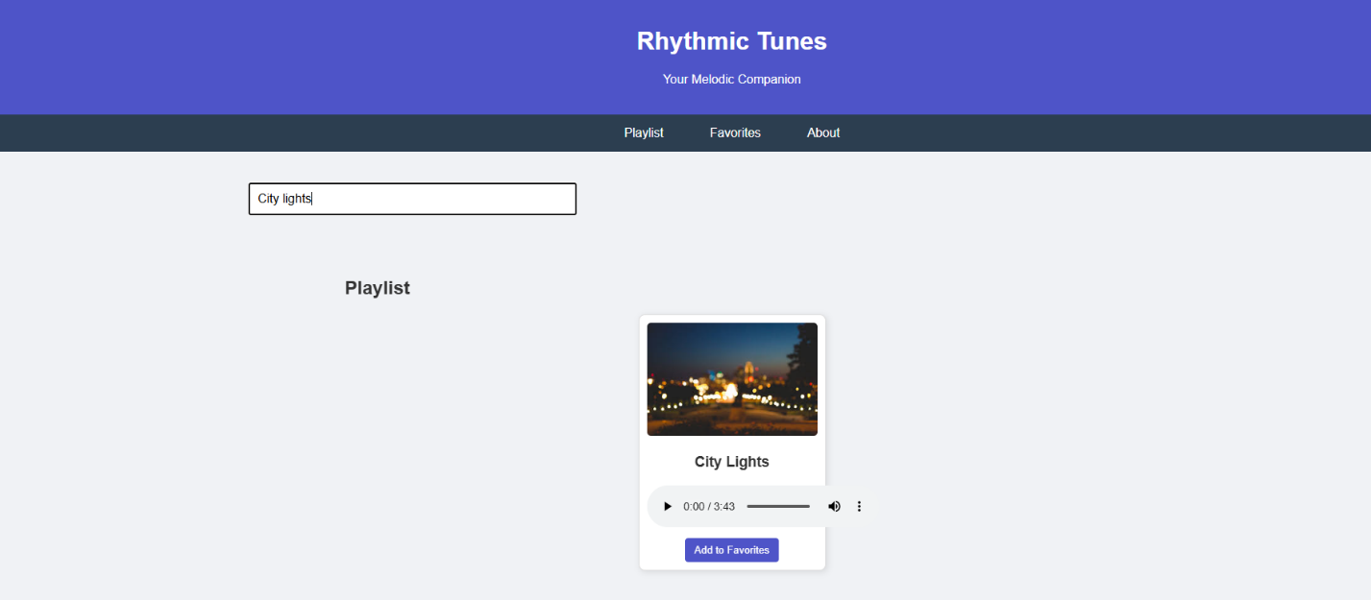

**Demo link:** [**https://drive.google.com/file/d/1XtKtbMq8Wl3A4fLgMQMlZd1fEo4SLmWL/view?usp=drive_link**](https://drive.google.com/file/d/1XtKtbMq8Wl3A4fLgMQMlZd1fEo4SLmWL/view?usp=drive_link)