|  |
| --- |
|  |
| ***Building a Face-Detection App*** |
| Done in 7days master class from Ethnus Codemithra |

|  |
| --- |
|  |

|  |
| --- |
|  |

***1.AWS Login with username :***

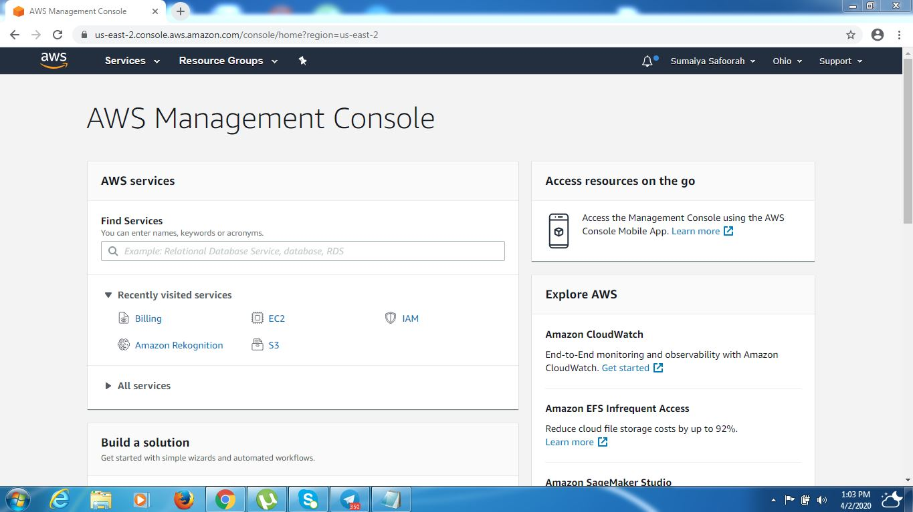

***2. EC2 Dashboard :***

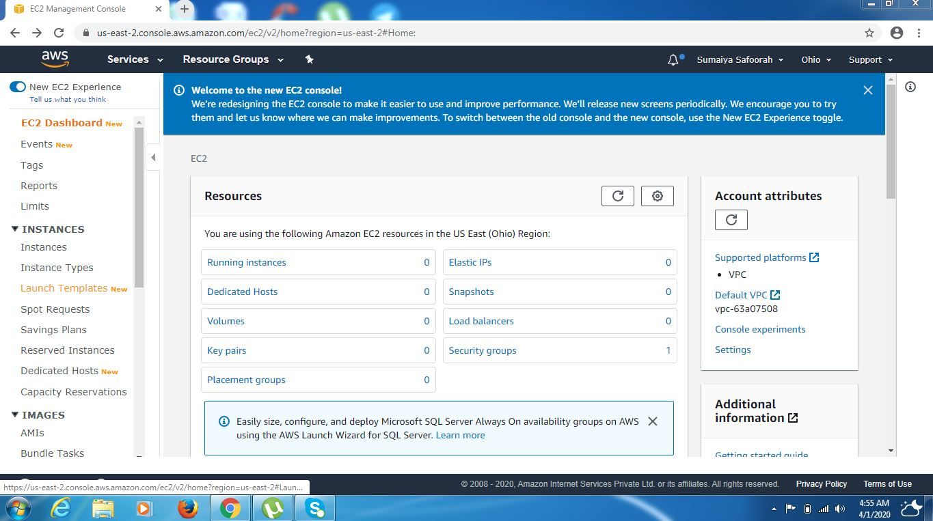

***3.S3 Dashboard :***

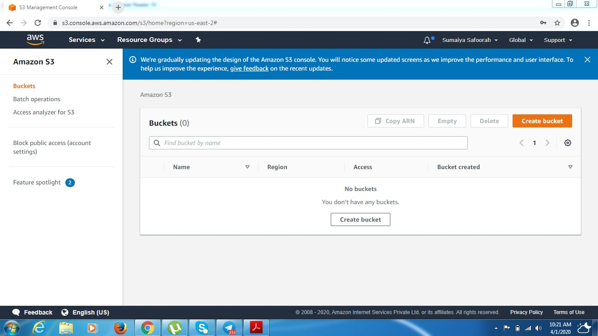

***4.Rekognition Dashboard :***

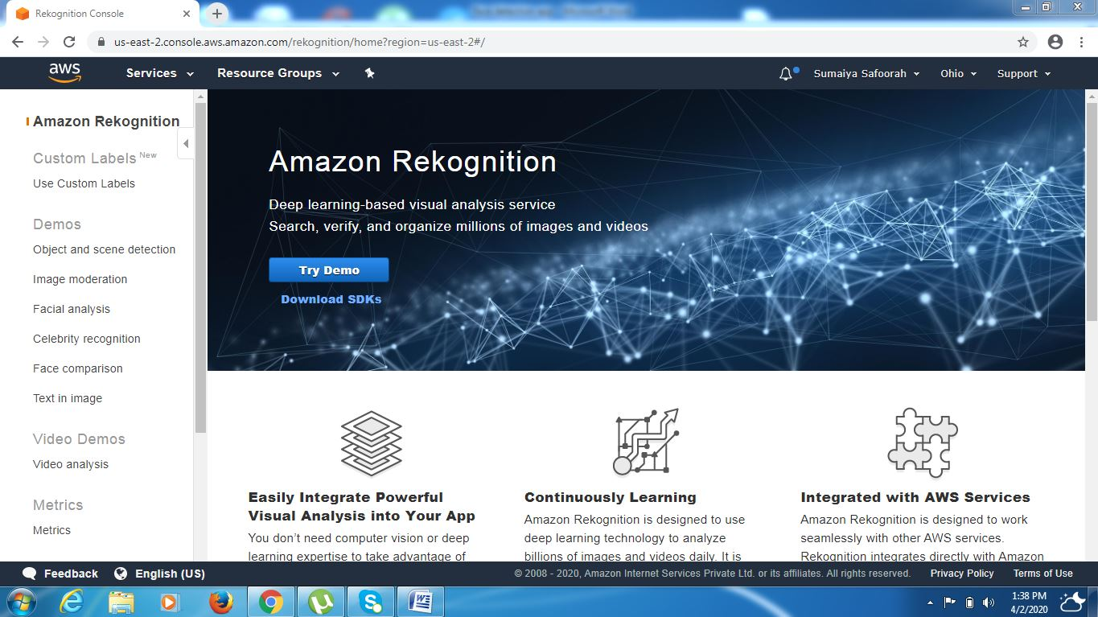

***EC2***

***5. Choosing an AMI :***

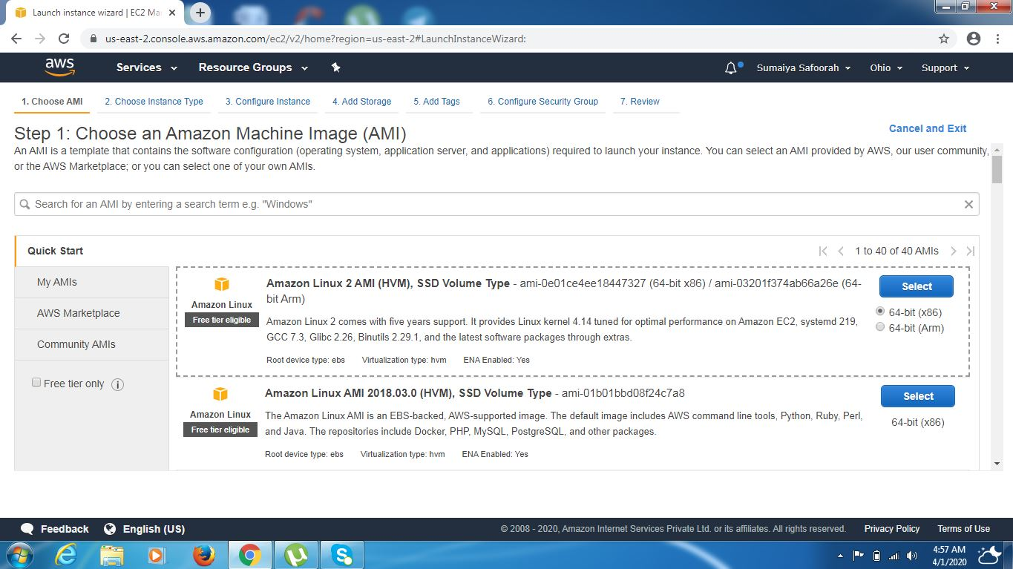

***6. Choosing an Instance type :***

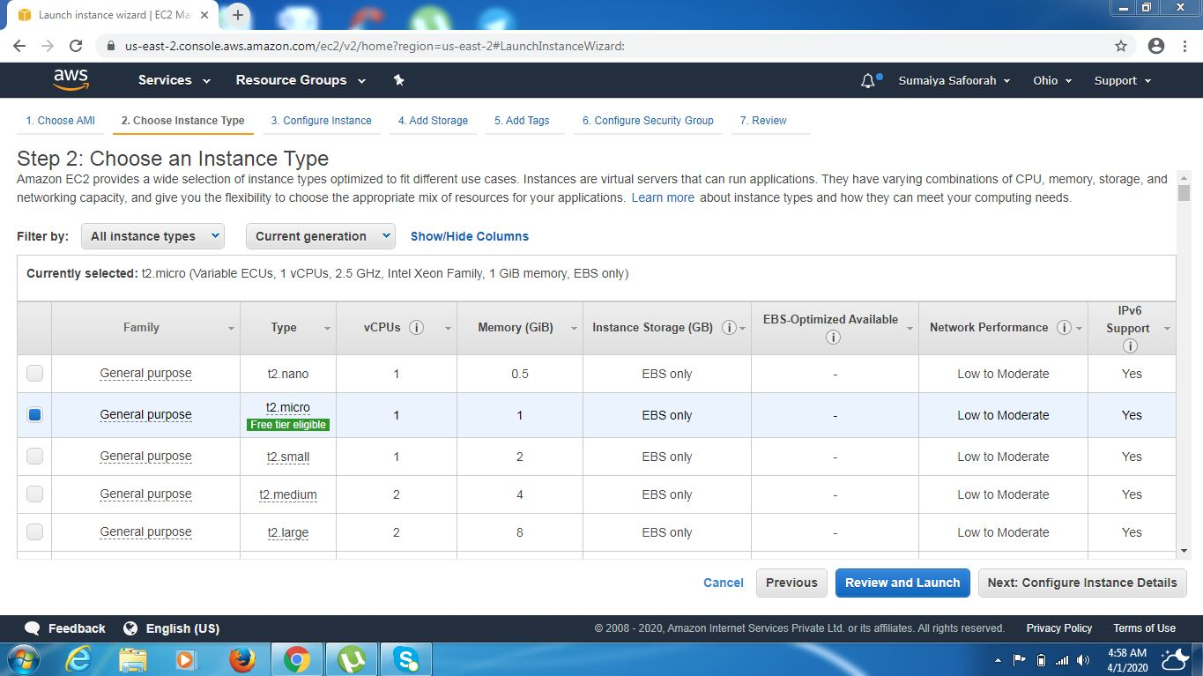

***7. Adding Storage:***

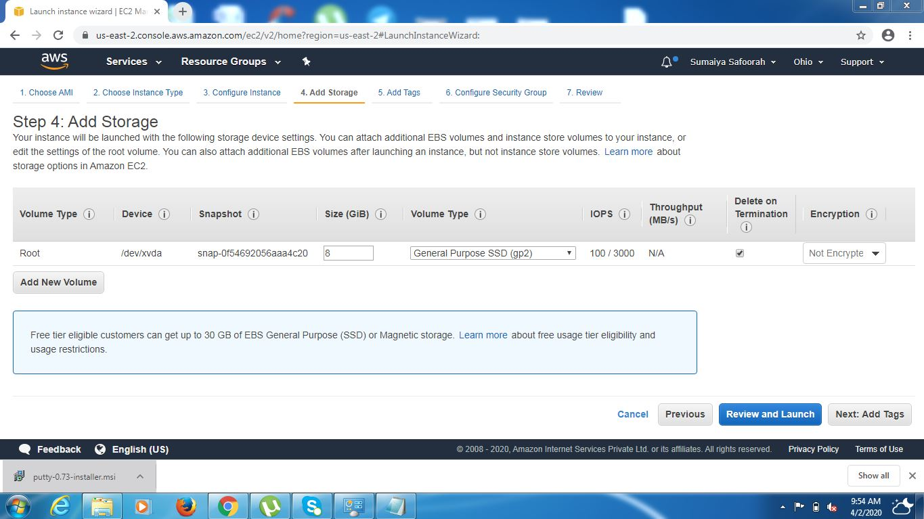

***8. Configuring Security Group:***

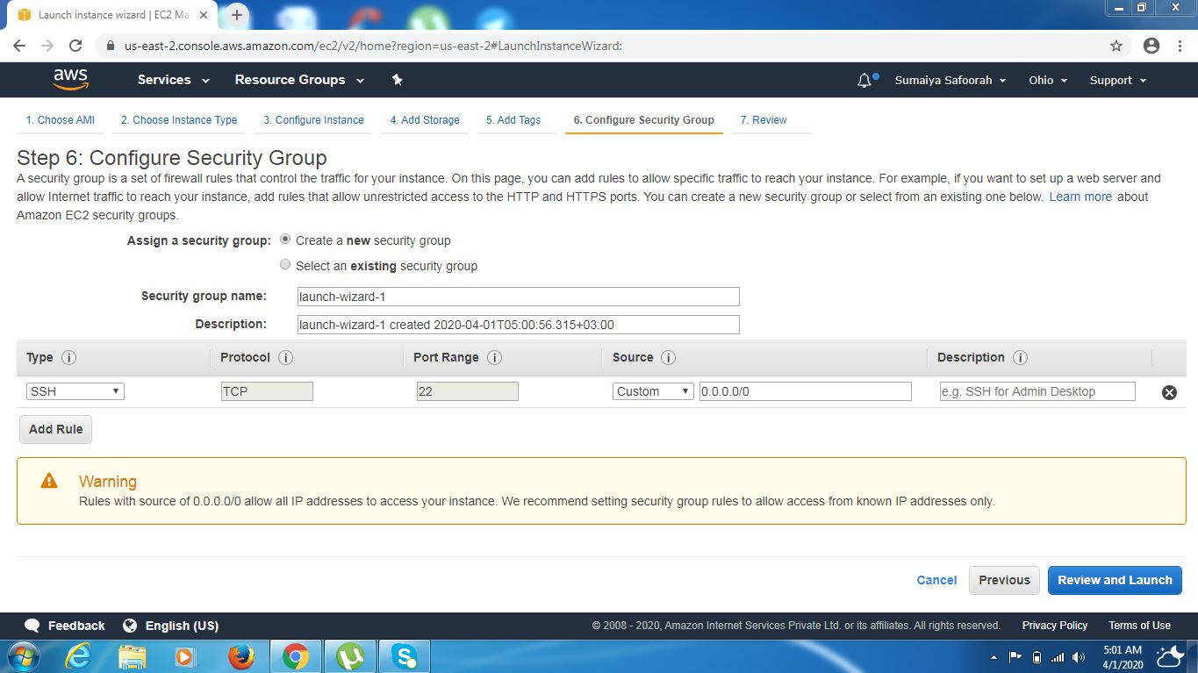

***9.Keypair Download:***

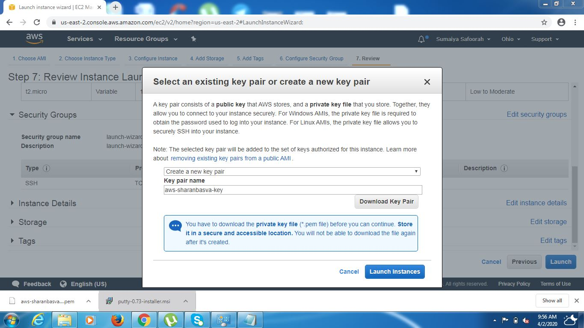

***10. Puttygen Conversion from pem to ppk:***

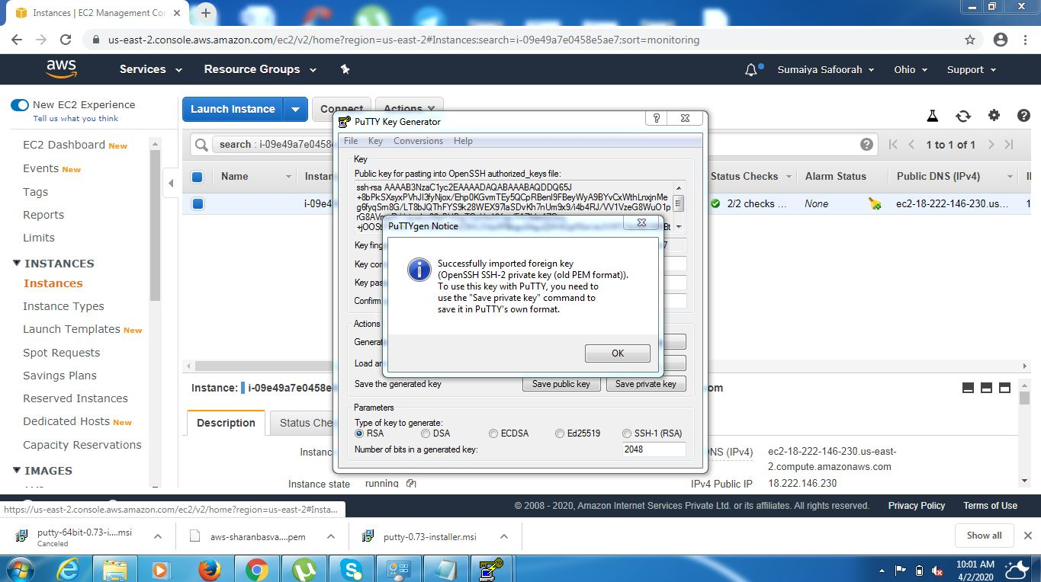

***Saving .pek file:***

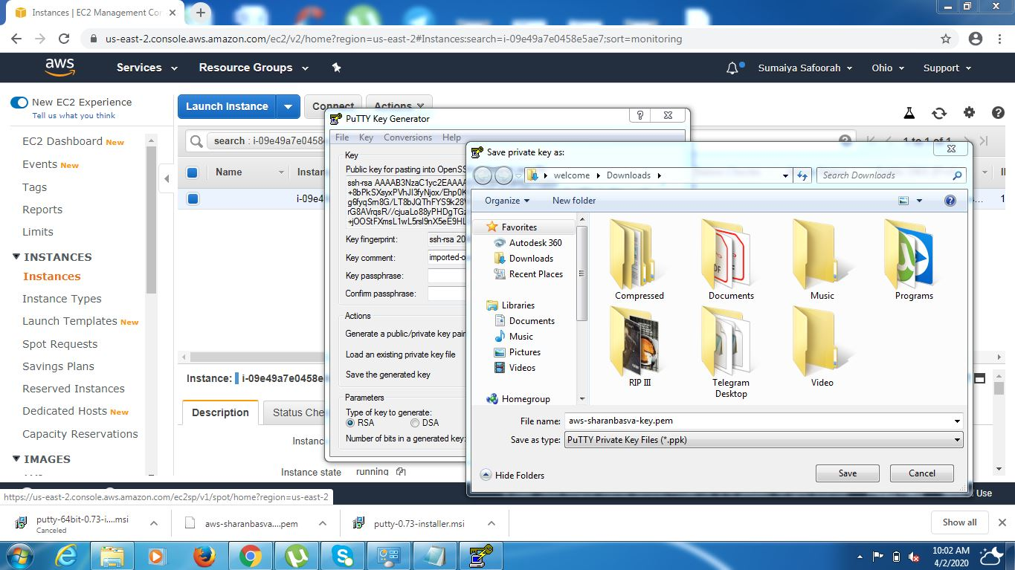

***11. Logged into EC2 Black Screen:***

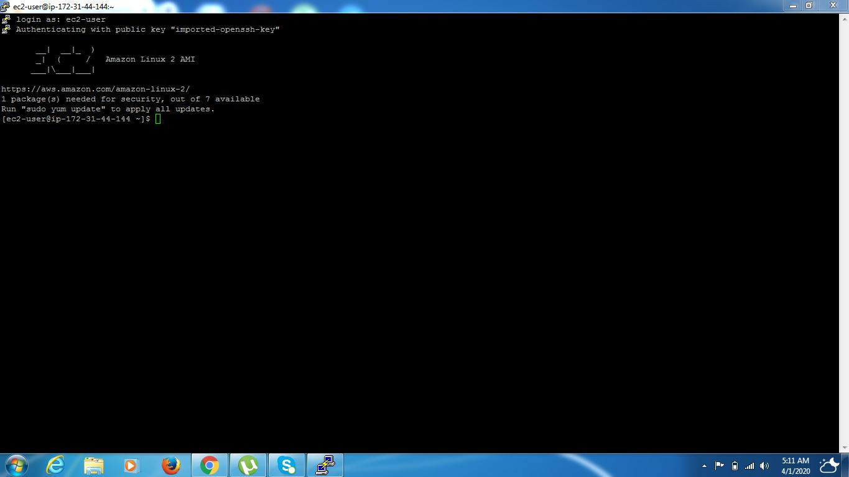

***S3***

***12. Creating a Bucket:***

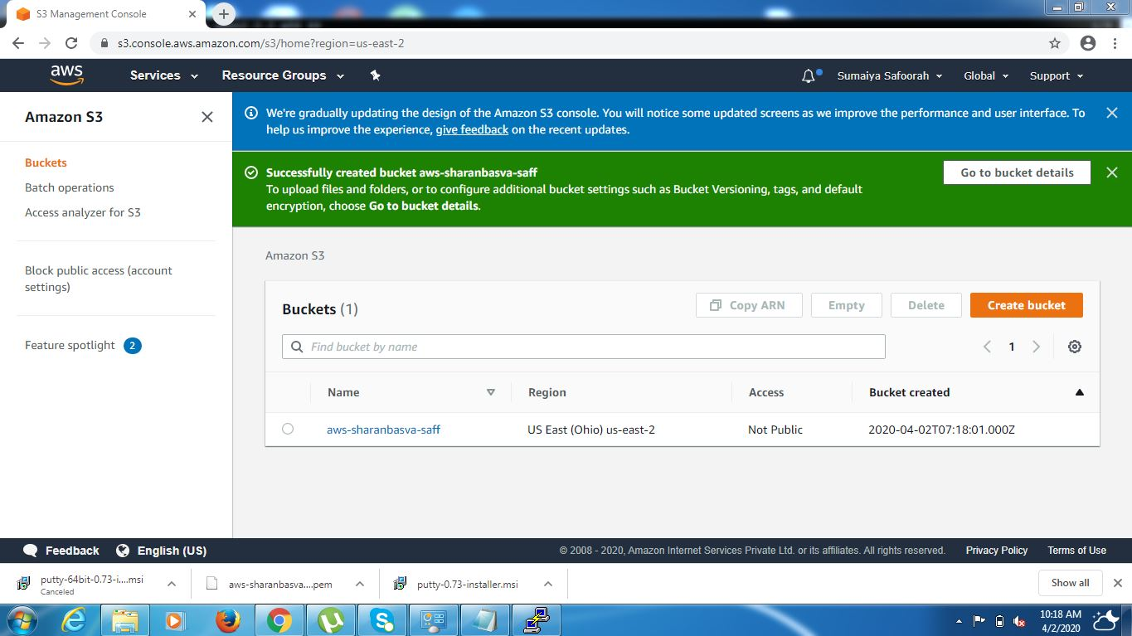

***13. Uploading an Object:***

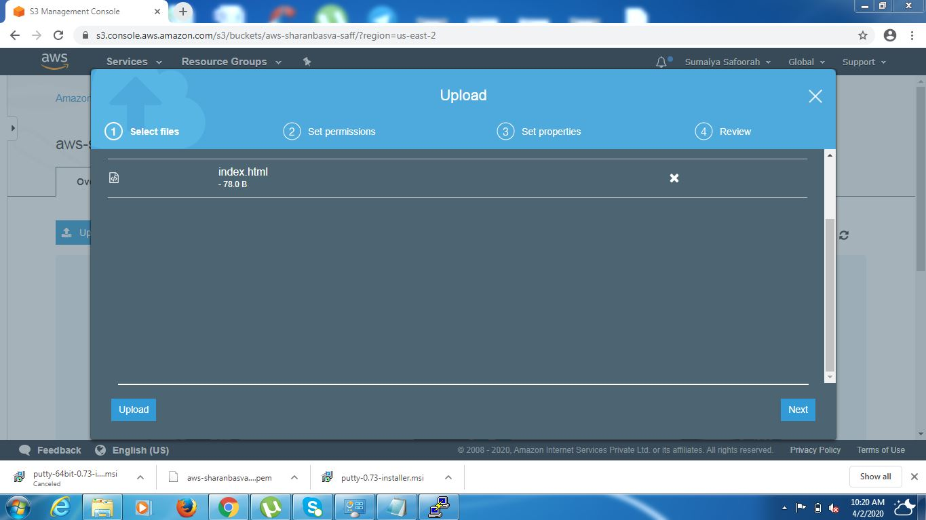

***14. Enabling Static Website:***

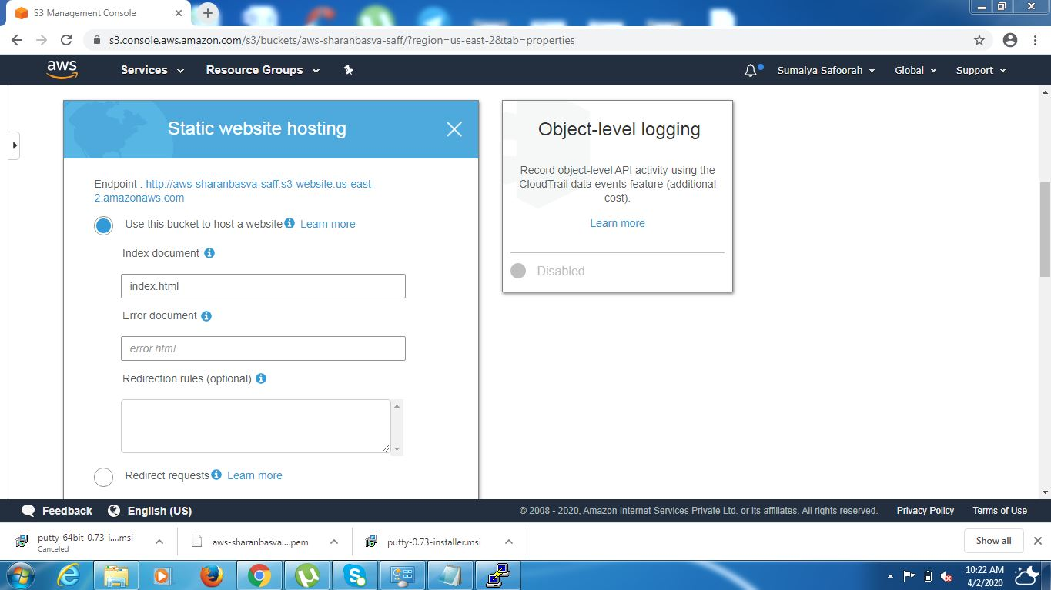

***15. Making the Object Public:***

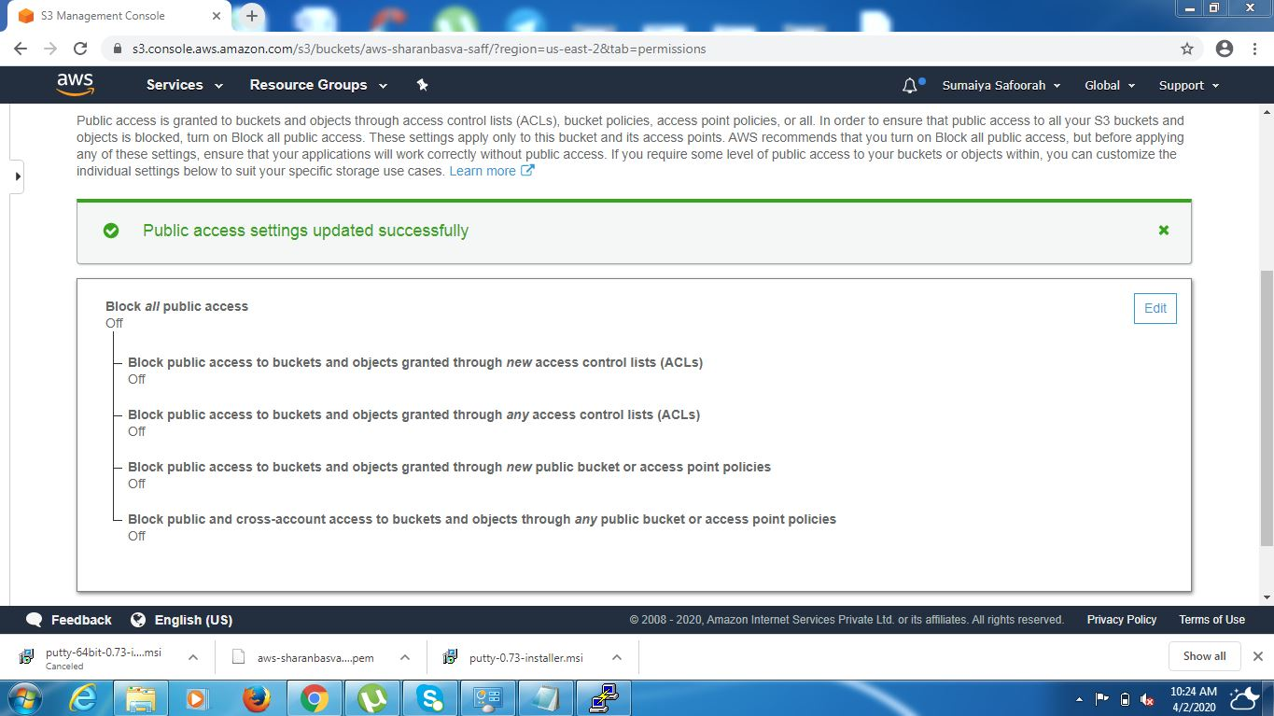

***16. Checking S3 Link On Browser:***

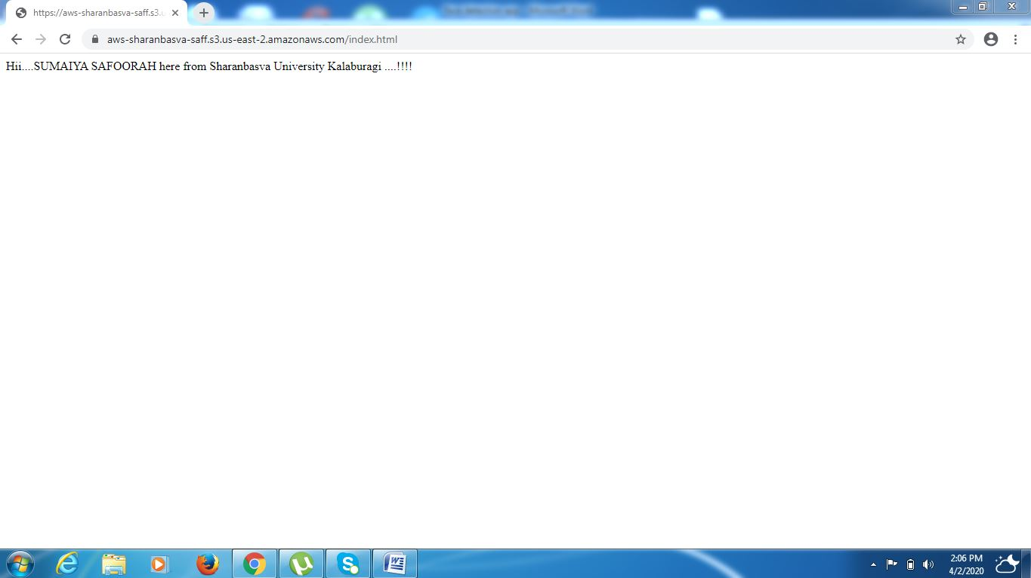

***REKOGNITION***

***17. Detecting Face:***

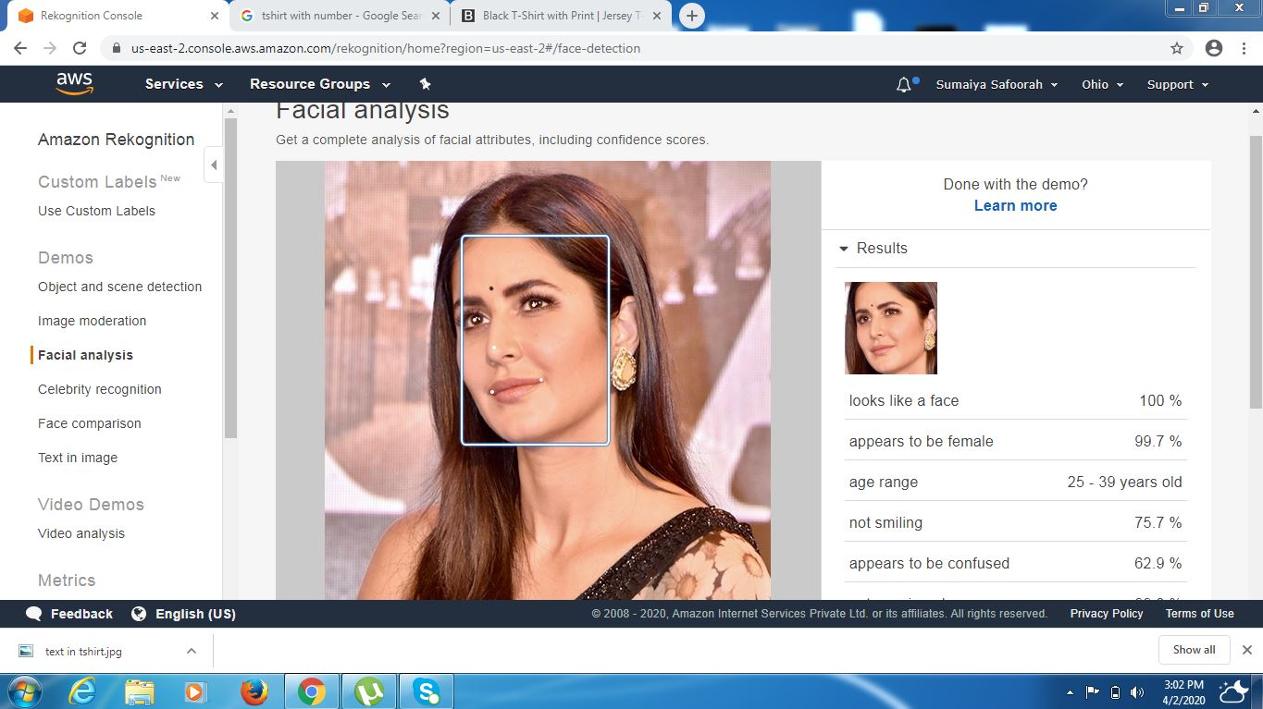

***18:Face Compare:***

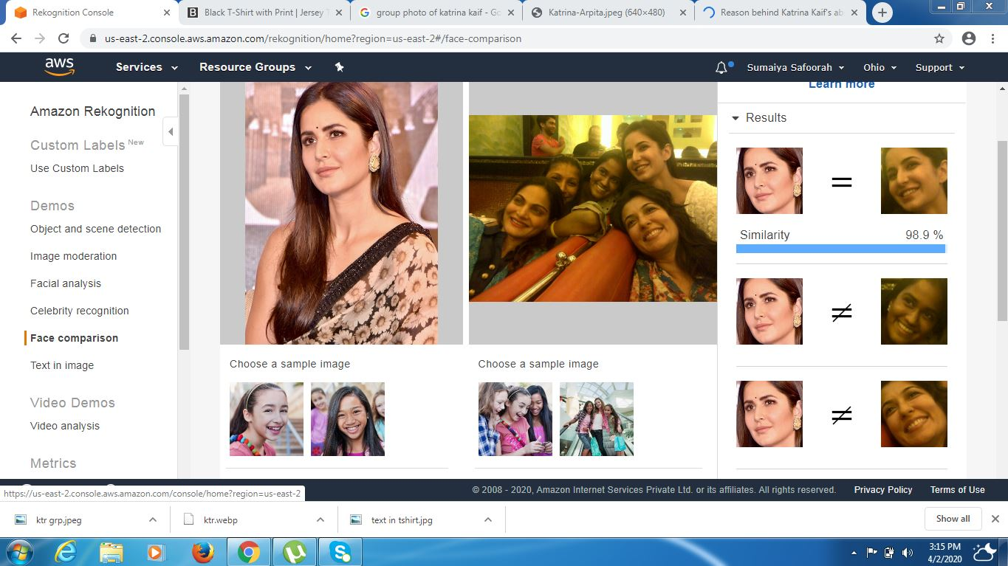

***19:Celebrity Rekognition:***

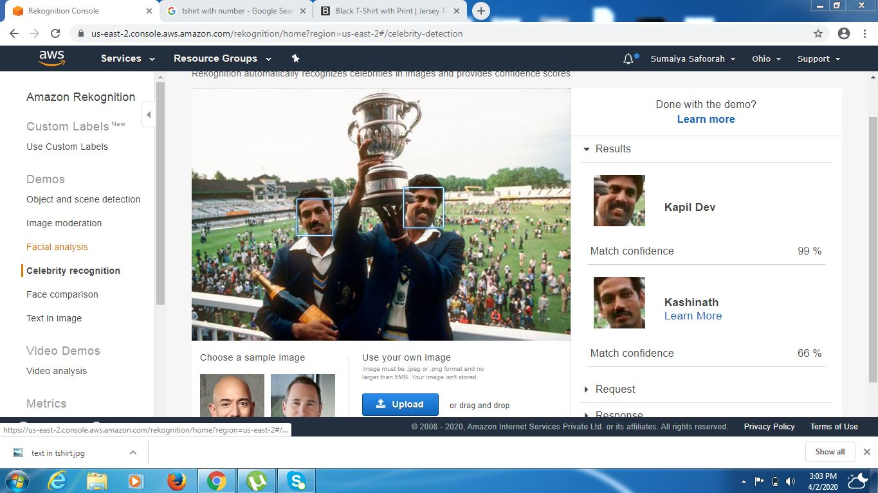

***20: Text in Image:***

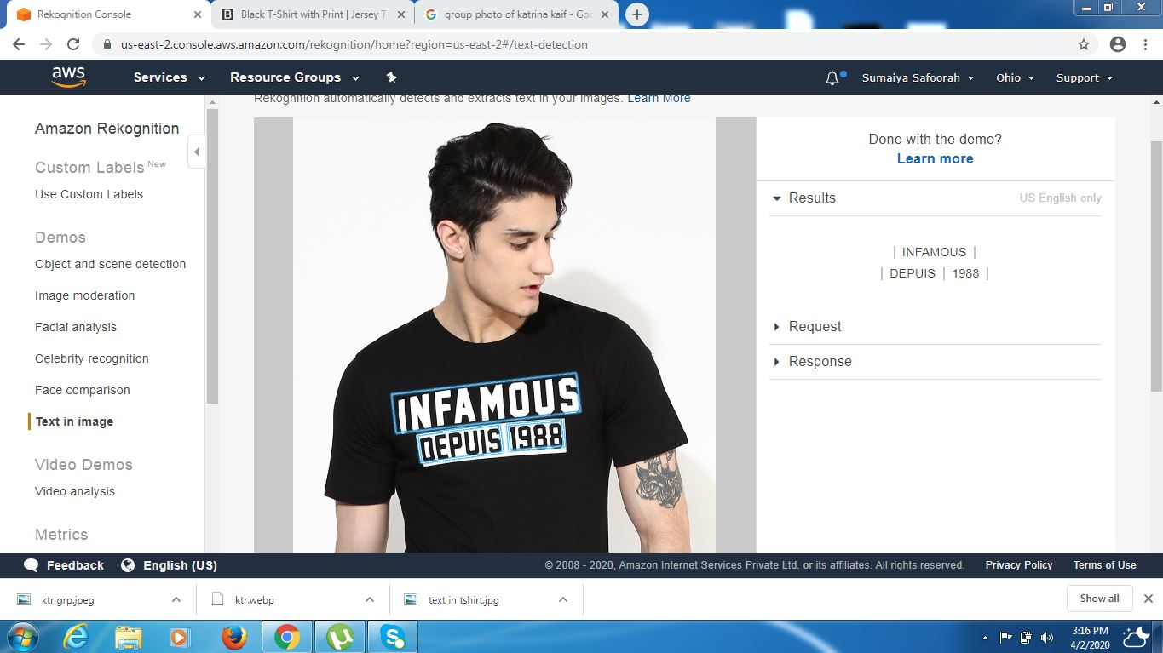

***EC2 & S3***

***21. Installing aws-sdk :***

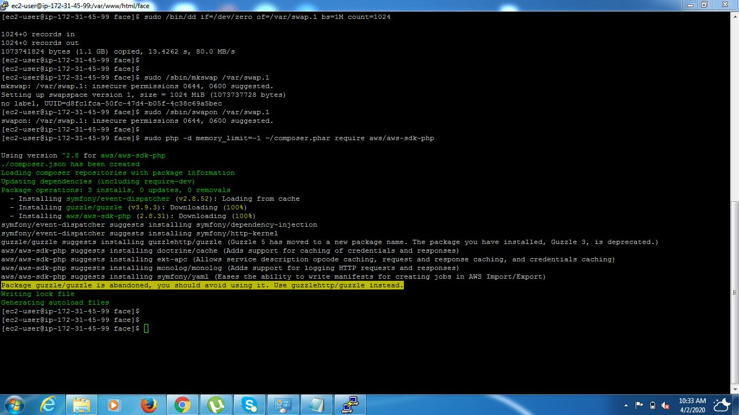

***22. Installing php:***

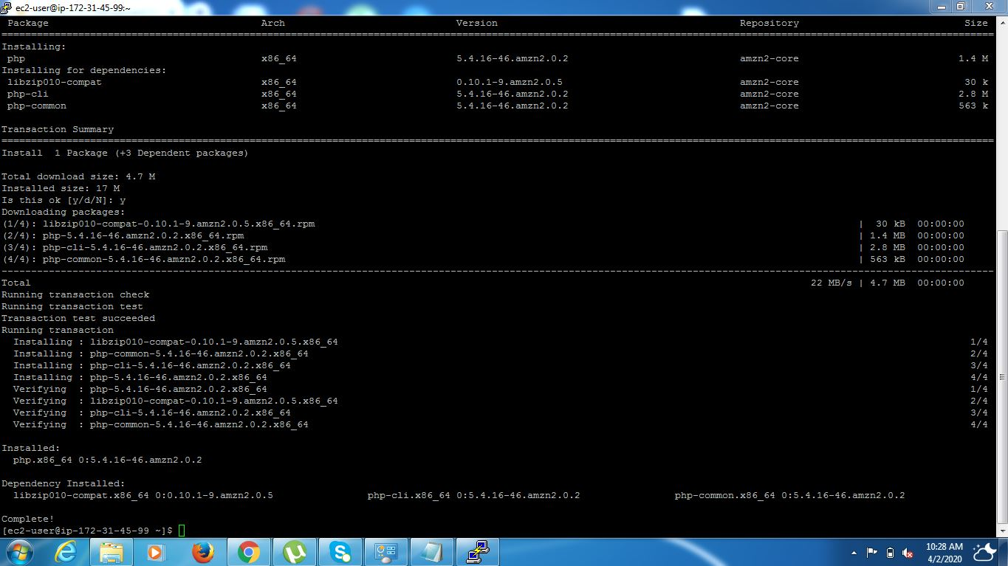

***23. index.php file code:***

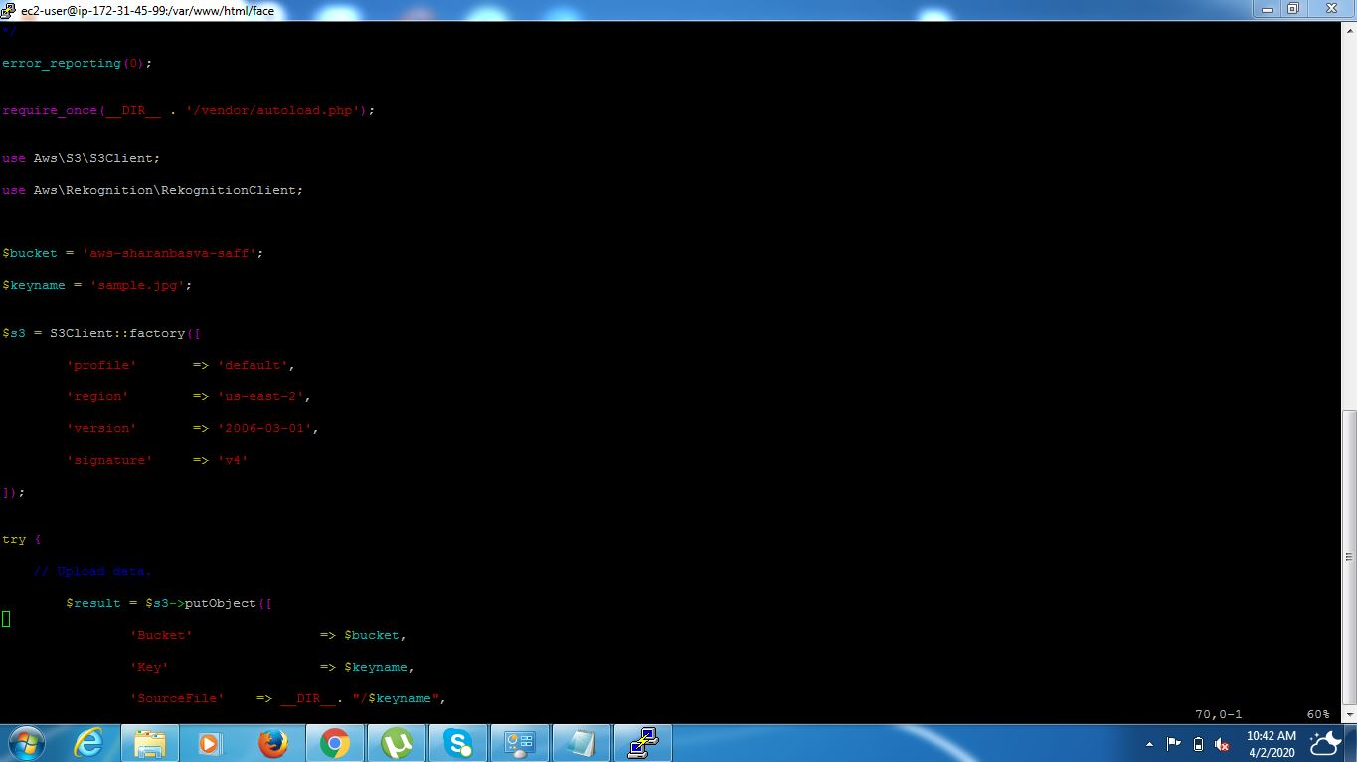

***24. Upload Success Screenshot:***

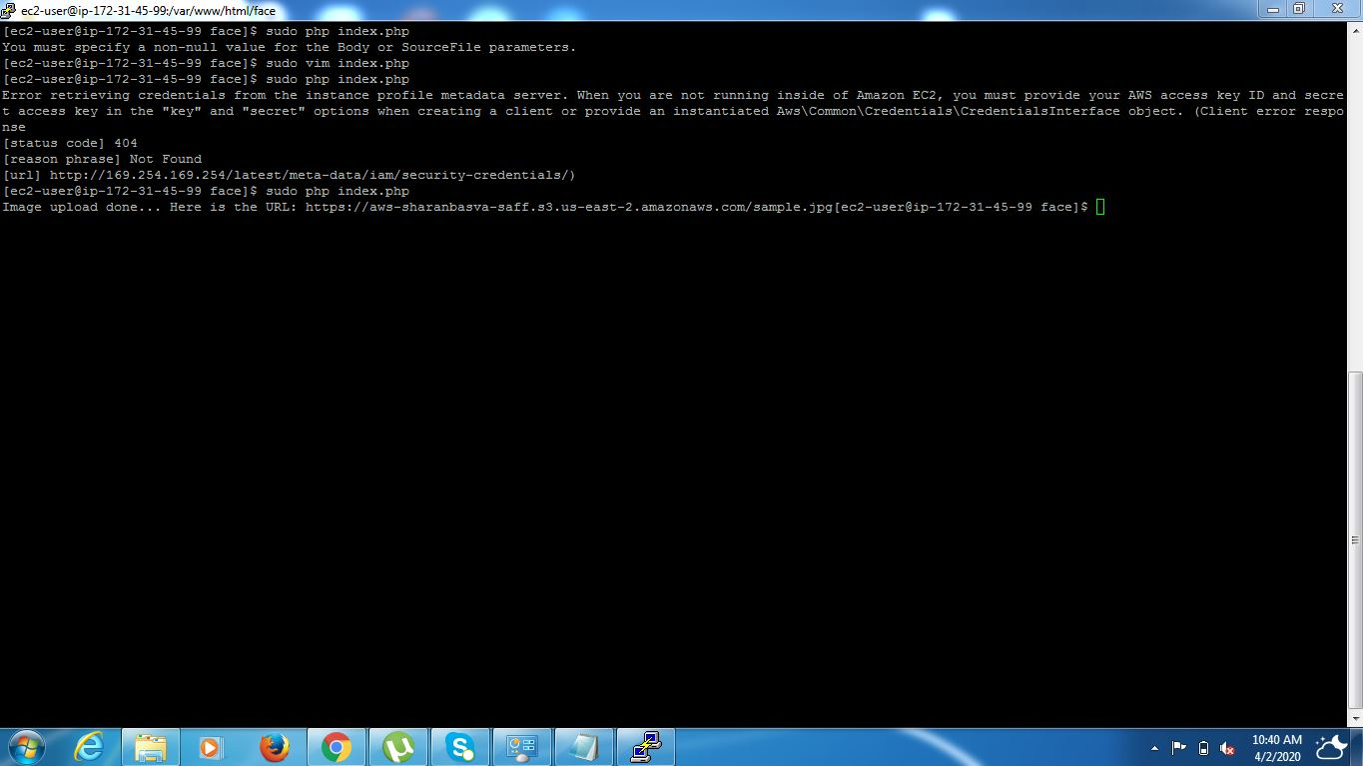

***EC2 & Rekognition***

***25. Faces Detect Success:***

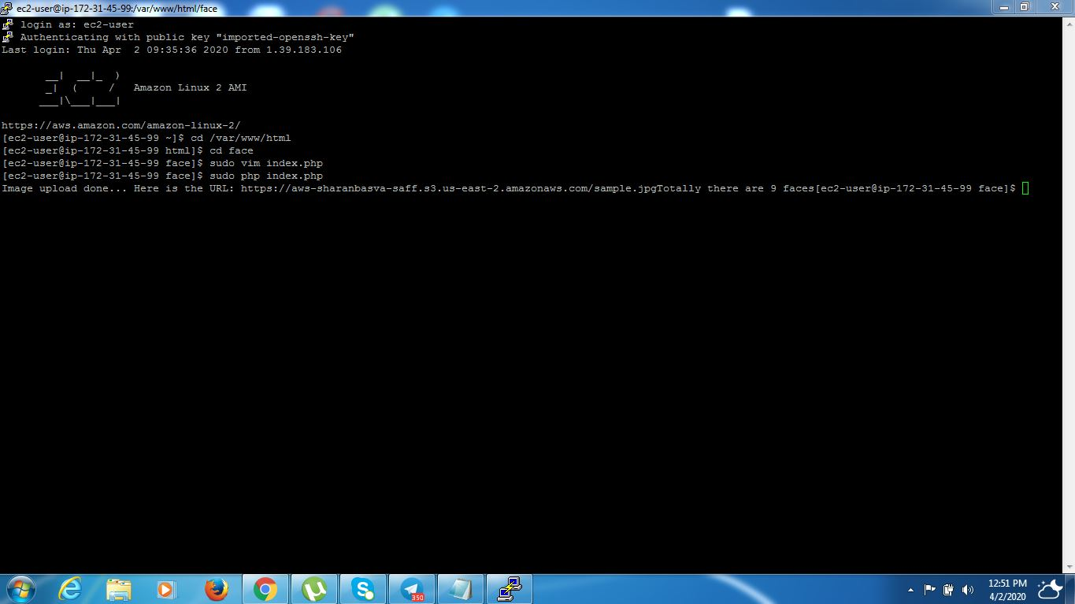

***26.Number Of Males in Image:***

