

**INSTITUTE** **FOR** **ADVANCED** **COMPUTING**

**AND SOFTWARE** **DEVELOPMENT** **(IACSD),**

**AKURDI,** **PUNE**

Documentation On

**Art O’ Craft**

PG-DAC March 2023

**Submitted By :**

**Group No:76**

**Roll No. Name**

**233157 Jyoti Dorage**

**233219 Sumaiyya Jamadar**

**Project Guide Centre Co-ordinator**

**Mrs. Rupali Thorat Mr. Rohit Puranik**

**ABSTRACT**

This document includes all the information required to create ,style and implement website for online art and gallery. Nowadays, instead of visiting actual stores people prefers online services. This system allow customers to shop for different artforms online while sitting at home or any location provided it has fair network.

This will be beneficial for both artists and customers. Artists will be able to promote their

arts and also can sell their artforms. While, customers can buy those arts without visiting Actual store.

**ACKNOWLEDGEMENT**

I take this occasion to thank God, almighty for blessing us with his grace and taking our endeavour to a successful culmination. I extend my sincere and heartfelt thanks to our esteemed guide, **Mrs. Rupali Thorat** for providing me with the right guidance and advice at the crucial juncture sand for showing me the right way. I extend my sincere thanks to our respected **Centre** **Co-Ordinator** **Mr.** **Rohit Puranik** , for allowing us to use the facilities available. I would like to thank the other faculty members also, at this occasion. Last but not the least, I would like to thank my friends and family for the support and encouragement they have given me during the course of our work.

**Jyoti Dorage (233157)**

**Sumaiyya Jamadar (233219**)

**Contents**

**ABSTRACT.............................................................................................................................1**

**ACKNOWLEDGEMENT......................................................................................................2**

**INTRODUCTION...................................................................................................................4** **FEATURES.............................................................................................................................4**

**1.1** **PROJECT** **OBJECTIVE ...........................................................................................4**

**1.2** **PROJECT** **OVERVIEW..............................................................................................4**

**1.3** **PROJECT** **SCOPE** **.....................................................................................................4**

**1.4** **STUDY** **OF** **THE** **SYSTEM** **.......................................................................................4**

**1.4.1** **MODULES...................................................................................................................5** **SYSTEM** **ANALYSIS ...........................................................................................................5**

**2.1** **EXISTING** **SYSTEM** **.....................................................................................................6**

**2.2** **PROPOSED** **SYSTEM...................................................................................................6**

**2.3** **SYSTEM** **REQUIREMENT** **SPECIFICATION..........................................................7**

**2.3.1** **GENERAL** **DESCRIPTION......................................................................................** **7**

**2.3.2** **SYSTEM** **OBJECTIVES** **............................................................................................** **7**

**2.3.3** **SYSTEM** **REQUIREMENTS....................................................................................** **7**

**SYSTEM** **DESIGN.................................................................................................................7**

**3.1** **INPUT** **AND** **OUTPUT** **DESIGN** **...................................................................................8**

**3.1.1** **INPUT** **DESIGN** **.........................................................................................................** **8**

**3.1.2** **OUTPUT** **DESIGN.....................................................................................................** **9** **DATABASE** **DESIGN** **..........................................................................................................10**

**3.2** **DATABASE.....................................................................................................................** **10**

**3.3** **SYSTEM** **TOOLS...........................................................................................................10**

**3.3.1** **FRONT** **END..............................................................................................................** **10**

**3.3.2** **BACKEND.................................................................................................................** **11**

**0** **LEVEL** **DFD........................................................................................................................12**

**1LEVEL** **DFD** **……………………….....................................................................................12**

**E-RDIAGRAM.......................................................................................................................13**

**CLASS** **DIAGRAM................................................................................................................14**

**SEQUENCE** **DIAGRAM.......................................................................................................15**

**USE CASE** **DIAGRAM..........................................................................................................16**

**ACTIVITY** **DIAGRAM.........................................................................................................17**

**TABLE** **STRUCTURE** **...........................................................................................................19**

**PROJECT DIAGRAMS........................................................................................................21** **CONCLUSION.......................................................................................................................24**

**FUTURE SCOPE...................................................................................................................24**

**REFERENCES…………........................................................................................................25**

**INTRODUCTION**

This software requirement specification includes all the information required to create ,style and implement website for online art and gallery. Artists need to register themselves so can put their artforms for sale. Customers can buy different sketches , paintings , crafts from various registered artists. Also ,there is online payment gateway option available for making payments.

**Features:** -

* Separate login for admin, artists and customers.
* Easy to add or update artists and customers .
* Easy to search arts by artists name .
* Admin can maintain lists of artists , customers , orders and products.
  1. **PROJECTOBJECTIVE :**

The main functionality of this project is that, accessing art details of various registered artists and making request for the same from anywhere anytime and from any platform or device. There is an online billing and accounting . In this system the bills and receipts are easily maintained and also the system is user friendly .

* 1. **PROJECT** **OVERVIEW**

This project consists of three different modules namely admin , artists and customers .

Admin can login into system using their username and password. They can maintain list of registered

artists and customers. Also , admins can maintain list of products and orders.

Artists first need to register themselves to access the system. Once registered , then they can add their various arts for sale . Artists can update information about arts like art description , art price , etc .Customers can search arts by various artists using artist name. Once found they can add them to

cart or place order for the same. Then , they can make payment using online payment gateway.

* 1. **PROJECT SCOPE**

This system provides friendly user interface to every user of the system. This application will help people to buy different arts from various artists while sitting at home. This will be beneficial to all the people who cannot visit arts tore directly or couldn’t make time for the same. It helps to understand the needs of the customers and to overcome the manual work of the documentation and make it online which will be feasible and flexible and try to make it user friendly. Web-platform means that the system will be available for access 24/7 except when there is a temporary server issue which is expected to be minimal.

**STUDY** **OF** **THE** **SYSTEM :**

* + 1. **Modules**

This system consists of three different modules.

* Admin
* Artists
* Customers

**Admins :**

1) Login into system

2) Update and maintain orders and products

3) Maintain list of artists and customers

**Artists :**

1. Register into system
2. Update their database
3. Add various artforms
4. Maintain database

**Customers :**

1. Register into system
2. Update their database
3. Search for various artforms using artist name
4. Maintain database
5. Add arts to cart
6. Place order
7. Make payment

* **SYSTEM ANALYSIS**

System analysis is the process of gathering and interpreting facts, diagnosing problems, and using the information to recommend improvements on the system. System analysis is a problem-solving activitythat requires intensive communication between the system users and systemdevelopers.

System analysis or study is an important phase of any system development process. The system is viewed as a whole, the inputs are identified, and the system is subjected to close study to identify the problem areas. The solutions are given as a proposal. The proposal is reviewed on user request and suitable changes are made. This loop ends as soon as the user is satisfied with the proposal.

* **EXISTING SYSTEM**

The current system for art gallery maintain pen and paper data to add new arts of various artists.

✓It is less customer-friendly.

✓Customer has to visit store every time if they wish to buy or even see arts.

✓It is difficult to put arts of many artists at one place as large space will be required for the same.

✓Store owner has to maintain the whole paper work describing the details flats and their owners.

✓It is a time-consuming process

✓Not in reach of distant users.

* **PROPOSED SYSTEM**

The proposed system provides friendly user interface to every user of the system. This application will help artists and customers with clear visibility and smooth functioning. This will be beneficial to all the users who travel abroad and who cannot make time to visit store every time if they wish to see or buy the product. As this system is available online, members will have an access to it. It understands the needs of the customers and to overcome the manual work of the documentation and make it online which will be feasible and flexible and try to make it user friendly. Web-platform means that the system will be available for access 24/7 except when there is a temporary server issue which is expected to be minimal.

**2.3** **SYSTEM** **REQUIREMENTSPECIFICATION**

**2.3.1** **GENERAL** **DESCRIPTION**

* **Product** **Description:**

The art and gallery store allows customers and artists to register themselves to have access to the system. This system allows artists to put up their arts for sale. Customers can login into system and then make request for different arts if they want to buy them.

* **Problem** **Statement:**

Going to actual physical store to buy various arts can be time consuming and tedious process. Also for visiting actual store , customers need to travel for miles if shop is far away. So to avoid it , there is online shop where artists can promote their arts and customers can buy them without actually visiting store thus reducing travel expenses and without wasting tine for the same.

**2.3.2** **SYSTEM** **OBJECTIVES**

To provide website for art and gallery store.

**2.3.3** **SYSTEMREQUIREMENTS**

**2.3.3.1 Functional requirements**

* Admin login into system
* Admin update and maintain orders and products
* Admin maintain list of artists and customers
* Artists register into system
* Artists update their database
* Artists add various artforms
* Artist maintain database
* Customers register into system
* Customers update their database
* Customers search for various artforms using artist name
* Customers maintain database
* Customers add arts to cart
* Customers place order and make payment

**2.3.3.2 Non-functional requirements**

### Performance

This website can perform thoroughly without any crashes. So it has high performance.

### Reliability

This website is robust. User can rely on it.

### Availability

This website is available 24/7 throughout . User can access it anytime from anywhere .

### Security

As we have stored our data on mysql which is prominent in its security, users can rest assured about privacy of their data. This website will provide secure environment for both artists and customers so that they can put up their personal details such as contact or interests without any doubts.

### Portability

Customers can access website from their laptops as well as mobile devices as system is portable. It can be accessible from stationary as well as mobile devices.

* **SYSTEM** **DESIGN**

System design is the solution for the creation of a new system. This phase focuses on the detailed implementation of the feasible system. Its emphasis on translating design. Specifications to performance specification. System design has two phases of development :

* Logical design
* Physical design

During logical design phase the analyst describes inputs (sources), outputs(destinations), databases (data sores) and procedures (data flows) all in a format that meets the user requirements. The analyst also specifies the needs of the user at a level that virtuallydetermines the information flow in and out of the system and the data resources. Here the logical design is done through data flow diagrams and database design. The physical design is followed by physical design or coding. Physical design produces the working system by defining the design specifications, which specify exactly what the candidate system must do. The programmers write the necessary programs that accept input from the user, perform necessary processing on accepted data and produce the required report on a hard copy or display it on the screen.

**3.1** **INPUT** **AND** **OUTPUT** **DESIGN**

**3.1.1** **INPUT** **DESIGN:**

Input design is the link that ties the information system into the world of its users. The input design involves determining the inputs, validating the data, minimizing the data entry and provides a multi-user facility. Inaccurate inputs are the most common cause of errors in data processing. Errors entered by the data entry operators can be controlled by input design. The user-originated inputs are converted to a computer-based format in the input design. Input data are collected and organized into groups of similar data. Once identified, the appropriate input media are selected for processing. All the input data are validated and if any data violates any conditions, the user is warned by a message. If the data satisfies all the conditions, it is transferred to the appropriate tables in the database. In this project the student details are to be entered at the time of registration. A page is designed for this purpose which is user friendly and easyto use. The design is done such that users get appropriate messages when exceptions occur.

**3.1.2** **OUTPUT** **DESIGN:**

Computer output is the most important and direct source of information to the user. Output design is a very important phase since the output needs to be in an efficient manner. Efficient and intelligible output design improves the system relationship with the user and helps in decision making. Allowing the user to view the sample screen is important because the user is the ultimate judge of the quality of output. The output module of this system is the selected notifications

**DATABASE** **DESIGN**

**3.2** **DATABASE**

Databases are the storehouses of data used in the software systems. The data is stored in tables inside the database. Several tables are created for the manipulation of the data for the system. Two essential settings for a database are

▪ Primary key - the field that is unique for all record occurrences

▪ Foreign key- the field used to set relation between tables

Normalization is a technique to avoid redundancy in the tables.

**3.3** **SYSTEM** **TOOLS**

The various system tools that have been used in developing both the front end and the back end of the project are being discussed in this chapter.

**3.3.1** **FRONT** **END:**

React(18.2.0)is a library which is developed by Facebook are utilized to implement the frontend. React (also known as React.js or ReactJS) is a [free and open-source front-end](https://en.wikipedia.org/wiki/Free_and_open-source_software) [JavaScript library](https://en.wikipedia.org/wiki/JavaScript_library) for building [user interfaces](https://en.wikipedia.org/wiki/User_interfaces) or UI components. It is maintained by [Facebook](https://en.wikipedia.org/wiki/Facebook%2C_Inc) and a community of individual developers and companies. React can be used as a base in the development of [single](https://en.wikipedia.org/wiki/Single-page_application) [page](https://en.wikipedia.org/wiki/Single-page_application) or mobile applications. However, React is only concerned with state management and rendering that state to the [DOM,](https://en.wikipedia.org/wiki/Document_Object_Model) so creating React applications usually requires the use of additional libraries for routing, as well as certain client-side functionality.

**3.3.2** **BACKEND:**

The back end is implemented using MySQL which is used to design databases.

**MySQL:**

MySQL(8.0.32) is the world's second most widely used open-source relational database management system (RDBMS). The SQL phrase stands for Structured Query Language.

**Spring-Boot(3.1):**

This is used to connect MYSQL and fetch data from database and store the data in database. The Spring Framework is [an application framework a](https://en.wikipedia.org/wiki/Application_framework)nd [inversion of control container](https://en.wikipedia.org/wiki/Inversion_of_control) for the [Java](https://en.wikipedia.org/wiki/Java_platform) [platform.](https://en.wikipedia.org/wiki/Java_platform) The framework's core features can be used by any Java application, but there are extensions for building web applications on top of the [Java EE](https://en.wikipedia.org/wiki/Java_EE) (Enterprise Edition) platform. Although the framework does not impose any specific [programming model, i](https://en.wikipedia.org/wiki/Programming_model)t has become popular in the Java community as an addition to the [Enterprise JavaBeans](https://en.wikipedia.org/wiki/Enterprise_JavaBeans) (EJB) model. The Spring Framework is Open-source Framework.

**UML Diagrams :**

1. **Data flow diagram**

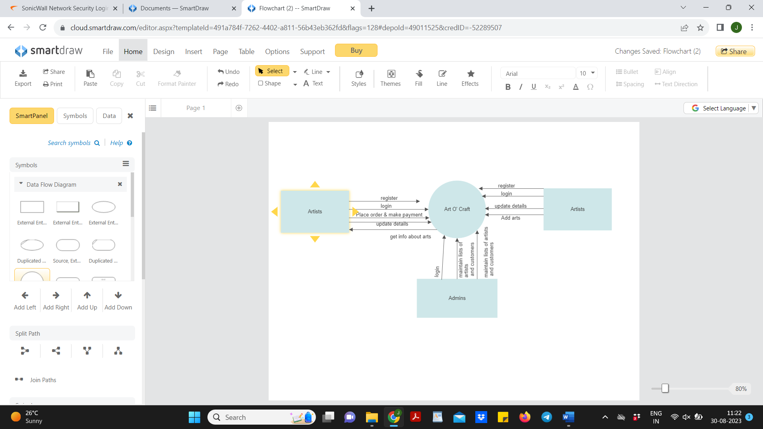

Fig 1.Level 0 diagram

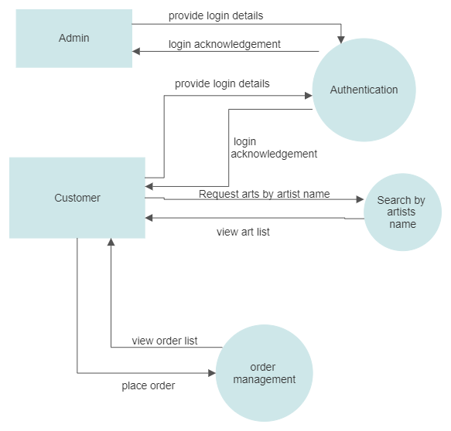

Fig 2. Level 1 diagram

1. **ER diagram**

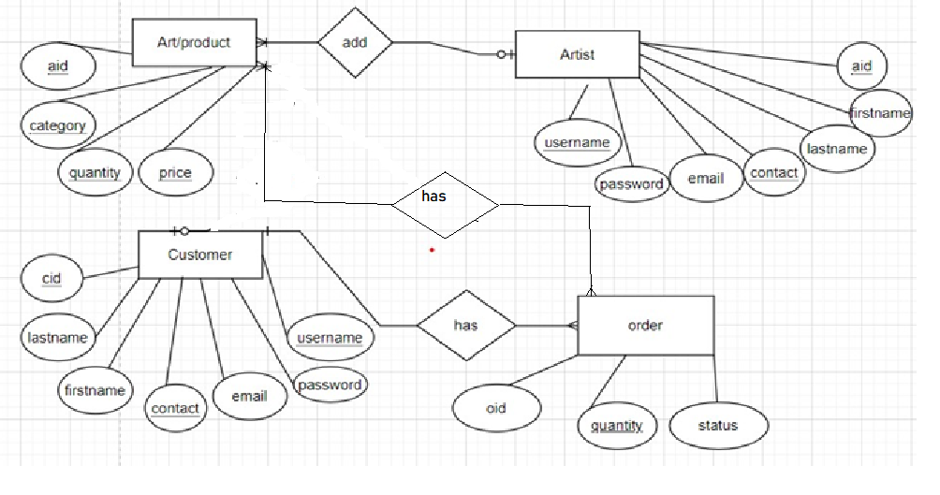

Fig 3. ER diagram

1. **Class diagram**

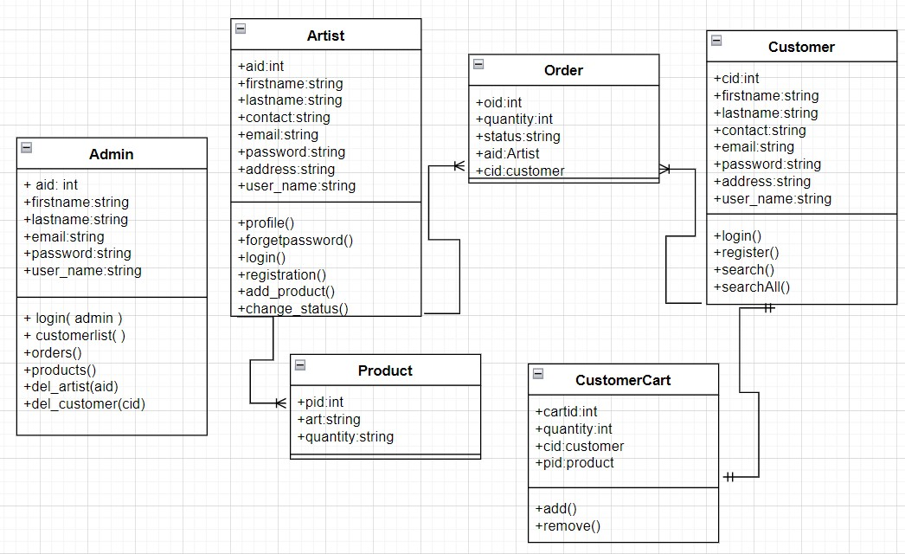

Fig 4.Class diagram for art o’ craft

1. **Sequence diagram**

* **To place order and make payment**

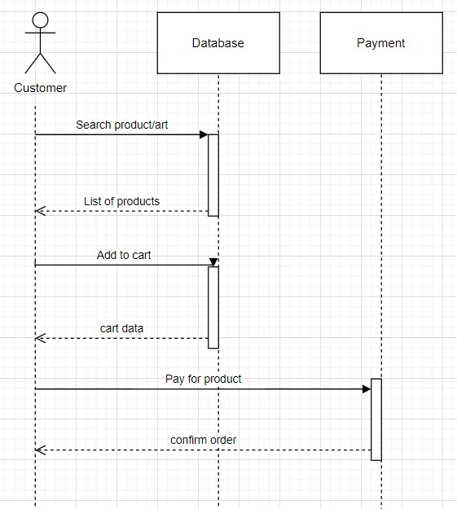

Fig 5. Sequence diagram to place order

1. **Use case diagram**

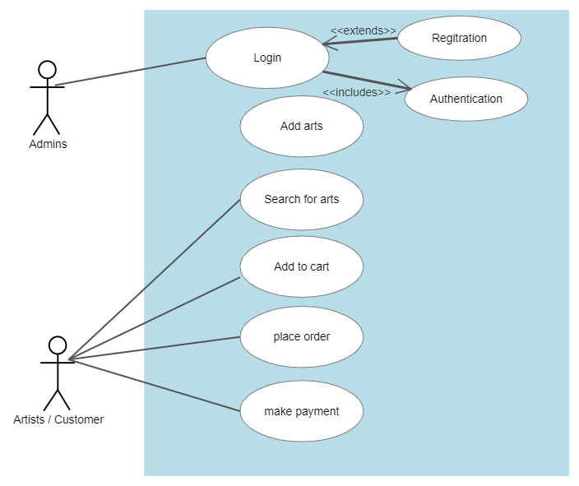

Fig 6 .Use case diagram

1. **Activity diagram**

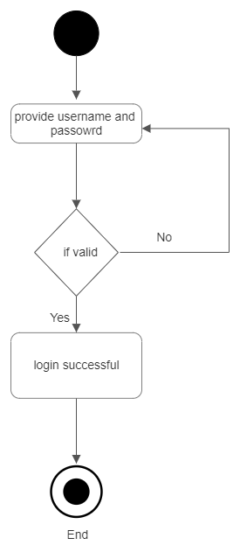

Fig 7. Activity diagram for login

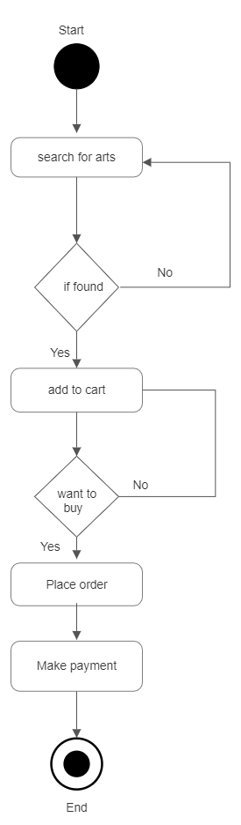

Fig 8. Activity diagram to place order and make payment

**Table structure :**

1. **admins**

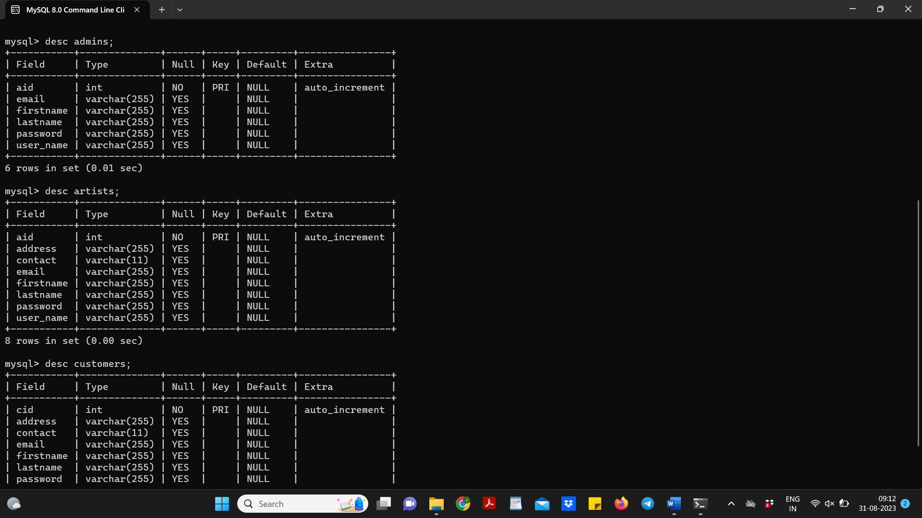

1. **artists**

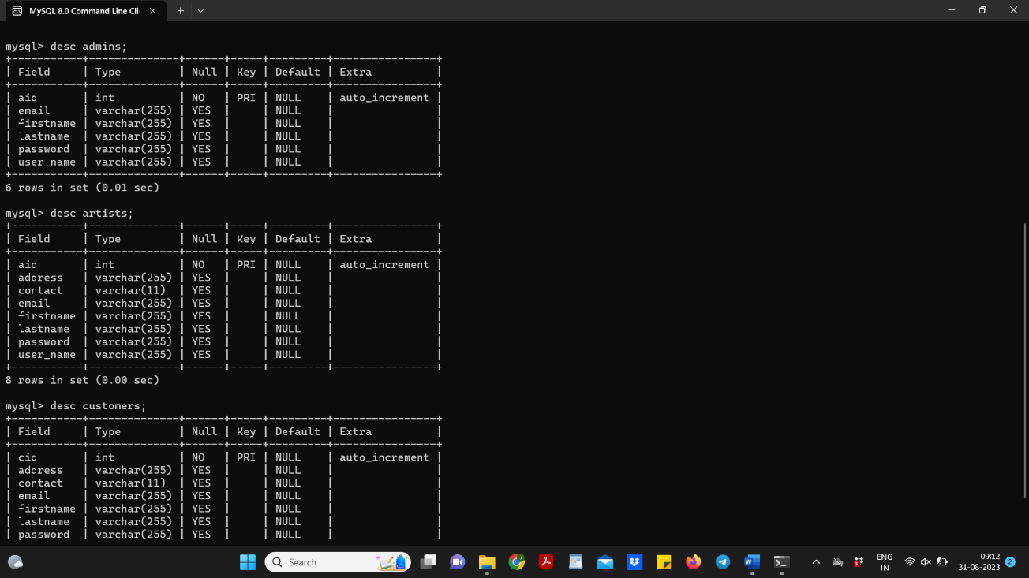

1. **customers**



1. **products**

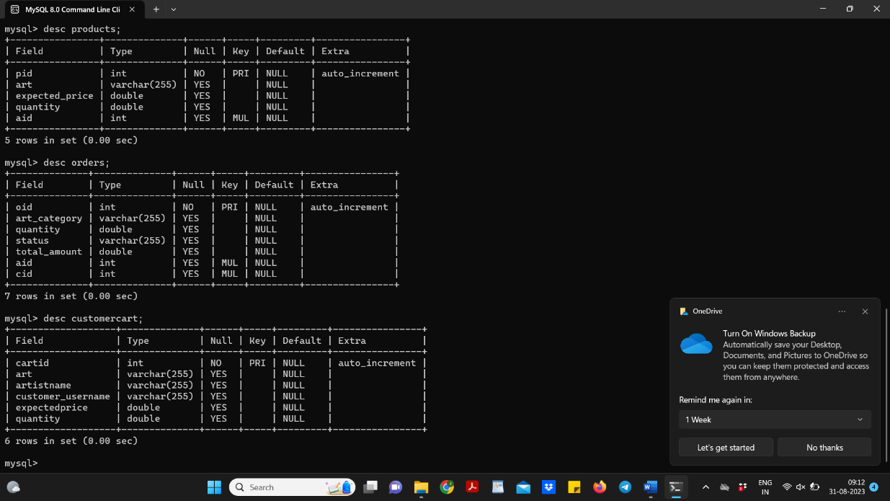

**5 ) orders**

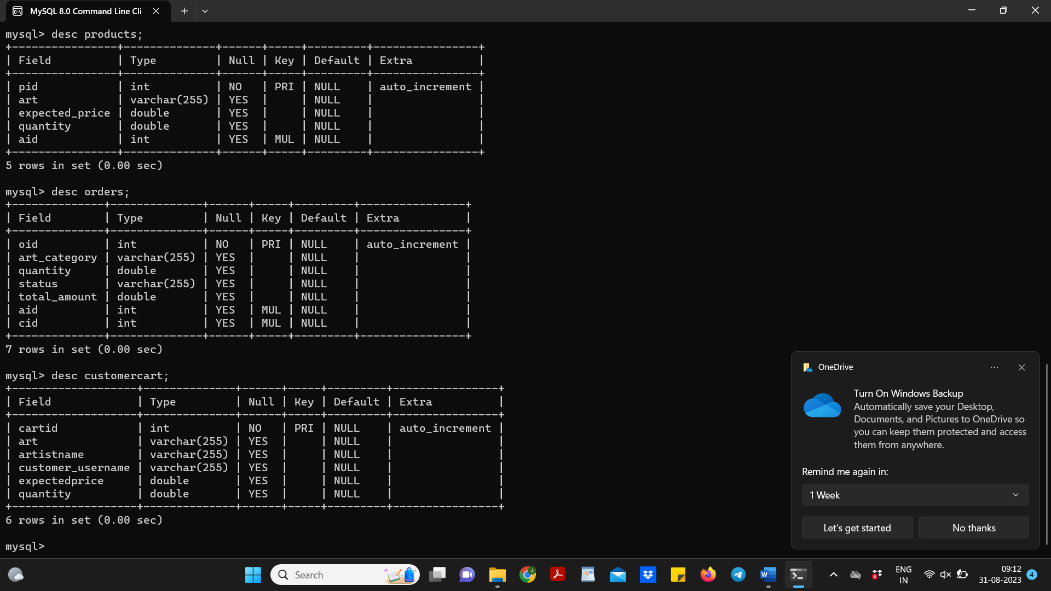

**6) customercart**



**Project Screenshots :**

**Home page :**

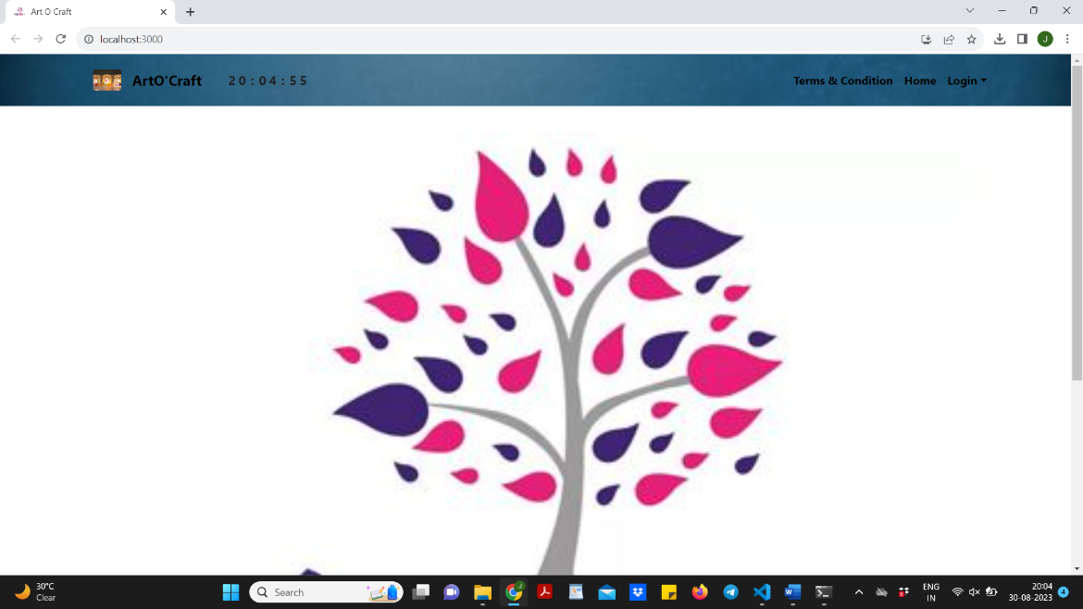

**Admin login :**

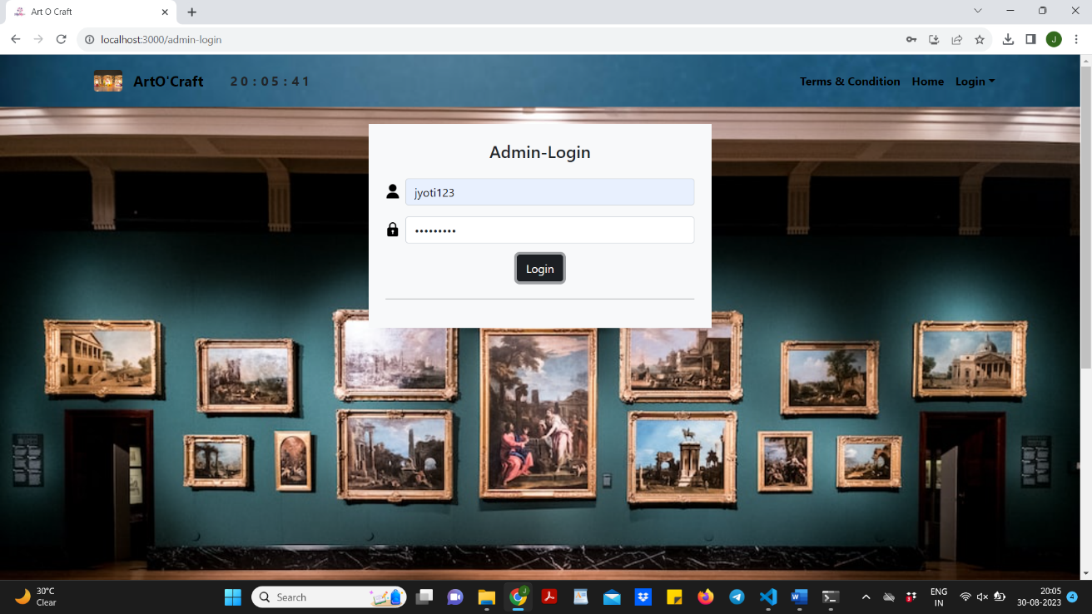

**Artist list :**

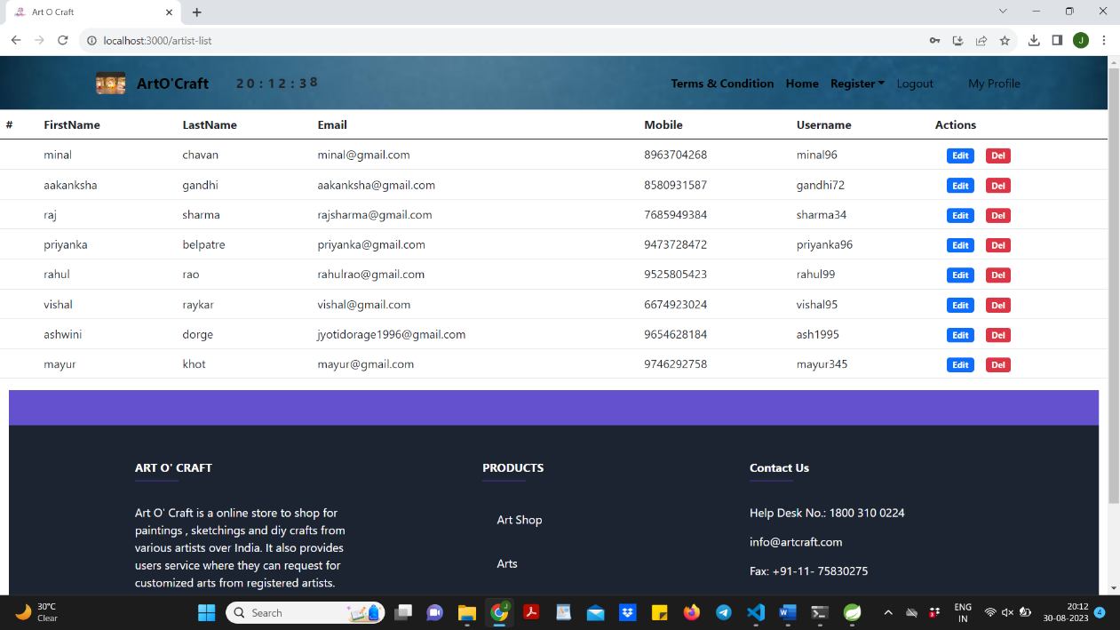

**Customer list :**

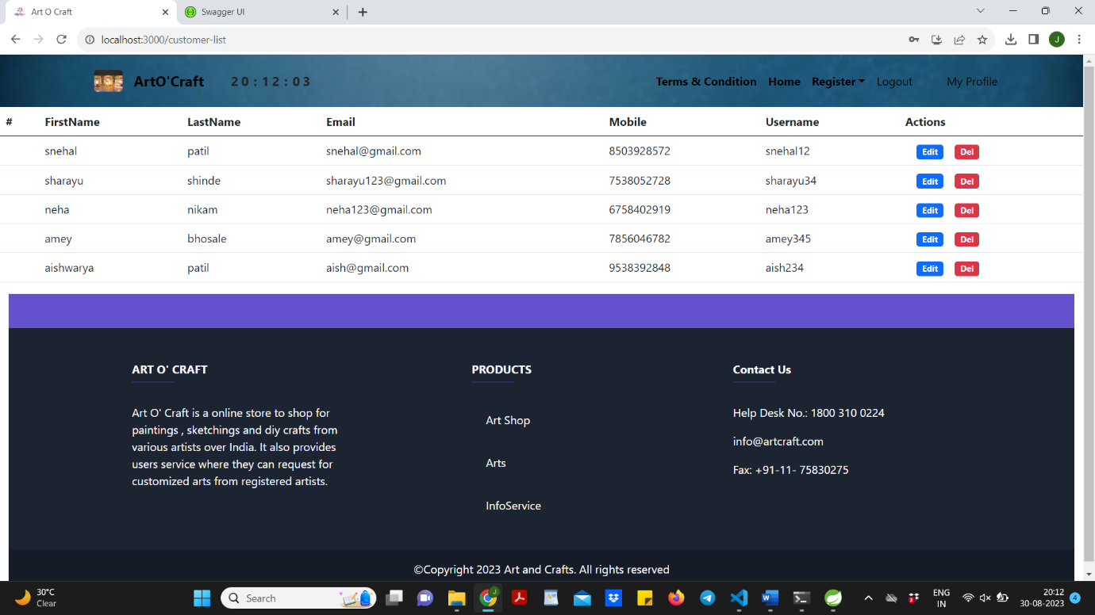

**Product list :**

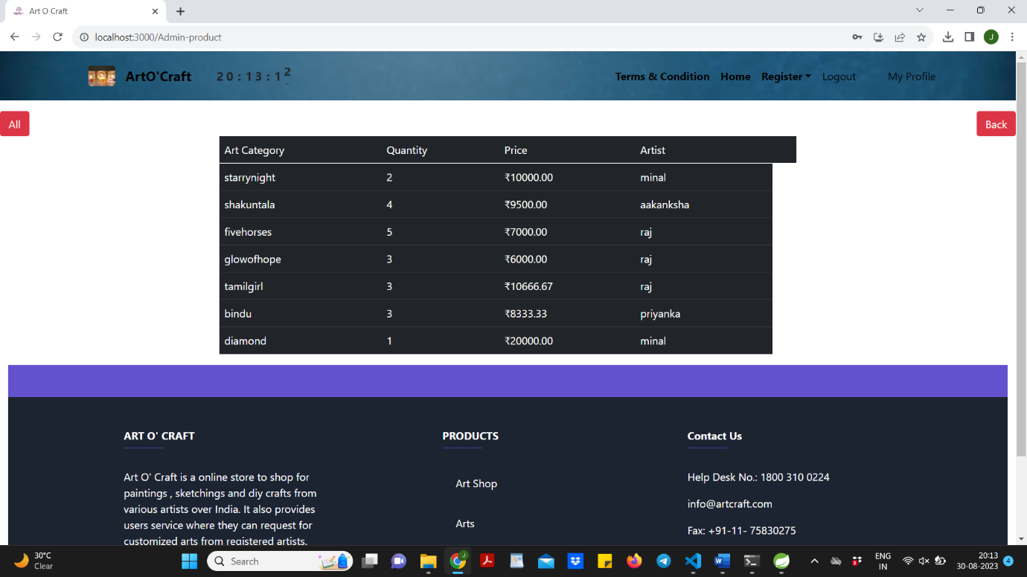

**Order list :**

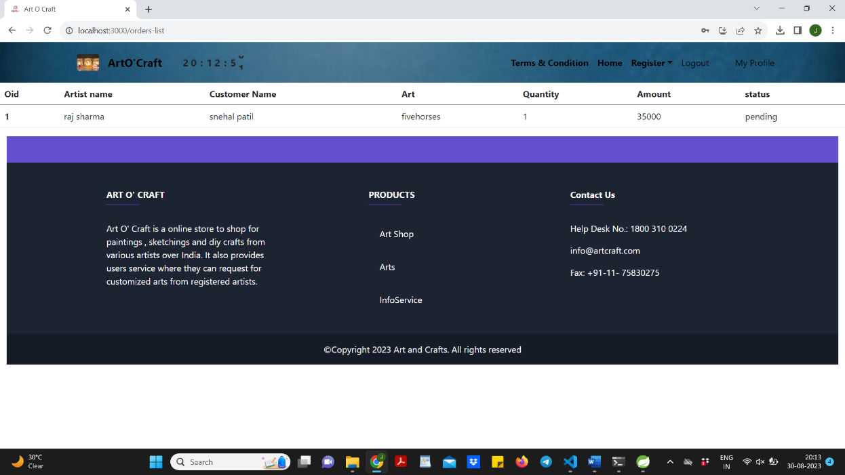

# **Conclusion :**

* This project aid in automating the existing manual system. This is a paperless work. It can be monitored and guarded remotely also provide accurate information .
* Online art gallery Store the customer can purchase various artforms online. It is different from the traditional physical stores as it helps to overcome problem of limited space and narrow sales channels and other issues, for people to purchase arts.
* Online art gallery store system can easily find the information and purchase artforms. Also the operating conditions are simple, user-friendly, to a large extent to solve real-life problems in the purchase of arts.

# **Future Scope :**

* As for other future developments, the following can be done: Artists can categorized different artforms like for paintings (portraits , charcoal painting , color painting , abstract painting), diy crafts(greetings , scrapbook , home decor) and sketches.
* Customers can request for customized artforms from various artists which are registered into the system.

**References :**

* React Tutorial (w3schools.com)
* Spring Data JPA - Reference Documentation
* React – A JavaScript library for building user interfaces (reactjs.org)
* Bootstrap · the most popular HTML, CSS, and JS library in the world. (getbootstrap.com)