|  |  |  |  |  |  |  |  |  |  |
| --- | --- | --- | --- | --- | --- | --- | --- | --- | --- |
| **SCHOOL OF COMPUTER SCIENCE AND ARTIFICIAL INTELLIGENCE** | | | | | **DEPARTMENT OF COMPUTER SCIENCE ENGINEERING** | | | | |
| **ProgramName:**B. Tech | | | | **Assignment Type: Lab** | | | **AcademicYear:**2025-2026 | | |
| **CourseCoordinatorName** | | | | Venkataramana Veeramsetty | | | | | |
| **Instructor(s)Name** | | | | |  | | --- | | Dr. V. Venkataramana (Co-ordinator) | | Dr. T. Sampath Kumar | | Dr. Pramoda Patro | | Dr. Brij Kishor Tiwari | | Dr.J.Ravichander | | Dr. Mohammand Ali Shaik | | Dr. Anirodh Kumar | | Mr. S.Naresh Kumar | | Dr. RAJESH VELPULA | | Mr. Kundhan Kumar | | Ms. Ch.Rajitha | | Mr. M Prakash | | Mr. B.Raju | | Intern 1 (Dharma teja) | | Intern 2 (Sai Prasad) | | Intern 3 (Sowmya) | | NS_2 ( Mounika) | | | | | | |
| **CourseCode** | | | 24CS002PC215 | **CourseTitle** | | AI Assisted Coding | | | |
| **Year/Sem** | | | II/I | **Regulation** | | R24 | | | |
| **Date and Day**  **of Assignment** | | | Week3 - Thursday | **Time(s)** | |  | | | |
| **Duration** | | | 2 Hours | **Applicableto**  **Batches** | |  | | | |
| **AssignmentNumber:5.4**(Present assignment number)/**24**(Total number of assignments) | | | | | | | | | |
|  | | | | | | | | | |
|  | **Q.No.** | **Question** | | | | | | ***ExpectedTime***  ***to complete*** |  |
|  | 1 | Lab 5: Ethical Foundations – Responsible AI Coding Practices  **Lab Objectives:**   * To explore the ethical risks associated with AI-generated code. * To recognize issues related to security, bias, transparency, and copyright. * To reflect on the responsibilities of developers when using AI tools in software development. * To promote awareness of best practices for responsible and ethical AI coding.   **Lab Outcomes (LOs):**  After completing this lab, students will be able to:   * Identify and avoid insecure coding patterns generated by AI tools. * Detect and analyze potential bias or discriminatory logic in AI-generated outputs. * Evaluate originality and licensing concerns in reused AI-generated code. * Understand the importance of explainability and transparency in AI-assisted programming. * Reflect on accountability and the human role in ethical AI coding practices..   **Task Description #1:**  **•** Prompt GitHub Copilot to generate a Python script that collects user data (e.g., name, age, email). Then, ask Copilot to add comments on how to anonymize or protect this data.  **Expected Output #1:**  **•** A script with inline Copilot-suggested code and comments explaining how to safeguard or anonymize user information (e.g., hashing emails, not storing data unencrypted).  **Task Description #2:**  **•** Ask Copilot to generate a Python function for sentiment analysis. Then prompt Copilot to identify and handle potential biases in the data.  **Expected Output #2:**  **•** Copilot-generated code with additions or comments addressing bias mitigation strategies (e.g., balancing dataset, removing offensive terms).  **Task Description #3:**  **•** Use Copilot to write a Python program that recommends products based on user history. Ask it to follow ethical guidelines like transparency and fairness.  **Expected Output #3:**  **•** Copilot suggestions that include explanations, fairness checks (e.g., avoiding favoritism), and user feedback options in the code.  **Task Description #4:**  • Prompt Copilot to generate logging functionality in a Python web application. Then, ask it to ensure the logs do not record sensitive information.  **Expected Output #4:**  • Logging code that avoids saving personal identifiers (e.g., passwords, emails), and includes comments about ethical logging practices.  **Task Description #5:**  **•** Ask Copilot to generate a machine learning model. Then, prompt it to add documentation on how to use the model responsibly (e.g., explainability, accuracy limits).  **Expected Output #5:**  **•** Copilot-generated model code with a README or inline documentation suggesting responsible usage, limitations, and fairness considerations.  **Note: Report should be submitted a word document for all tasks in a single document with prompts, comments & code explanation, and output and if required, screenshots**  **Evaluation Criteria:**   | **Criteria** | **Max Marks** | | --- | --- | | How to anonymize or protect this data | 0.5 | | Identify and handle potential biases in the data. | 0.5 | | Follow ethical guidelines like transparency and fairness. | 0.5 | | logs do not record sensitiv information. | 0.5 | | How to use the model responsibly | 0.5 | | **Total** | **2.5 Marks** | | | | | | | Week3 - Thursday |  |
|  |  |  | | | | | |  |  |

**Task Description #1:**

**•** Prompt GitHub Copilot to generate a Python script that collects user data (e.g., name, age, email). Then, ask Copilot to add comments on how to anonymize or protect this data.

**Expected Output #1:**

**•** A script with inline Copilot-suggested code and comments explaining how to safeguard or anonymize user information (e.g., hashing emails, not storing data unencrypted).

Test 1.1:

Prompt:

generate a Python script that collects user data (e.g., name, age, email).

Then add comments on how to anonymize or protect this data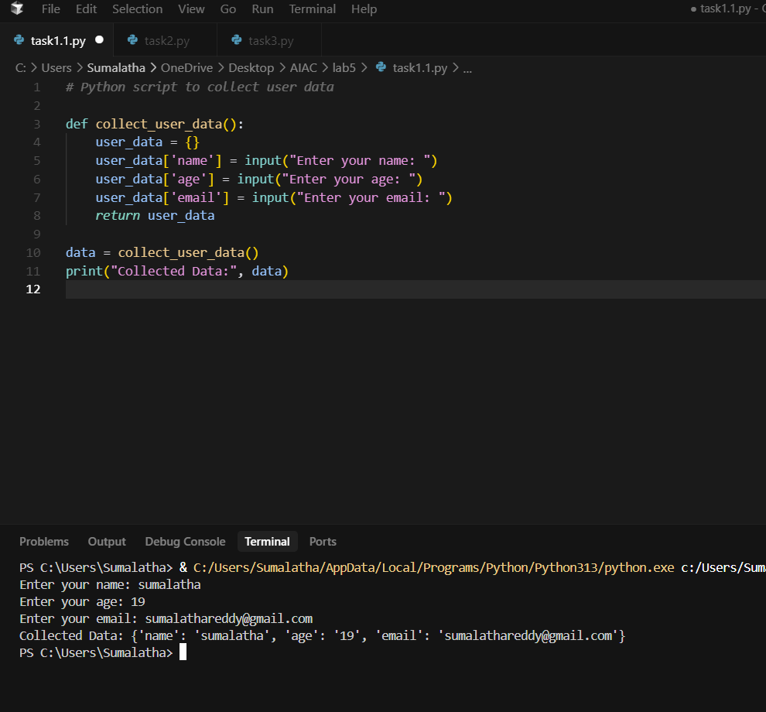

Task1.2:

Prompt:

Write a Python script that collects user data such as name, age, and email, and stores it in a dictionary and the hide the important and secured data.

Code:

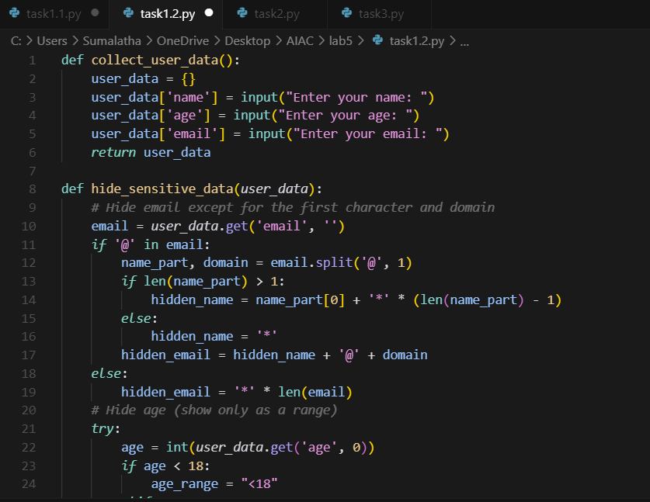

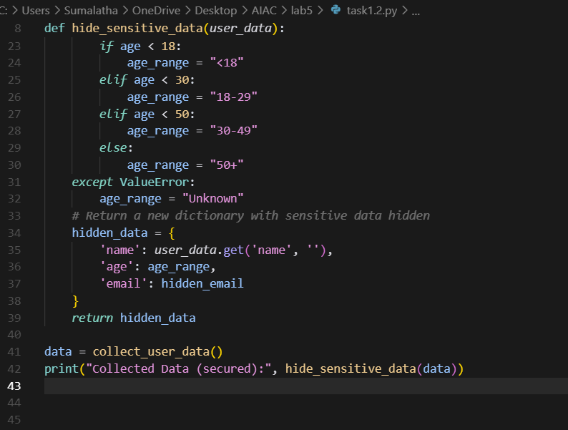

Output:

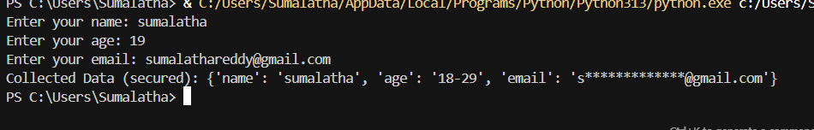

**Task Description #2:**

**•** Ask Copilot to generate a Python function for sentiment analysis. Then prompt Copilot to identify and handle potential biases in the data.

**Expected Output #2:**

**•** Copilot-generated code with additions or comments addressing bias mitigation strategies (e.g., balancing dataset, removing offensive terms).

Prompt:

Generate a Python function for sentiment analysis and identify whether the sentiment is positive, negative, or neutral by taking the input from the console.

#Example 1: How is your Holiday ? He said it was an awesome positive sentiment.

# Exmaple 2 :How was the movie? She said it was worst negative sentiment.

Code:

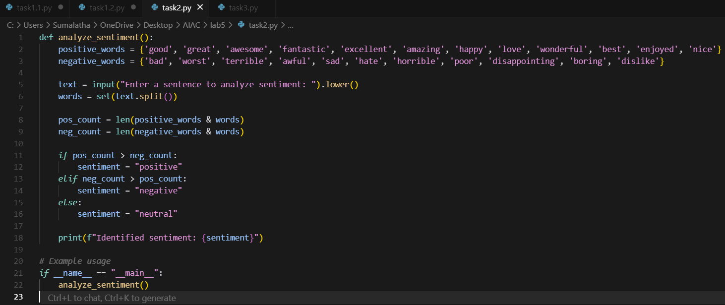

Output:

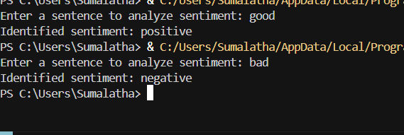

**Task Description #3:**

**•** Use Copilot to write a Python program that recommends products based on user history. Ask it to follow ethical guidelines like transparency and fairness.

**Expected Output #3:**

**•** Copilot suggestions that include explanations, fairness checks (e.g., avoiding favoritism), and user feedback options in the code.

Prompt:

Write a Python program that recommends products based on what the user bought before. Be fair (do not always pick the same brand), explain why each product is suggested, and let the user give feedback (like or dislike) to improve the system , add comments to the specific command .

Code:

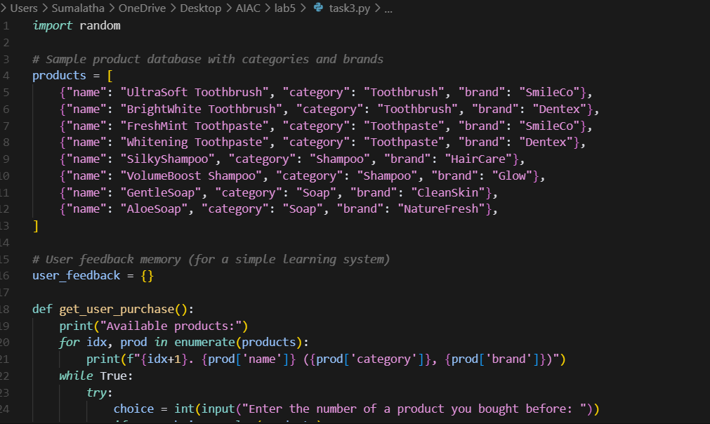

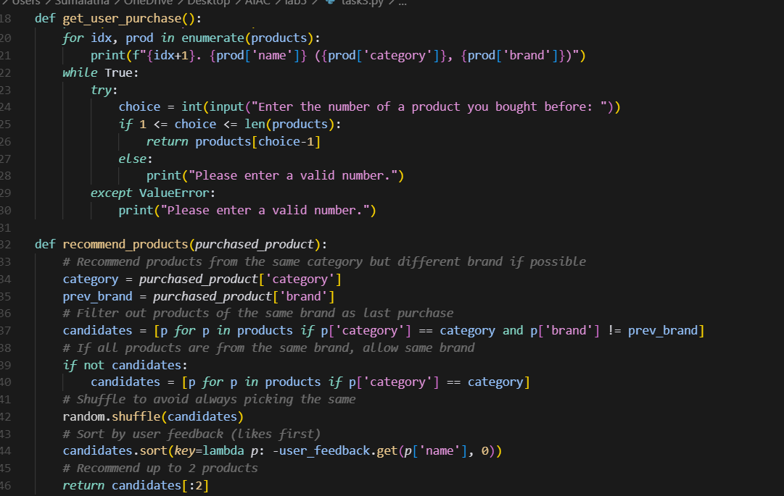

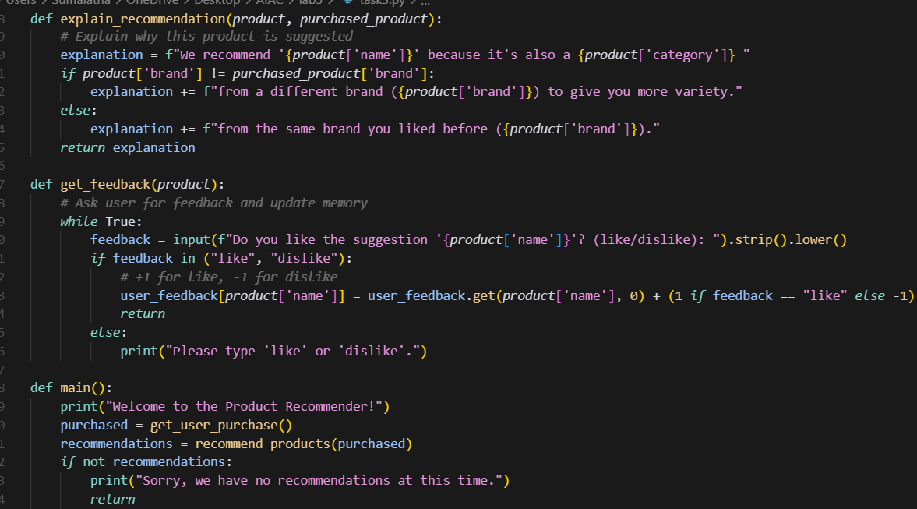

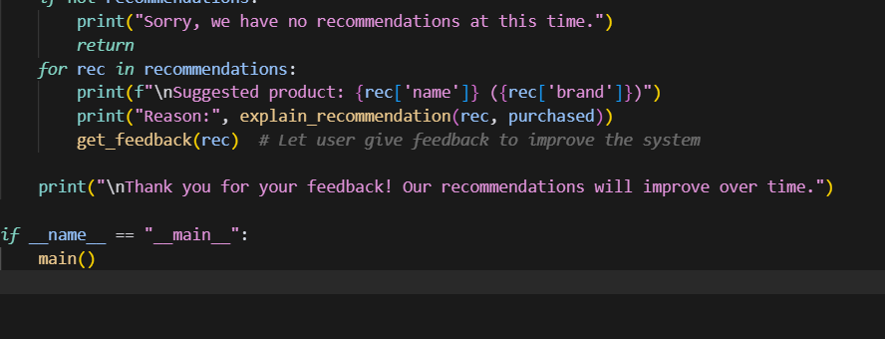

Output:

