1. Write a Python code to calculate the sum of odd and even numbers in a given list using GitHub  
   Copilot along with VS Code. Use zero shot prompting.

Prompt: write a python code that calculate the sum of even and odd numbers individually by taking the inputs from the user.

Code:

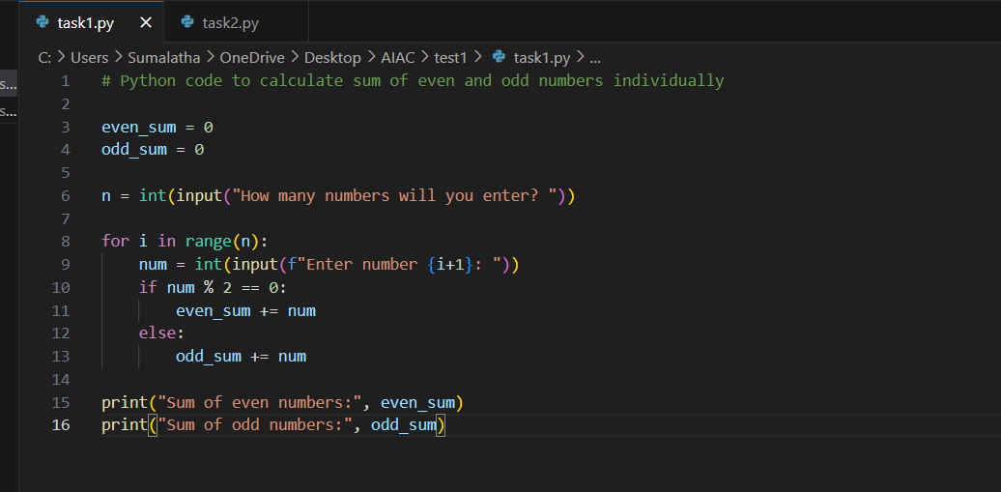

Output:

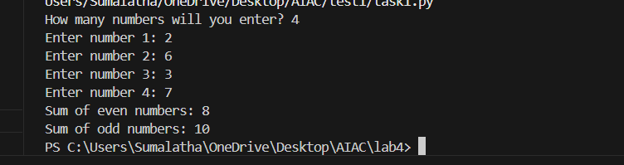

1. Write a Python code for given a list of integers, remove duplicates and print the sorted result.  
   GitHub Copilot along with VS Code. Use one shot prompting

Prompt: write a python code that takes the input as the list of integers and then removes the duplications list among then and prints the sorted numbers .

example : input list :[2,5,7,2,9,]

output list :[2,5,7,9]

code:

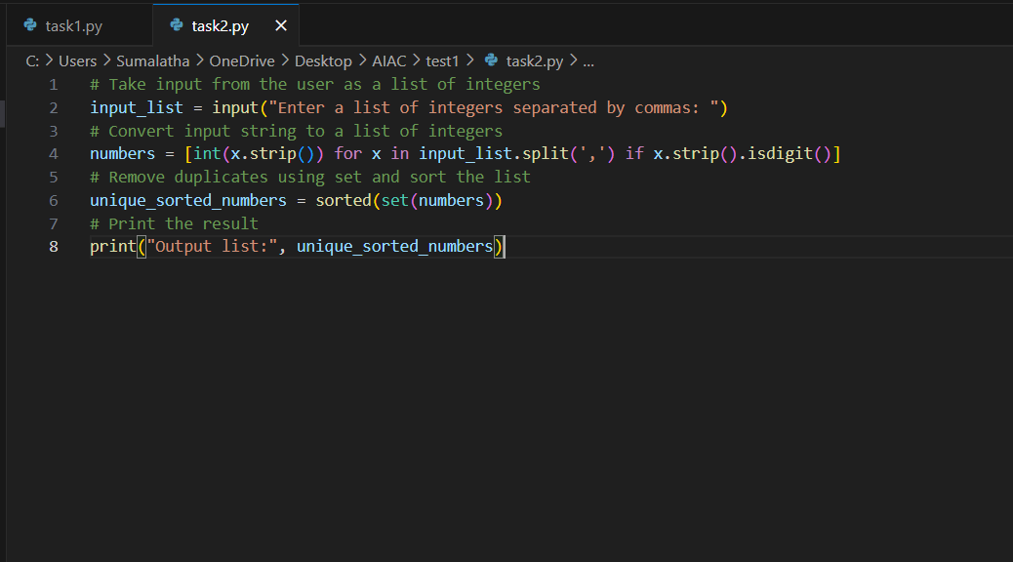

Output:

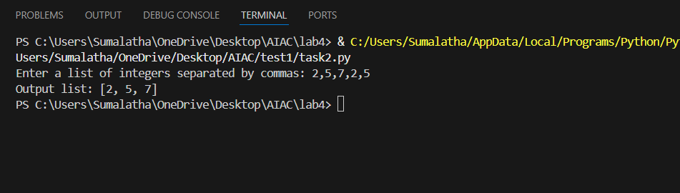

1. Write a Python function that converts the temperature between Celsius, Fahrenheit, and Kelvin  
   based on user choice. Use the Cursor AI tool. Use few shot prompting

Prompt: write a python function that takes input as integer number from the user and converts them intlo Celsius, Fahrenheit, and Kelvin on requried of user and give the result as user needed temperature and calls the function.

example1 : input: enter the temperature : 50 . enter the unit of input temperature(c/k/f): k .enter the option you need to covert(c/k/f): c. output: 50k is equal to -223.1c . example2:input: enter the temperature:273 . enter the unit of input temperature (c/k/f):k . enter the option you need to convert(c/k/f):c . output: 273k is equal to 0

code:

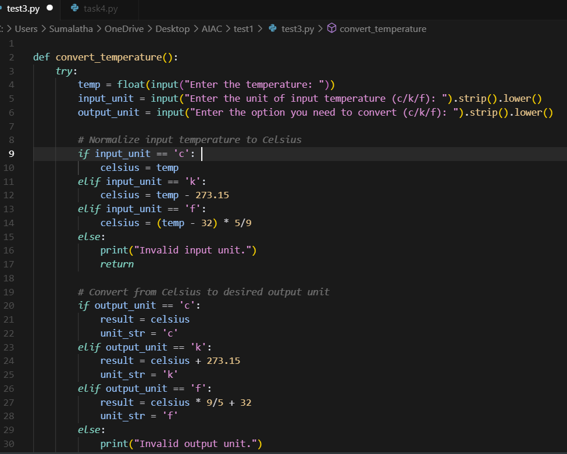

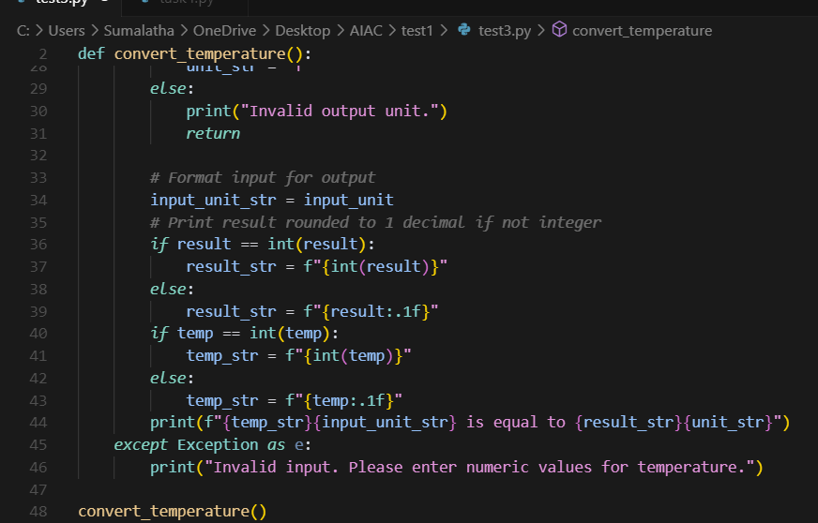

Output:

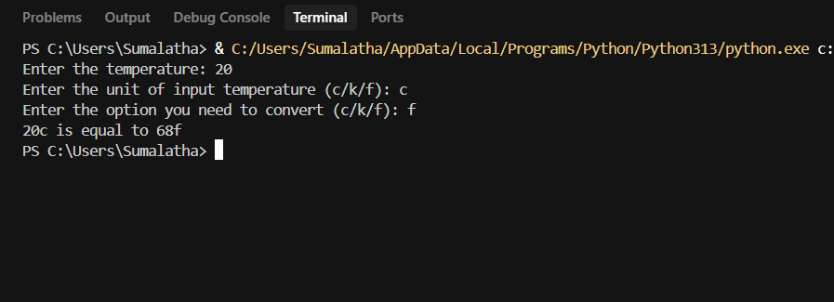

1. Write a Python function to remove punctuation, convert to lowercase, and remove stop words  
   from a given text. Use the Cursor AI tool. Use zero shot prompting.  
   prompt:

write a python function that takes input as string from the user and removes the punctuation , convert to lowercase and remove stop words from the given text and print the output.

Code:

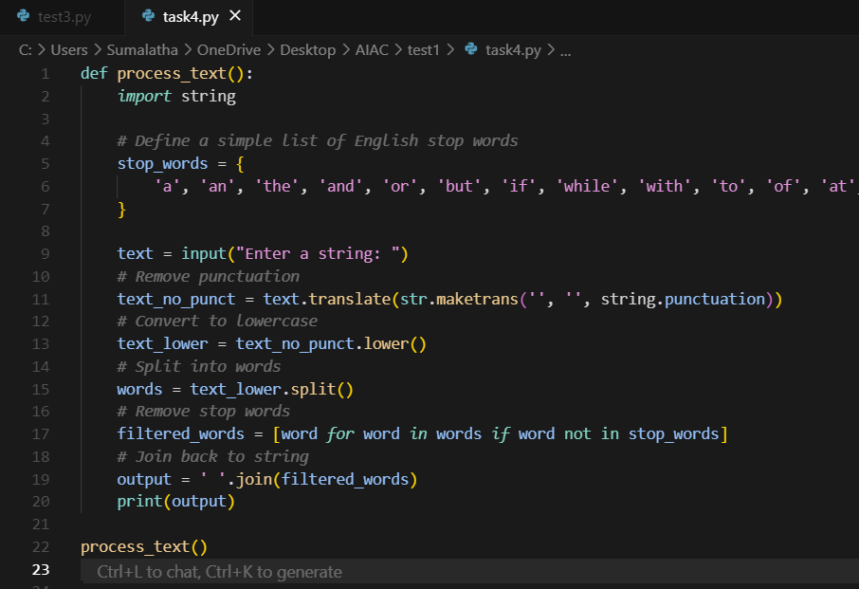

Output:

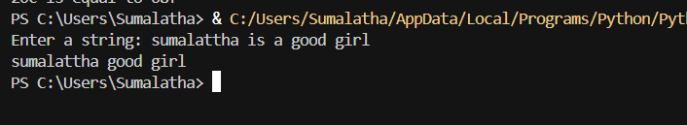

Output: