|  |
| --- |
| Synchronization among Multiple Nanomachines for Simultaneous Targeted Drug Delivery |
| Tania Islam1,Ethungshan Shitiri2,and Ho-Shin Cho*  School of Electronics Engineering  Kyungpook National University,Daegu,Korea  Email:Tania.bd.09@knu.ac.kr {2ethungshan,*hscho}@ee.knu.ac.kr |

* **Synchronization** → Drug release nanomachines (DN) perform a tow way message exchange mechanism with a coordinator nanomachine (CN)
* **Simultaneous drug delivery** → CN will provide a common time for drug deleivery nanomachines to release their drug

A potential application of MC → Targeted Drug Delivery (TDD)

TDD → Localized drug administration

**3. Solution**

Moleculer Communication(MC) → A new communication

Paradigm where molecules act as the information carriers

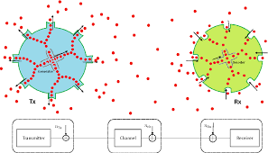

* **Simultaneous Drug delivery with multiple nanomachines**

1. How to perform synchronization?
2. When to release the drug molecules?
3. **Simultaneous** drug release nanomachines will release drug at a common time

* **A Critical requirement in TDD → Synchronization**
* **Establishing coordination among the nanomachines to perform drug release at an agreed time**

2. Problem Statement

1.Introduction

**4.System Model & Proposed Scheme**

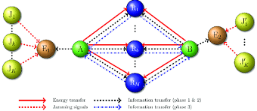

**To evaluate the performance of the proposed scheme through computer simulations**

This study was supported by the BK21 PLUS project funded by the Ministry of Education,Korea (21A20131600011)and the Natonal Research

Foundation of Korea (NRF) grant funded by the Korean Government (MSIP) (2017RIA2B4002622)

0

**Acknowledgement**

**5.Future Work**

Propagating delay between CN and DNI, $T_{d2}=\frac{T2-T5}{2}$ Propagation delay between CN and DN2 $Td_{2}=\frac{T2-T5}{2}$

Drug release time for DNI, $z_{d_{1}}=T_{R-T_{d1}}$ Drug release time for DN2, $z_{d_{2}}=T_{R-T_{d2}}$