DevOps Assignment – AWS Course Project

1. Project Overview
This project demonstrates an end-to-end DevOps implementation using modern cloud-native tools and best practices. The goal of the project is to design, provision, configure, and deploy a containerized application on AWS using Infrastructure as Code (IaC), Configuration Management, and CI/CD automation.

2. TASK 1 – Infrastructure Setup (AWS)

Objective
To provision a secure, scalable, and production-ready AWS infrastructure using Terraform.
Summary:
In Task-1, AWS infrastructure was created entirely using Terraform. A custom VPC was designed with public and private subnets spread across multiple Availability Zones to ensure high availability. Internet access was managed using an Internet Gateway for public subnets and a NAT Gateway for private subnets.
A Bastion host was deployed in a public subnet to enable secure SSH access to private instances. Jenkins and Application EC2 instances were deployed in private subnets to avoid direct public exposure. An Application Load Balancer (ALB) was configured to expose Jenkins securely.
To ensure safe and consistent Terraform execution, remote state management was implemented using Amazon S3 with versioning and DynamoDB for state locking.
Key Outcomes:
- Fully automated AWS infrastructure
- Secure network isolation
- Remote Terraform backend using S3 and DynamoDB
- ALB-based access to Jenkins

Step 1: VPC Creation
- Created a VPC devops-vpc with CIDR 10.0.0.0/16.

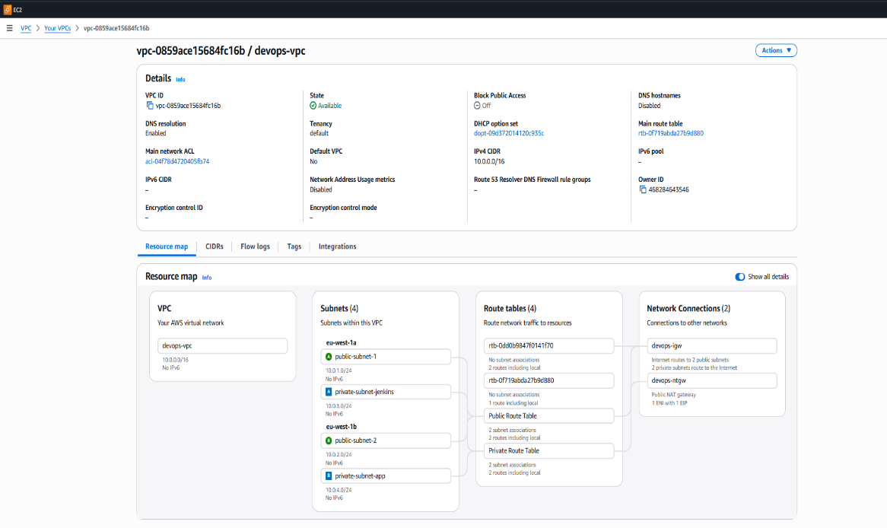

Screenshot: VPC details page

Step 2: Subnet Creation
Subnet | CIDR | AZ | Purpose
public-subnet-1 | 10.0.1.0/24 | eu-west-1a | ALB
public-subnet-2 | 10.0.2.0/24 | eu-west-1b | Bastion
private-subnet-jenkins | 10.0.3.0/24 | eu-west-1a | Jenkins
private-subnet-app | 10.0.4.0/24 | eu-west-1b | Application

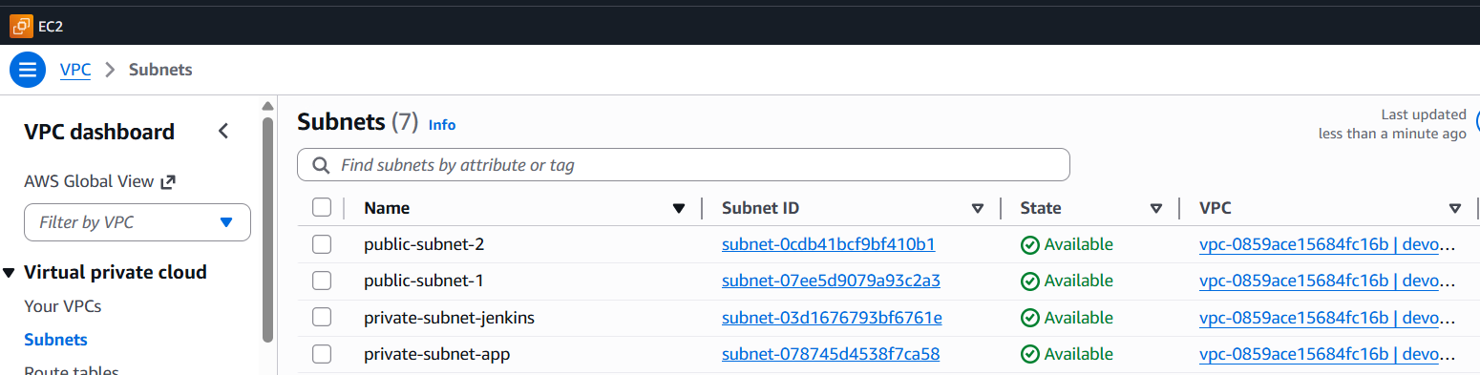
Screenshot: Subnets list

Step 3: Internet Gateway & NAT Gateway
- Internet Gateway attached to VPC.
- NAT Gateway created in public subnet for private subnet egress.
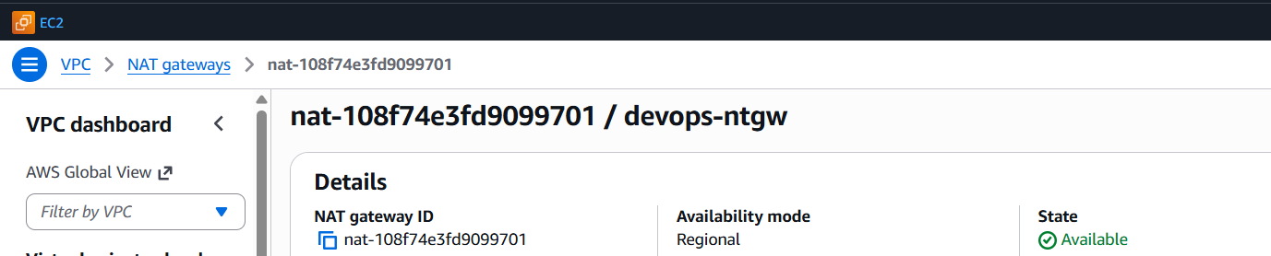
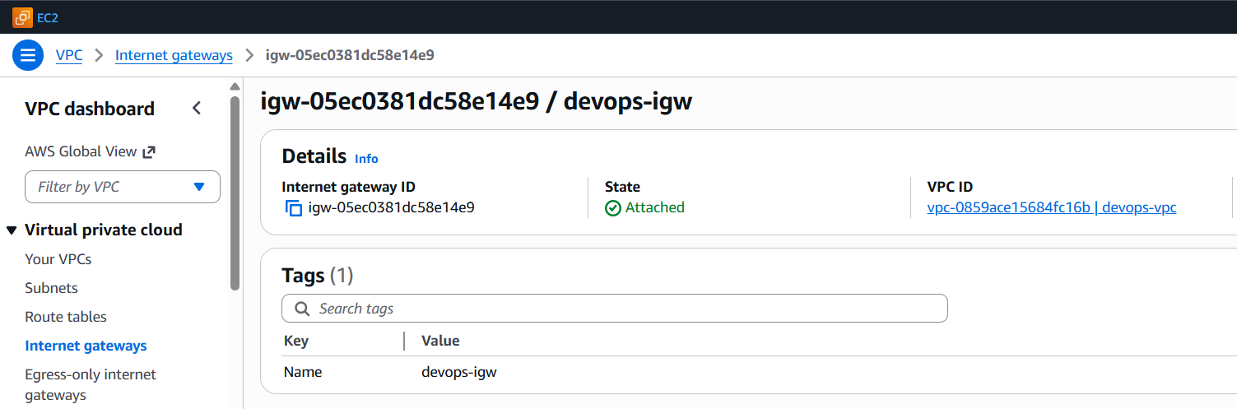
Screenshot: IGW and NAT Gateway

Step 4: Route Tables
- Public Route Table: 0.0.0.0/0 → Internet Gateway
- Private Route Table: 0.0.0.0/0 → NAT Gateway

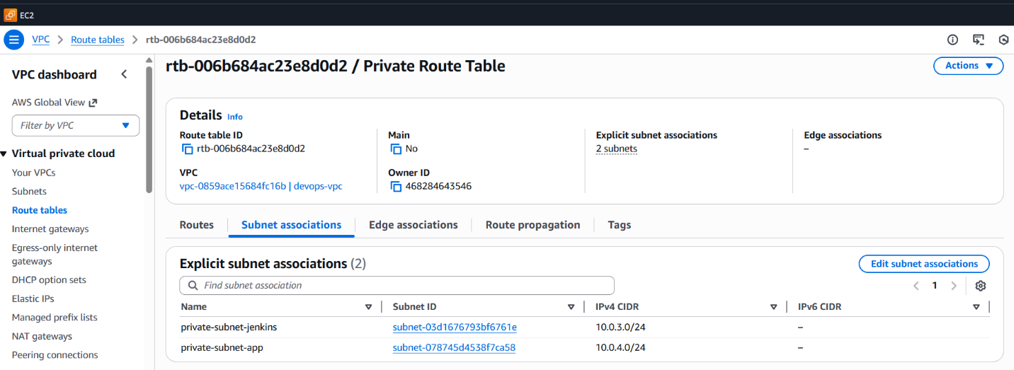
Screenshot: Route tables

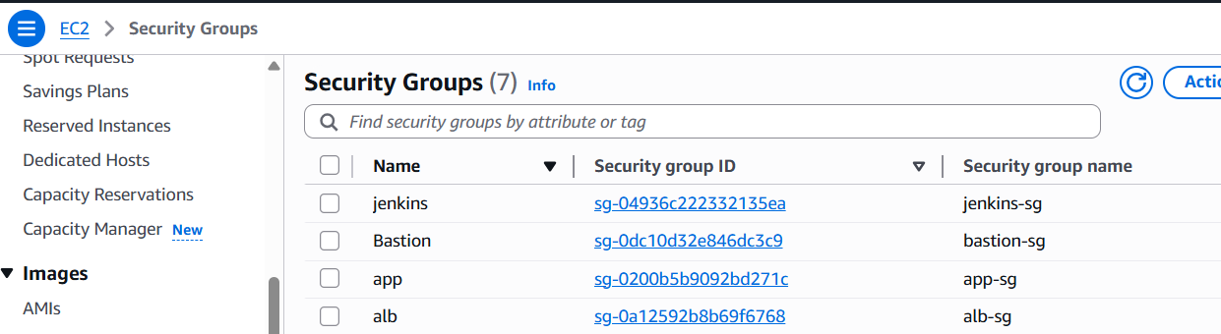
Step 5: Security Groups
Security Group | Purpose | Inbound Rules
bastion-sg | Bastion access | SSH (22) from personal IP
alb-sg | ALB access | HTTP (80) from 0.0.0.0/0
jenkins-sg | Jenkins access | SSH (22) from bastion-sg, TCP 8080 from alb-sg
app-sg | App access | SSH (22) from jenkins-sg
Screenshot: Security group rules

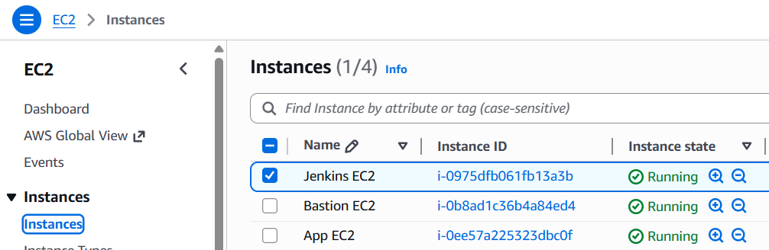
Step 6: EC2 Instance Creation
Instance | Subnet | Instance Type | Public IP
Bastion | Public | t3.micro | Yes
Jenkins | Private | t3.medium | No
App | Private | t3.small | No

Screenshot: EC2 instances

Step 7: AWS CLI, S3 and DynamoDB Table
- AWS CLI is installed and configured on a Linux machine.
- Create an S3 bucket using Terraform.
- S3 versioning enabled.
- DynamoDB table created.

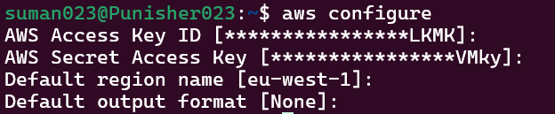
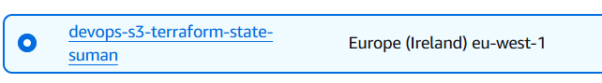

Screenshot: AWS CLI configure, S3 and DynamoDB Table

3. TASK 2 – Configuration Management & CI Foundation
Objective:
To automate server configuration and Docker installation using Ansible.
Summary:
In Task-2, Ansible was used as the configuration management tool to automate Docker installation on both Jenkins and Application EC2 instances. The Bastion host acted as the Ansible control node, while Jenkins and App EC2 instances were configured as managed nodes.
A role-based Ansible structure was used to ensure modularity, reusability, and idempotency. Docker was installed, enabled, and configured so that the application user could run Docker commands without manual intervention.
Key Outcomes:
- Automated Docker installation
- Consistent configuration across servers
- Reduced manual setup and configuration errors
- Prepared infrastructure for CI/CD pipelines

Subtask 1: Ansible & Docker Installation
- Ansible installed on Bastion host
- Inventory defined for Jenkins and App hosts
- Docker installed via Ansible using official Docker repository
- Docker service enabled and running

Subtask 2: Jenkins Installation (Manual on Jenkins EC2)
- Java 21 installed.
- Jenkins installed using official Jenkins repository.
- Jenkins configured to run under /jenkins context using systemd override.
- Jenkins service started and enabled.
- Jenkins service started and enabled at boot.
- Initial Jenkins setup completed with a custom admin user.
- http://jenkins-alb-849070241.eu-west-1.elb.amazonaws.com/jenkins/
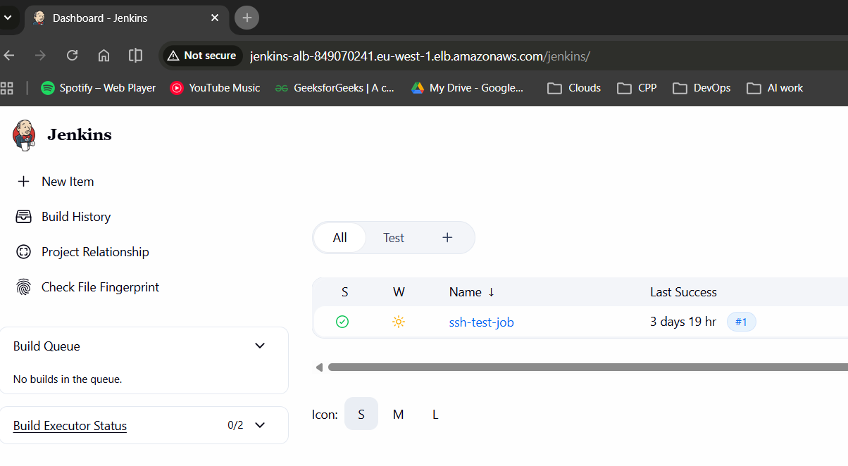
Screenshot: Jenkins service status

Subtask 3: Application Load Balancer
- Internet-facing ALB created on port 80
- Target Group configured on port 8080
- Health check path set to /jenkins/
- Listener rule configured for /jenkins and /jenkins/*
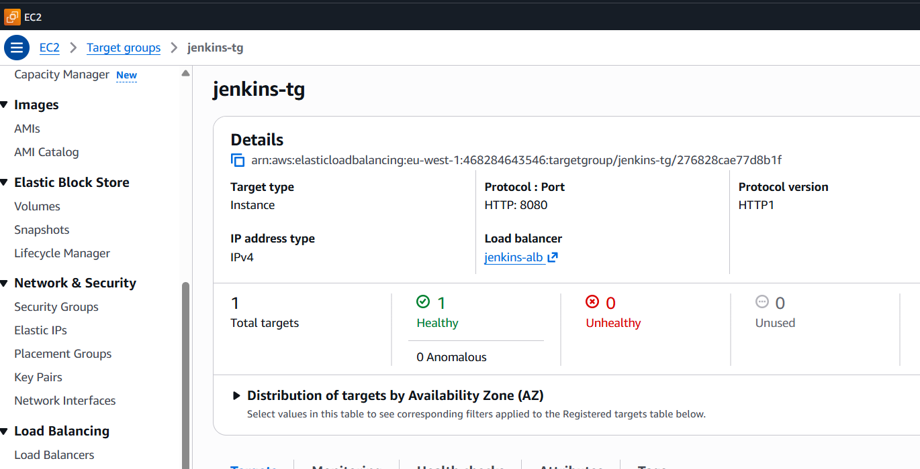
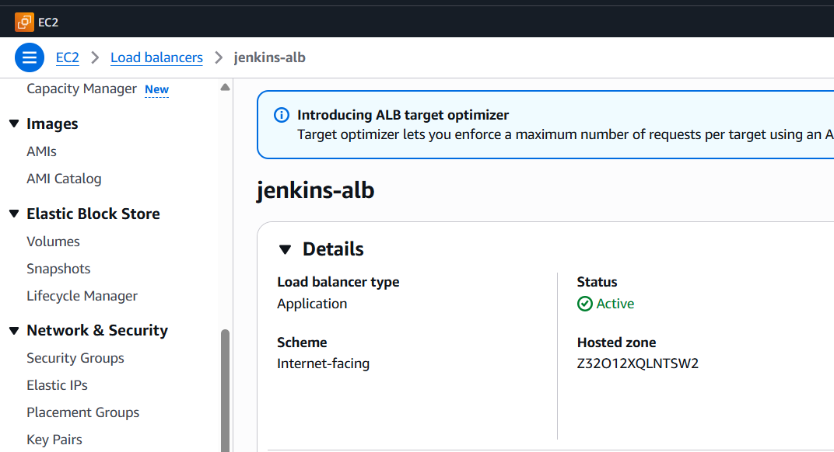

Screenshot: Target group showing Healthy state

Subtask 4: ECR, IAM, and SSH Configuration
- Private ECR repository created for Node application.
- IAM role with AmazonEC2ContainerRegistryFullAccess attached to Jenkins and App EC2.
- Jenkins and App authenticated to ECR using IAM role.
- New SSH key generated on Jenkins EC2 (no personal keys used).
- Jenkins successfully connects to App EC2 via SSH.

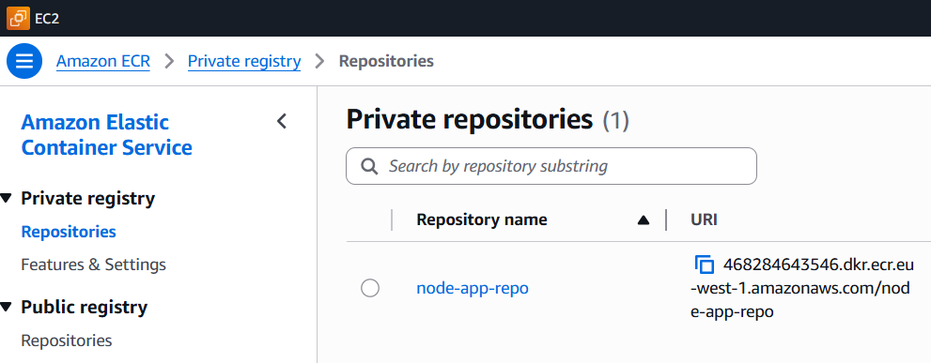
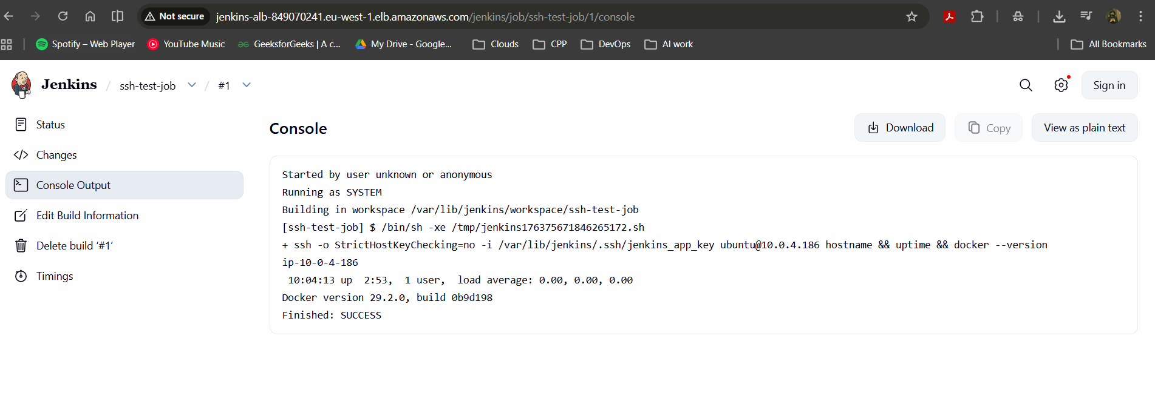
Screenshot: Jenkins SSH job output

4. TASK 3 – CI/CD Pipeline

Objective
To build a complete CI/CD pipeline that automates application build, containerization, and deployment.
Summary:
In Task-3, a CI/CD pipeline was implemented using Jenkins. The application source code, Dockerfile and Jenkinsfile were stored in a Git repository. Jenkins was configured to pull the source code, build a Docker image, and push the image to Amazon Elastic Container Registry (ECR).
The pipeline also included a deployment stage that securely connected to the Application EC2 instance, pulled the latest image from ECR, stopped any existing container, and ran the updated container. This ensured automated and repeatable deployments.
Key Outcomes:
- Fully automated CI/CD pipeline
- Docker image build and push to ECR
- Automated deployment on App EC2
- Successful end-to-end application delivery

Pipeline Overview
- Source code checkout
- Docker image build
- Push image to Amazon ECR
- Deploy container on App EC2 via SSH

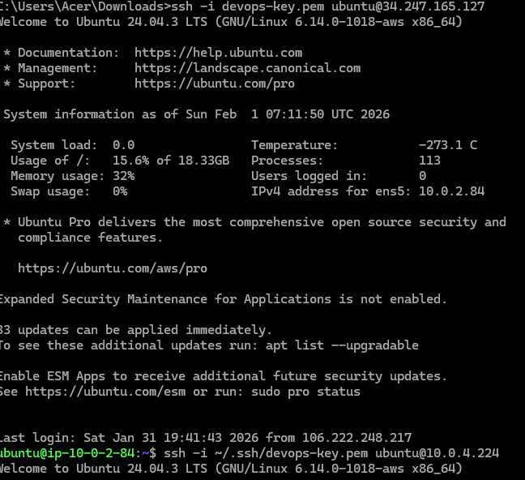

Screenshot: Jenkins pipeline execution

5. Codebase Structure
The project codebase is organized into three independent repositories, each responsible for a specific stage of the DevOps lifecycle. This separation improves clarity, maintainability, and scalability.
1. Terraform Codebase (Infrastructure as Code – Task-1)
Purpose:
Provision AWS infrastructure using Terraform with remote state management.
Repository Structure:
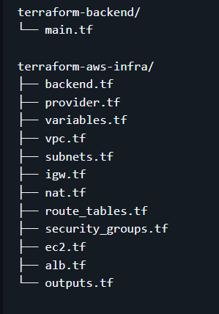
2. Ansible Codebase (Configuration Management – Task-2)
Purpose:
Automate Docker installation and system configuration on Jenkins and Application EC2 instances.
Repository Structure:
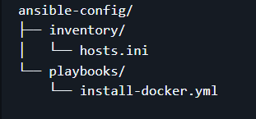
3. Application & CI/CD Codebase (Task-3)
Purpose:
Containerise the application and automate build and deployment using Jenkins.
Repository Structure:
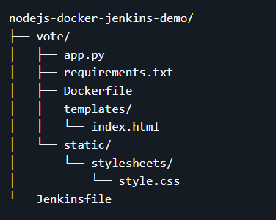

GitHub Repositories Reference
All the code developed for this project has been maintained in a single GitHub repository.
The repository is logically organised into separate folders for Terraform, Ansible, and the application CI/CD code to maintain clear separation of concerns.
GitHub Repository Link:

6. Network Architecture Diagram
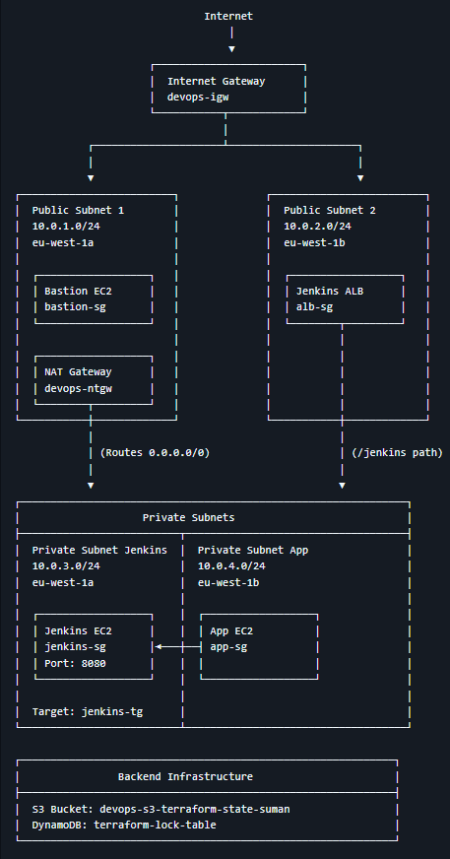
Screenshot: Architecture diagram

Estimated Monthly Cost (Approx.)
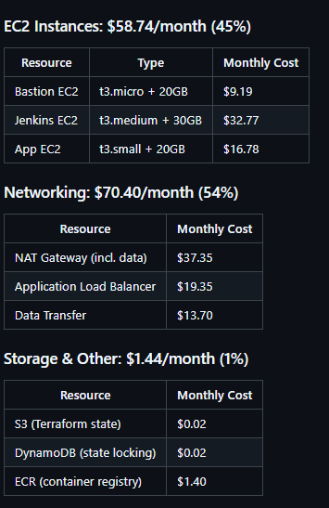
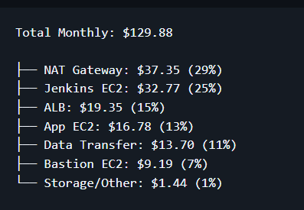
Screenshot: Cost Breakdown by Component

7. Conclusion
This project successfully demonstrates a complete end-to-end DevOps workflow by integrating Infrastructure as Code, Configuration Management, and CI/CD automation on AWS.
In Task-1, a secure and scalable AWS infrastructure was provisioned using Terraform. The infrastructure design followed AWS best practices by using a custom VPC, public and private subnets, Internet Gateway, NAT Gateway, and security groups. Critical services such as Jenkins and the application were deployed in private subnets and exposed securely using an Application Load Balancer. Terraform remote state management using Amazon S3 and DynamoDB ensured safe and consistent infrastructure changes.
In Task-2, Ansible was used as a configuration management tool to automate Docker installation and configuration on Jenkins and Application EC2 instances. By using Ansible roles and playbooks, the configuration process became consistent, repeatable, and idempotent, eliminating manual setup errors and preparing the servers for CI/CD automation.
In Task-3, a complete CI/CD pipeline was implemented using Jenkins, Docker, and Amazon ECR. The pipeline automated source code checkout, Docker image build, image push to ECR, and deployment on the Application EC2 instance. This ensured faster, reliable, and repeatable application deployments with minimal manual intervention.
Overall, the project highlights the practical implementation of modern DevOps practices, including automation, scalability, security, and maintainability. It demonstrates how infrastructure provisioning, configuration management, and continuous delivery can work together to deliver a robust and production-ready deployment pipeline on AWS.

