Untitled

Suman

09/11/2020

## R Markdown

slr <- read.csv("G:/Suman/batch34/R Markdown/slr.csv", stringsAsFactors=TRUE)  
  
dim(slr)

## [1] 12 3

str(slr)

## 'data.frame': 12 obs. of 3 variables:  
## $ Observation.no: int 1 2 3 4 5 6 7 8 9 10 ...  
## $ Advt : int 92 94 97 98 100 102 104 105 105 107 ...  
## $ Sales : int 930 900 1020 990 1100 1050 1150 1120 1130 1200 ...

summary(slr)

## Observation.no Advt Sales   
## Min. : 1.00 Min. : 92.00 Min. : 900   
## 1st Qu.: 3.75 1st Qu.: 97.75 1st Qu.:1012   
## Median : 6.50 Median :103.00 Median :1110   
## Mean : 6.50 Mean :101.75 Mean :1088   
## 3rd Qu.: 9.25 3rd Qu.:105.50 3rd Qu.:1162   
## Max. :12.00 Max. :110.00 Max. :1250

hist(slr$Sales,col="red")

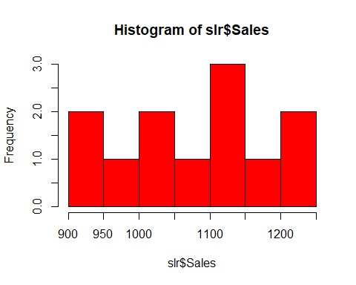

hist(slr$Advt,col="blue")

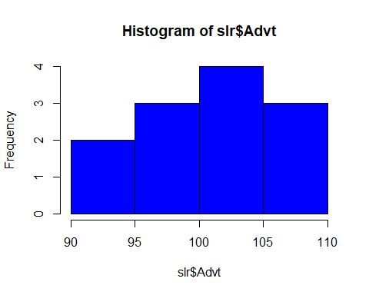

summary(cars)

## speed dist   
## Min. : 4.0 Min. : 2.00   
## 1st Qu.:12.0 1st Qu.: 26.00   
## Median :15.0 Median : 36.00   
## Mean :15.4 Mean : 42.98   
## 3rd Qu.:19.0 3rd Qu.: 56.00   
## Max. :25.0 Max. :120.00

## Including Plots

You can also embed plots, for example:



slr <- read.csv(“G:/Suman/batch34/R Markdown/slr.csv”, stringsAsFactors=TRUE)

dim(slr) str(slr) summary(slr) hist(slr$Sales,col="red") hist(slr$Advt,col=“blue”)