Frest Ubuntu Machine Jenkin machine se agent pe docker container run krna
Sudo apt update
Sudo apt install openjdk-17-jdk
Then follow instruction to install Jenkins
Store jenkin key (default location) /etc/apt/keyrings
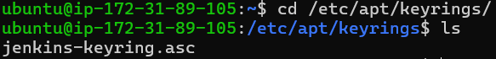
Sudo apt update
Sudo apt install jenkins
Verify Jenkins install or ver
Aws pe inbound port opent kre 8080 (Jenkins default port 8080)
Now access
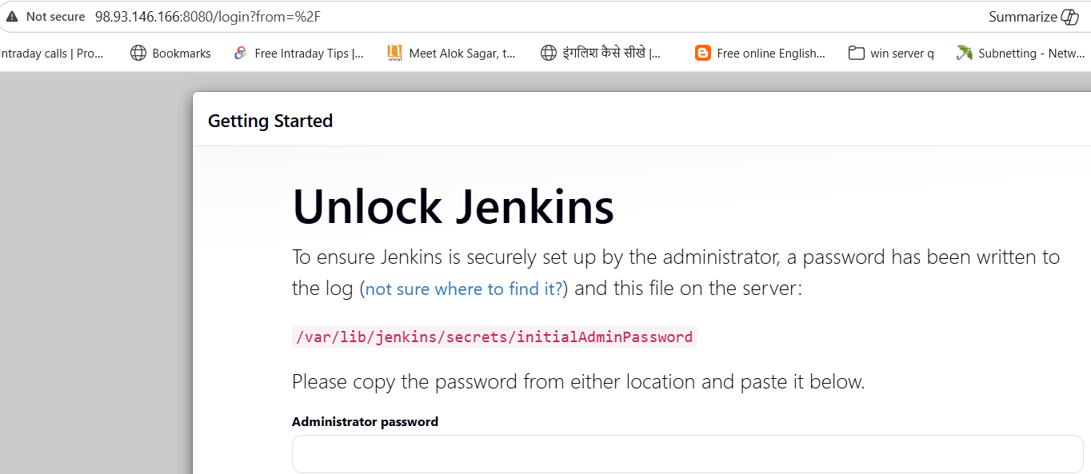
Now retrive Jenkins default password
Now Click install suggested plugin configure username password nextstart using Jenkins
Now install require plugin Go jenkins manage Jenkins plugins Git pluginPipelineMaven integration SonarQube scanner SSH Agent(Container Deployment ke liye)
Now Integrate GitHub, SonarQube and Docker hub with Token
GitHub Integrate with Jenkins

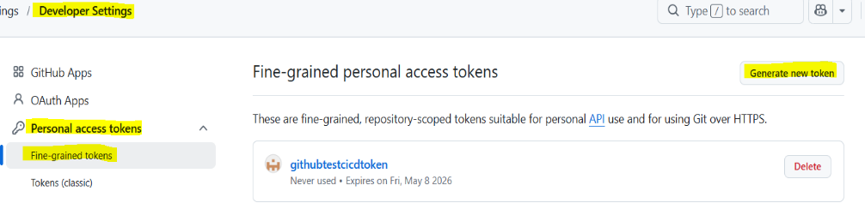
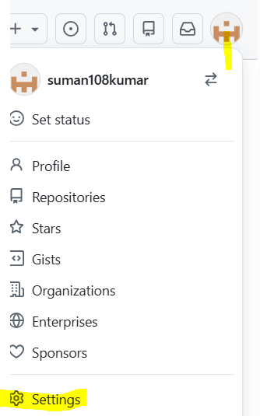
Integrate with GitHub Generate Token Setting Developer setting personal access token fine gran token put token name Select expire Select public / all repo add permission content R/W meta deta R/O create copy token (so Token only one time)

Add token on jenkin manage jenkins credential global add credential user name with password user name mera jo github ka user name hai wo password me token ko pest krna hai id GitHubToken (remember id use in jenkinfile)create
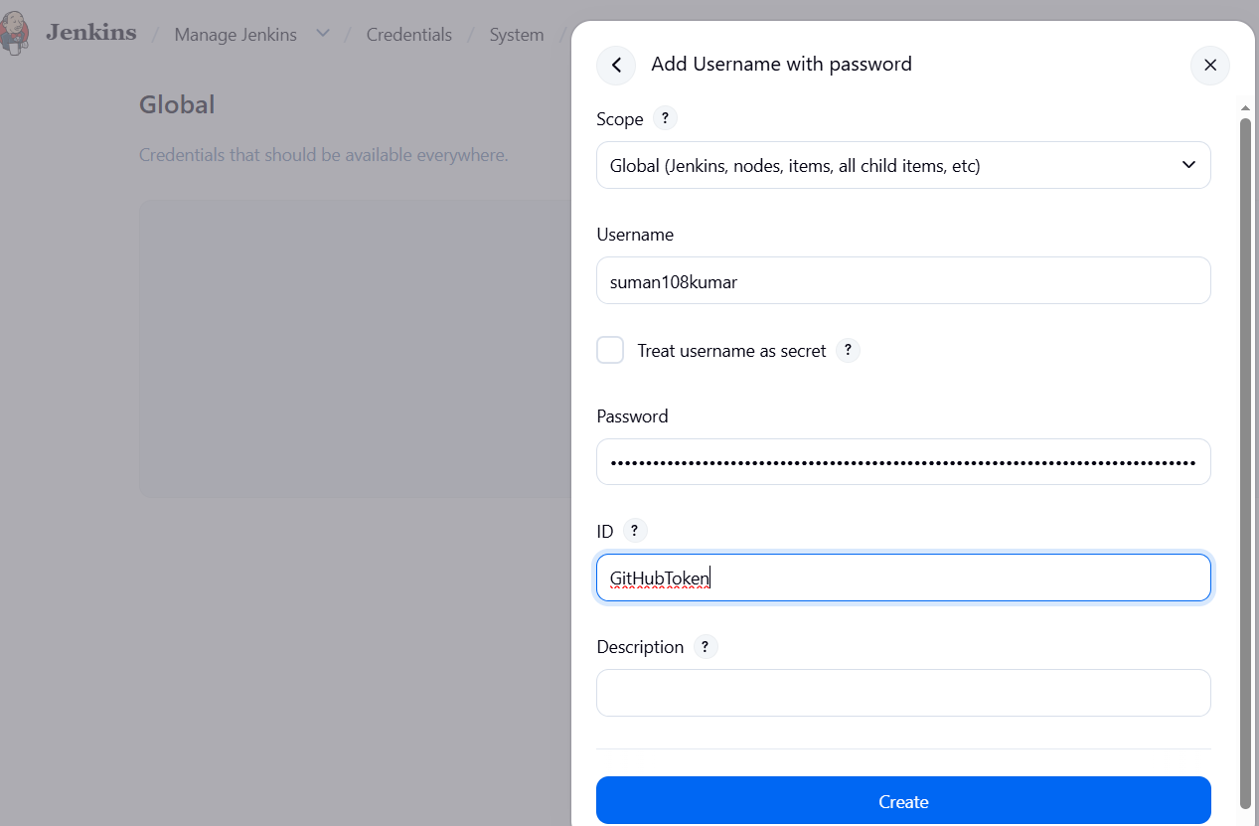
SonarQube Integrate
Go to sonarcloud click on my account security put name click generate token copy token (one time visiable)
Go to Jenkins –> Manage jen credential global add cre secret text secret me token pest krna haiid sonar-cloud—token
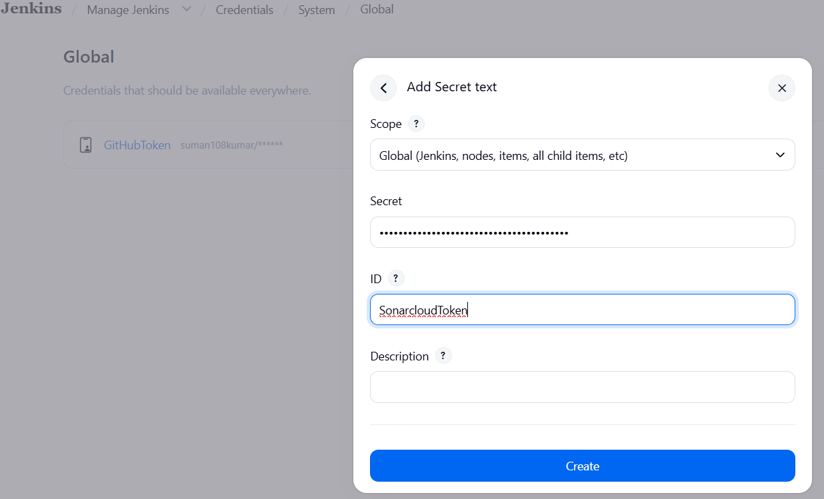
Now Integrate with Docker Hub
signin https://hub.docker.com hub left side exp hub repository Put Repository Name public create
Go to DockerHub click on Profile Icon Account SettingSetting Personal Access Token Generate new Token Discription Token name None read & write generate 2. At the password prompt, enter the personal access token. Copy save in Notepad password only one time view token
Now ADD token on Jenkins manage Jenkins credential add credential user name with password user name copy from docker profile password me token id any name (but remember Jenkins file me dalna hai) create
Install Docker in Jenkin machin jenkin machin me jenkin user hona chahiye --> sudo apt install -y docker.io sudo systemctl enable docker sudo systemctl start docker sudo usermod -aG docker jenkins (Jenkins user ko permission dene ke liye) sudo systemctl restart jenkins ab mujhe docker file chahiye ise github repo root me hona chahiye

Now configure

Go to sonar cloud Dashboard click my project Analyze new project (Nhi dikhe to r side top me + sig pe click kre) create a project manually create another org create one manually Name sonarTestOrg key auto aayega yadi already exist aayega to kuch letter add kr denge chuse plan free create organization
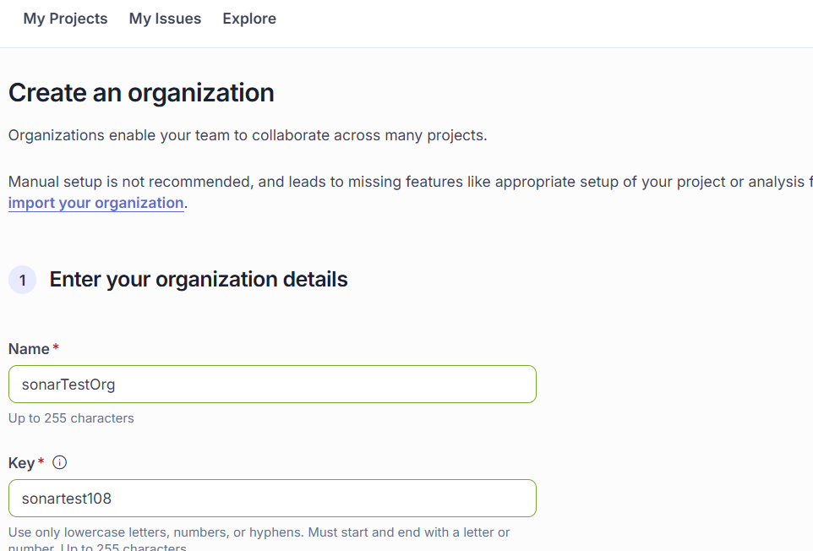
then open org jo humne bnaya tha Display Name SonarQubeProject (use in jen file) project visibility Public (because free AC)
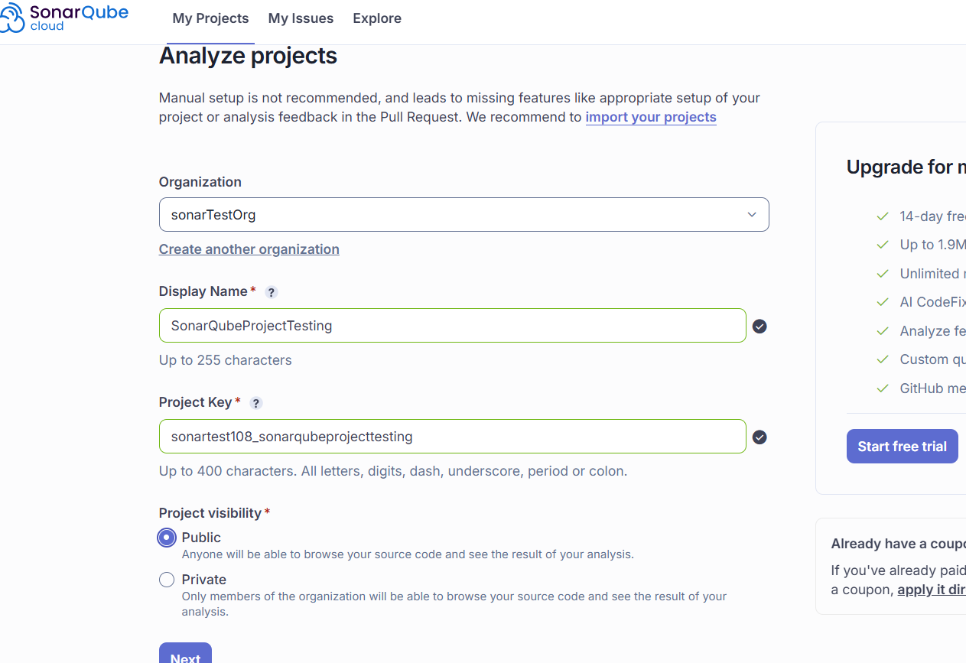
Next select previous ver create project ok ab mujhe kuch info likh ke rakhna hai my project jo my project bnaya tha wo visible hoga SonarTestOrg (click) left side icon click on information like project key ko copy krna hai and org key ko ok
Go to Jenkins –> Manage jen SystemsonarQube servers Add sonarQube Name SonarCloud (use in jenkinsfile) server url https://sonarcloud.io scrool and select server authentication token (Jis name se crediantial add kiya tha use select krna hai) save
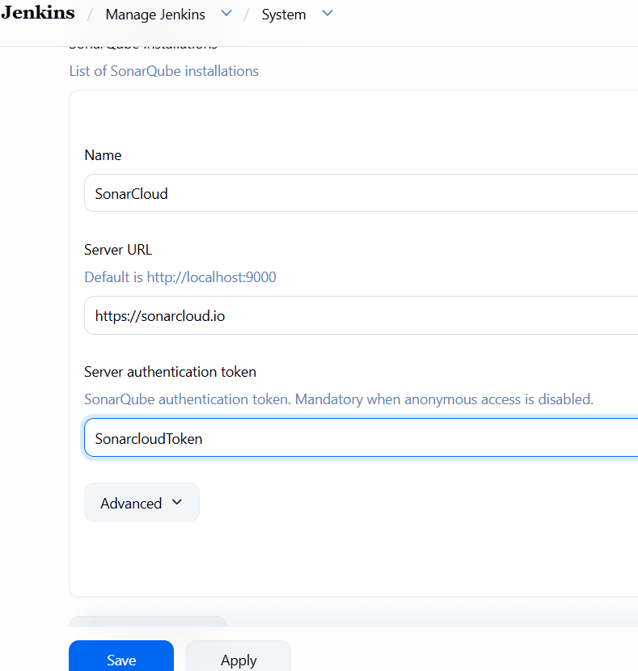

Maven Configure no need to install on physical machine
Go to Jenkins manage Jenkins tools scrool down maven installation add maven name MAVEN (name jenkinfile me use hoga so be carefully) save
Go to jenkin New item create pipeline new item name super lab pipeline ok pipeline script from scm git put github repo url credential select jo Jenkins me bnaya hai branch main save build now

Auto Container deploy to node
Agent VM pe bhi Jenkins user create karein:
sudo adduser suman
sudo passwd suman
sudo usermod -aG docker suman

sudo apt install docker.io -y
sudo systemctl enable docker
sudo systemctl start docker

AB controller pe ssh generate krenge
sudo su - jenkins
ssh-keygen -t ed25519 -C "jenkins@server"

Ab agent machin pe jana hai
Sudo su – Jenkins (user se login hona hai)
Mkdir .ssh
echo ‘controller public key’ > ~/.ssh/authorized_keys
Step 2: Set correct permissions
chmod 700 ~/.ssh
chmod 600 ~/.ssh/authorized_keys
Test login from controller to agent if without password login done then good
ssh jenkins@agent public ip/ Privat ip

Auto Deployment No require Add Node
Plugin install krna SSH Agent
Go to jenkin UI
Manage jenkin system Configure crediantial ssh username with private key username (jis machin pe deploy krna hai ush machin ka username) key (Jenkins machin jis pe ssh ka pvt key hai wo add krna hai) ID (jo name dalenge wo jenkinfile me use hoga Deployment section me)

Jenkins Credentials (SSH Username with private key)
- Username = A2 machine ka user
- Private Key = A1 (Jenkins controller) ki SSH key

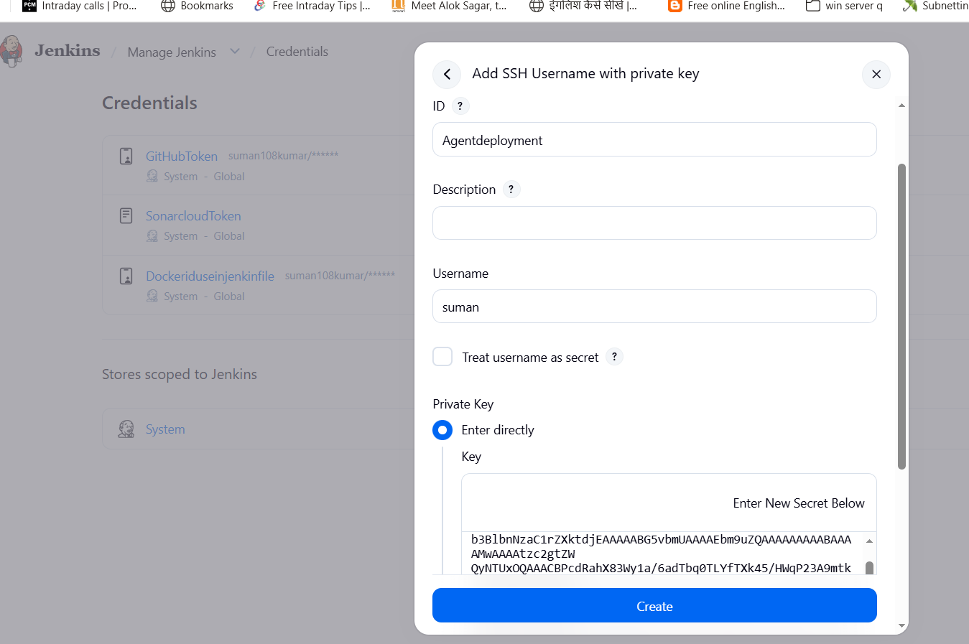

Jenkin Backup
sudo mkdir -p /backup/jenkins-backup
🔥 Better method (Recommended): TAR backup
Direct copy ke bajay compressed backup better hota hai:
sudo tar -czvf /backup/jenkins-backup.tar.gz /var/lib/jenkins
✔ smaller size
✔ easy restore
✔ safer transfer

🔄 Verify backup
ls -lh /backup
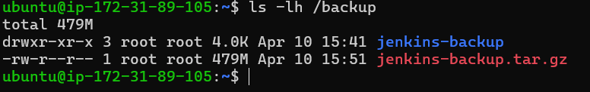
Blue green Setup

- Jenkins me apni job open karo
- Configure pe click karo
- Scroll karke option dhundo:
👉 “This project is parameterized” (ise tick kro)
➕ Ab parameters add karo:
Blue-green deployment ke liye tum aise parameters use kar sakte ho:
- Choice Parameter
  - Name: ENV Choices:Blue Green

sudo apt install nginx
install Java, Docker
sudo visudo open krna hai
ye line last me add krna hai
suman ALL=(ALL) NOPASSWD: ALL
sudo vi /etc/nginx/sites-available/default
server { listen 80; location / { proxy_pass http://localhost:8081; proxy_set_header Host $host; proxy_set_header X-Real-IP $remote_addr; } }

Pipeline Utility Steps , AnsiColor , Docker Pipeline , Blue Ocean (optional UI better visualization)
sudo apt install nginx
Cd /etc/nginx/sites-available
sudo nano /etc/nginx/sites-available/default
3. Blue-Green config (BEST WAY)
Is tarah set karo 👇
upstream securevault_app {
server 127.0.0.1:8081; # BLUE (ya GREEN switch karoge yahan)
}
server {
listen 80;
server_name _;
location / {
proxy_pass http://securevault_app;
proxy_set_header Host $host;
proxy_set_header X-Real-IP $remote_addr;
proxy_set_header X-Forwarded-For $proxy_add_x_forwarded_for;
}
}
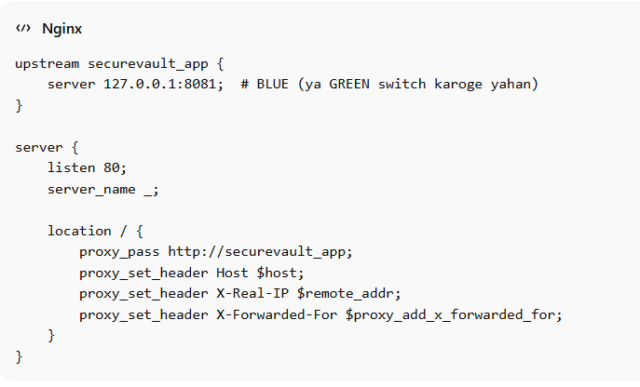
Agent machin pe
sudo nano /etc/nginx/sites-available/default (ish location pe ye add krna hai)

# Upstream (ONLY ONE ACTIVE TARGET AT A TIME)
upstream securevault_app {
server 127.0.0.1:8081; # BLUE (default active)
# server 127.0.0.1:8082; # GREEN (switch when deploying)
}

server {
listen 80;
server_name _;

access_log /var/log/nginx/securevault_access.log;
error_log /var/log/nginx/securevault_error.log;

location / {
proxy_pass http://securevault_app;

proxy_http_version 1.1;

# Standard production headers
proxy_set_header Host $host;
proxy_set_header X-Real-IP $remote_addr;
proxy_set_header X-Forwarded-For $proxy_add_x_forwarded_for;
proxy_set_header X-Forwarded-Proto $scheme;

# Websocket support (safe default)
proxy_set_header Upgrade $http_upgrade;
proxy_set_header Connection "upgrade";

proxy_connect_timeout 5s;
proxy_read_timeout 60s;
proxy_send_timeout 60s;
}
}

ubuntu@ip-172-31-24-118:~$ sudo cat /etc/nginx/upstream.conf
server 127.0.0.1:8081;

sudo nano /etc/nginx/active_port.conf
8081
sudo visudo open krna hai
ye line last me add krna hai
suman ALL=(ALL) NOPASSWD: ALL

