Ethical Hacking

- Execute and display the results for the following commands in Kali Linux Operating Systems:
- rm command
- users command
- tree command

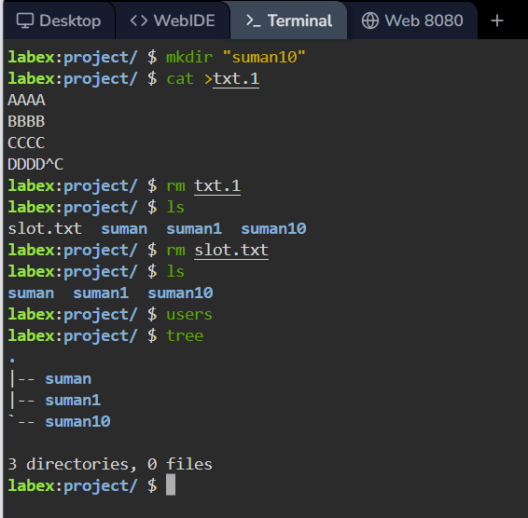
For users command I used in online linux lab

