Infrared Wireless Communication Controlled Home Automation system Using Arduino Mega

Abstract
This project presents an IR remote controlled home automation system based on Arduino Mega. The system receives infrared commands from a standard TV-style remote control and switches home appliances through relay modules. Each relay operates as an electronic switch, allowing low-voltage control signals from the microcontroller to safely control higher-voltage loads. The project is simple, low-cost, and easy to expand for multiple rooms or devices. It demonstrates the practical use of embedded systems in modern home automation and offers convenient wireless control without requiring mobile internet or Wi-Fi.

Introduction
Home automation is an important application of embedded systems because it improves convenience, safety, and energy management in daily life. Traditional switching of lights and appliances requires manual operation, which may not always be comfortable or efficient. In this project, an infrared remote is used as a simple wireless interface to control appliances through Arduino Mega. The system is suitable for small homes, laboratories, classrooms, and prototype smart-home demonstrations.

Objective of the Project
To control multiple home appliances using an IR remote.
To use Arduino Mega as the main controller for decoding remote commands.
To operate relay modules as output switches for electrical loads.
To provide a simple and low-cost home automation solution.
To verify the pin connections according to the uploaded circuit and code file.

Components Used
Component | Quantity | Description
Arduino Mega 2560 | 1 | Main microcontroller board
IR receiver module | 1 | Receives commands from the remote control
IR remote control | 1 | Sends control signals wirelessly
Relay module | 4 | Switches appliances or loads
LED / Lamp loads | 4 | Represents the controlled output devices
Jumper wires | As required | Used for making connections
External power supply | 1 | Provides power to the relay/load side

Pin Connection Summary (Verified from Code and Diagram)
The uploaded code uses IR_pin = 11, which means the IR receiver signal line should be connected to digital pin 11 on Arduino Mega. The relay outputs are declared as relays[] = {30, 31, 32, 33, 34}, but only the first four elements are initialized in the loop (i < 4). Since the diagram shows four relay modules, the practical setup should use four relay inputs on pins 30, 31, 32, and 33. Pin 34 is not used in the current four-relay setup.
Device | Arduino Mega Pin | Purpose
IR receiver VCC | 5V | Power supply
IR receiver GND | GND | Ground
IR receiver OUT / DAT | D11 | IR signal input
Relay 1 IN | D30 | Controls Load 1
Relay 2 IN | D31 | Controls Load 2
Relay 3 IN | D32 | Controls Load 3
Relay 4 IN | D33 | Controls Load 4
Relay VCC | 5V | Relay module supply
Relay GND | GND | Common ground

Circuit Diagram
Component | Module Pin | Arduino Mega Pin | Purpose
IR Receiver Module | VCC | 5V | Power supply
IR Receiver Module | GND | GND | Ground connection
IR Receiver Module | OUT / DAT | D11 | Receives IR signal from remote
Relay Module 1 | IN | D30 | Controls Load 1
Relay Module 1 | VCC | 5V | Relay power
Relay Module 1 | GND | GND | Common ground
Relay Module 2 | IN | D31 | Controls Load 2
Relay Module 2 | VCC | 5V | Relay power
Relay Module 2 | GND | GND | Common ground
Relay Module 3 | IN | D32 | Controls Load 3
Relay Module 3 | VCC | 5V | Relay power
Relay Module 3 | GND | GND | Common ground
Relay Module 4 | IN | D33 | Controls Load 4
Relay Module 4 | VCC | 5V | Relay power
Relay Module 4 | GND | GND | Common ground
LED / Load 1 | Through Relay 1 | External Supply | Output device
LED / Load 2 | Through Relay 2 | External Supply | Output device
LED / Load 3 | Through Relay 3 | External Supply | Output device
LED / Load 4 | Through Relay 4 | External Supply | Output device

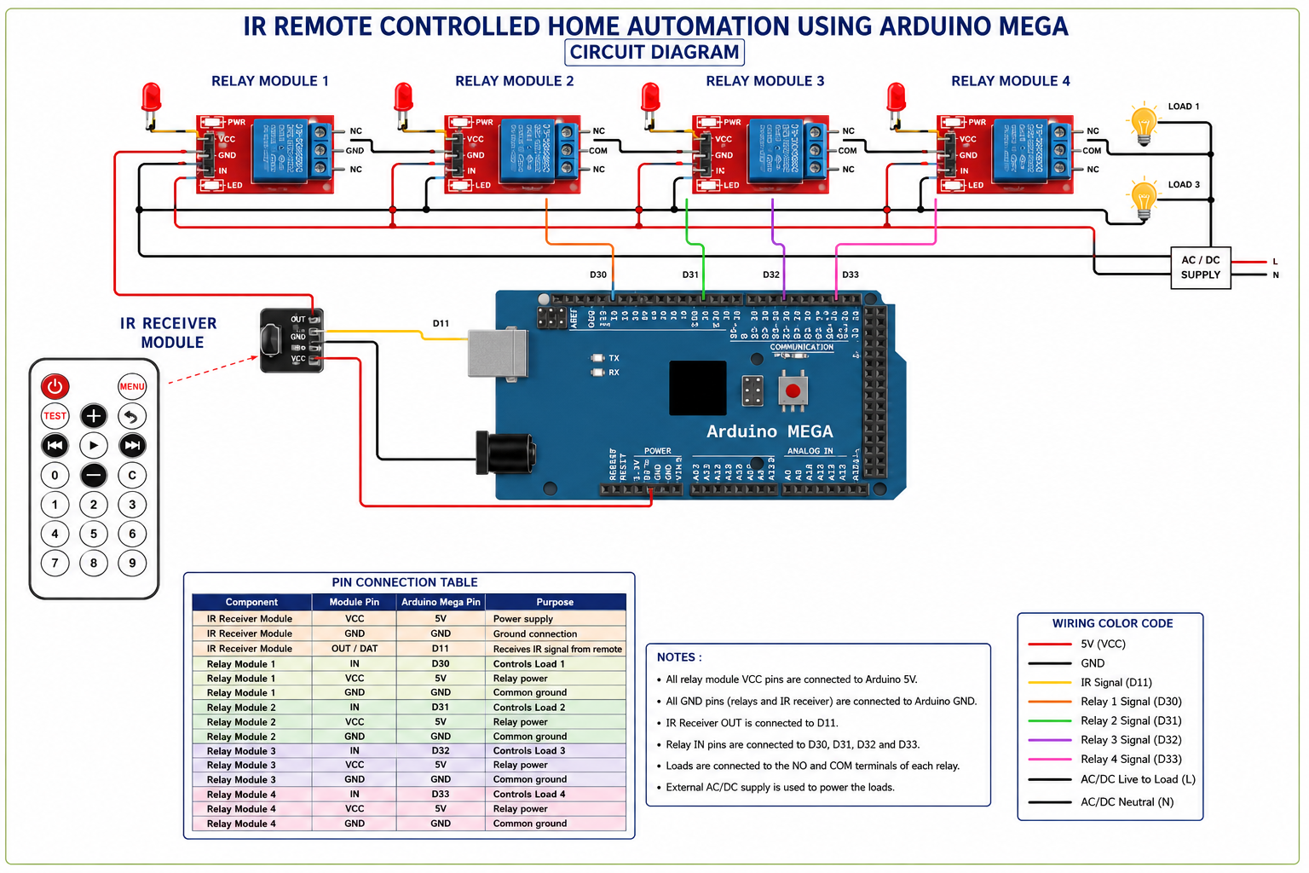

Working Principle
The IR remote sends a coded infrared signal when a button is pressed.
The IR receiver module detects the signal and forwards it to Arduino Mega.
Arduino decodes the received command and identifies which button was pressed.
According to the command, the controller changes the relay state.
The relay module switches the connected load ON or OFF.
Because the relay isolates the control side and load side, the microcontroller remains protected from the load voltage.

Algorithm / Program Logic
• Start
• Include the IR remote library.
• Declare the IR receiver pin as pin 11.
• Create an array of relay pins.
• Create a boolean array to store ON/OFF states of the relays and initialize all as OFF.
• In setup():
- Start serial communication at 9600 baud.
- Initialize the IR receiver.
- Set the relay pins as output.
- Turn all relays OFF initially by writing HIGH to the relay pins.
• In loop():
- Check whether an IR signal is received.
- If a signal is received, read the command code from the remote.
- Compare the code using switch-case.
- If code is 48:
  - Toggle relay 1 state.
  - Turn relay 1 ON if state becomes true, otherwise turn it OFF.
- If code is 24:
  - Toggle relay 2 state.
  - Turn relay 2 ON if state becomes true, otherwise turn it OFF.
- If code is 122:
  - Toggle relay 3 state.
  - Turn relay 3 ON if state becomes true, otherwise turn it OFF.
- If code is 16:
  - Toggle relay 4 state.
  - Turn relay 4 ON if state becomes true, otherwise turn it OFF.
- Resume IR reception.
• Repeat the process continuously.

Code

GitHub Link :- https://github.com/suman1eight9ece24-svg

Result
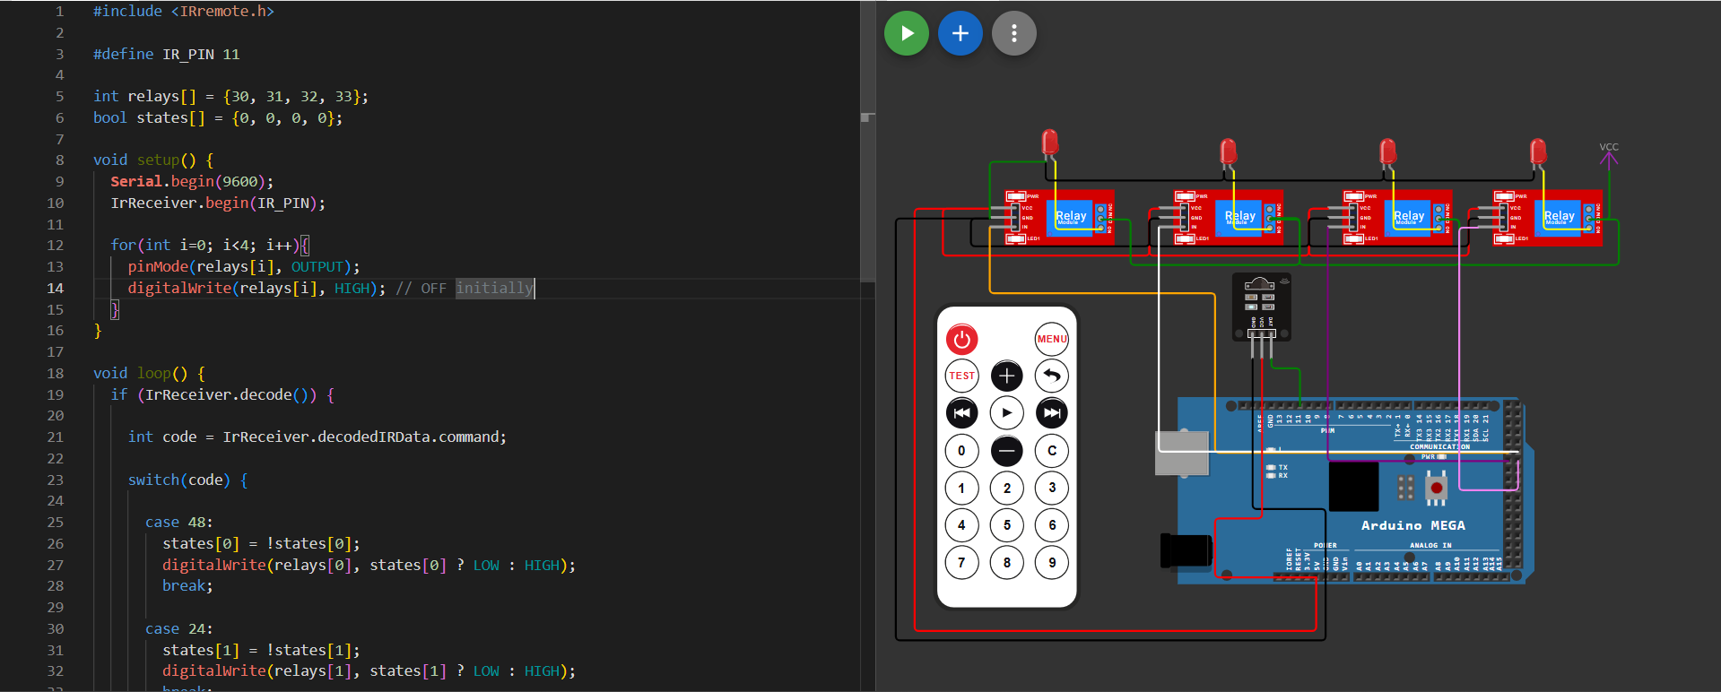
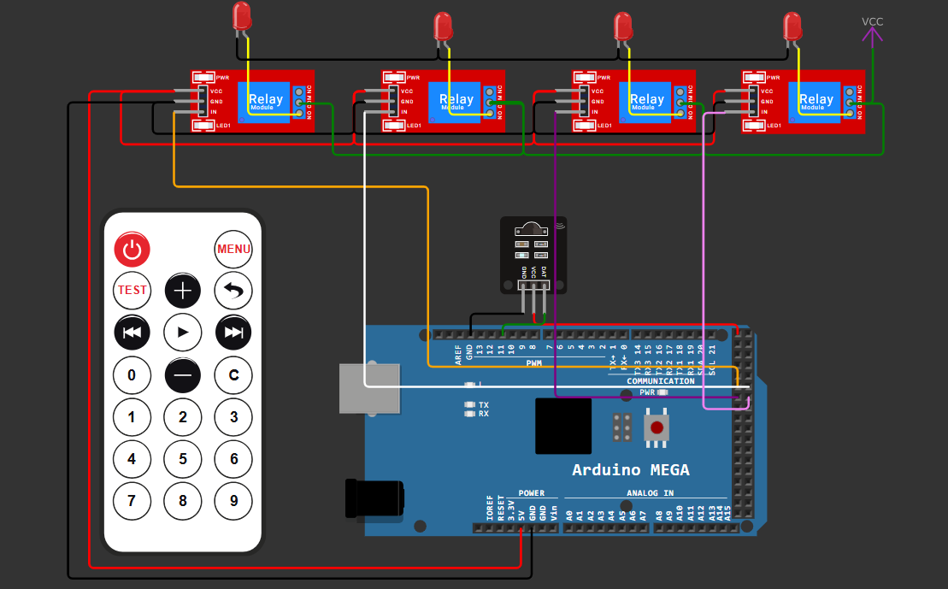
For better to understand this projects result see my GitHub Account .

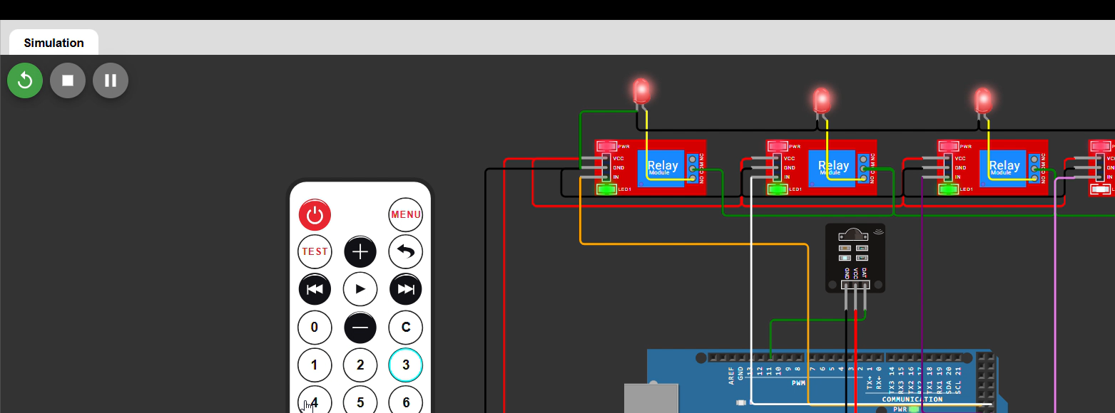
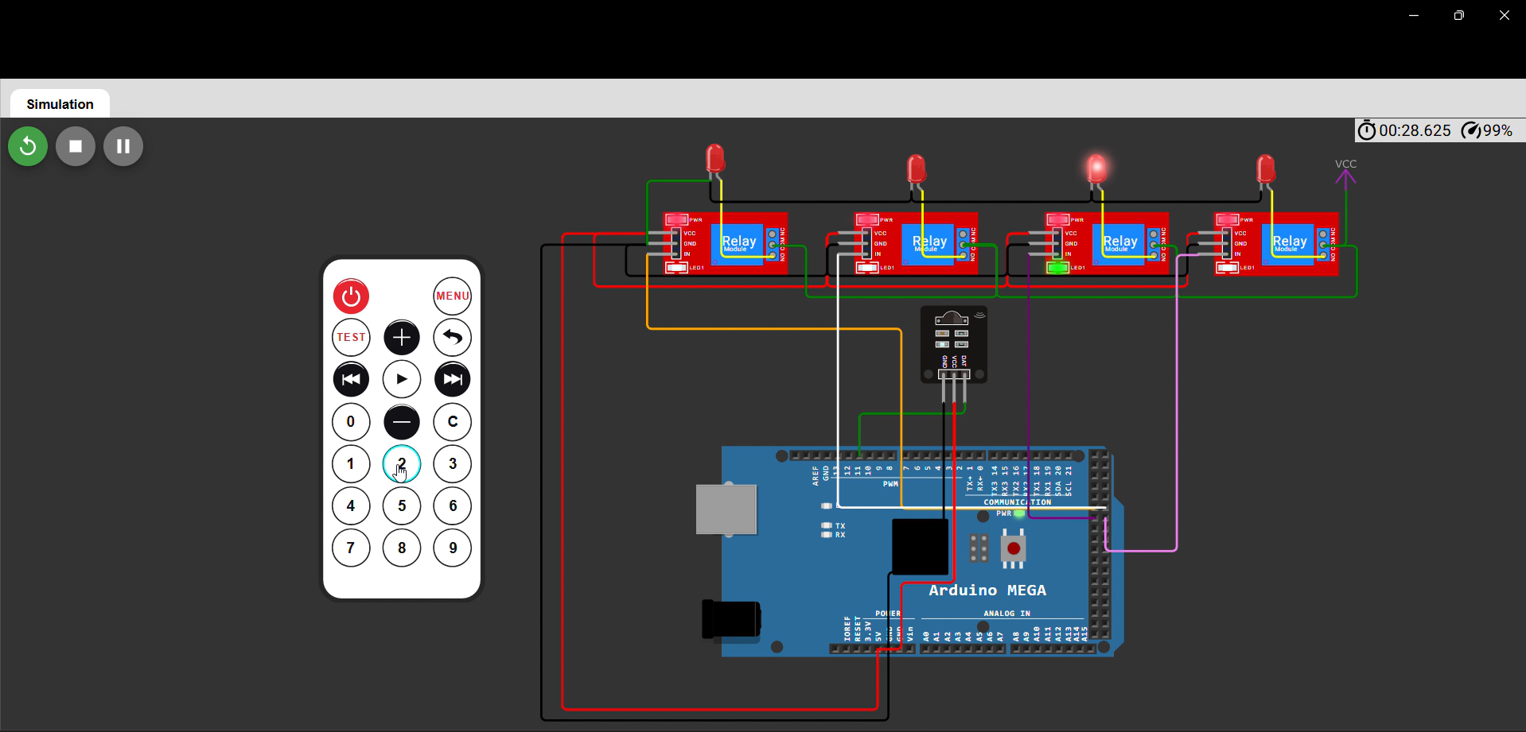

Applications
Switching lights and fans in a home automation system.
Remote control of classroom or lab appliances.
Low-cost smart home prototypes and demonstration projects.
Automation of multiple electrical loads using a simple handheld remote.

Future Improvements
Add feedback display to show the current ON/OFF status of each relay.
Extend the project with Wi-Fi or Bluetooth control in addition to IR remote control.
Use a mobile app for remote monitoring and switching.
Add voice control and scheduling features for smarter automation.

Conclusion
The IR remote controlled home automation project successfully demonstrates how Arduino Mega can be used to control home appliances through relay modules. The system is inexpensive, easy to implement, and convenient for controlling multiple loads from a distance. It provides a strong foundation for advanced smart-home systems and can be expanded with additional communication methods and user feedback features.

