Garden Monitoring System with Blynk Using ESP32

Abstract
This project presents a smart garden monitoring system based on the ESP32 microcontroller and Blynk IoT platform. The system measures soil moisture, water level, temperature, and humidity using a capacitive soil moisture sensor, a resistive soil moisture sensor, a water level sensor, and an SHT40 sensor. The measured values are sent to the Blynk dashboard for real-time monitoring. A pump connected to the ESP32 can also be controlled from the Blynk switch, allowing convenient remote operation. The system is useful for automatic garden care, water management, and environmental monitoring. It is low-cost, practical, and suitable for IoT-based smart farming applications.
Introduction
Water management and environmental monitoring are important in modern gardening and agriculture. Plants need the right amount of water, and overwatering or underwatering can affect growth and soil condition. Manual monitoring of soil and water level is time-consuming and less efficient.
To solve this problem, an IoT-based garden monitoring system was developed using ESP32 and Blynk. The ESP32 reads data from multiple sensors and sends the information to a mobile dashboard. This allows the user to monitor the garden condition from anywhere through the internet. The project also supports pump control, making irrigation more flexible and convenient.
Objective of the Project
The main objectives of this project are:
To measure soil moisture using two different sensors.
To monitor water level in the tank or garden setup.
To read temperature and humidity using the SHT40 sensor.
To display sensor data on the Blynk dashboard in real time.
To control a pump remotely using a Blynk switch.
To develop an IoT-based garden monitoring system using ESP32.
Components Used
Component | Quantity | Description
ESP32 board | 1 | Main microcontroller and Wi-Fi controller
SHT40 sensor | 1 | Measures temperature and humidity
Capacitive soil moisture sensor | 1 | Measures soil moisture without corrosion
Resistive soil moisture sensor | 1 | Measures soil moisture using analog output
Water level sensor | 1 | Detects water level
Pump output | 1 | Controls water pump
Blynk mobile app | 1 | IoT dashboard for monitoring and control
Jumper wires | Required | Electrical connections
Breadboard | Optional | Easy prototyping

Pin Configuration
Component | Sensor Pin | ESP32 Pin | Description
ESP32 | VIN / 3V3 | 3.3V | Power supply
 | GND | GND | Common ground
SHT40 | SDA | GPIO 21 | I2C data line
 | SCL | GPIO 23 | I2C clock line
 | VCC | 3.3V | Power supply
 | GND | GND | Ground
Capacitive Soil Moisture Sensor | AOUT | GPIO 34 | Analog input
 | VCC | 3.3V | Power supply
 | GND | GND | Ground
Water Level Sensor | AOUT | GPIO 35 | Analog input
 | VCC | 3.3V | Power supply
 | GND | GND | Ground
Resistive Soil Moisture Sensor | AOUT | GPIO 32 | Analog input
 | VCC | 3.3V | Power supply
 | GND | GND | Ground
Relay Module / Pump Control | IN | GPIO 2 | Pump control output
 | VCC | 5V / VIN | Relay power
 | GND | GND | Ground

Circuit Diagram :
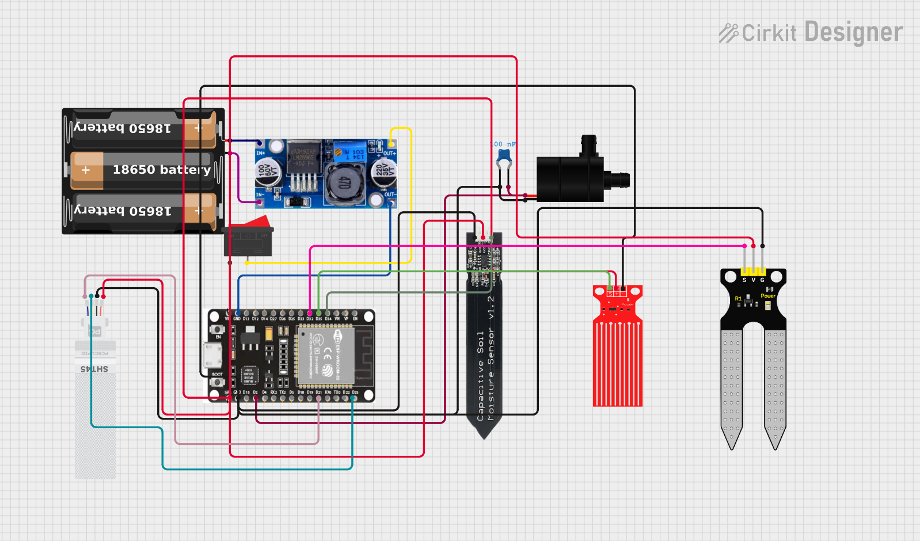

Working Principle
The system works by continuously reading values from the connected sensors. The ESP32 reads soil moisture from the capacitive and resistive sensors, water level from the water sensor, and temperature and humidity from the SHT40 sensor using I2C communication. These values are then converted into readable form and sent to the Blynk application using virtual pins.
The Blynk dashboard displays the sensor values in real time so that the user can monitor garden conditions easily. A switch widget on the dashboard controls the pump connected to GPIO 2. When the switch is turned ON, the ESP32 sets the pump pin HIGH; when the switch is turned OFF, the pin goes LOW. This allows remote irrigation control through the mobile app.

Algorithm / Program Logic
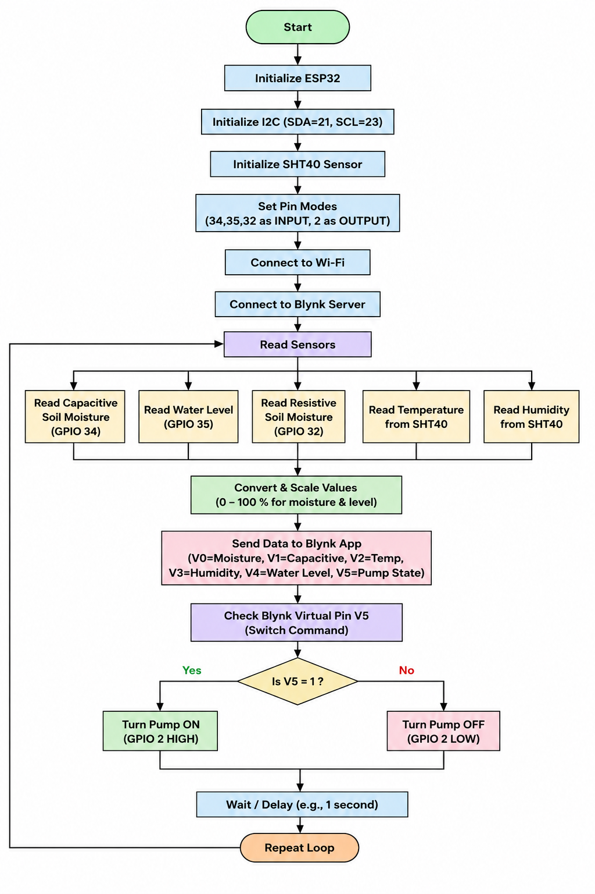
Code
GitHub Link :- https://github.com/suman1eight9ece24-svg
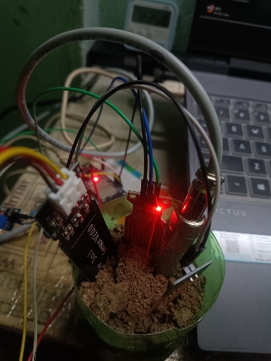
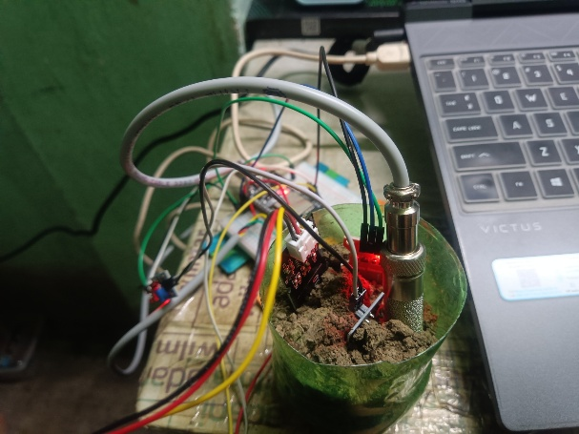
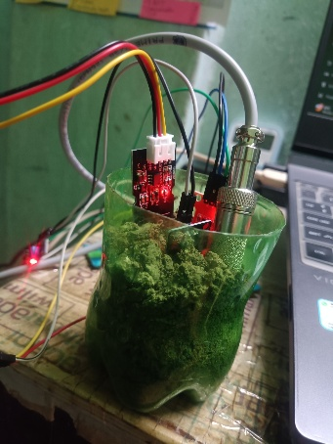
Results

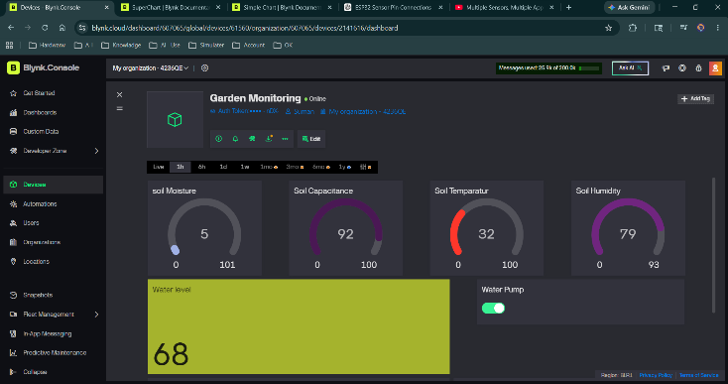
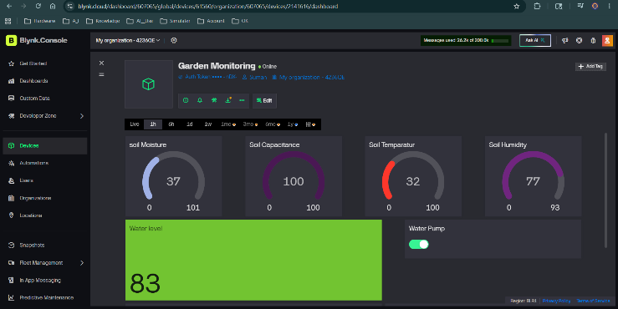

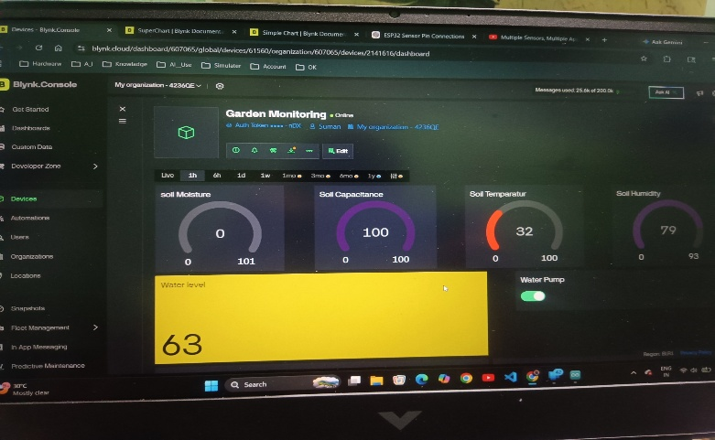
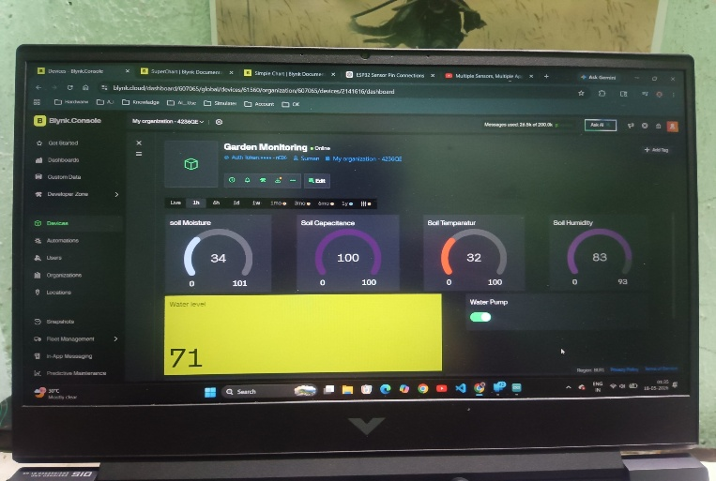

Applications
This project can be used in the following areas:
Smart garden monitoring
Automatic irrigation systems
Smart farming and agriculture
Greenhouse monitoring
Water tank monitoring
Home plant care systems
IoT-based environmental monitoring
Future Improvements
The project can be improved further by adding:
Automatic pump ON/OFF based on soil moisture level
LCD or OLED display for local data viewing
Cloud data logging for long-term monitoring
Mobile notifications for low water or dry soil conditions
Solar power support for outdoor use
Multiple sensor zones for larger gardens
Conclusion
The garden monitoring system successfully combines ESP32, Blynk, and multiple sensors to create a practical IoT-based solution for plant care and water management. It provides real-time monitoring of soil moisture, water level, temperature, and humidity, while also allowing remote pump control from a mobile dashboard. The project is simple, low-cost, and useful for smart gardening and automated irrigation applications.

