PROJECT REPORT

An Autonomous Obstacle Avoiding Car That’s Gives Accident Alert In Mobile With GPS Location Using 4G Advance Communication

1. Abstract

This project presents an autonomous obstacle avoiding car integrated with an accident alert and GPS tracking system using ESP32. The system is designed to improve vehicle safety and provide immediate emergency notifications during accidents. The car automatically detects obstacles using an HC-SR04 ultrasonic sensor mounted on a servo motor and changes direction intelligently to avoid collisions. An MPU6050 accelerometer and gyroscope sensor is used to detect sudden vibration, impact, or tilt changes during accidents. When an accident is detected, the ESP32 collects the live GPS location from the NEO-6M GPS module and sends an emergency SMS alert through the SIM800L GSM module to a predefined mobile number. The project combines autonomous navigation, sensor-based monitoring, wireless communication, and real-time location tracking into a single embedded system prototype. This system can reduce emergency response time and improve road safety.

2. Introduction

Road accidents are one of the major causes of injuries and deaths worldwide. In many cases, victims do not receive immediate medical assistance because emergency services and family members are not informed quickly. Delayed response time can increase the severity of injuries and may lead to loss of life.

To solve this problem, an intelligent accident alert and obstacle avoiding system is proposed. The project combines autonomous navigation with accident detection and emergency communication. The vehicle can automatically avoid nearby obstacles using ultrasonic sensing technology. At the same time, the system continuously monitors vibration and angle variation using the MPU6050 sensor. If a sudden impact or abnormal tilt is detected, the ESP32 controller sends an SMS alert containing the live GPS location to a predefined mobile number using the SIM800L GSM module.

The project demonstrates practical applications of embedded systems, IoT communication, automation, and sensor integration in modern vehicle safety systems.

3. Real-Life Problem and Proposed Solution
Problem: In a crash situation, the vehicle occupant may be unconscious, trapped, or unable to make a phone call. This creates delayed emergency response, uncertainty for family members, and a lack of immediate location information.
Proposed solution: The accident alert car continuously monitors motion and vibration using the MPU6050 sensor. When a sudden impact or abnormal angle change is detected, the ESP32 reads the GPS position from the NEO-6M module and sends an SMS alert through the SIM800L module to a stored mobile number. This makes the accident report automatic, fast, and location-aware.

4. Objective of the Project
The main objectives of this project are:
To design an autonomous obstacle avoiding car using ESP32.
To detect obstacles using an ultrasonic sensor.
To rotate the ultrasonic sensor using a servo motor for wider scanning.
To control DC motors using the L298N motor driver.
To detect accidents using MPU6050 accelerometer and gyroscope sensor.
To obtain live GPS location using the NEO-6M GPS module.
To send accident alert SMS using SIM800L GSM module.
To reduce emergency response time during road accidents.
To develop a low-cost smart vehicle safety prototype.

5. Components Used
Component | Quantity | Description
ESP32 | 1 | Main microcontroller for sensing, control, and communication
MPU6050 | 1 | Accelerometer and gyroscope for vibration / tilt detection
NEO-6M GPS Module | 1 | Provides live latitude and longitude
SIM800L GSM Module | 1 | Sends SMS emergency messages
HC-SR04 Ultrasonic Sensor | 1 | Detects obstacles in front of the vehicle
Servo Motor | 1 | Moves the ultrasonic sensor for scanning
L298N Motor Driver | 1 | Controls the direction and speed of the DC motors
4WD Chassis Kit | 1 | Vehicle body with wheels and motors
Lithium-ion Battery | 1 | Supplies power to the prototype

6. Pin Configuration and Circuit

⚙️ Ultrasonic Sensor Pin Configuration →
Module PIN | ESP32 PIN | Function
VCC | 5 V | Voltage I/P
GND | GND | Voltage I/P
TRIG | GPIO 4 | Send the sound signal
ECHO | GPIO 34 | Receive the sound signal

⚙️ Servo Motor Pin Configuration →
Module PIN | ESP32 PIN | Function
Red (VCC) | 5V | Voltage I/P
Brown/Black (GND) | GND | Voltage I/P
Orange/Yellow (Signal) | GPIO 13 | Angle I/P

⚙️L298N Motor Driver Connections →
L298N Pin | ESP32 Pin | Function
IN1 | GPIO 26 | Left motor direction
IN2 | GPIO 25 | Left motor direction
IN3 | GPIO 33 | Right motor direction
IN4 | GPIO 32 | Right motor direction
ENA | GPIO 22 | Left motor speed (PWM)
ENB | GPIO 23 | Right motor speed (PWM)

L298N Pin | Connection
12V / VCC | Battery Pack +
GND | Battery Pack −
5V | Not needed if jumper enabled

L298N Terminal | Motor
OUT1 + OUT2 | Left motors
OUT3 + OUT4 | Right motors

🔌 ESP32 Pin Configuration →
ESP32 GPIO | Connected To | Purpose / Signal | Wire Color (from your diagram, approx.) | Notes
4 | HC-SR04 TRIG | Ultrasonic trigger pulse | Purple / violet | Output
34 | HC-SR04 ECHO | Ultrasonic echo return | Orange | Input-only pin — perfect choice
13 | Servo signal (orange) | PWM control for servo | Pink / magenta | Standard servo PWM pin
26 | L298N IN1 | Left motor direction | Blue | —
25 | L298N IN2 | Left motor direction | Green | —
33 | L298N IN3 | Right motor direction | Purple | —
32 | L298N IN4 | Right motor direction | Brown / maroon | —
22 | L298N ENA | Left motors PWM (speed) | Cyan / light blue | PWM channel A
23 | L298N ENB | Right motors PWM (speed) | Yellow-green | PWM channel B

⚙️MPU6050
MPU6050 | ESP32
SDA | GPIO 21
SCL | GPIO 19
VCC | 3.3V
GND | GND

⚙️SIM800L
SIM800L | ESP32
TXD | GPIO 18
RXD | GPIO 5
GND | GND
VCC | External 4V Supply

⚙️GPS NEO-6M
GPS Pin | ESP32
TX | GPIO 16
RX | GPIO 17
VCC | 3.3V or 5V
GND | GND

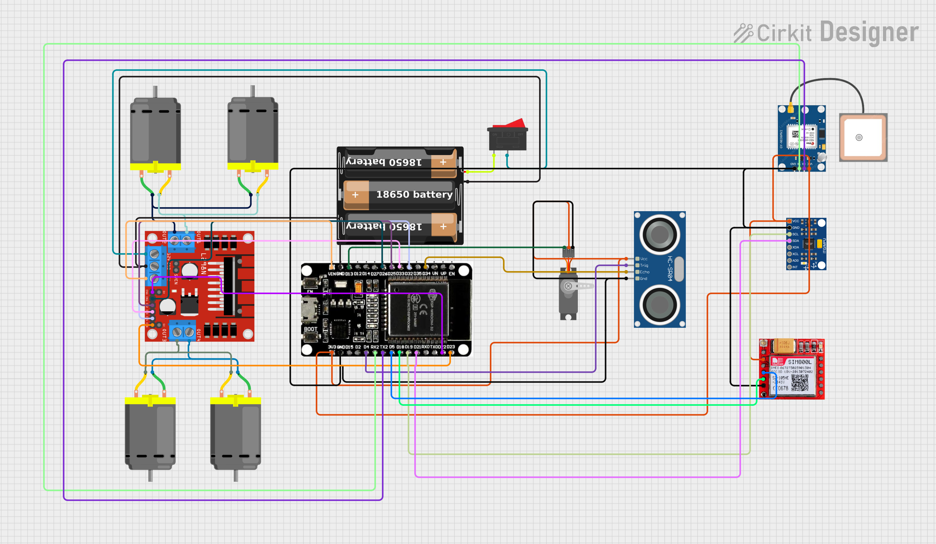

6. Working Principle
The system works by integrating multiple sensors and communication modules with the ESP32 microcontroller.
- After powering ON, the ESP32 initializes all sensors and communication modules.
- The ultrasonic sensor continuously measures the distance between the car and nearby obstacles.
- The servo motor rotates the ultrasonic sensor left, right, and front to scan the surroundings.
- If the front path is clear, the car moves forward.
- If an obstacle is detected, the ESP32 compares left and right distances and selects the safest direction.
- The L298N motor driver controls the movement of the DC motors based on sensor readings.
- The MPU6050 continuously monitors acceleration and angular movement.
- If sudden vibration, impact force, or abnormal tilt exceeds the threshold value, the system identifies it as an accident.
- The ESP32 then reads the current GPS coordinates from the NEO-6M GPS module.
- The SIM800L GSM module sends an emergency SMS containing the accident alert and live GPS location to a predefined mobile number.
- The active buzzer can also provide an audible warning during emergency conditions.
The entire process operates automatically without human intervention.

6 Algorithm / Program Logic
Step 1: System Initialization
- Start the microcontroller and initialize all hardware peripherals.
- Configure the motor driver (L298N) pins and PWM channels for motor speed control.
- Initialize serial communication interfaces for debugging, GPS, and GSM modules.
- Set the ultrasonic sensor servo motor to the center position (90°).
- Initialize the MPU6050 accelerometer and gyroscope sensor.
- Configure the SIM800L GSM module in SMS text mode.
- Start communication with the GPS module and wait for valid coordinate data.
- Record the initial stable Roll and Pitch orientation values of the vehicle as reference angles.
Step 2: Continuous Safety Monitoring
- Continuously read acceleration and orientation data from the MPU6050 sensor.
- Calculate the resultant acceleration and compare it with the predefined threshold.
- Detect an accident condition if:
  - Acceleration exceeds 2.0G, or
  - Tilt angle changes by more than 35° from the baseline orientation.
- If an accident is detected:
  - Immediately stop all motors.
  - Read the current GPS coordinates.
  - Generate a Google Maps location link using latitude and longitude.
  - Send an emergency SMS alert containing the accident message and location link to the predefined emergency contact number.
  - Keep the vehicle in a halted state until reset or recovery.
Step 3: Obstacle Avoidance – First Condition (Initialization / Blocked State)
- Measure the forward obstacle distance using the ultrasonic sensor.
- If the forward distance is greater than 20 cm:
  - Move to Condition 2 (Cruising State).
- Otherwise:
  - Rotate the servo to scan the left and right directions.
  - Measure left and right obstacle distances.
- Compare both side distances:
  - If either side distance is greater than 20 cm:
    - Turn the vehicle toward the safer direction.
    - Enter Condition 2.
- If all directions are blocked (≤ 20 cm):
  - Move the vehicle backward until a safe distance is achieved.
  - Execute a 180° rotation turn.
  - Return to the First Condition for path evaluation.
Step 4: Obstacle Avoidance – Condition 2 (Cruising State)
- Continuously measure the forward obstacle distance while moving.
- If the forward distance is greater than 30 cm:
  - Move forward at normal speed.
- If the forward distance is between 10 cm and 30 cm:
  - Continue moving forward cautiously at reduced speed.
- If the forward distance becomes less than or equal to 10 cm:
  - Stop the vehicle immediately.
  - Scan left and right directions using the servo-mounted ultrasonic sensor.
- If any side distance is greater than 20 cm:
  - Perform a 90° turn toward the safer side.
  - Continue operating in Condition 2.
- If all directions are blocked:
  - Reverse the vehicle until a safe distance is obtained.
  - Perform a 180° rotation turn.
  - Return to the First Condition.
Step 5: Repeat Process
- Repeat the safety monitoring and obstacle avoidance procedures continuously during operation.
- Continue navigation until the system is powered off or manually stopped.

6. Code

GitHub Link :- https://github.com/suman1eight9ece24-svg

6. Results
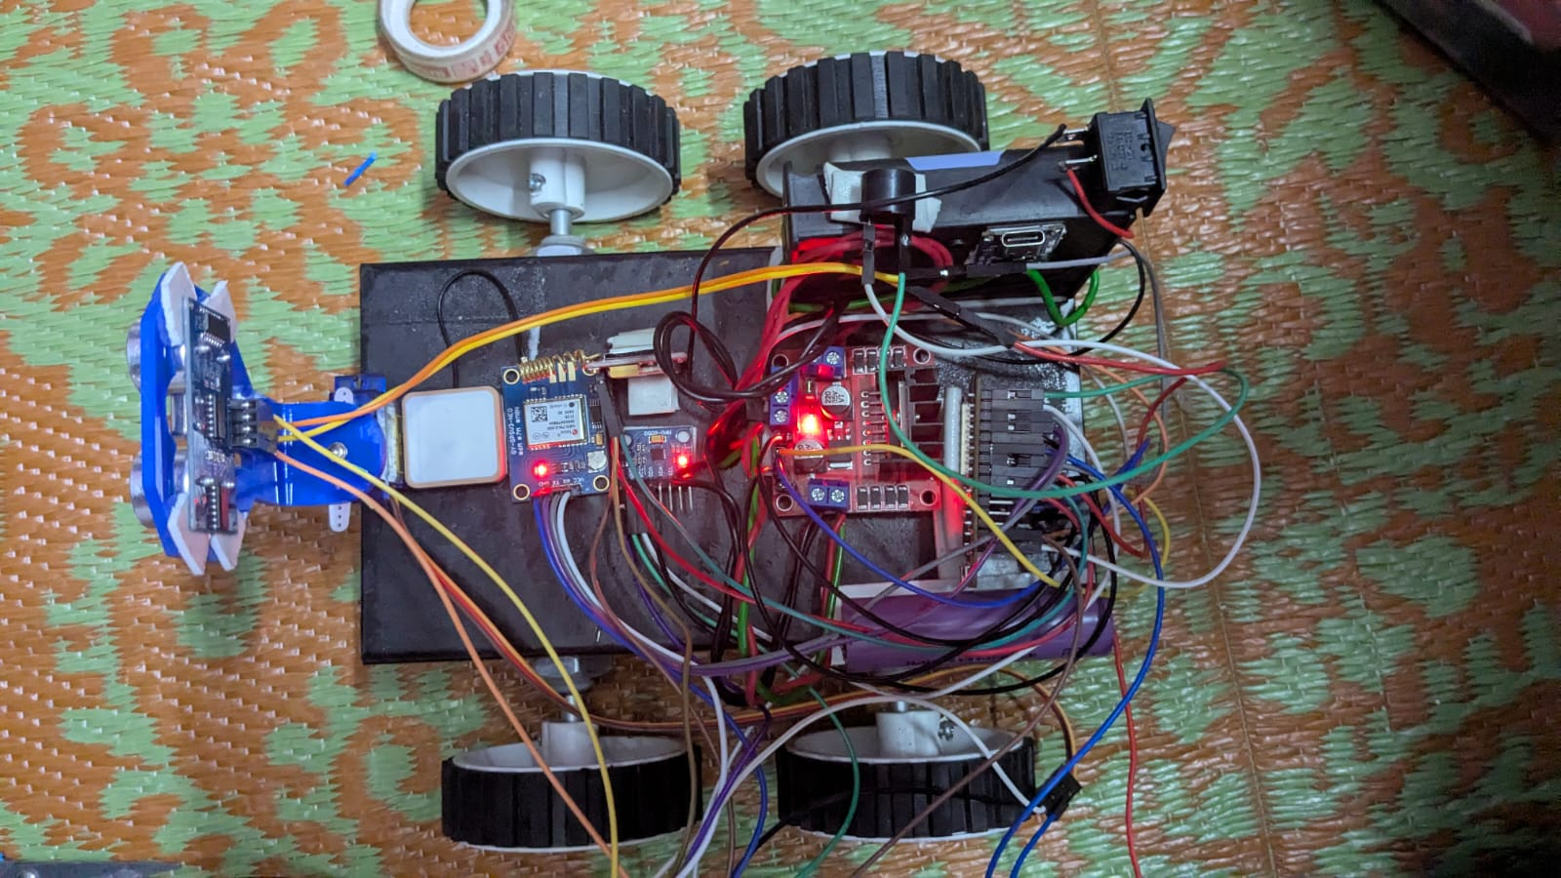

7. Technical Approach
The project uses ESP32 as the central controller because it supports multiple GPIOs, serial communication, PWM output, and sensor integration. The MPU6050 is used as the crash-sensing unit, the NEO-6M provides location data, and SIM800L transmits the alert message over the GSM network. This combination creates a low-cost embedded emergency system.
The accident detection threshold can be tuned during testing to reduce false triggers caused by normal bumps or rough roads. Once the threshold is set properly, the system can identify severe impact conditions more reliably.

8. Implementation Plan
- Design and plan the sensor connections and power arrangement.
- Integrate the MPU6050, GPS, and GSM modules with the ESP32.
- Calibrate the motion threshold for accident detection.
- Test SMS delivery and GPS coordinate capture.
- Combine the alert function with the existing vehicle control program.
- Verify the system through controlled vibration and tilt tests.

9. Applications
- Smart accident alert systems
- Autonomous delivery robots
- Vehicle safety monitoring systems
- Intelligent transportation systems
- Rescue and emergency response vehicles
- Security and surveillance robots
- Educational robotics laboratories
- Smart city transportation projects.

10. Future Improvements
The project can be further improved using the following features:
- Integration with mobile applications for real-time tracking.
- Addition of camera modules for live video streaming.
- Cloud-based accident data storage.
- AI-based road and traffic analysis.
- Integration of voice assistant control.
- Real-time speed monitoring.
- Automatic emergency calling feature.
- Wi-Fi and IoT dashboard monitoring.
- Solar-powered battery charging system.
- Advanced obstacle mapping using LiDAR sensors.
.

11. Conclusion
The project successfully demonstrates an autonomous obstacle avoiding car integrated with an accident alert and GPS tracking system. The ESP32-based system can intelligently avoid obstacles using ultrasonic sensing and motor control mechanisms. In addition, the MPU6050 sensor detects sudden impacts or abnormal vehicle orientation during accidents.
When an accident occurs, the system automatically sends an SMS alert containing the live GPS location through the SIM800L GSM module. This feature can significantly reduce emergency response time and improve road safety.
The project is low-cost, compact, and highly useful for embedded system learning and smart transportation research. It combines automation, wireless communication, sensing technology, and IoT concepts into a practical real-world application .

