**Electronics for Computer Engineering**

**2016 fall-CSE-3323**

Instructor: Gergely V. Zaruba

University of Texas Arlington

**Project: 3X3X3 LED Cube**

Submitted by: Suman Shrestha

Student ID: 1001162735

Date: 12/16/2016

**3 *3 *3 LED Cube**

Out of all the options available for this project, I chose 3*3*3 LED Cube. It is a cube of nine LED’s on each level to form a cube shape. In total 27 LED’s were used. The main components used were 555 Timer and 4020 IC. Additionally, few other two capacitors, nine resistors and nine n channel MOSFETs were used in making a LED cube to work. The concepts taught over the semester were very useful while doing this project like dropper resistors, transistors as a switch, and soldering etc. From the 555 timer the output pin is used in sending pulsating frequencies to the clock of 4020 IC. When the 4020 IC is clocked in and is HIGH it switches the n-channel MOSFET and current flows through the LED’s. The resistors in series with MOSFET limits the current. The transistors help in flowing current only through the columns of LEDs all the time. LEDs are controlled by 4020 Binary Counter IC. 4020 IC can produce 512 different patterns before the loop starts again. Here the frequency and the speed of the change in patterns are controlled by the Potentiometer connected to the output pin of the 555- timer.

**Components Used:**

1. **4020 IC**

The 4020 IC is a binary counter which can be controlled through the input as clock. When the clock receives high binary counter adds it count. It has twelve buffered outputs and asynchronous master reset input. For our circuit all the PINs were not used. This created 512 different patterns in our circuit. The pin layout is shown below.

Pin 10 is the clock input of 4020 IC which is connected to the output (pin 3) of the 555-timer which acts as a timer for changing the patterns for LEDs. Pin 11 is the master reset of the 4020 which is connected to 0.1 uF capacitor and is connected to ground in our circuit. This needs to be grounded because since it is active HIGH if it is left free it will reset continuously.

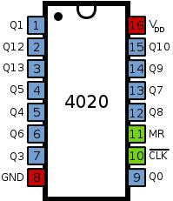

Figure 1: Pin layout of Binary Counter(4020)

1. **555 Timer**

555 timers are an integrated circuit that can be used for various oscillator, timer and pulse generation applications. The pin layout of 555-Timer IC is as follows: Pin 1 is connected to ground and Pin 8 is connected to Vcc. As shown in the label in the diagram Pin 2 is a trigger and making this low will start timing. Pin 3 is the output. Pin 4 is reset. Pin 6 is connected to pin 2 for the timing purpose. When the capacitor is full pin 6 is used to discharge the capacitor.

Also the output continuous pulses of a particular specified frequency. This connection in the circuit sends signals to 4020 IC that controlled the columns of the LED Cube. A 10K potentiometer in connection to the 555- Timer controls the speed which the patterns of the LEDs keep changing.

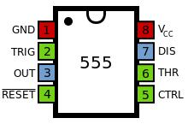

Figure 2: Pin layout for 555 Timer IC

1. **Potentiometer**

It is a three terminal resistor with a sliding or rotating contact that forms an adjustable voltage divider. If only two terminals are used it acts as a resistor.

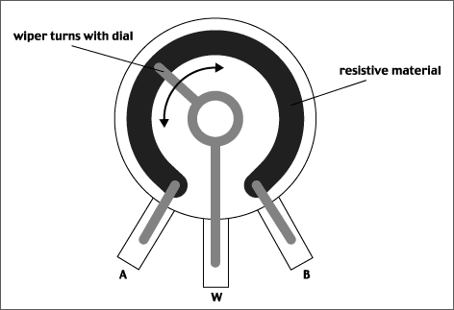

Figure 3: Potentiometer

1. **Capacitors**

It is a device used to store an electric charge, consisting of one or more pairs of conductors separated by an insulator. For this project, two capacitors were used. The capacitor was of 22 uF and the other of 100 nF.

1. **9 N- Channel MOSFETs.**

By setting different parameters of a Common-Source Amplifier, visitors can explore the three operation modes of a MOSFET.

1. **9 Resistors**

It is a device having a designed resistance to the passage of an electric current.

1. **27 LEDs**

27 LEDs of size 3 mm and green in color was used to construct the LED cube of 3X3X3.

**Flow Diagram:**

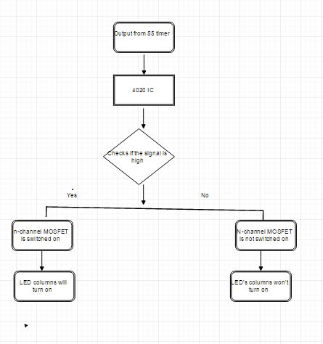

Figure 4: Flow Diagram of the LED cube

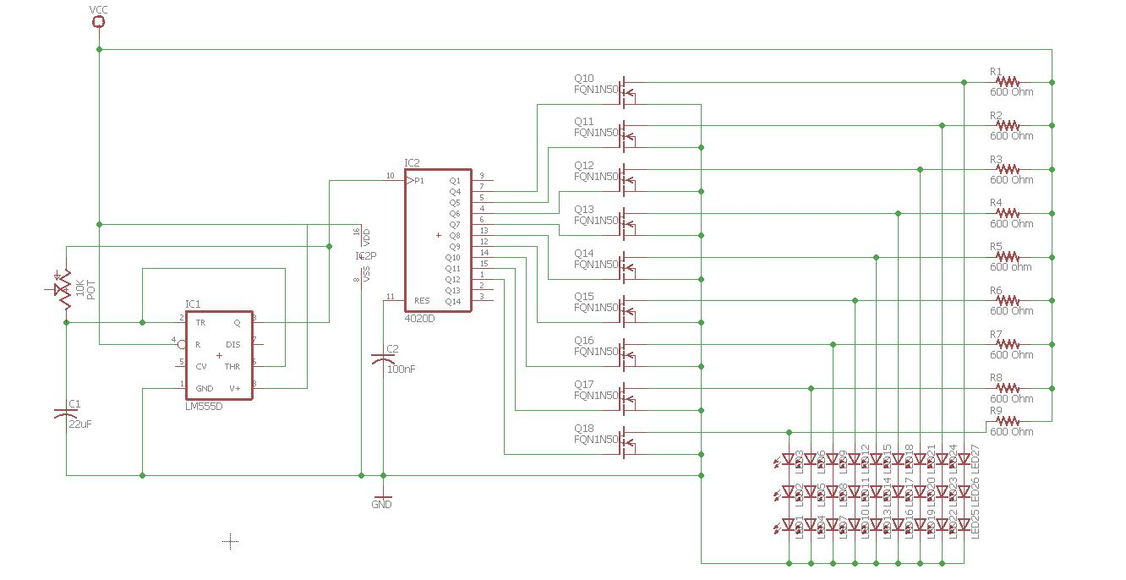**Schematic for 3X3X3 LED cube:**

Figure 5: Circuit Schematic for 3X3X3 LED cube

***Fig: 3*3*3 LED Cube Circuit***

My LED cube consisted of three levels and nine columns. Each column has 3 LEDs in series where all the nodes are connected together. Cathodes are connected to each other and to the ground. N- Channel MOSFET acts as a mediator between the output of 4020 IC and LEDs. The resistors act as a resistive current.

A MOSFET is a voltage controlled device that has Gate, Drain and Source terminals as shown in below. When there is a voltage at the gate, it generates an electric field that controls the current flow through the channel between drain and source. In our circuit n-channel MOSFET is used to switch the outputs of the 4020 IC to turn the columns of LEDs on and off.



Figure 6: MOSFET symbol

Resistors of 600 Ohms were used to limit the current through the LEDs. The calculation of resistor values is shown below:

Voltage along column of LEDs = 9V

Voltage for each LED = 9/3 = 3 V.

Since we need 5 mA to flow through each LED to make sure it turns.

Resistance = 3V/5 mA = 600 Ohms

To turn on the LED the forward voltage has to reach which is between 1.5 and 4V. if we exceed the characteristic forward voltage, the LED’s resistance quickly drops off, which results on the LED’s to draw huge amount of current and burn out the LED. This is why it is important in our circuit to have these dropper resistors to make sure that the LEDs will not burn.

**Circuit Construction:**

Online resources were very useful in understanding how the 555 timer and 4020 IC can be integrated together. After learning how this can be added together in a circuit a 10 K potentiometer was connected to control the frequency of switching pulses of the stable mode that controlled the switching of LEDs. Pin 3 of the timer is connected to pin 10 of 4020 IC. When it receives high signal it creates 512 different patterns before repeating itself. The Reset pin of 4020 IC has to be connected to ground because if it is left alone, it keeps resetting the circuit itself. Before connecting to the ground 0.1 uF was connected to pin 11. Then all the output of the IC was connected to the n- channel MOSFET which acts as a switch. N- Channel MOSFET was used to make sure the current was flowing through the LEDs only when the output of the binary counter is high. Then in between the MOSFET and LEDs current limiting resistors were added. Resistors were connected to the drain of the n-channel MOSFET. For the cube 9 LEDS were connected in each level. Three levels of LEDs were connected to make a cube. All the cathodes of the LEDs were connected to each other and then connected to each level and then connected to the ground. Anodes of the LEDs were connected to each other and then to the 4020 through the drain of the MOSFET.

The picture of prototype is shown below:

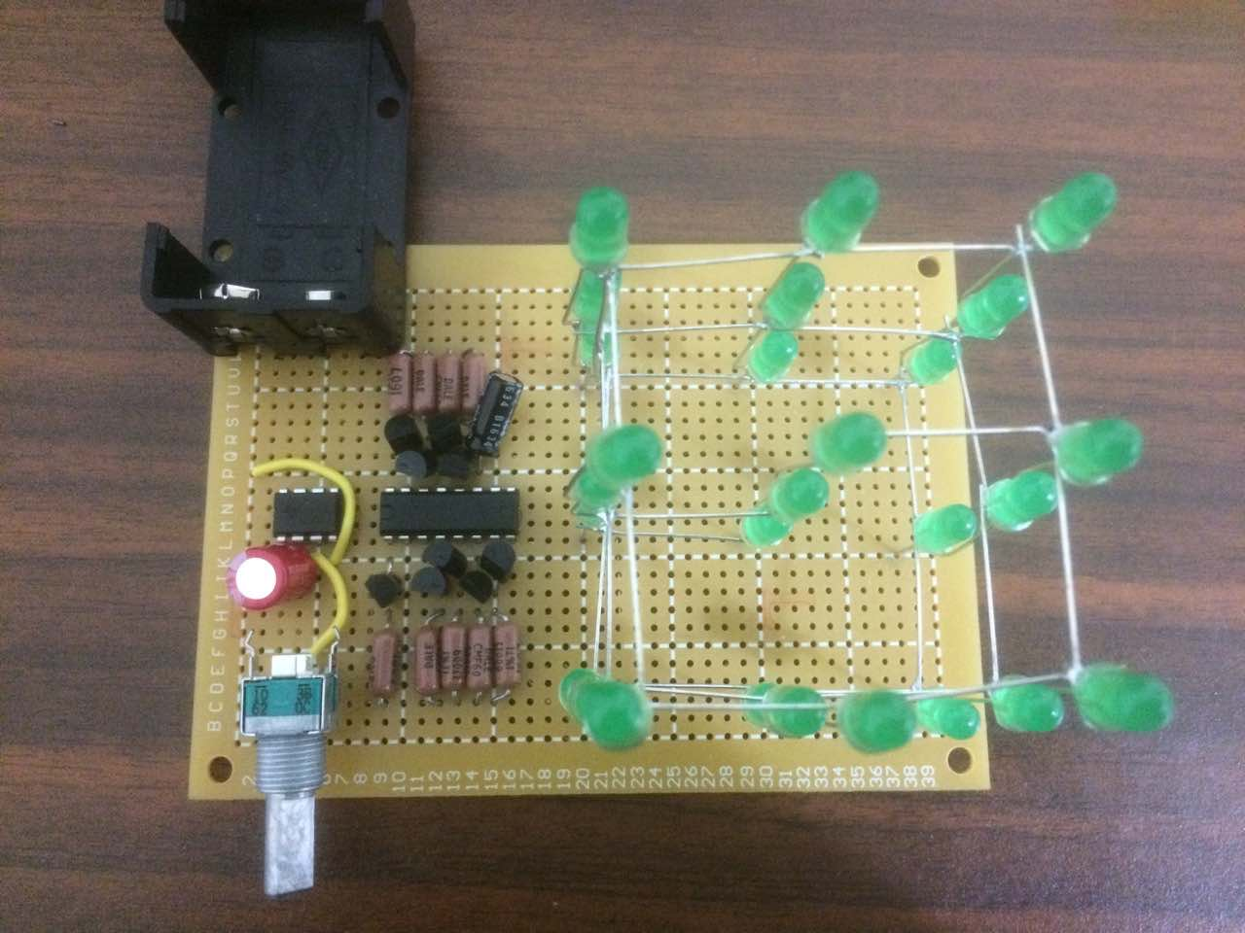

Figure 7: 3X3X3 LED cube without voltage supply

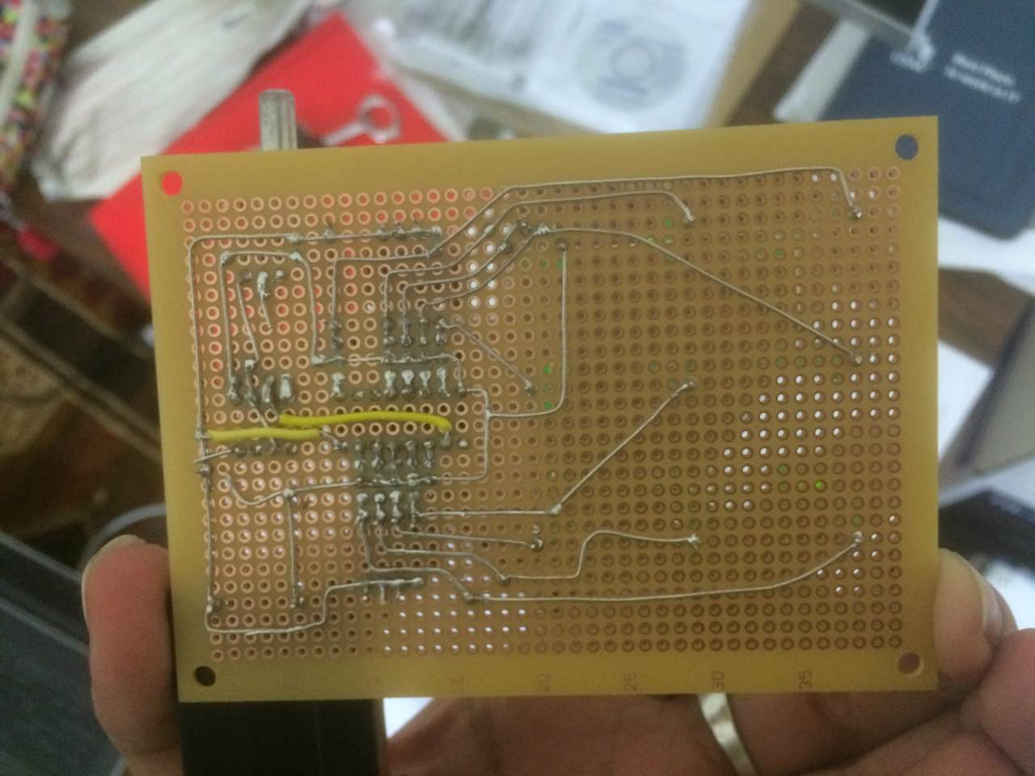

Figure 8: Soldering and circuit underneath the PCB board for 3X3X3 LED cube

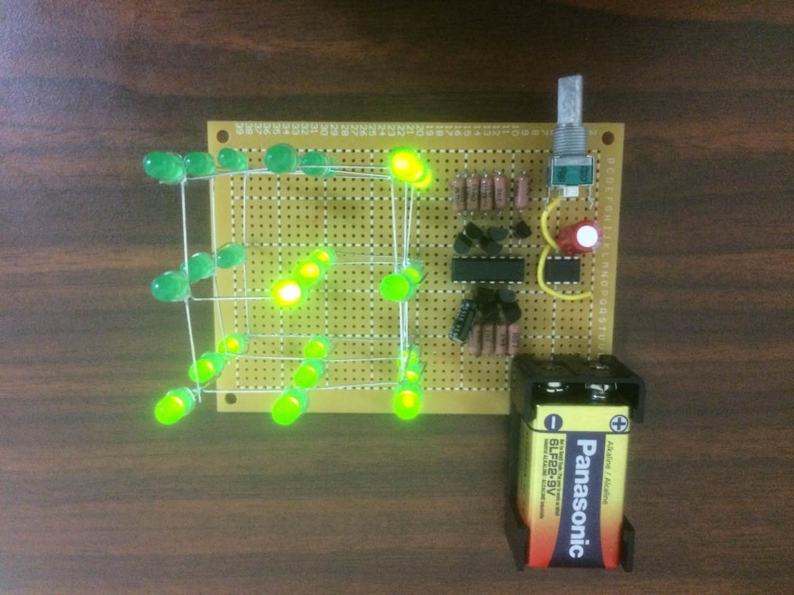

Figure 9: The functioning LED cube with 9V DC power supply

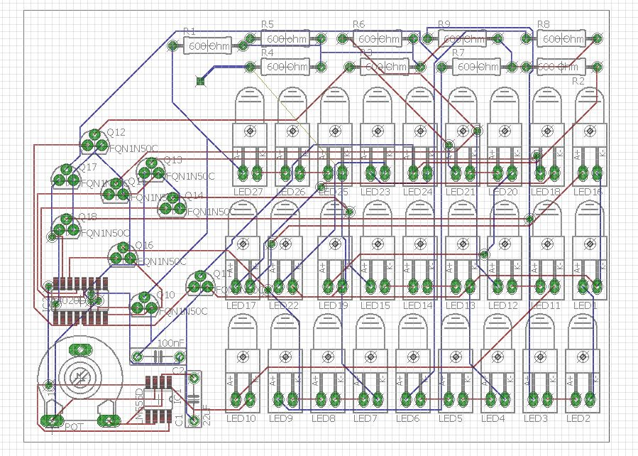

Figure 10: PCB board of 3X3X3 LED cube

**Issues faced:**

Most difficult part of building the prototype was to fit everything in one board. I tried many different possible ways by drawing it on the paper first. But it didn’t work. Then I went on actually putting each item on the board without soldering to see a picture of how it would look like. After some trial and error method I figured out the way to fit it in a single board. I spent a lot of time in making a circuit and realizing it in a breadboard. At first I had no idea how to use n-channel and resistors in the circuit. While realizing the circuit in the breadboard, significant time was spent on debugging the circuit that was only lighting up the middle row LEDs with no pattern at all. After thorough careful observation, I found a short circuit which resulted in heating up the 555 timer. After doing several researches on n-channel MOSFETs and several attempts in constructing the breadboard, I was able to implement the LED cube.

**Astable mode of operation:**

In the 3X3X3 Led cube that was built, astable operation of 555 timer was used to produce high and low clock pulses of required interval. Output pulse form the IC is fed to the two counter ICs in parallel arrangement, so as to give the clock signals simultaneously. In my circuit realization, did not use the control pin and discharge pin of 555 timer. Although, the LED cube works perfectly fine, this created a small window when changing the speed of the LED patterns. Another cause of the small window in my circuit was because I was only using the two pins of the three pin potentiometer. Only, the output pin and VCC pin were used but not the VSS pin. Thus, the LED cube have been better with the elimination of the time window, if those pin were implemented.

**Conclusion:**

Overall**,** I like the project very much. I am completely satisfied with my choice for the project. Event though, I had no idea at the beginning about what I am doing, good hours spent on research over online websites gave me a basic idea and concept of the LED cube I was about to build. I was happy when the realization of the LED cube on the breadboard functioned properly. The, the real task was soldering. With my little experience on soldering, it was the just the matter of time. At the end, I was able to fit all the components and the 27 LEDs in one small pcb board. When the prototype was ready it looked nice and was able to see the LED cube shining. I was proud of my self as I restricted the wire being exposed on the top as much as possible with only two wires being visible. The hardest part for me was laying out the components and soldering them al underneath with creating an overlap. This project was very useful in clearing up the concepts that was taught in the class during this semester. I learned by actual implementation of those concepts.