NAME :- SUMAN KARAK
CIN:
FIT/DEC25/CS4996

Incident Response Report
Cyber Security Task 2 – Security Operations Center (SOC)
Internship Program by Future Interns

1. Introduction
This incident response report documents the analysis and response to security alerts identified using Splunk SIEM as part of the SOC Internship Task. The objective of this task is to simulate real-world SOC operations such as log monitoring, alert triage, incident classification, and response planning.

2. Tools Used
- Splunk Enterprise (Free Trial)
- Sample SOC Logs
- Windows Operating System
- Web Browser (Splunk Web Interface)
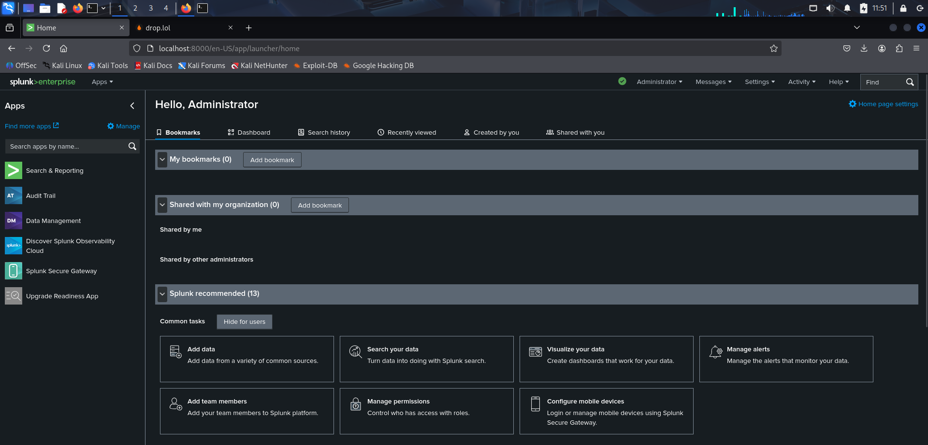

3. Log Analysis Summary
Security logs were ingested into the Splunk SIEM platform. The logs contained authentication events, network activity, malware alerts, and file access records. Several suspicious activities were detected during log analysis.

4. Identified Security Incidents

INC-01: Ransomware Detection – High Severity
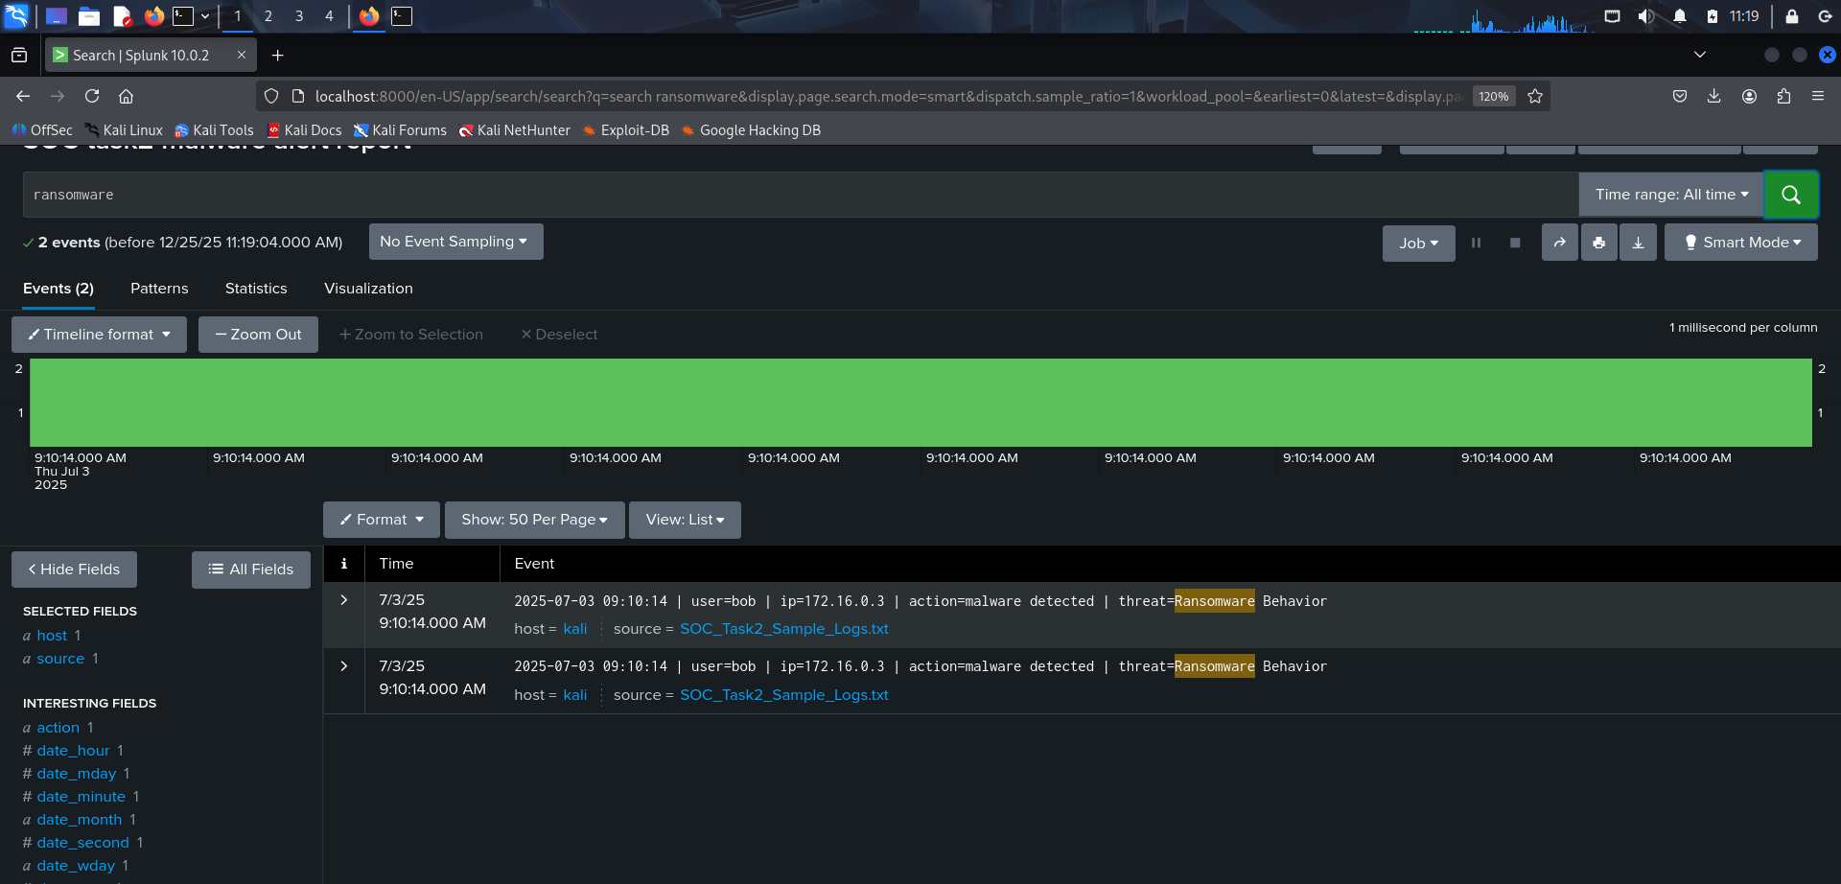
In this case in 7/3/25 from the ip 172.16.0.3 ransomware malware detected
INC-02: Rootkit Malware Detection – High Severity
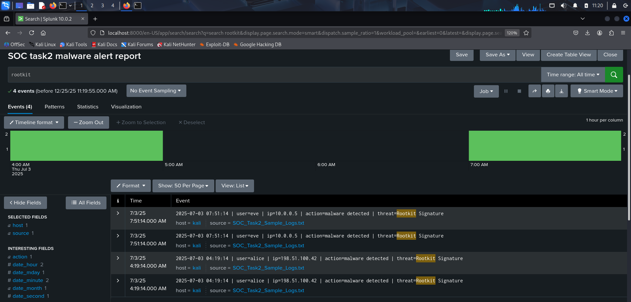
In this case from ip 10.0.0.5 and 198.51.100.42 rootkit signature found

INC-03: Multiple Failed Login Attempts – Medium Severity
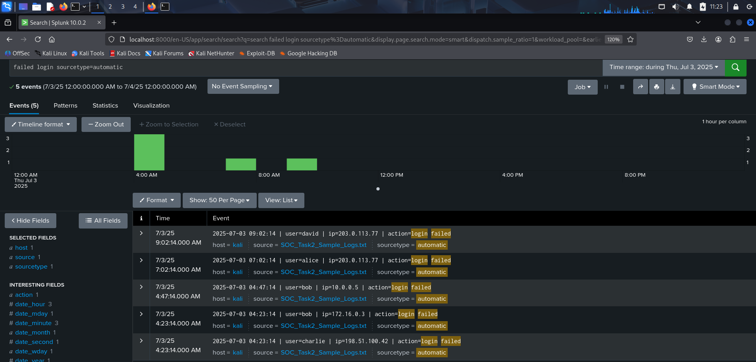
Here we can see multiple login failed from the same ip

INC-04: Suspicious External IP Activity – Medium Severity
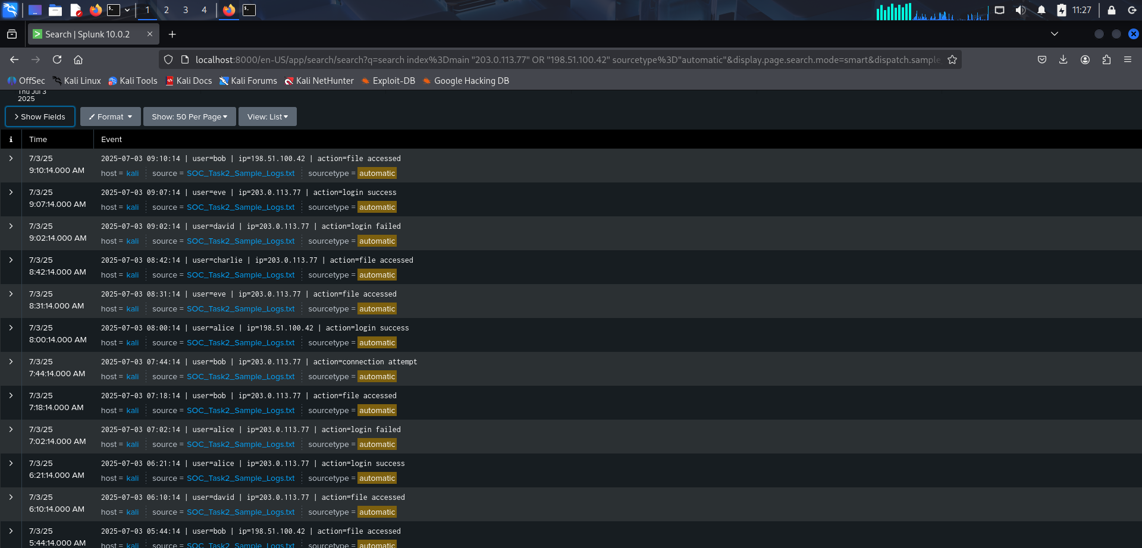
In this case from ip 198.51.100.42 and 203.0.113.77 we have notices suspicious activity noticed

INC-05
File Access After Malware Detection – Medium Severity
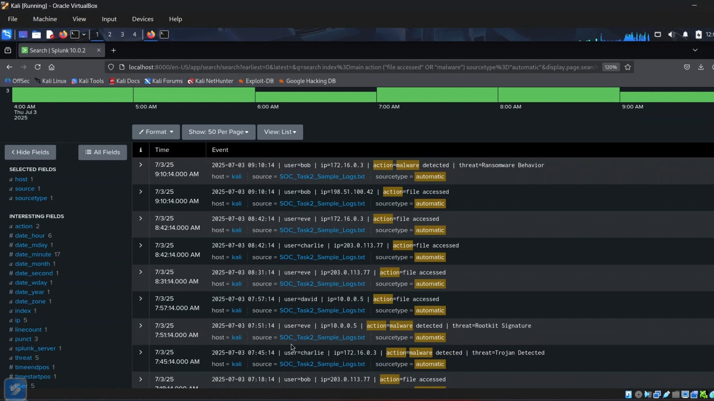
In this case we can see that after malware detection from the same ip -file got accessed .

5. Incident Timeline
• Failed login attempts detected
• Malware alerts triggered
• Suspicious file access observed
• Incident escalated for response

6. Impact Analysis
Unaddressed incidents could lead to unauthorized access, data loss, system compromise, and operational disruption.

7. Incident Response Actions
• Isolated affected systems
• Blocked malicious IPs
• Reset compromised credentials
• Performed malware cleanup
• Continuous monitoring

8. Conclusion
This SOC task provided practical exposure to SIEM-based alert monitoring and incident response procedures.

