# DEPARTMENT OF COMPUTER SCIENCE AND ENGINEERING

**CSE 3330/5330 - Database Systems and File Structures**

**Exam #2**

**Friday November 20, 2020**

**Due Date: Monday November 23, 2020 @ 11.59 pm**

|  |  |  |
| --- | --- | --- |
|  | Total Points | Earned |
| Multiple Choice | 13 |  |
| Query Questions | 47 |  |
| Total | 60 |  |

NAME: Suman Thapa Magar

UTA ID: 1001643016

## Multiple Questions, T/F, Fill In the blanks:

1. (1 point) A functional dependency is a relationship between or among:
   * tables
   * rows
   * relations
   * attributes

**ANS:**

1. (1 point) If attributes A and B determine attribute C, then it is also true that:
   * A → C.
   * B → C.
   * (A,B) is a composite determinant.
   * C is a determinant

**ANS:**

1. (1 point) If attribute A determines both attributes B and C, then it is also true that:
   * A → B.
   * B → A.
   * C → A.
   * (B,C) → A.

**ANS:**

1. (1 point) **TRUE/FALSE**: 3NF is designed to cope with Multi valued dependency

**ANS:**

1. (1 point) **TRUE/FALSE:** The cost of a file scan is essentially the same for a heap file and a sorted file.

**ANS:**

1. (3 point) Which of the following symbols do not represent relational operators from the original relational algebra?
   * γ
   * θ
   * δ

o +

* + ×

**ANS:**

1. (1 point) A BCNF is:
   * loss less join and dependency preserving
   * loss less join but not dependency preserving
   * not loss less join but dependency preserving
   * none of these

**ANS:**

1. (3 points) In the normal form, a composite attribute is converted to individual attributes.
2. (1 point) The storage media that is operated directly from computer's central processing unit is considered as
   * primary storage
   * secondary storage
   * tertiary storage
   * all of above

**ANS:**

## Query Questions: ρ σ α π

1. (4 points) Is the following table in First normal form (1NF). Explain why or why not. If why not convert to 1NF:

|  |  |
| --- | --- |
| **Instructor's name** | **Course code** |
| Prof. George | (CS101, CS154) |
| Prof. Atkins | (CS152) |

1. (8 points) Reference the table below for the next set of questions:

|  |  |  |  |
| --- | --- | --- | --- |
| **Course code** | **Course venue** | **Instructor's name** | **Department** |
| MA214 | Lecture Hall 18 | Prof. George | CS Department |
| ME112 | Auditorium building | Prof. John | Electronics Department |

* 1. List all functional dependencies for this table?
  2. Is this in Second Normal Form (2NF)? Explain why or why not. If why not convert to 2NF.

1. (5 points) Is the following functional dependency in BCNF (**hint**: *check the lossless join*)

R=ABCDE, F = {A -> BC, C -> DE)

1. (5 points) Convert the following SQL query to a relational algebra query:

select C.name

from LineItem L, Orders O, Customer C, Nation N where L.oid=O.oid and O.cid=C.cid and C.nid=N.nid

and N.name = ‘Canada’ and O.orderdate > ‘2010-12-31’;

**ANS:**

COMBINED_TABLES <- σ L.oid = O.oid AND O.cid = C.cid AND C.nid = N.nid AND N.name = ’Canada’ AND O.orderdate > ’2010-12-31’ (ρ L (LineItem) x ρ O (Orders) x ρ C (Customer) x ρ N (Nation))

RESULT <- πC.name (COMBINED_TABLES)

1. (10 points) For the following question, consider the following schema:

Jedi-Teams (master, apprentice) Jedi(name, side, home-planet)

Government(leader, planet, position) Inhabitants(specie, planet)

* 1. Given a query to find all planetary leaders who are apprentices and use the dark side of the force, Express this query in terms of relational algebra:

*select leader*

*from Jedi-Teams, Jedi, Government*

*where apprentice = name and*

*name = leader and*

*side = 'dark'*

**ANS:**

COMBINED_TABLES 🡨 (Jedi-Teams |X| apprentice = name (σ side=’dark’ (Jedi)) )

|X| name= leader (Government)

RESULT 🡨 πleader (COMBINED_TABLES)

* 1. Express this query in terms of relational algebra:

select count(*), home-planet from Jedi, Inhabitants

where specie = 'wookies' and planet = home-planet and side = 'light'

group by home-planet

**ANS:**

COMBINED_TABLES 🡨 (σ side=’light’ Jedi |X| home-planet = planet (σ specie = ‘wookies’ (Inhabitants) )

RESULT 🡨 πcount(*),home-planet ( home-planet ℑ COUNT (*) (COMBINED_TABLES))

1. (5 points) Consider the following database schema:

Likes (enthusiast, sports)

Frequents (enthusiast, sports channel) Serves (sports channel, sport)

Write the relational algebra query that answers the following question: which enthusiast watches only sports channel that play only sport they like?

1. (10 points) Solve the following relational expressions for relations below:

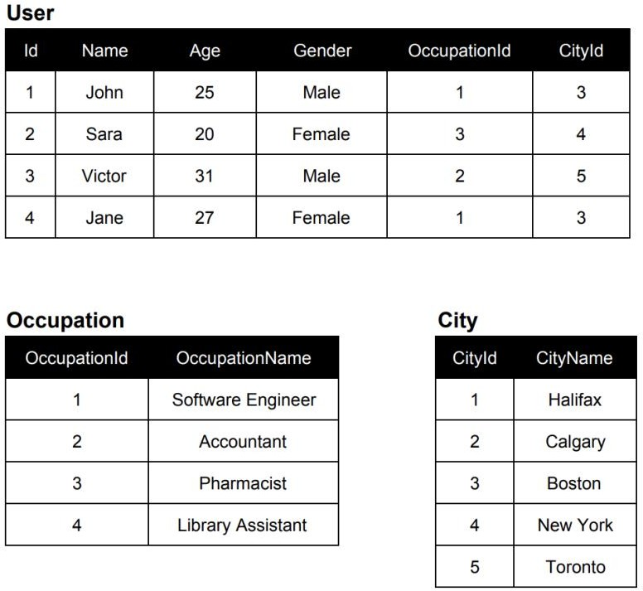

* 1. PName(RAge>25(User))

**Ans:**

|  |
| --- |
| Name |
| Victor |
| Jane |

* 1. RId>2∨Age!=31(User)

**Ans:**

* 1. RUser.OccupationId=Occupation.OccupationId(User X Occupation)
  2. User ⋈ Occupation ⋈ City
  3. PName,Gender(RCityName=”Boston”(User ⋈ City))