Query 1:

ALTER TABLE RENTAL

ADD Returned INT NOT NULL;

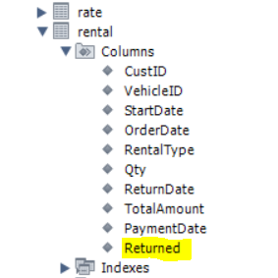

SET SQL_SAFE_UPDATES = 0;

UPDATE RENTAL

SET Returned = CASE

WHEN RENTAL.PaymentDate IS NULL THEN 0

ELSE 1

END;

SET SQL_SAFE_UPDATES = 1;

OUTPUT:

