**SQL COMMANDS TO CREATE TABLES:**

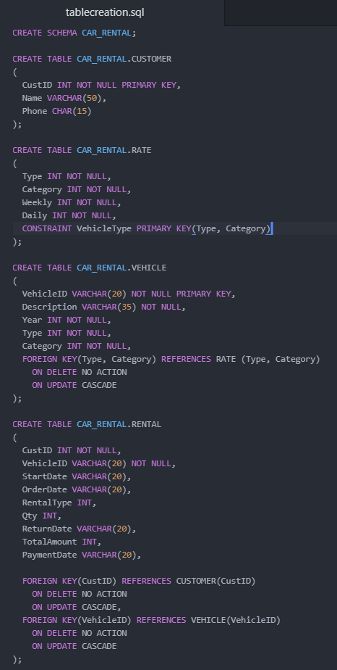

**SQL QUERIES TO CALCULATE THE TOTAL RECORDS PER TABLE:**



**RESULT:**

|  |
| --- |
| TOTAL_CUSTOMERTABLE_RECORDS |
| 31 |



**RESULT:**

|  |
| --- |
| TOTAL_RATETABLE_RECORDS |
| 12 |



**RESULT:**

|  |
| --- |
| TOTAL_VEHICLETABLE_RECORDS |
| 61 |



**RESULT:**

|  |
| --- |
| TOTAL_RENTALTABLE_RECORDS |
| 23 |