Jenkins Home based Assessment Screenshot

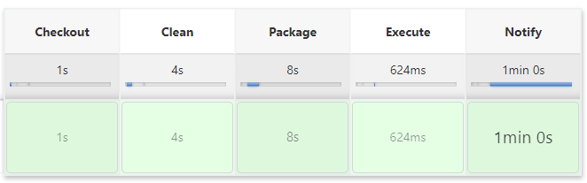

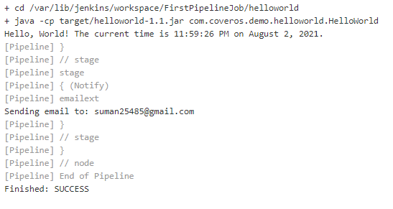

Shell Script Home based Assessment  


