Actual Result: Inventory Page

Image1

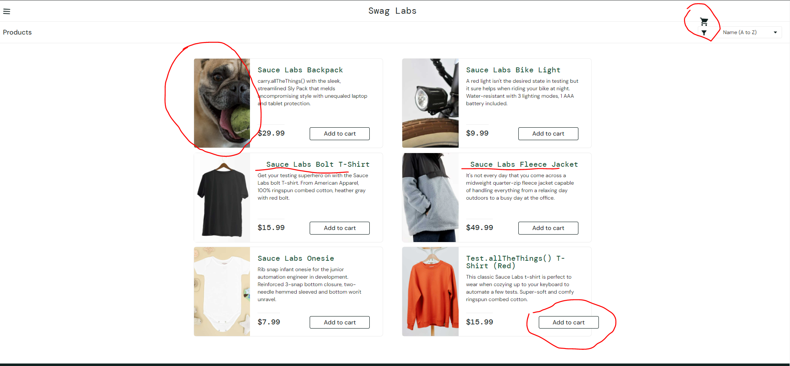

Expected Result: Inventory Page

Image2

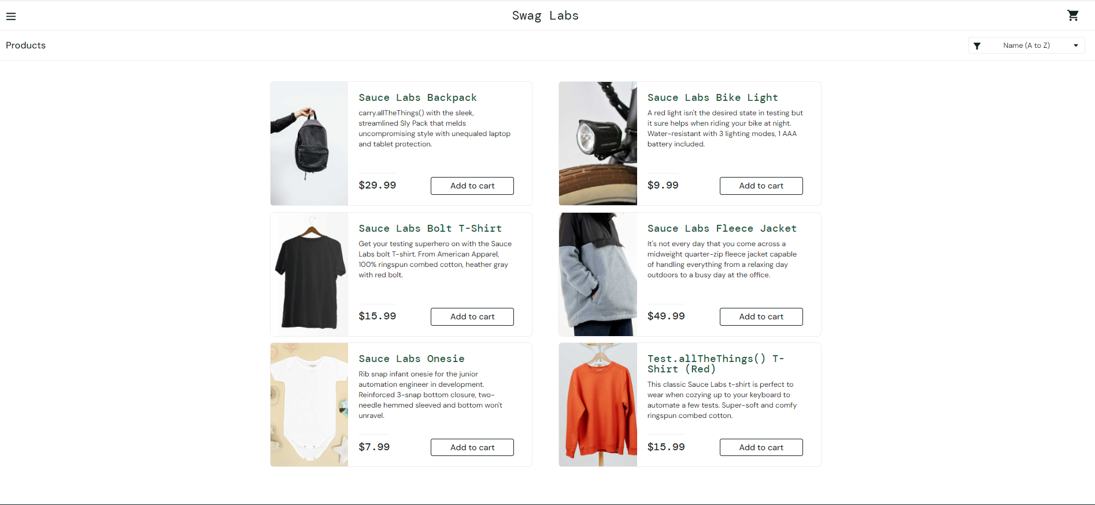

Actual Result: Cart Page

Image3

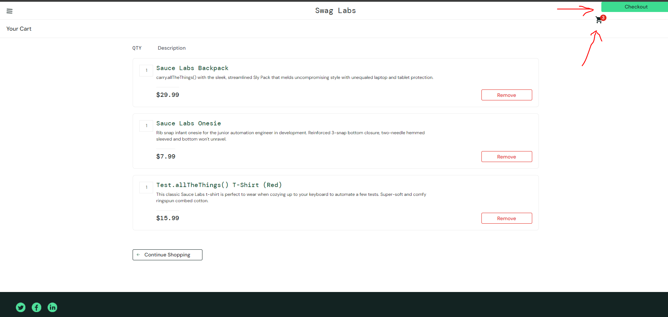

Expected Result: Cart Page

Image4

