**Tenants**

**Users**

**Cases**

**Orders** **(Donation)**

**Transactions**

**Administrators**

**Support**

**Public**

**Service** **Tickets**

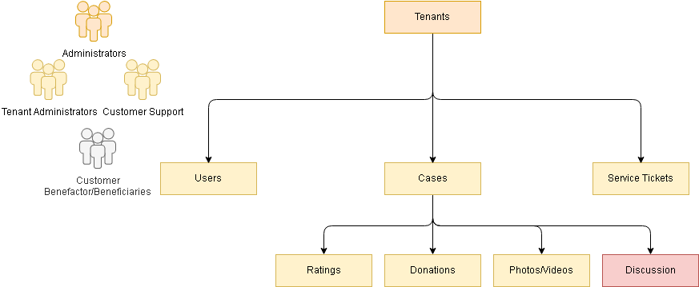

|  |  |  |  |
| --- | --- | --- | --- |
| **Tenants** | **Users** | **Cases** | **Tickets** |
| tenantId  name  businessName  baseLanguage  baseCurrency  address: { country, state, city, place, addressLine1, pincode }  location: { longitude, latitude }  contacts:[{ctype, firstName, lastName, phone, email}] | tenantId  userId (email)  email (unique)  phone (unique)  basic: {firstName, lastName, profilePhoto , language}  authProviders: [{ provider, userid,token,phash,psalt }]  verification: { activated (default: true)  emailVerified (default: true)  phoneVerified (default: true)} | tenantId  caseId  revision  language  status  title  description  commission  address: { country, state, city, place, addressLine1, pincode }  location: { longitude, latitude }  attachments: [ {fileType, imageType, videoType, title, uniqueName }]  beneficiary: { userId, firstName, lastName }  donations: [{ user: { userId, firstName, lastName }, order: { currency, amount }}]  rating: {count, average}  category: [“category name”]  tags: [“tag name”] | tenantId  ticketType  caseid (optional)  email  phone  title  description  attachments: [ {fileType, imageType, videoType, title, uniqueName }] |
|  |  |  |  |
| **Documents (n/a)** | **Case Ratings** | **Case Orders** | **Case Transaction Log** |
| tenantId  docType  refId  refId2  fileType,  imageType,  videoType,  title,  uniqueName | tenantId  caseId  rating  on  comments  user: { userId, firstName, lastName } | tenantId  orderId  caseId  currency  amount  breakdown: { name, currency, amount }  user: { userId, firstName, lastName }  transactions: [{ currency, amount, trnReference, trnHash }] | tenantId  caseId  order: {}  trnInfo: {} |